How to compare project credits for various PCs

You must bring up the application tab Host List and select what you want to compare

1 – In the group Select PCs to compare, pick one. Milkyway is shown in the example below
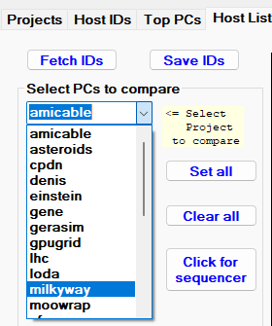

2 - Once selected, all PCs that had Milkyway as a project will be shown.
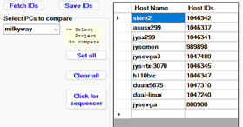
3 – Using the mouse, hold down the CTRL key and select any PCs you want to study.
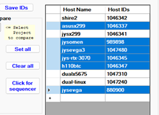

4 – Selecting the above Click for sequencer button you will be directed to app tab Sequencer
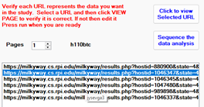
In the above image, note that the PC h110btc was selected and you can view the web page before running the sequencer.
At the web page, some projects have optional applications that can be selected. For example, milkyway has study 4 which can be selected by entering 4 in the APPID field where XX is listed. Click APPLY to select that study.
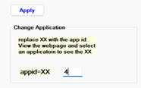

5 – Select the button Sequence the data analysis and wait for the web site data to be obtained. You can press CANCEL to stop
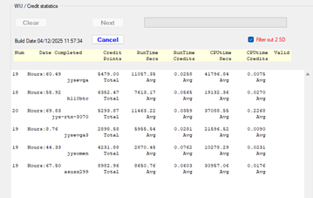

6 - Select a PC in the group: Click to view raw data
