This shows how to load the demo project information
1 – Go to the application tab and click the Fetch IDs button
- Select the Host List tab in this app and select Fetch IDs
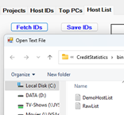

- Look down at the group titled Change Default Project PC
- Select the PC that you want to get credit info from
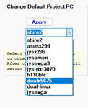
- Click the Apply button (you will be taken to tab 1)
- Select the project you are interested in. The ones in blue are the only ones registered.
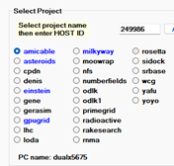
- Click the RUN button
