This module creates an HTML document that is a list of URLs to the known HP bios simulator documents.
The documents are all PDFs. Currently, HP is removing these PDFs.
The missing documents, when found, are temporarily being stored at https://stateson.net/bios_sim.
Eventually I plan on created sets for 20 attachments so the missing documents can be stored
in the HP support database. There is a limit of 20 attachments.

Files  BiosSimulators.html  BiosSimulators.txt  Missing.txt | Description  This is the list of URLs that is needed  This is the database of URL created by this application.  A list of missing documents and the attachment ID if an ID exists

ADD A NEW ITEM
How to add a newly discovered document that you just found at https://h10032.www1.hp.com/ctg/Manual/c07956211.pdf
The title of the document is HP Engage Go 10 Mobile System and it is identified as an interactive BIOS simulator.
The below image is the default settings. Note that Interactive Bios simulator is already set in the dropdown box.
There are 4 known selections. Select one of them or enter a custom description
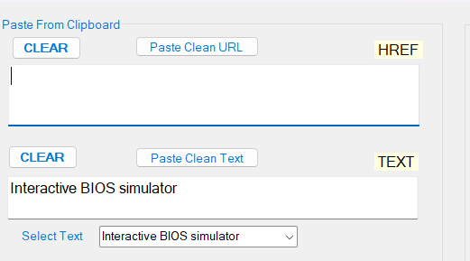

Enter the URL in the box, then add the name of the simulator and click Make Url.
The below image shows the results
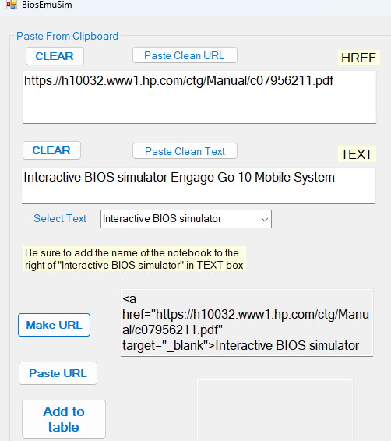
Then click “Add To Table. If you click SAVE then BiosSimulators.txt is updated.
The new item is in the table but it needs to be exported to BiosSimulators.html
In addition it is not in alphabetical order. Click EXPORT and the exit this
application and restart it. Then run the EXPORT again.
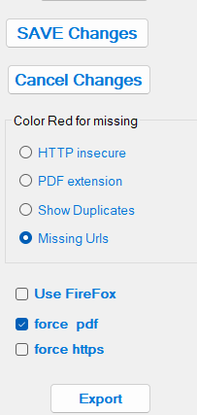

Search for obsolete or missing URLs
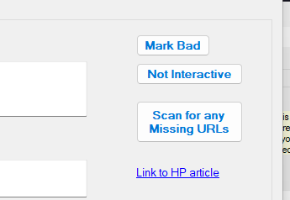
Click that Scan button. Missing URLS (if any) show up
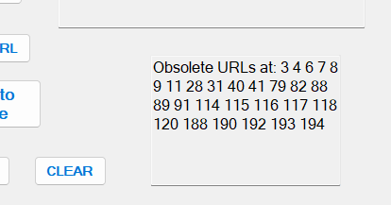

To fix this you must use the wayback archive to obtain the missing PDF file
save the file and then edit “missing.txt” and put the file there.
if the file is an attachment in the KB database then enter the attachment ID.
If not, then the file is assumed to be at https://stateson.net/bios_sims
and not ID is needed.

How to delete an entry I the table
Select the entry and press the DEL key then click the SAVE button.

A number of changes do not take effect until the program is restarted.
ln addition, a warning indicator (red digits) may still be shown until a subsequent restart.
After exporting, start the app back up and export second time. To do TODO

To publish the export, bring up the KB article and delete all content.
Switch the to html code
Start notepad from the release folder
C:\Users\josep\source\repos\MacroEditor\bin\x64\Release\DataFiles>notepad BiosSimulators.html
Copy and paste the contents into the html dialog box, then publish.

