EDIT LINK dialog box

This tool allows you to replace a phrase with an object such as a URL that can be clicked on. You can select a word or phrase with the cursor or just position the cursor in a space. The URL counld be a link to an image and you can specify if the image needs to be clicked to be seen or is to be displayed in the web page.

When you click on "EDIT LINK" the item you selected can be changed to an object such as a URL If nothing is selected then an item can be inserted. If the item you selected is NOT a url then the SET TEXT dialog box pops up.

SET TEXT dialog box

When this pops up, you will see the text you selected, if any. There is a place to enter the URL and you can select a phrase to precede the other URL and a phrase to follow it. Click "Form Object" to create the object and click "Test Object" to see it in the browser. Optionally you can surround your selection with a box.

Click "Apply and exit" to replace the text back it the main EDIT BOX with the new object.

There are 4 demonstration macros you can view. The first demo shows how to bring up the google.com site. After clicking "Click for demo1" you can click "Test Object" to see the results. If you change any of the BOX options be sure to click the "Form Object" before viewing the change.

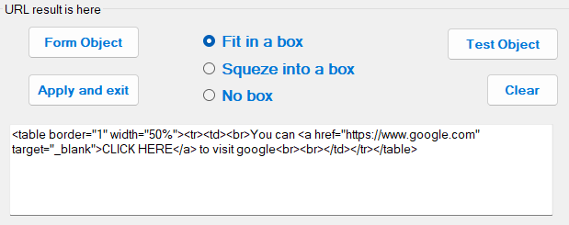

If in the main menu, you selected a URL then the LinkObject dialog box shows up. It has the same functions as the SetText dialog box.