The Printer form is used to compose technical information about the printer.

Before bringing up this form you should have used the mouse to highlight and copy the model name of the printer. If you did not do that then you need to enter the name into the model field and click update

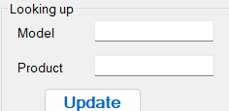

Click MissingID to do an HP system search of the Model name.

Click GOOGLE to do a structured search for the following items

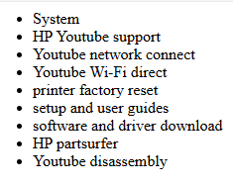

You create your help docment by usign the mouse to select text then then click the corresponding button oi the ALdd Objects tab. Suppose the user needs help with the model 8015 printer. You have the user manual open to page 51 where it discusses using the WPS push button method of connecting Wi-Fi

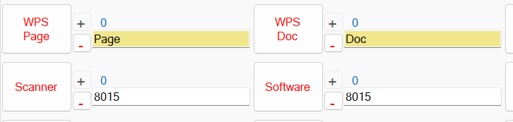

You select and copy the phrase "51" with the mouse and click the WPS Page button. Then you select the URL to the document and click the WPS Doc button. You bring up the software page. Select and copy the URL to 8015 software page and click Software.

Reset Video - Url to video, if any, showing how to reset the printer

Reset Steps - steps to reset if no video is found

Router Video - video of network connect to router

Direct Video - video of network connect usign Wi-Fi direct

Direct Page - If no video then the page number of the manual

Direct Doc - if no video then the URL to the manual for WiFi direct

WPS Page - page number in manual for pushbutton connect

WPS Doc - URL to manual to download for the pushbutton method

Driver - link to download the printer driver

Scanner - link to download the scanner driver if separate from printer

Software - URL to all the software

All Docs - URL to all the documentation

Reference - URL to the reference or spec pate

Parts - url to HP's partsurfer for the device

Assembly - assembly or disassembly video

YouTube - URL to HP's YouTube support page for the device.

If additional videos then click the + button. If the additional video is for a slightly different model then be sure to change the 8015 to the the model such as 8020. Note that most series of models have the same software. Do not add additional models that are very different. If documenting the 8000 series do not add the 9000 for example.