Search for key words

You can search for one or more words in all the macros. The search returns

- The file ID: HP, PC, AIO, LJ, DJ, OJ, OS, NET, HW

- The macro number 1..30 for HP and 1..50 for all others

- The name of the macro.

- The number of occurrences. If 3 keywords the number 1, 2 or 3 will be displayed.

Selecting one of the macros in the view will show which of the keywords were found.  
Double clicking any row will bring up the body of the macro.  
You can optionally exit and position to the macro last selected.

Example search: "battery"

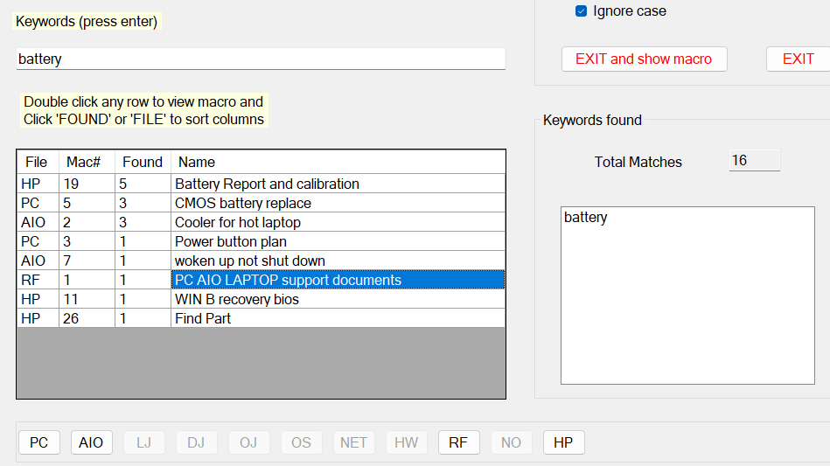

Selecting any of the buttons on the bottom will show only those items in the selected file

Example "country eng fra"

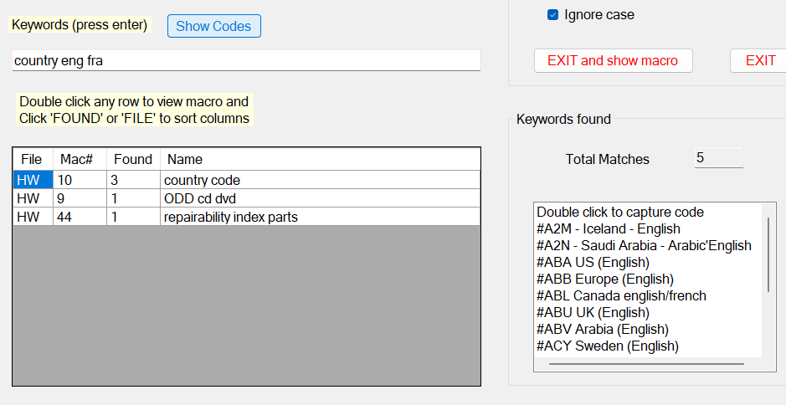

Clicking "Show Codes" causes the country codes to be displayed. If you double click an  
entry "US" in the Keywords Found list then, for example, "#ABA" is put into the clipboard