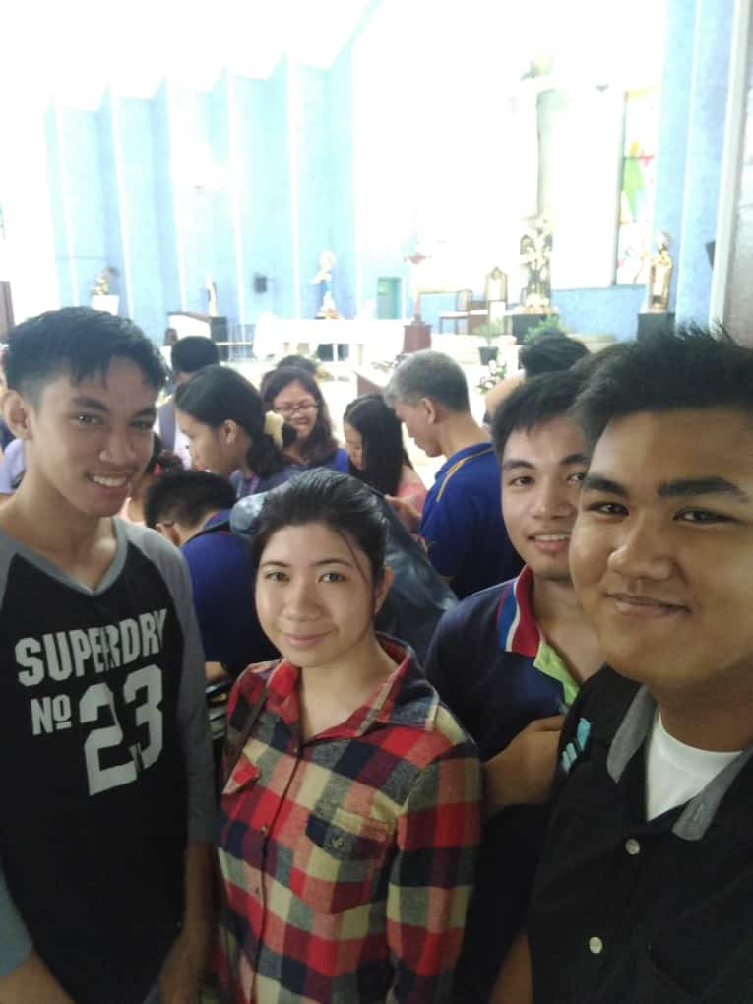

Degillo, John Stephen K21 8-19 week 3

St. Nicholas of Tolentino Oratory