John Stephen Degillo 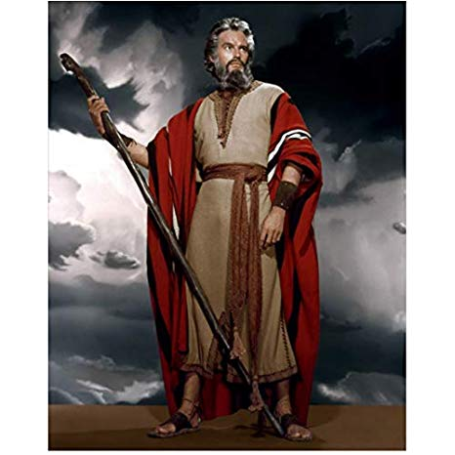BSIT

K21 REED

MOSES

From the Hebrew name מֹשֶׁה (Mosheh), which is most likely derived from Egyptian mes meaning "son", but could also possibly mean "deliver" in Hebrew. ... The biblical Moses was drawn out of the Nile by the pharaoh's daughter and adopted into the royal family, at a time when the Israelites were slaves in Egypt.

He is the most important prophet in Judaism. ... After the Ten Plagues, Moses led the Exodus of the Israelites out of Egypt and across the Red Sea, after which they based themselves at Mount Sinai, where Moses received the Ten Commandments.

https://www.behindthename.com/name/moses

https://www.biblicalarchaeology.org/daily/biblical-topics/exodus/who-was-moses-was-he-more-than-an-exodus-hero/