1. Mt. Pulaski Courthouse State Historic Site
Icon Key
MV
Multiple Venders

Bathroom Available

Food Available

- Food Available
 |  |  | 113 S. Washington St. |  | 8am – 4pm
Enjoy Warm Refreshments, Festive Treats, and Christmas Decor
2. Salt Creek Crafters – American Legion Home
MV |  |  | 103 E. Scroggin Ave |  | 8am – 4pm
Crafts, Antiques, Florals, Clothing, Soaps, Candles,
Jewelry, Pampered Chef, Wood, Holiday
3. Boy Scout Troop 122
MV |  |  | 103 E. Scroggin Ave. (parking lot) |  | 10am – 2pm
Fresh Hot Pork Chop Sandwiches


4. Mt. Pulaski High School
MV |  |  | 206 Spring St. |  | 8am – 4pm
60+ Vendors, Crafts Homemade Goods, & Direct Market Sales



5. Vinegar Hill Treasure Chest
MV |  |  | 121 S. Lafayette St. – New Location |  | 8am – 4pm
Antiques, Repurposed Furniture, Wood Crafts,
Vintage, Handmade, Misc.


6. Topper’s Storage – Complete Storage Solutions
MV |  |  | 926 McDonald St. |  | 8am – 4pm

Large Indoor Shopping – Christmas Décor/Gifts &
Multiple Food Trucks
7. The Crafty Corner
 |  |  | 403 N. Spring St. |  | 10am – 1am
Hats, Ear Warmers, Miniatures, Backed Goods, and Scrubbies



8. Mt. Pulaski Public Library
 |  |  | 320 N. Washington St. |  | 8am – 4pm
Annual Book Sale! FREE Donuts & Hot Drinks

9. Mt. Pulaski Township Historical Museum
 |  |  | 102 – 104 E. Cooke St. |  | 8am – 4pm
Bake Sale & Gently used Christmas items for sale
10. Red Ribbon Christmas
 |  |  | 505 E. Cooke St. |  | 8am – 4pm
Christmas, Thanksgiving & Americana Crafts & Items
11. Daily Wrap
 |  |  | 113 S. Washington (On the Square) |  | 8am – 4pm
Breakfast, and Lunch Wraps, Fresh and Fried Sides.
12. Mt. Pulaski Grade School
MV |  |  | 119 N. Garden St. |  | 8am – 4pm
60+ Vendors, cookie walk, walking tacos, sloppy joes, & hot dogs



13. Mt Pulaski Cafe
 |  |  | 304 E. McDonald St. |  | 6am – 730pm
Breakfast, Lunch, & Dinner Served All Day.
14. We Three Sweets
 |  |  | 113 S. Washington (On the Square) |  | 8am - 4pm
Hot Chocolate, Homemade Marshmallows, Hot Cider,
Cinnamon Rolls, Sweet Treats
15. Zion Lutheran Church
MV |  |  | 203 S. Vine St. |  | 11am-1:30pm
Soup and Sandwiches and Vendors
16. Mt Pulaski Court House Gazebo |  |  |  |  | 8am - 4pm
113 S Washington
Gazebo decorated for Christmas Photo Op
17. Johnson’s True Value Hardware
MV |  |  | 501 E. Chestnut St. |  | 8am - 4pm
Retail full Line Hardware store, Christmas Decore and Holiday lighting
18. Davis Dairy Bar, Inc.
 |  |  | 511 E. Chestnut St. |  | 8am – 4pm
 |  |  | Mini Donuts |  | 8am-1030am
 |  |  | Limited Menu |  | 11am-4pm
19. St. Thomas Aquinas Church
 |  |  | 321 S. Lafayette St. |  | 7am - 11am
Pancakes, sausage, biscuits & gravy, drink and bake sale


20. Annette Hahn
 |  |  | 102 S. Garden St. |  | 8am – 4pm
In Loving Memory of Annette, over 15-year Board Member of the Christmas on Vinegar Hill Committee; Gone but not Forgotten.
21. The Next Stop Saloon
 |  |  | 100 E. Cooke St. |  | 11am – 1am
Special Holiday Drinks, Cold Beer, Pizza, & Gaming
22. Boomer’s BBQ
 |  |  | 113 S. Washington (On the Square) |  | 8am – 4pm
Brisket, Pork, Nachos, Fries, Wings, Etc..
23. Market on the Hill
 |  |  | 125 S. Lafayette St. |  | 7am - 7pm


Sandwiches, Soup, Baked Treats, Iced Lattes, Coffee, Crafts & More
24. Pizza Man - Photo Op
 |  |  | 120 E, Cooke St. |  | 8am – 4pm
Fence Decorated for Christmas Photo Op
25. Loo’s Sugar Buzz
 |  |  | 113 S. Washington (On the Square) |  | 8am – 4pm
Coffees, Dirty Drinks, Lemonade sack ups, and Sweet Tea

Chestnut Location
C1 Chestnut Fire Dept.
MV |  |  | 110 E. Olive St. |  | 8am – 4pm
Crafts, Bake Sale, Jewelry, and More!
Elkhart Location
E1 Elkhart Station General Store
 |  |  | 101 Governor Oglesby St. |  | 8am – 4pm
General Store with Illinois Products and Wine Tastings
E2 The Talk of the Town
 |  |  |  | 115 Governor Oglesby St. |  | 8am – 2pm
Restaurant and Bar: Good Food and Good Drinks
Latham Location

L1 BB’s BFE Bar & Grill
MV |  |  | 2371 N Rt. 121 |  | 10:30am – 12am


Restaurant and Bar: Hot Food and Cold Drinks

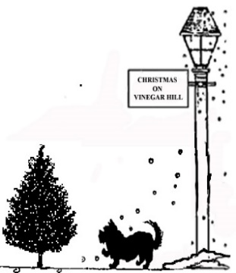
Look for the Tree Sign
for Participating Locations
Visit a Location with  symbol & receive a reusable shopping bag with any donation to the
2024 Christmas on Vinegar Hill Event (while supplies last)


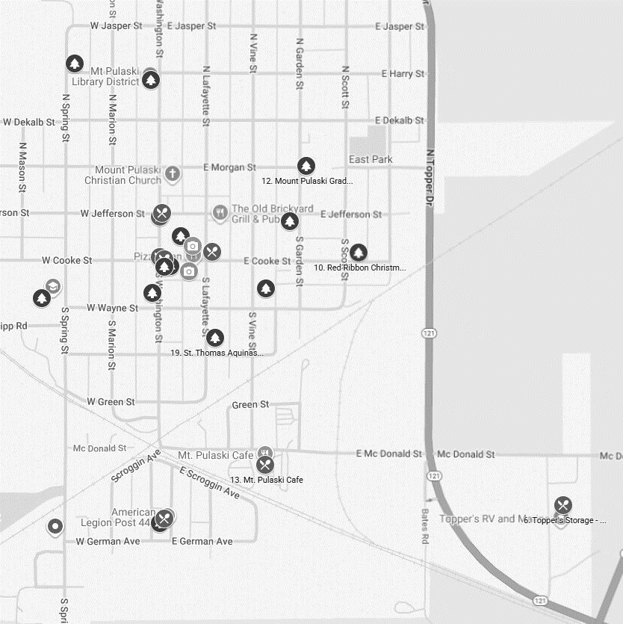
Mt. Pulaski
THANK YOU
for your patronage and to our
Christmas on Vinegar Hill
grant benefactors:
Mt. Pulaski Economic Development & Planning Board
Tomlinson Trust
Community Foundation for the Land of Lincoln
Logan County Tourism Bureau
The City of Mt. Pulaski
Casey’s General Store


Sponsors
Eaton Corp.
INB
Land & Home Real Estate & Property Management

Scan for
Google Map of Event
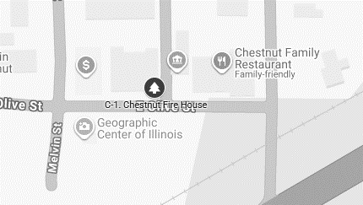
Chestnut
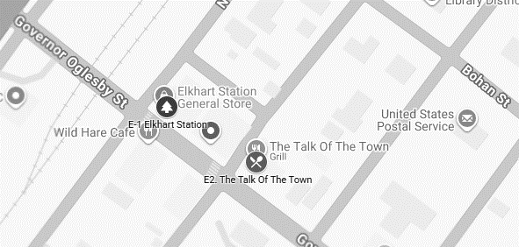
Elkhart

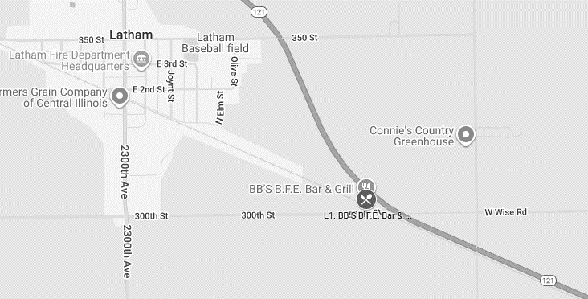
Latham

Follow us on FACEBOOK &
www.cityofmtpulaski.com
click on “In our community”
then “Christmas on Vinegar Hill”
for updates & vendor listings!

