Read Me - EasyGraph

By Charles Stoksik and Bryan Josloff

**Function:** EasyGraph is an excel like application that allows users to create simple and easy to use graphs with their datasets. EasyGraph has an intuitive functionality such that anyone can enter data into the application and create personal graphs or store their data.

**Where to run EasyGraph:** EasyGraph works best on Qt_5_9 to Qt_5_12 for MacOS. Unfortunately the headers do not contain color on the windows version. Also if the mac is set to dark mode then the aesthetic colors of the application pop the best.

All pictures and images are created by us and included in the images.qrc file. May need to add prefix /images to access.

**Screenshots and Navigation:**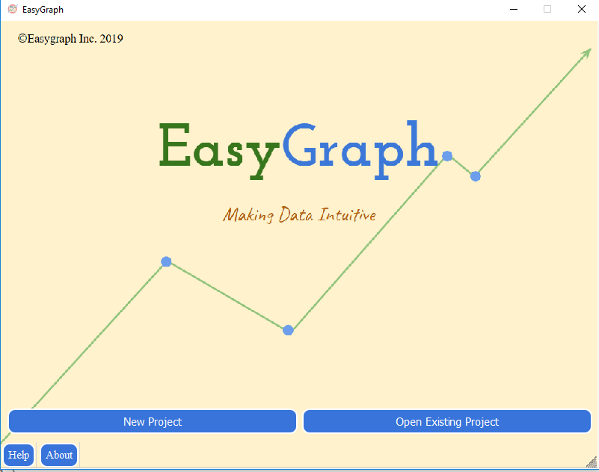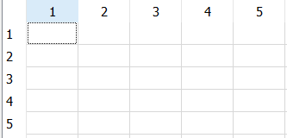

1. Open EasyGraph - see Splash-Screen of icon and go to the home page above.
2. New Project will transport you to a new EasyGraph file with no name. There will be a blank table, the standard toolbar, and a graphic of rectangles where the chart will appear.
3. If you choose to open a new project you will be prompted to a window connecting your file system to EasyGraph. You will only be able to open .ezg files (one or more will be included in our project submission to play around with). When opening a previous file graphs will not be auto-generated and values will not be pre-selected, however they will still be located in the same sections.
4. Within the project each icon corresponds to a certain program functionality
   1. First three correspond to new, open, and save. These are pretty standard
   2. Second four correspond to cut, copy, paste, and delete. These are specific for values in the table, not other part of the code can be copied or pasted into (unless it’s the pop-up window lineEdit).
   3. The last icon (the palette) changes the theme color. It allows the user to select a theme color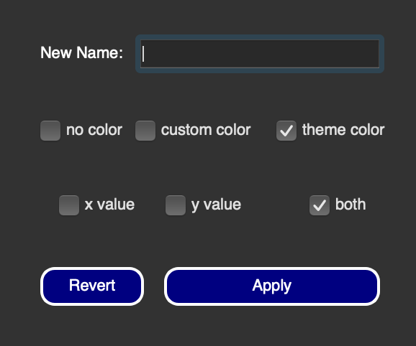
5. A central feature to EasyGraph is the ability to customize your header widgets. If you double-click a header a window will pop-up to allow you to customize the window. You can set text, color, and axes. (Screenshot of Mac cus windows is cheeks and doesn’t let me screenshot without it disappearing)
6. You need to assign headers to axes to graph results. There is no highlighting and generating a graph (that is a future goal).
7. Unfortunately color does not show up in the headers on Windows so for best results use Mac.
8. There are four types of graphs that can be generated with EasyGraph: Linear, Scatter, Bar and Pie. Linear connects each point, Scatter adds the data as points, Bar creates bars, and pie creates a pie chart.
9. For further instructions go to the About menu and select Instructions.

Ex. If you were to close this file and re-open it the graph would be replaced by the rectangles picture. Also velocity, acceleration, and position would not be selected, however they would still be located in the y-value section.