**Exercise 1: Create a Spring Web Project using Maven**

Code:

SpringLearnApplication.java

**package** com.cognizant.spring_learn;

**import** org.springframework.boot.SpringApplication;

**import** org.springframework.boot.autoconfigure.SpringBootApplication;

@SpringBootApplication

**public** **class** SpringLearnApplication {

**public** **static** **void** main(String[] args) {

SpringApplication.*run*(SpringLearnApplication.**class**, args);

}

}

pom.xml

<?xml version="1.0" encoding="UTF-8"?>

<project xmlns="http://maven.apache.org/POM/4.0.0" xmlns:xsi="http://www.w3.org/2001/XMLSchema-instance"

xsi:schemaLocation="http://maven.apache.org/POM/4.0.0 https://maven.apache.org/xsd/maven-4.0.0.xsd">

<modelVersion>4.0.0</modelVersion>

<parent>

<groupId>org.springframework.boot</groupId>

<artifactId>spring-boot-starter-parent</artifactId>

<version>3.5.3</version>

<relativePath/> <!-- lookup parent from repository -->

</parent>

<groupId>com.cognizant</groupId>

<artifactId>spring-learn</artifactId>

<version>0.0.1-SNAPSHOT</version>

<name>spring-learn</name>

<description>Demo project for Spring Boot</description>

<url/>

<licenses>

<license/>

</licenses>

<developers>

<developer/>

</developers>

<scm>

<connection/>

<developerConnection/>

<tag/>

<url/>

</scm>

<properties>

<java.version>17</java.version>

</properties>

<dependencies>

<dependency>

<groupId>org.springframework.boot</groupId>

<artifactId>spring-boot-starter-web</artifactId>

</dependency>

<dependency>

<groupId>org.springframework.boot</groupId>

<artifactId>spring-boot-devtools</artifactId>

<scope>runtime</scope>

<optional>true</optional>

</dependency>

<dependency>

<groupId>org.springframework.boot</groupId>

<artifactId>spring-boot-starter-test</artifactId>

<scope>test</scope>

</dependency>

</dependencies>

<build>

<plugins>

<plugin>

<groupId>org.springframework.boot</groupId>

<artifactId>spring-boot-maven-plugin</artifactId>

</plugin>

</plugins>

</build>

</project>

Output:

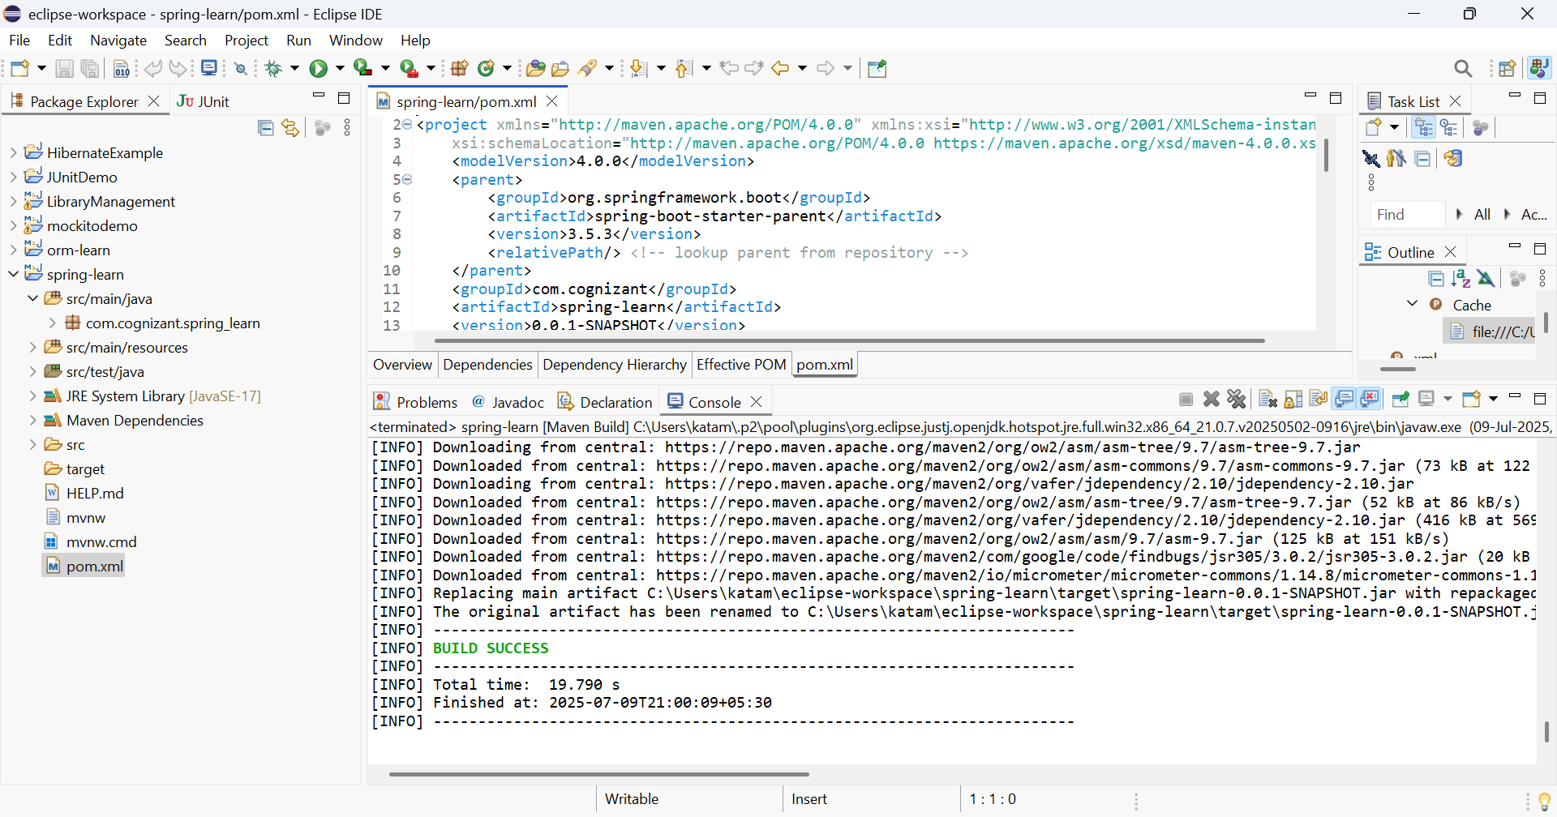

**Exercise 2: Spring Core – Load Country from Spring Configuration XML**

**Code:**

pom.xml

<?xml version="1.0" encoding="UTF-8"?>

<project xmlns="http://maven.apache.org/POM/4.0.0" xmlns:xsi="http://www.w3.org/2001/XMLSchema-instance"

xsi:schemaLocation="http://maven.apache.org/POM/4.0.0 https://maven.apache.org/xsd/maven-4.0.0.xsd">

<modelVersion>4.0.0</modelVersion>

<parent>

<groupId>org.springframework.boot</groupId>

<artifactId>spring-boot-starter-parent</artifactId>

<version>3.5.3</version>

<relativePath/> <!-- lookup parent from repository -->

</parent>

<groupId>com.cognizant</groupId>

<artifactId>spring-learn</artifactId>

<version>0.0.1-SNAPSHOT</version>

<name>spring-learn</name>

<description>Demo project for Spring Boot</description>

<url/>

<licenses>

<license/>

</licenses>

<developers>

<developer/>

</developers>

<scm>

<connection/>

<developerConnection/>

<tag/>

<url/>

</scm>

<properties>

<java.version>17</java.version>

</properties>

<dependencies>

<!-- Spring Boot Starter for Web -->

<dependency>

<groupId>org.springframework.boot</groupId>

<artifactId>spring-boot-starter-web</artifactId>

</dependency>

<!-- Spring Boot DevTools -->

<dependency>

<groupId>org.springframework.boot</groupId>

<artifactId>spring-boot-devtools</artifactId>

<scope>runtime</scope>

<optional>true</optional>

</dependency>

<!-- Spring Boot Test -->

<dependency>

<groupId>org.springframework.boot</groupId>

<artifactId>spring-boot-starter-test</artifactId>

<scope>test</scope>

</dependency>

<!-- SLF4J Logging API -->

<dependency>

<groupId>org.slf4j</groupId>

<artifactId>slf4j-api</artifactId>

<version>1.7.36</version>

</dependency>

<!-- Logback Classic (Logback implementation for SLF4J) -->

<dependency>

<groupId>ch.qos.logback</groupId>

<artifactId>logback-classic</artifactId>

<version>1.2.11</version>

</dependency>

<!--this to resolve NoClassDefFoundError -->

<dependency>

<groupId>ch.qos.logback</groupId>

<artifactId>logback-core</artifactId>

<version>1.2.11</version>

</dependency>

</dependencies>

<build>

<plugins>

<plugin>

<groupId>org.springframework.boot</groupId>

<artifactId>spring-boot-maven-plugin</artifactId>

</plugin>

</plugins>

</build>

</project>

country.xml

<?xml version="1.0" encoding="UTF-8"?>

<beans xmlns="http://www.springframework.org/schema/beans"

xmlns:xsi="http://www.w3.org/2001/XMLSchema-instance"

xsi:schemaLocation="

http://www.springframework.org/schema/beans

https://www.springframework.org/schema/beans/spring-beans.xsd">

<bean id="country" class="com.cognizant.spring_learn.Country">

<property name="code" value="IN"/>

<property name="name" value="India"/>

</bean>

</beans>

logback.xml

<configuration>

<appender name="STDOUT" class="ch.qos.logback.core.ConsoleAppender">

<encoder>

<pattern>%d{HH:mm:ss.SSS} [%thread] %-5level %logger{36} - %msg%n</pattern>

</encoder>

</appender>

<root level="DEBUG">

<appender-ref ref="STDOUT" />

</root>

</configuration>

SpringLearnApplication.java

**package** com.cognizant.spring_learn;

**import** org.slf4j.Logger;

**import** org.slf4j.LoggerFactory;

**import** org.springframework.context.ApplicationContext;

**import** org.springframework.context.support.ClassPathXmlApplicationContext;

**public** **class** SpringLearnApplication {

**private** **static** **final** Logger ***LOGGER*** = LoggerFactory.*getLogger*(SpringLearnApplication.**class**);

**public** **static** **void** main(String[] args) {

***LOGGER***.debug("START main()");

*displayCountry*();

***LOGGER***.debug("END main()");

}

**public** **static** **void** displayCountry() {

ApplicationContext context = **new** ClassPathXmlApplicationContext("country.xml");

Country country = context.getBean("country", Country.**class**);

***LOGGER***.debug("Country: {}", country);

}

}

Country.java

**package** com.cognizant.spring_learn;

**import** org.slf4j.Logger;

**import** org.slf4j.LoggerFactory;

**public** **class** Country {

**private** **static** **final** Logger ***LOGGER*** = LoggerFactory.*getLogger*(Country.**class**);

**private** String code;

**private** String name;

**public** Country() {

***LOGGER***.debug("Inside Country Constructor.");

}

**public** String getCode() {

***LOGGER***.debug("Getting code: {}", code);

**return** code;

}

**public** **void** setCode(String code) {

***LOGGER***.debug("Setting code: {}", code);

**this**.code = code;

}

**public** String getName() {

***LOGGER***.debug("Getting name: {}", name);

**return** name;

}

**public** **void** setName(String name) {

***LOGGER***.debug("Setting name: {}", name);

**this**.name = name;

}

@Override

**public** String toString() {

**return** "Country [code=" + code + ", name=" + name + "]";

}

}

Output:

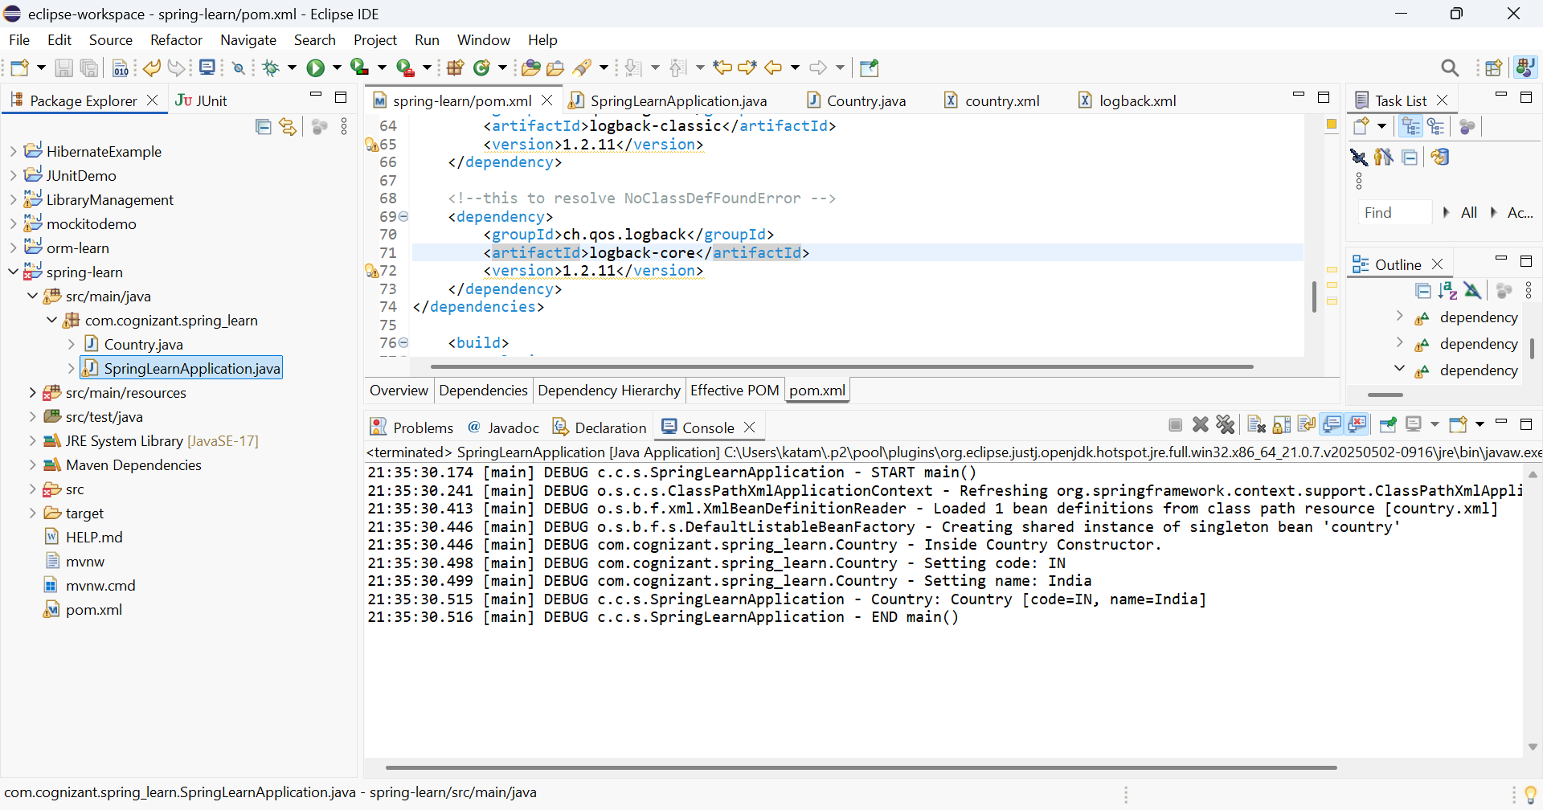

**Exercise 3: Hello World RESTful Web Service**

**Write a REST service in the spring learn application created earlier, that returns the text "Hello World!!" using Spring Web Framework.**

Code:

HelloController.java

**package** com.cognizant.spring_learn.controller;

**import** org.slf4j.Logger;

**import** org.slf4j.LoggerFactory;

**import** org.springframework.web.bind.annotation.GetMapping;

**import** org.springframework.web.bind.annotation.RestController;

@RestController

**public** **class** HelloController {

**private** **static** **final** Logger ***LOGGER*** = LoggerFactory.*getLogger*(HelloController.**class**);

@GetMapping("/hello")

**public** String sayHello() {

***LOGGER***.debug("START sayHello()");

String response = "Hello World!!";

***LOGGER***.debug("END sayHello()");

**return** response;

}

}

application.properties:

spring.application.name=spring-learn

server.port=8083

SpringLearnApplication.java

**package** com.cognizant.spring_learn;

**import** org.springframework.boot.SpringApplication;

**import** org.springframework.boot.autoconfigure.SpringBootApplication;

@SpringBootApplication

**public** **class** SpringLearnApplication {

**public** **static** **void** main(String[] args) {

SpringApplication.*run*(SpringLearnApplication.**class**, args);

}

}

Output:

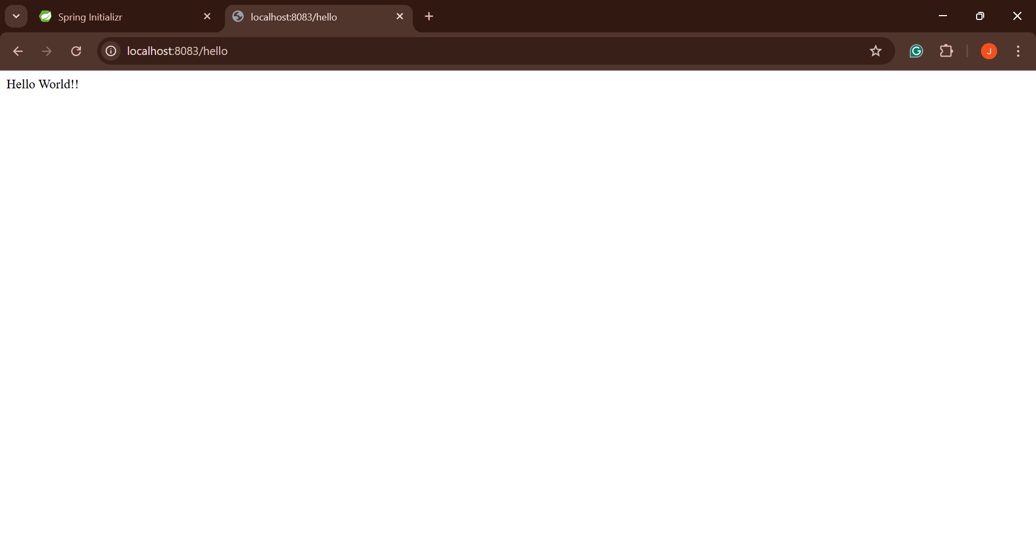

**Exercise 4: REST - Country Web Service**

**Write a REST service that returns India country details in the earlier created spring learn application.**

Code:

application.properties:

spring.application.name=spring-learn

server.port=8083

SpringLearnApplication.java

**package** com.cognizant.spring_learn;

**import** org.springframework.boot.SpringApplication;

**import** org.springframework.boot.autoconfigure.SpringBootApplication;

@SpringBootApplication

**public** **class** SpringLearnApplication {

**public** **static** **void** main(String[] args) {

SpringApplication.*run*(SpringLearnApplication.**class**, args);

}

}

CountryController.java

**package** com.cognizant.spring_learn.controller;

**import** com.cognizant.spring_learn.model.Country;

**import** org.slf4j.Logger;

**import** org.slf4j.LoggerFactory;

**import** org.springframework.context.ApplicationContext;

**import** org.springframework.context.support.ClassPathXmlApplicationContext;

**import** org.springframework.web.bind.annotation.GetMapping;

**import** org.springframework.web.bind.annotation.RestController;

@RestController

**public** **class** CountryController {

**private** **static** **final** Logger ***LOGGER*** = LoggerFactory.*getLogger*(CountryController.**class**);

@GetMapping("/country")

**public** Country getCountryIndia() {

***LOGGER***.debug("START getCountryIndia()");

ApplicationContext context = **new** ClassPathXmlApplicationContext("country.xml");

Country country = (Country) context.getBean("country");

***LOGGER***.debug("END getCountryIndia()");

**return** country;

}

}

Country.java

**package** com.cognizant.spring_learn.model;

**import** org.slf4j.Logger;

**import** org.slf4j.LoggerFactory;

**public** **class** Country {

**private** **static** **final** Logger ***LOGGER*** = LoggerFactory.*getLogger*(Country.**class**);

**private** String code;

**private** String name;

**public** Country() {

***LOGGER***.debug("Inside Country Constructor.");

}

**public** String getCode() {

**return** code;

}

**public** **void** setCode(String code) {

***LOGGER***.debug("Setting code: {}", code);

**this**.code = code;

}

**public** String getName() {

**return** name;

}

**public** **void** setName(String name) {

***LOGGER***.debug("Setting name: {}", name);

**this**.name = name;

}

@Override

**public** String toString() {

**return** "Country [code=" + code + ", name=" + name + "]";

}

}

Output:

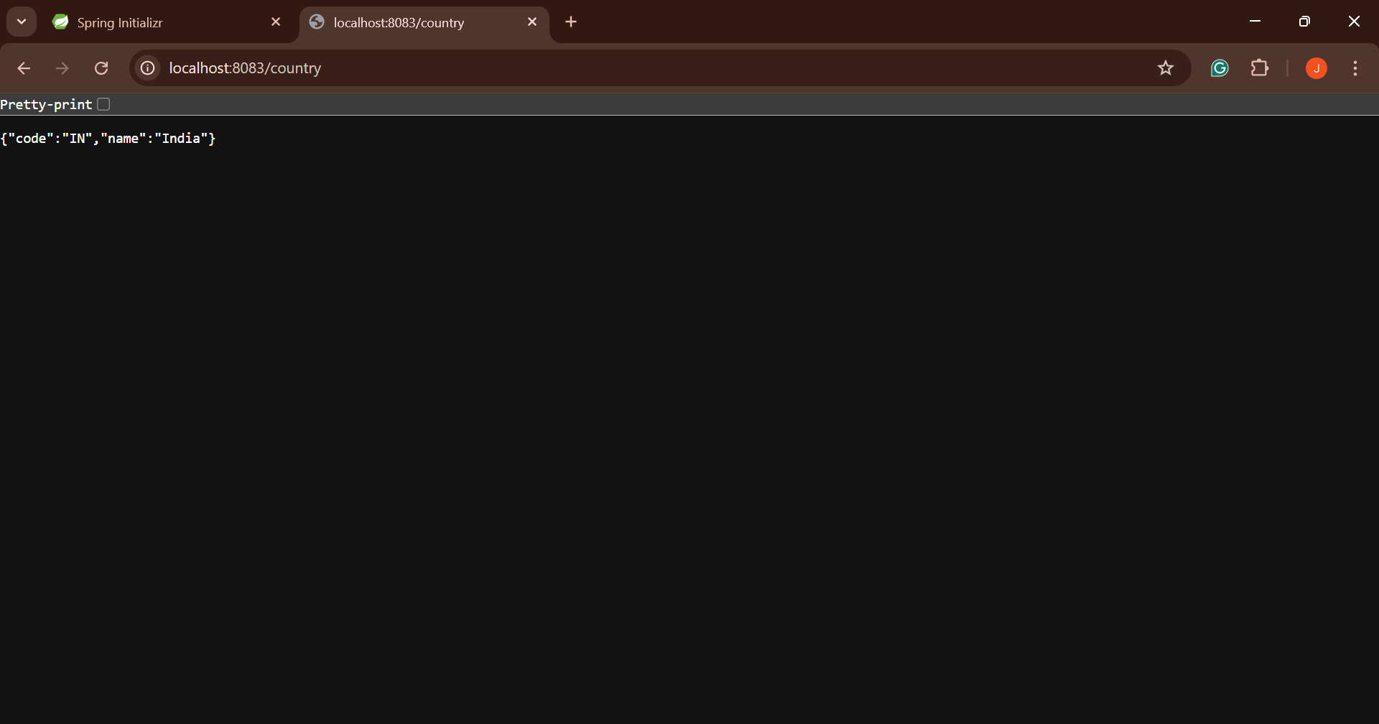

**Exercise 5: REST - Get country based on country code**

**Write a REST service that returns a specific country based on country code. The country code should be case insensitive.**

Code:

application.properties:

spring.application.name=spring-learn

server.port=8083

SpringLearnApplication.java

**package** com.cognizant.spring_learn;

**import** org.springframework.boot.SpringApplication;

**import** org.springframework.boot.autoconfigure.SpringBootApplication;

@SpringBootApplication

**public** **class** SpringLearnApplication {

**public** **static** **void** main(String[] args) {

SpringApplication.*run*(SpringLearnApplication.**class**, args);

}

}

country.xml

<?xml version="1.0" encoding="UTF-8"?>

<beans xmlns="http://www.springframework.org/schema/beans"

xmlns:xsi="http://www.w3.org/2001/XMLSchema-instance"

xsi:schemaLocation="

http://www.springframework.org/schema/beans

http://www.springframework.org/schema/beans/spring-beans.xsd">

<bean id="countryList" class="java.util.ArrayList">

<constructor-arg>

<list>

<bean class="com.cognizant.spring_learn.model.Country">

<property name="code" value="IN"/>

<property name="name" value="India"/>

</bean>

<bean class="com.cognizant.spring_learn.model.Country">

<property name="code" value="US"/>

<property name="name" value="United States"/>

</bean>

<bean class="com.cognizant.spring_learn.model.Country">

<property name="code" value="DE"/>

<property name="name" value="Germany"/>

</bean>

</list>

</constructor-arg>

</bean>

</beans>

CountryController.java

**package** com.cognizant.spring_learn.controller;

**import** com.cognizant.spring_learn.model.Country;

**import** com.cognizant.spring_learn.service.CountryService;

**import** org.springframework.beans.factory.annotation.Autowired;

**import** org.springframework.web.bind.annotation.*;

@RestController

**public** **class** CountryController {

@Autowired

**private** CountryService countryService;

@GetMapping("/countries/{code}")

**public** Country getCountry(@PathVariable String code) {

**return** countryService.getCountry(code);

}

}

Country.java

**package** com.cognizant.spring_learn.model;

**public** **class** Country {

**private** String code;

**private** String name;

**public** Country() {}

**public** Country(String code, String name) {

**this**.code = code;

**this**.name = name;

}

**public** String getCode() {

**return** code;

}

**public** **void** setCode(String code) {

**this**.code = code;

}

**public** String getName() {

**return** name;

}

**public** **void** setName(String name) {

**this**.name = name;

}

@Override

**public** String toString() {

**return** "Country [code=" + code + ", name=" + name + "]";

}

}

CountryService.java

**package** com.cognizant.spring_learn.service;

**import** com.cognizant.spring_learn.model.Country;

**import** org.springframework.beans.factory.annotation.Autowired;

**import** org.springframework.context.ApplicationContext;

**import** org.springframework.context.support.ClassPathXmlApplicationContext;

**import** org.springframework.stereotype.Service;

**import** java.util.List;

@Service

**public** **class** CountryService {

**public** Country getCountry(String code) {

ApplicationContext context = **new** ClassPathXmlApplicationContext("country.xml");

List<Country> countryList = context.getBean("countryList", List.**class**);

**return** countryList.stream()

.filter(c -> c.getCode().equalsIgnoreCase(code))

.findFirst()

.orElse(**null**);

}

}

Output:

