**Problem Statement:**

Create a React Application “eventexamplesapp” to handle various events of the form elements in HTML.

1. Create “Increment” button to increase the value of the counter and “Decrement” button to decrease the value of the counter. The “Increase” button should invoke multiple methods.

a. To increment the value

b. Say Hello followed by a static message.

**Solution:**

[**App.js**](http://app.js)

import React, { useState } from 'react';

import CurrencyConvertor from './CurrencyConvertor';

function App() {

const [count, setCount] = useState(0);

const increment = () => {

setCount(count + 1);

alert("Hello! Member1");

};

const decrement = () => {

setCount(count - 1);

};

const sayWelcome = (message) => {

alert(message);

};

const onPress = () => {

alert("I was clicked");

};

return (

<div style={{ padding: '20px' }}>

<h1>Counter: {count}</h1>

<button onClick={increment}>Increment</button>

<button onClick={decrement}>Decrement</button>

<button onClick={() => sayWelcome("Welcome!")}>Say Welcome</button>

<button onClick={onPress}>Click on me</button>

<hr />

<CurrencyConvertor />

</div>

);

}

export default App;

[**CurrencyConvertor.js**](http://currencyconvertor.js)

import React, { useState } from 'react';

function CurrencyConvertor() {

const [amount, setAmount] = useState('');

const [currency, setCurrency] = useState('');

const handleSubmit = () => {

const converted = parseFloat(amount) / 90;

if (!isNaN(converted)) {

setCurrency(converted.toFixed(2) + " Euro");

alert(`Converting ₹${amount} to Euro`);

} else {

alert("Please enter a valid number.");

}

};

return (

<div style={{ marginTop: '20px' }}>

<h2 style={{ color: "green" }}>Currency Converter</h2>

<label>Amount (₹): </label>

<input

type="text"

value={amount}

onChange={(e) => setAmount(e.target.value)}

/>

<br /><br />

<label>Converted Currency: </label>

<input type="text" value={currency} readOnly />

<br /><br />

<button onClick={handleSubmit}>Submit</button>

</div>

);

}

export default CurrencyConvertor;

**Output:**

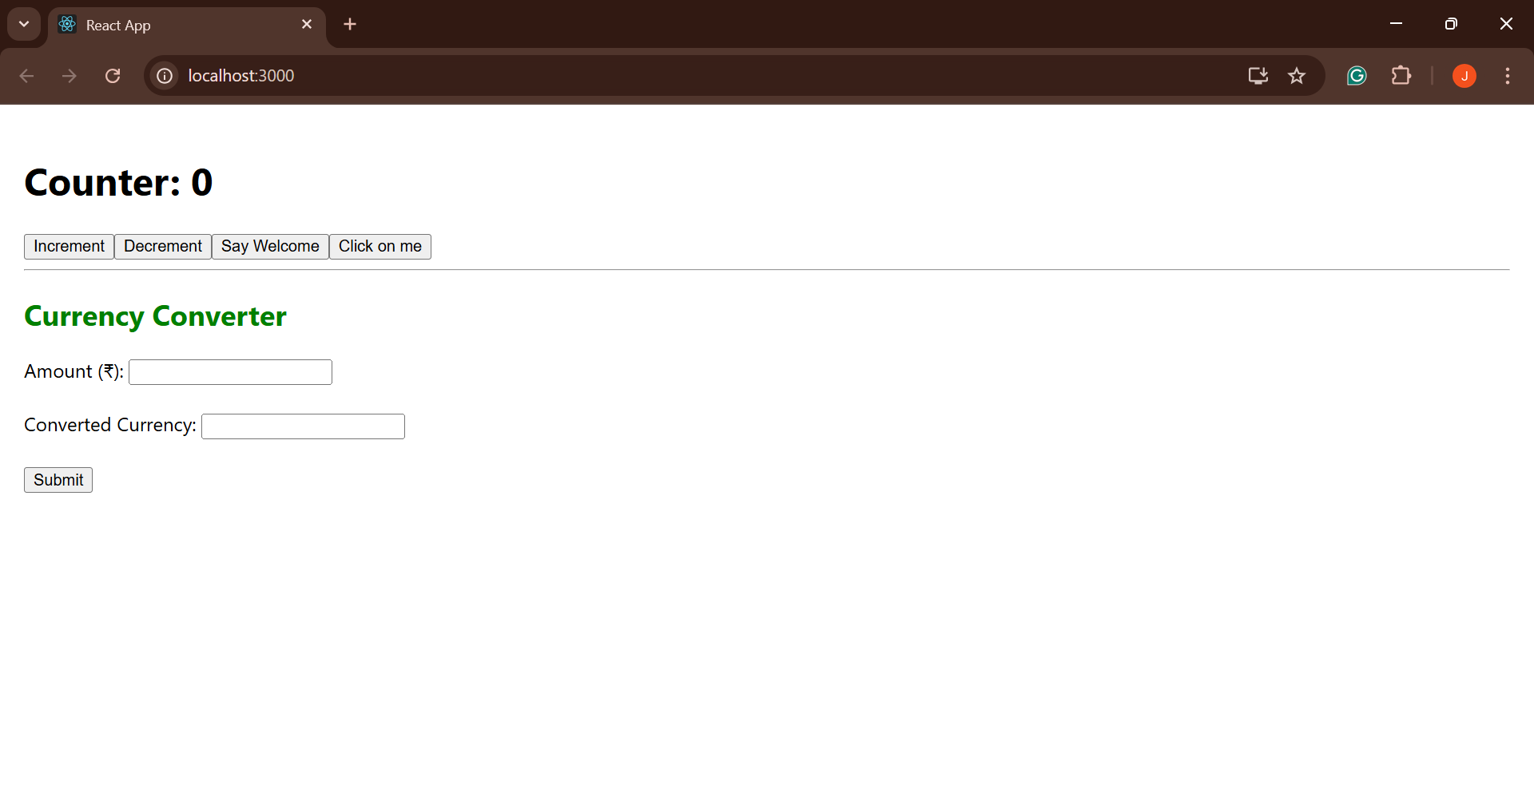

a button “Say Welcome” which invokes the function which takes “welcome” as an argument.

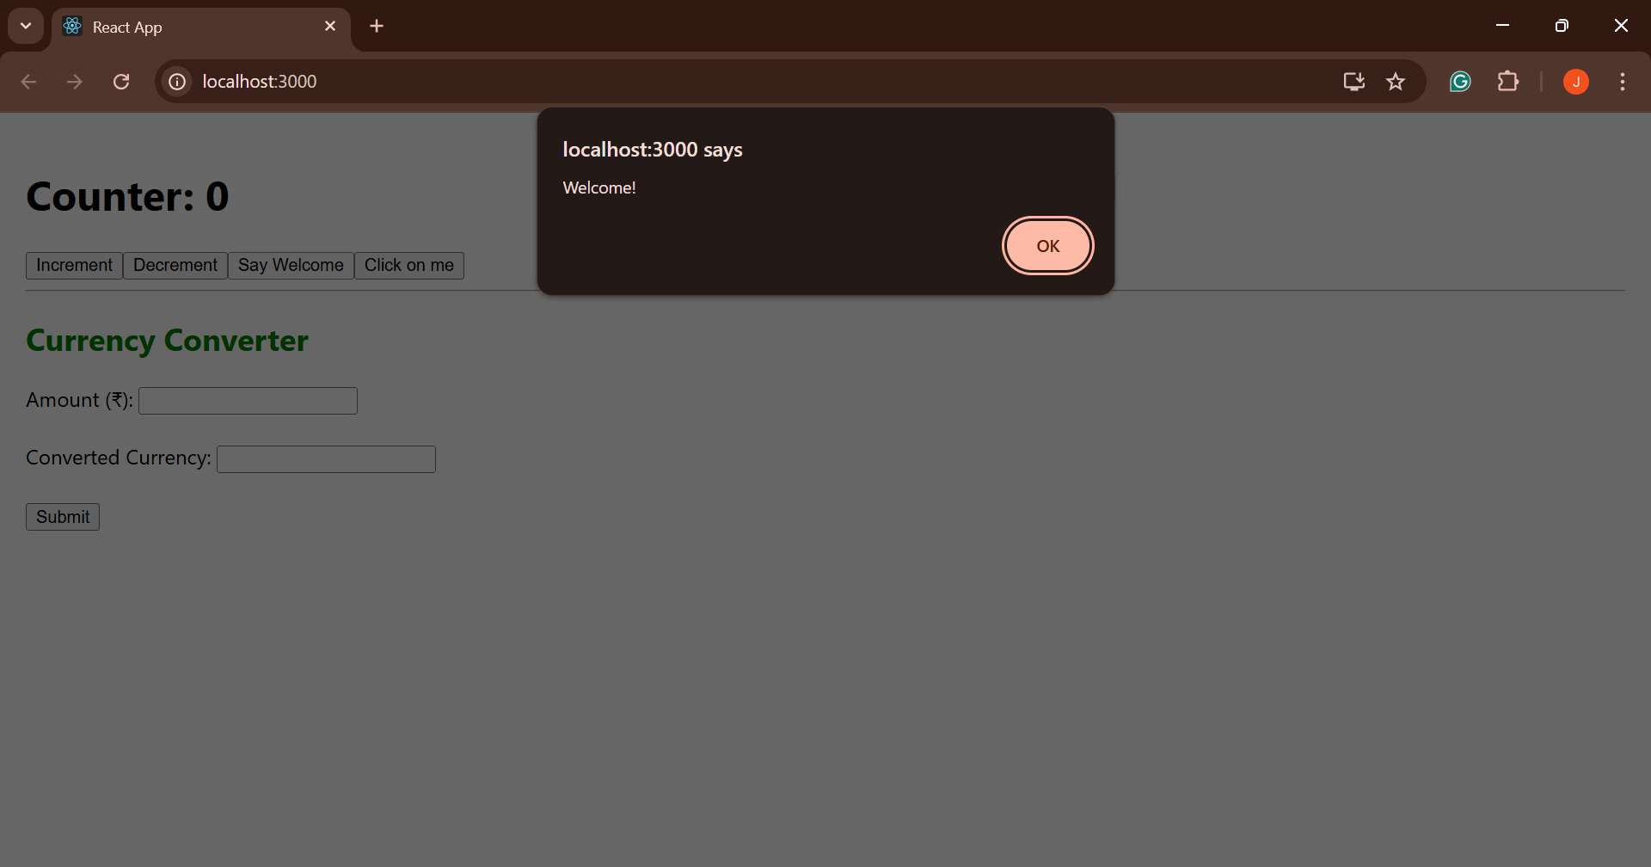

a button which invokes synthetic event “OnPress” which display “I was clicked”

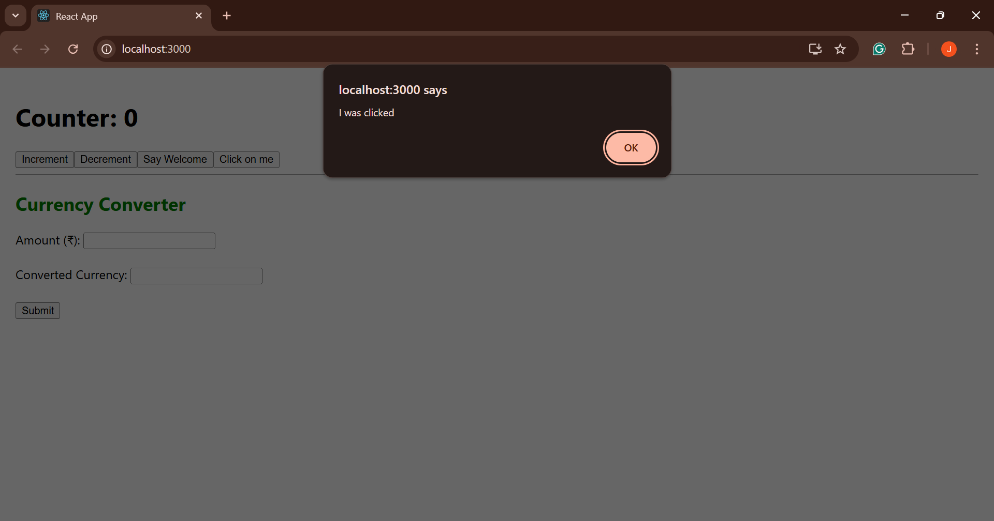

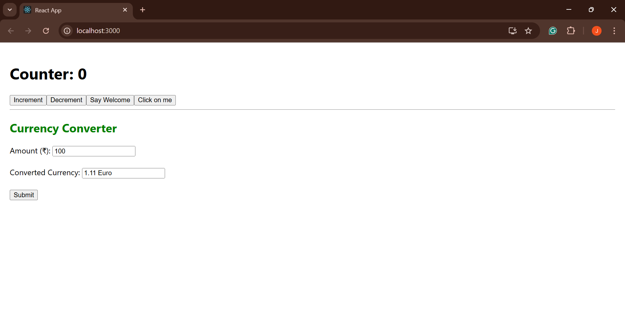

Click event of the button to invoke the handleSubmit event and handle the conversion of the euro to rupees.

