**ME-7120 Finite Element Method Applications**

**Project 1**

____________________________________________________

Sagar Sangle, Joel Summerfield & Andy Turner

**Course:** FEM

**Section:** ME-7120-01

**Prof:** Dr. Slater

­­­­­

**Submitted:** October 28th, 2016

Table of Contents

I. Nomenclature 0

II. Project Description 1

III. Results 1

1. Non-Tapered Beam 1

2. Rotated Non-Tapered Beam 2

3. Tapered Beam 2

4. Complex Truss 2

IV. Conclusion 3

V. Appendix 3

# Nomenclature

** = Displacement

P = Load

E = Young’s Modulus of Elasticity

I = Mass Moment of Inertia

# Project Description

1. Non-Tapered Beam:
   1. WFEM Analysis
   2. ANSYS Analysis
   3. Closed Form Solution
2. Rotated Non-Tapered Beam
   1. Use WFEM to show transformation matrix is correct
3. Tapered Beam:
   1. WFEM Analysis
   2. ANSYS Analysis
4. Complex Truss
   1. WFEM Analysis
   2. ANSYS Analysis

# Results

### Non-Tapered Beam

WFEM and ANSYS were used to analyze a non-tapered, 2 noded, 3D beam element (All of the code that was used for this project can be found in the Appendix section of this report). Figure 1 below shows the non-tapered beam that was analyzed. The boundary and loading conditions are shown as well as the geometry of the beam.

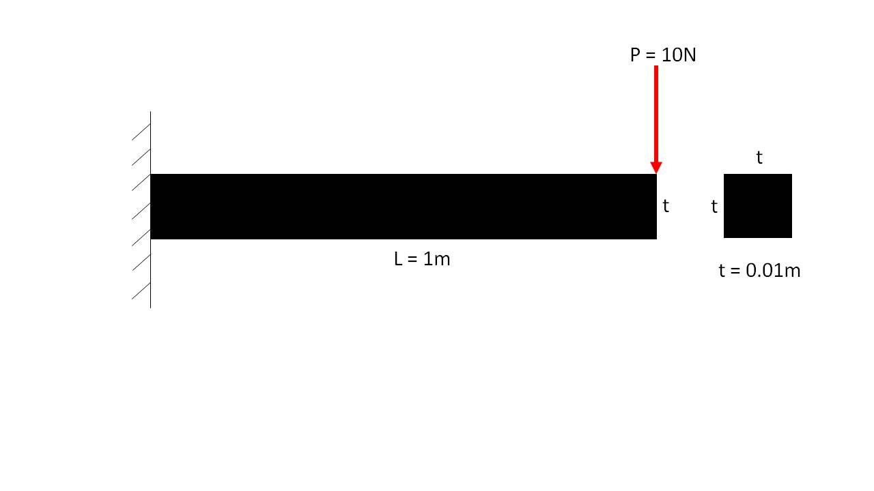

***Figure 1:*** *Non-Tapered Beam*

Mesh convergence studies were conducted in both WFEM and ANSYS. Figures 2 and 3 show the un-deformed and deformed non-tapered beam using WFEM with 1 element and 50 elements, respectively. Figures 4 and 5 show the un-deformed and deformed non-tapered beam using ANSYS with 1 element and 50 elements, respectively. Tables 1 and 2 below show the results obtained by WFEM and ANSYS , respectively. The natural frequencies for each mode were found using WFEM and are also shown in the Table 1. The converged results where then compared to the closed form solution. Equations (1-3) show how the closed form solution for a non-tapered beam was obtained.

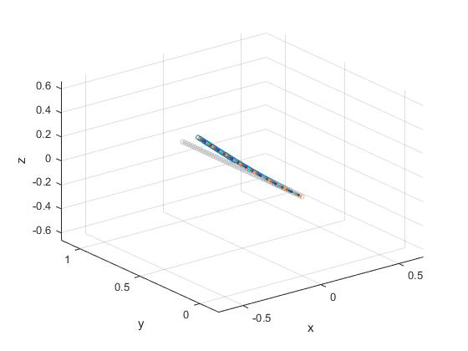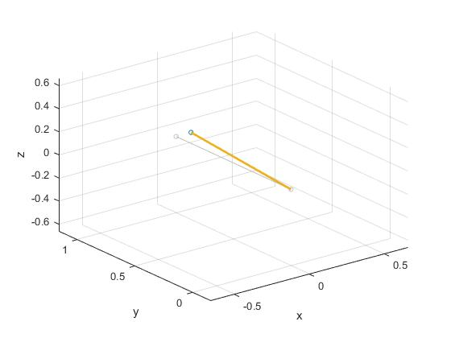

***Figure 2:*** *Non-Tapered Beam in*

*WFEM using 1 element*

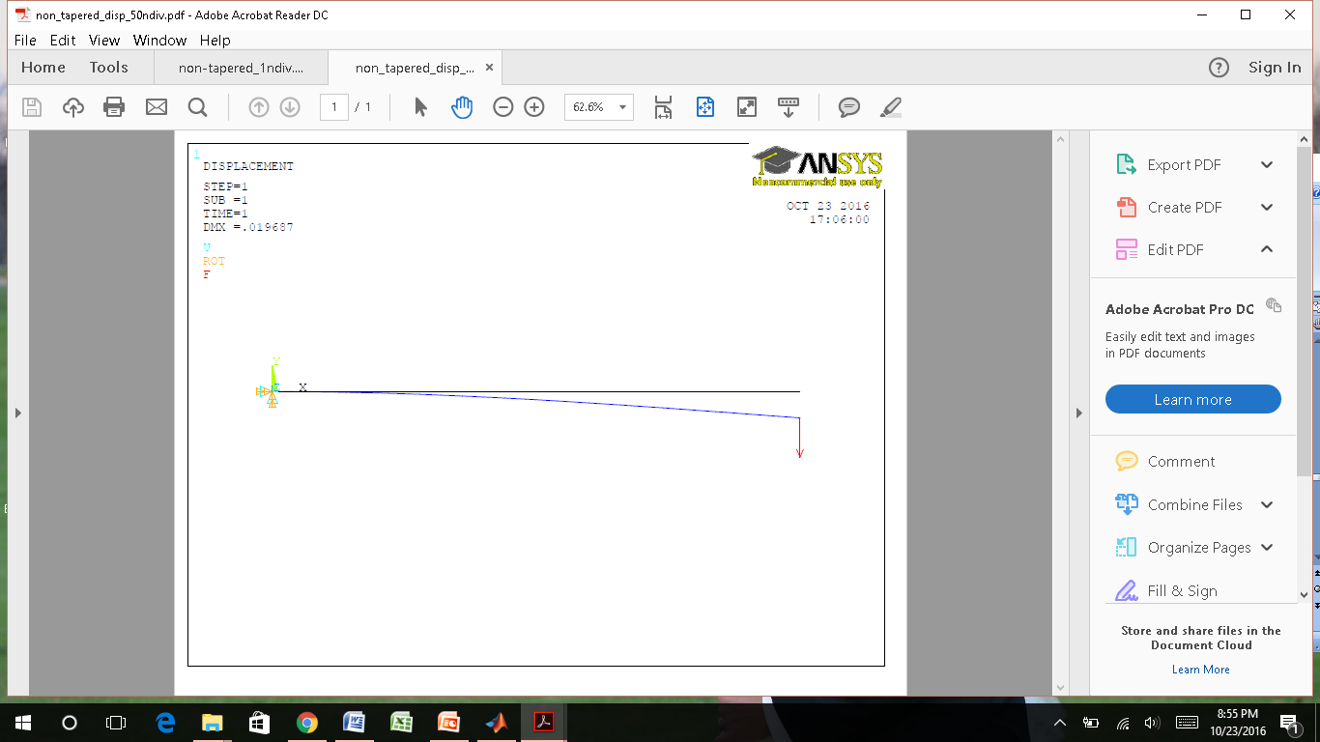

***Figure 3:*** *Non-Tapered Beam in*

*WFEM using 50 elements*

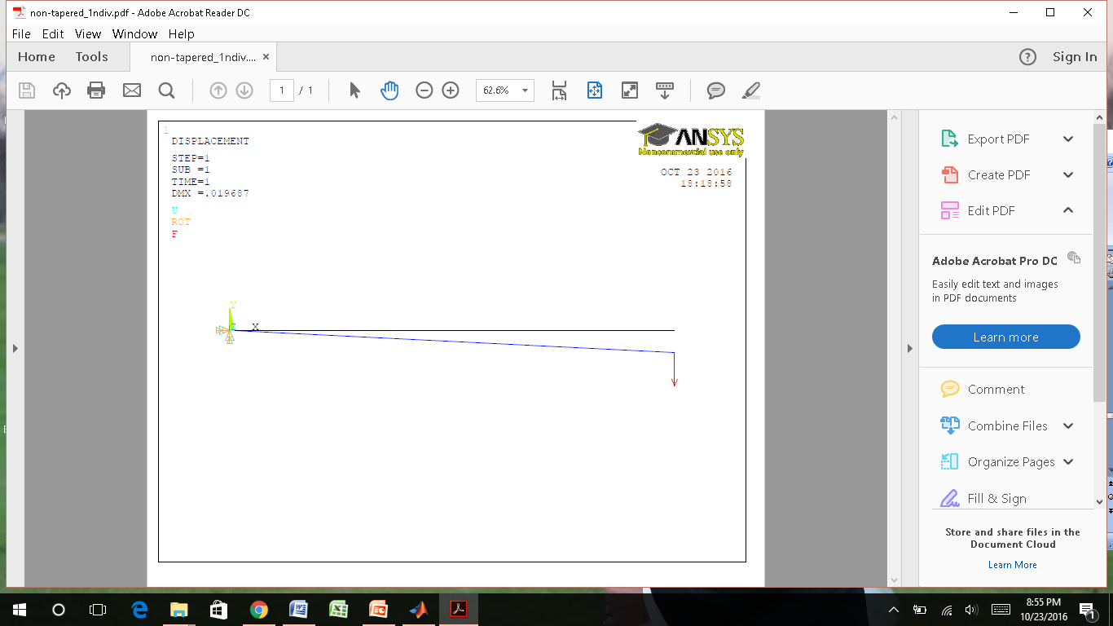

***Figure 4:*** *Non-Tapered Beam in*

*ANSYS using 1 element*

***Figure 5:*** *Non-Tapered Beam in*

*ANSYS using 50 elements*

|  |  |  |  |  |  |
| --- | --- | --- | --- | --- | --- |
| Table 1: WFEM Analysis of a Non-Tapered Beam | | | | | |
| **Elements** | **Displacement (m)** | **Frequency 1 (kHz)** | **Frequency 2 (kHz)** | **Frequency 3 (kHz)** | **Frequency 4 (kHz)** |
| 1 | 0.0197 | 8.262 | 81.401 | N/A | N/A |
| 2 | 0.0197 | 8.227 | 51.968 | 175.766 | 510.148 |
| 5 | 0.0197 | 8.223 | 51.557 | 144.806 | 286.063 |
| 10 | 0.0197 | 8.223 | 51.533 | 144.325 | 283.017 |
| 25 | 0.0197 | 8.223 | 51.531 | 144.289 | 282.755 |
| 50 | 0.0197 | 8.223 | 51.531 | 144.288 | 282.748 |

|  |  |
| --- | --- |
| Table 2: ANSYS Analysis of a Non-Tapered Beam | |
| **Elements** | **Displacement (m)** |
| 1 | 0.019687 |
| 2 | 0.019687 |
| 5 | 0.019687 |
| 10 | 0.019687 |
| 25 | 0.019687 |
| 50 | 0.019687 |

$δ=\frac{Fl^{3}}{3EI}$ (1)

$δ=\frac{(10N){(1m)}^{3}}{3(2.0408e10 N/{m^{2}})({{.01m}^{4}}/{12)}}$ (2)

$δ=0.019599 m$ (3)

### Rotated Non-Tapered Beam

### Tapered Beam

WFEM and ANSYS were also used to analyze a tapered, 2 noded, 3D beam element. Figure 6 below shows the tapered beam that was analyzed. All four sides of the square beam are tapered. The sides are reduced by 50% of their original length through the entire length of the beam, which is 1 meter. The boundary and loading conditions are shown as well as the geometry of the beam.

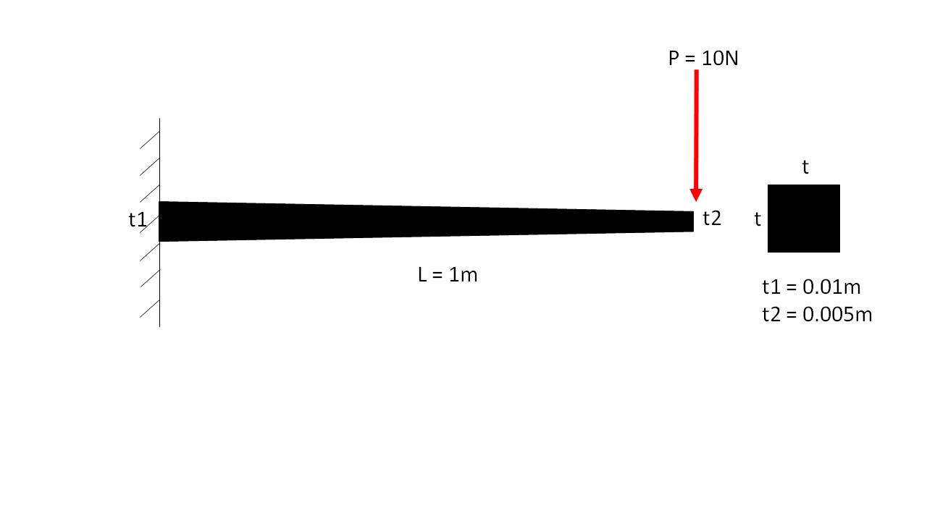

***Figure 6:*** *Tapered Beam*

Mesh convergence studies were conducted in both WFEM and ANSYS. Figures 7 and 8 show the un-deformed and deformed tapered beam using WFEM with 1 element and 50 elements, respectively. Figures 9 and 10 show the un-deformed and deformed non-tapered beam using ANSYS with 1 element and 50 elements, respectively. Tables 3 and 4 below show the results obtained by WFEM and ANSYS , respectively. The natural frequencies for each mode were found using WFEM and are also shown in the Table 3.

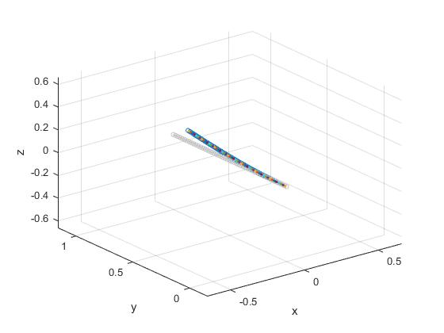

***Figure 7:*** *Tapered Beam in*

*WFEM using 1 element*

***Figure 8:*** *Tapered Beam in*

*WFEM using 50 elements*

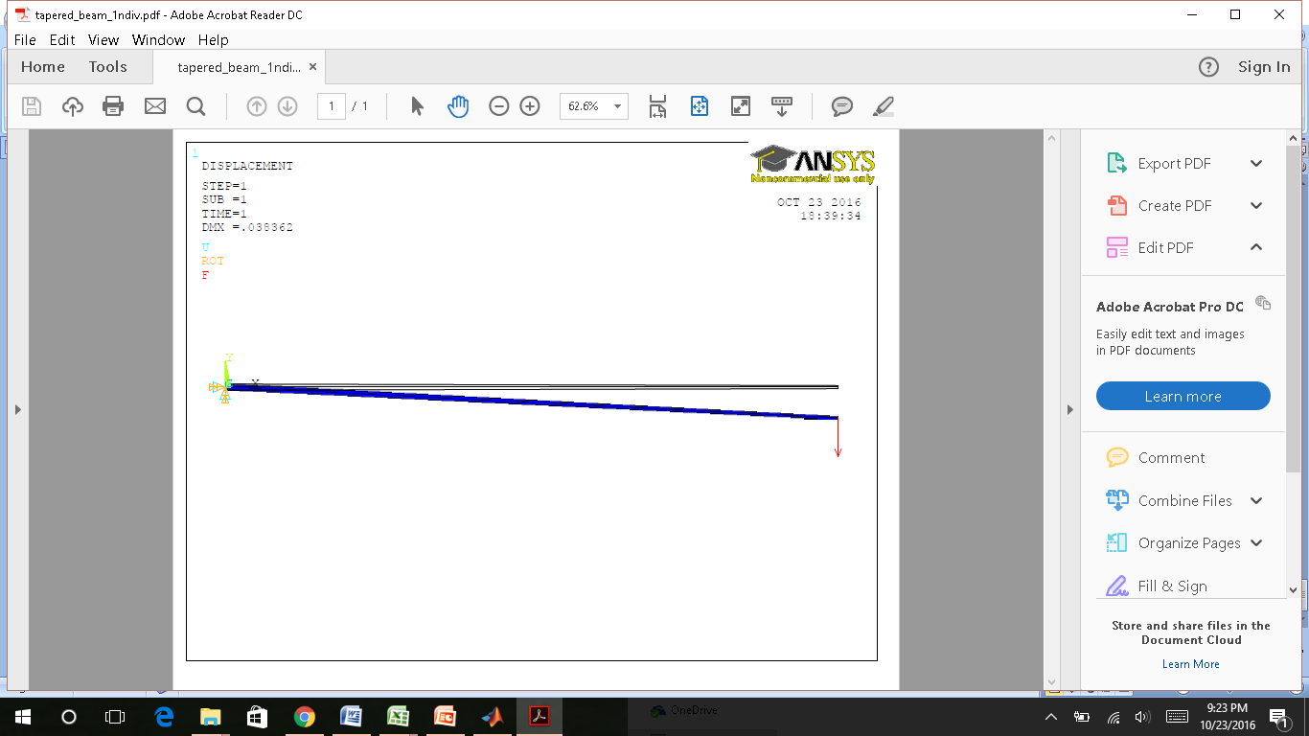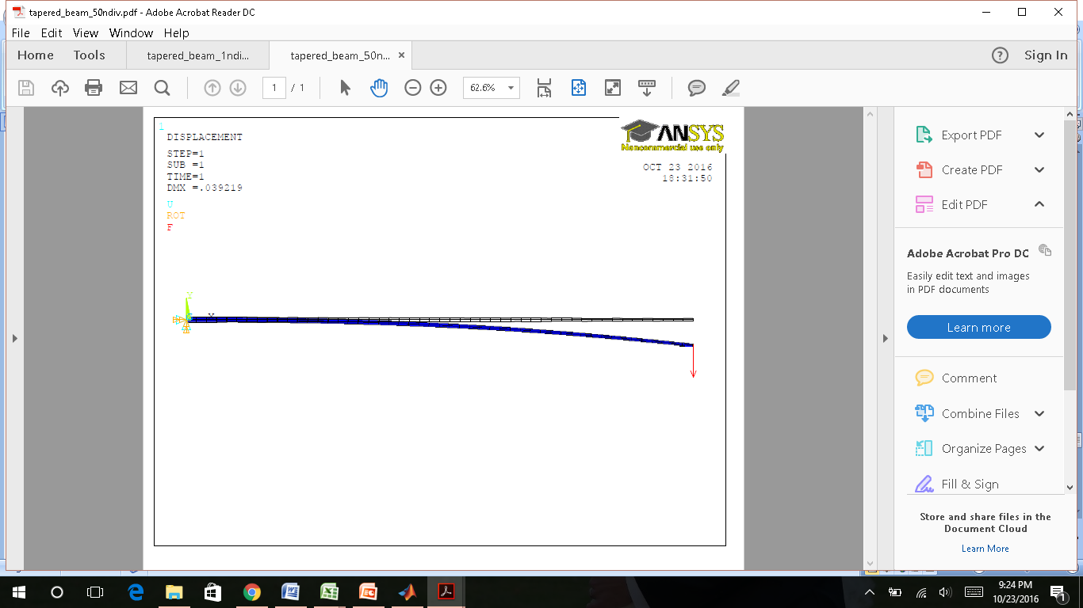

***Figure 7:*** *Tapered Beam in*

*ANSYS using 1 element*

***Figure 8:*** *Tapered Beam in*

*ANSYS using 50 elements*

|  |  |  |  |  |  |
| --- | --- | --- | --- | --- | --- |
| Table 3: WFEM Analysis of a Tapered Beam | | | | | |
| **Elements** | **Displacement (m)** | **Frequency 1 (kHz)** | **Frequency 2 (kHz)** | **Frequency 3 (kHz)** | **Frequency 4 (kHz)** |
| 1 | 0.0279 | 11.701 | 62.57 | N/A | N/A |
| 2 | 0.039 | 8.672 | 53.52 | 164.033 | 414.911 |
| 5 | 0.0456 | 7.244 | 45.769 | 129.379 | 256.305 |
| 10 | 0.0478 | 6.864 | 43.115 | 121.031 | 238.004 |
| 25 | 0.0491 | 6.655 | 41.725 | 116.88 | 229.16 |
| 50 | 0.0496 | 6.589 | 41.295 | 115.64 | 226.638 |

|  |  |
| --- | --- |
| Table 4: ANSYS Analysis of a Tapered Beam | |
| **Elements** | **Displacement (m)** |
| 1 | 0.038362 |
| 2 | 0.039041 |
| 5 | 0.039212 |
| 10 | 0.039219 |
| 25 | 0.039219 |
| 50 | 0.039219 |

### Complex Truss

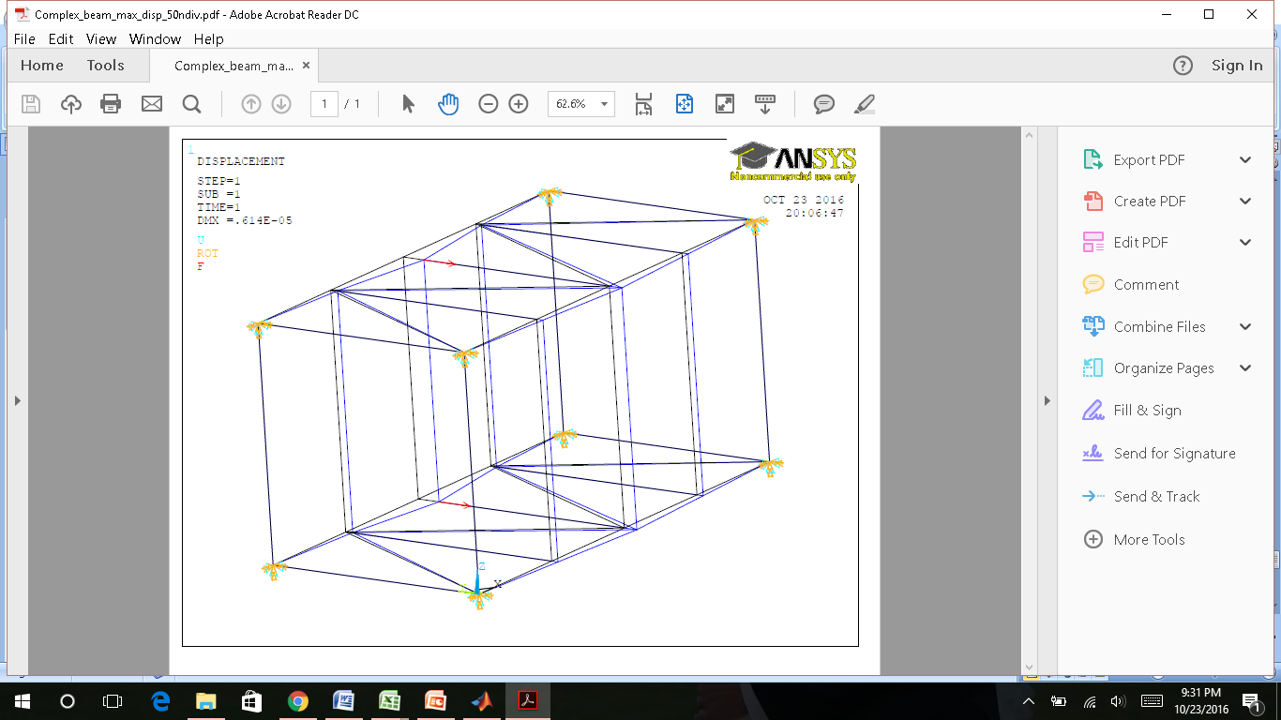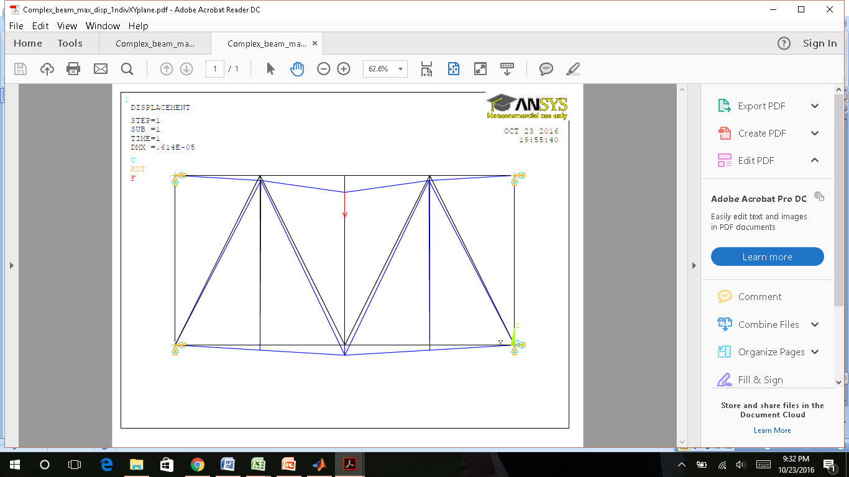

***Figure 11:*** *Non-Tapered Beam in*

*ANSYS using 1 element*

***Figure 12:*** *Non-Tapered Beam in*

*ANSYS using 50 elements*

# Conclusion

It was d

|  |  |  |  |
| --- | --- | --- | --- |
| Table 5: Results | | | |
|  | Non-Tapered Beam | Tapered Beam | Complex Truss |
| **Method** | **Displacement (m)** | **Displacement (m)** | **Displacement (m)** |
| WFEM | 0.0197 | 0.0496 |  |
| ANSYS | 0.0197 | 0.0392 | 6.14E-06 |
| Closed Form | 0.0196 | N/A | N/A |

# Appendix