Reading 1 Definitions
HTML tags are keywords composed of reserved words surrounded by angle brackets, such as <html> or <body>

Often these tags come in pairs designating an opening <html> and closing </html> tag; properly opened and closed tags are referred to as HTML elements. An HTML document is composed of HTML elements written in plain text using this tag notation. An HTML document therefore is synonymous with a webpage.

Boilerplate

<!DOCTYPE html>
<html lang="en">
<head>
<meta charset="utf-8">
<meta name="viewport" content="width=device-width">
<title></title>

<!--put your external stylesheet links here-->
<link rel="stylesheet" href="css/style.css">
<!--[if IE<9]>
<link rel="stylesheet" href="css/style.ie.css">
<![endif]-->

<!--you can also place internal styles here
place these within <style> tags-->

</head>

<body>
<!--put your initial page content here-->

<!--you can also use this space for internal scripts;
place these within <script> tags-->

<!--put your external script links here-->
<script type="text/javascript" src="js/main.js"></script>
</body>
</html>

in real life web development, you always reference resources in your directory externally using <link> tags and <script> tags with the src attribute. However, it is useful to know that you can include styles and scripts right in the HTML document, particularly because many content management systems like Wordpress might add these requiring subsequent editing.

you can add a <style> tag to your boilerplate to embed a CSS rule (details below):
Example 2.1: Adding styles in index.html
<!--Example 1 line 13-->
<!--you can also place internal styles here
place these within <style> tags-->

<style>
#mydiv {
background-color: red;
width: 80%;
margin: 0 auto;
height: 100px;
}
</style>

</head>
<body>
<div id="mydiv">
Hello World!
</div>
</body>

Great, this is exactly the right moment to ask about this — because main.js is where HTML stops being a document and starts being a program.
I’ll walk you through this in layers, from what it is → why it’s placed there → what belongs in it → how it connects to what you just wrote.
No hand-waving.

1️⃣ What main.js actually is
main.js is just a plain text file containing JavaScript.
The browser:
- Loads your HTML
- Builds the page structure (DOM)
- Loads and runs JavaScript files you reference
When you write:
<script src="js/main.js"></script>
you are telling the browser:
“After you load this page, go fetch main.js and execute it.”
Nothing more mystical than that.

2️⃣ Why the <script> tag goes at the bottom of <body>
This is one of those rules that seems arbitrary until it clicks.
What happens if JS runs too early?
JavaScript often touches HTML elements:
document.getElementById("mydiv")
If the browser hasn’t created #mydiv yet, JS fails.
So we do this:
<body>
<div id="mydiv">Hello World!</div>

<script src="js/main.js"></script>
</body>
Because:
- The HTML loads top → bottom
- By the time JS runs, the page exists
This avoids needing extra ceremony like DOMContentLoaded.

3️⃣ What belongs in main.js (for this class)
Early-stage JavaScript belongs to three categories:
① Output / sanity checks
console.log("JS is connected!");
This answers:
“Is my JS file actually loading?”
If you see this in DevTools → Console, the wiring works.

② DOM interaction
You now have:
<div id="mydiv">Hello World!</div>
So in main.js you can do:
const box = document.getElementById("mydiv");
box.style.border = "3px solid black";
That line:
- Finds your div
- Modifies it dynamically
- Proves JS ↔ HTML connection

③ Behavior (the point of JS)
JavaScript is for actions, not layout:
box.addEventListener("click", () => {
box.style.backgroundColor = "blue";
});
Now the page reacts.
HTML = structure
CSS = appearance
JS = behavior

4️⃣ Why main.js is separate from HTML
You could write:
<script>
alert("hi");
</script>
But separation matters:
File | Responsibility
HTML | Structure
CSS | Style
JS | Behavior
This is called separation of concerns — and your textbook is training you to do this early.

5️⃣ Folder structure matters (your case)
You referenced:
<script src="js/main.js"></script>
That means your folders must look like:
Chapter01/
├── index.html
└── js/
└── main.js
If JS doesn’t run, this is the first thing to check.

6️⃣ How to test main.js correctly (do this every time)
- Open page in browser (Live Server or file)
- Right-click → Inspect
- Go to Console
- Add this line to main.js:
console.log("main.js loaded");
- Save → refresh
If you see the message:
✅ JS is wired correctly

7️⃣ How this connects to what you just learned
You now have:
- #mydiv defined in HTML
- #mydiv styled in CSS
- main.js ready to act on it
This triangle is the foundation of everything web-mapping-related:
- Map containers
- Buttons
- Sliders
- Layer toggles
- Legends
Leaflet, Mapbox, D3 — all of them build on this exact pattern.

8️⃣ What NOT to put in main.js (yet)
- CSS rules
- HTML markup
- Layout decisions
Those go elsewhere.

TL;DR mental model
HTML = nouns (things)
CSS = adjectives (how they look)
JS = verbs (what they do)
main.js is where the verbs live.

If you want next:
- we can write your first meaningful main.js together
- or wire main.js to change #mydiv dynamically
- or preview how this becomes a map container in later units
You’re now at the exact point where the course turns the corner from static pages to interactive systems.

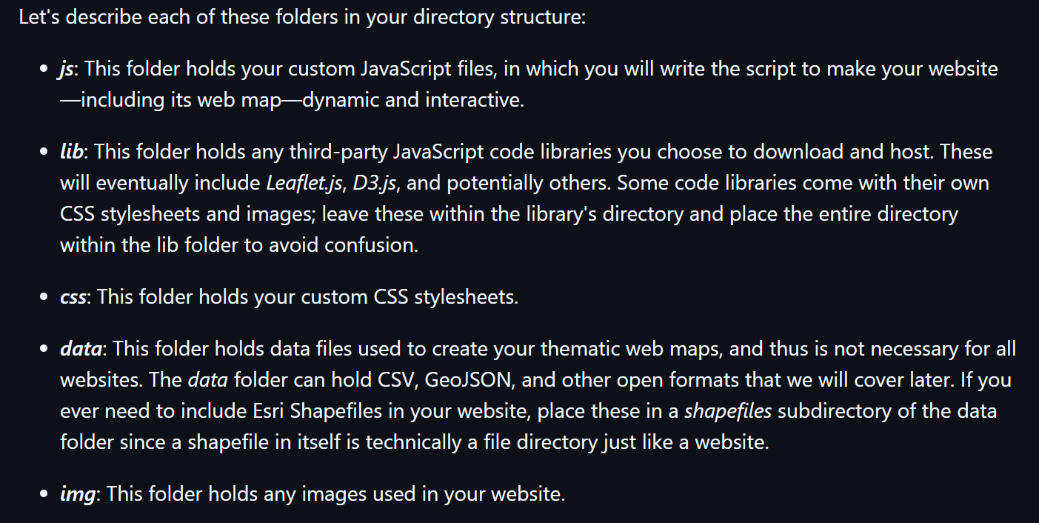

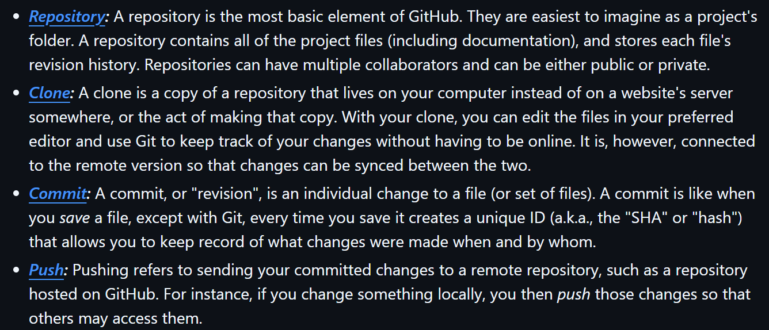

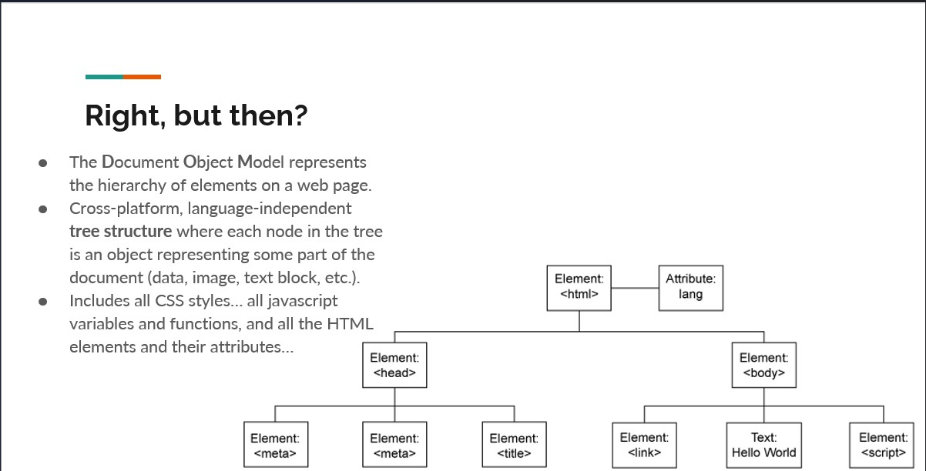

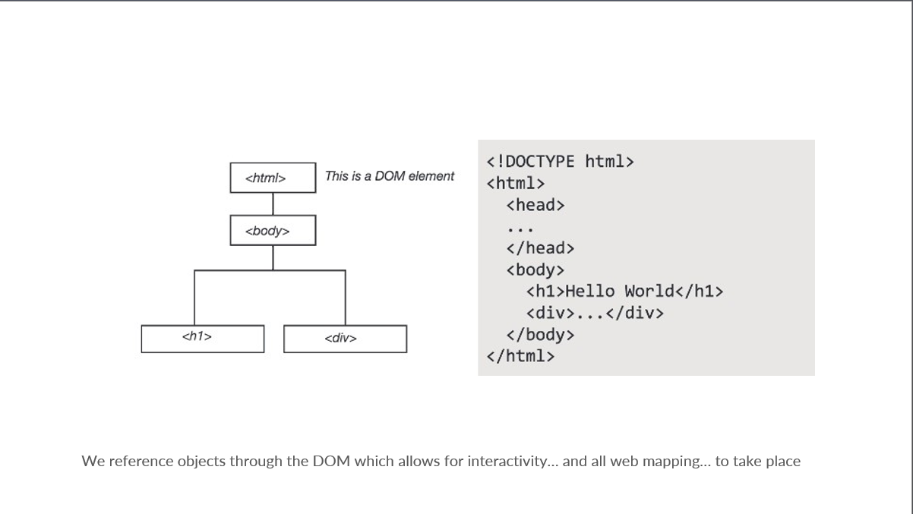
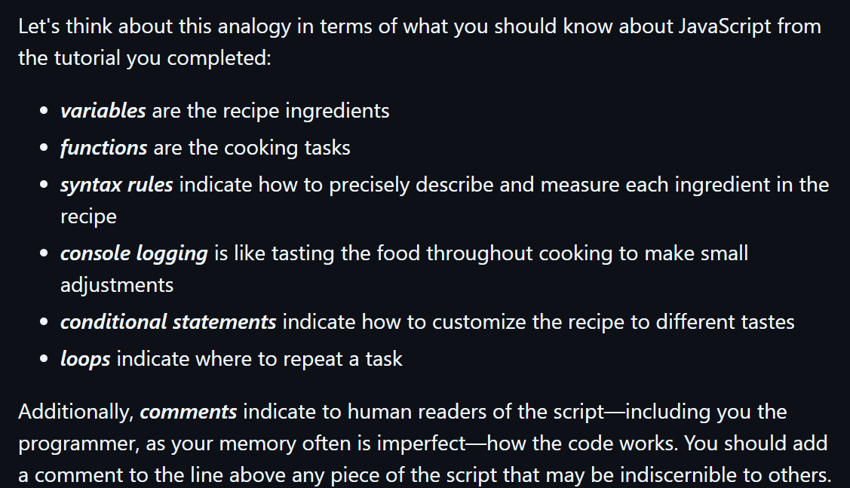

Lesson 2 data types
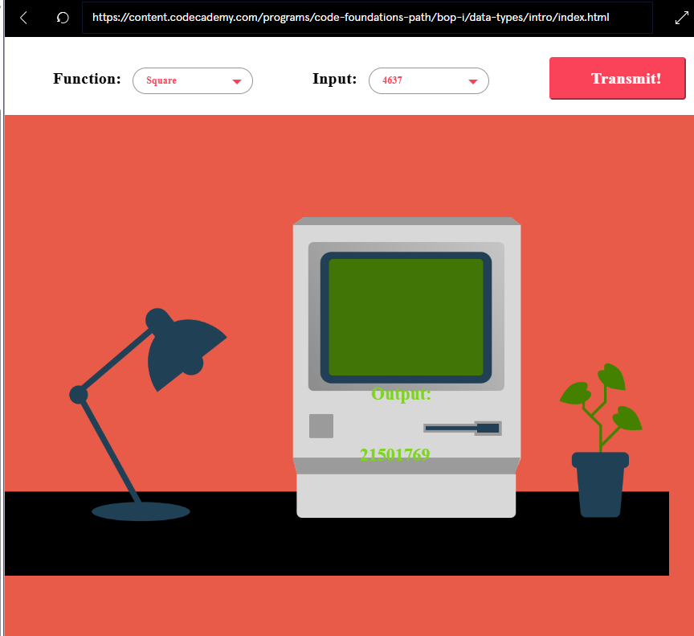

Numbers

Strings

Boolean

