ALL ROUNDER ROBOTIC CLEANER
-something to make your lives better

- Over all idea:-
We all know that no ones like to keep their rooms clean enough leave alone the house. But some people want to keep their home/workspace clean but are pretty lazy to do so and hence its for those people that I came up with this idea.
My idea consists of a robo which basically cleans and mops up your entire place neat and tidy. The robo will not only clean the floor, rooms etc but the roof also automatically and whenever you want without causing any difficulties

- Possible design and working:-

- Ground Cleaning:-
Actually lets assume that the robot is circular or oval in shape instead of giving it a humanoid form.
The brushes which are used to mop the floor can be built along the circumference/perimeter of the robot(depends on shape). So when the robot moves, the brushes on the circumference can be rotated at high speeds due to which the dust particles around it will be attracted towards the center of the robo due to centripetal force and can be sucked within just like a vaccum cleaner.
As for moping the floor we can use another kind of brushes and cleaner which mops the floor simultaneously as it travels the distance. These equipment need to be located at the bottom of the machine with 2 brushes rotating in opposite direction for efficient cleaning

- Aerial cleaning:-
The robot can have wings built on top of it just like a quad-copter or drone(the number of wings depends on the weight of the robot and nature of the building material)to carry itself to the roof or any place unreachable by us because no ones likes to stand on a ladder or chair and clean the cobwebs stuck up. So it can fly and clean above the cupboards etc.
This can mostly done by us using a remote control where we can fly them where we want.

If the robot built is too heavy to be carried around freely, we can make them crawl up on the walls and ceilings. I have seen this new remote controlled RC cars in the market which are capable of driving along the wall and roof due to the high vacuum created by it, below its body which allows it to stick onto almost any surface. Hence we can use these concepts to make the robot reach to many unreachable places. For this method we need many sensors to built if we want it to be automatic or we can use a remote control etc.

Hence its gonna be efficient for us if the robot as small and light as possible with enough capability to clean a significant about of area.

- Technical background:-
- For it to work automatically we need a couple of sensors like IR sensors, proximity sensors, photo sensors etc which will be required in obstacle detection, path finding and dirt/dust recognition respectively. Other sensors can be built depending upon the needs.
- For it to be remote controlled or to be driven manually, we will be requiring a transmitter, receiver, antenna etc to be controlled using radio waves which upon receiving activates the respective parts and motors.
- Some places like behind the cupboard, bed etc which are unreachable by both humans and machines can be done by building a small mechanical prosthetic arm which can be extended at the time of need and can be withdrawn within the robo when not required.
- Building materials can be light weight carbon nano fibers or something which is hard, has long durability, good looking etc.
- The robot can have an inbuilt camera or any sort of computer vision which can hep it in recognizing its surroundings and dirt/dust which needs to be cleared. We can use a photo sensor which detects any blockage or interruption in the path of light rays to recognize particles and matter so that it can clean them. For this a light source should be placed below the robot not to far from the floor.

- Advantages:-
I am not sure but I do agree that a product like this might have already been there or launched in the market but I still feel that its something worth constructing and we might be able to build something even better than those available out there in the stores currently.

- It can be highly portable, durable,long lasting and cost effective against hiring people for the household chores.
- It can be operated from anywhere using the technology of IOT and cloud. For example you are out of station and your house has been shut for more than 15 days and some friend of yours wants to stay there temporarily, you can clean up the house using this machine by just tapping and selecting on your mobile phone or any other internet connected devices from anywhere anytime and then shut it down once the work is done.
- It will run on battery with successive backups present within incase of a power failure or current loss in the region.

- Rough Diagram:-

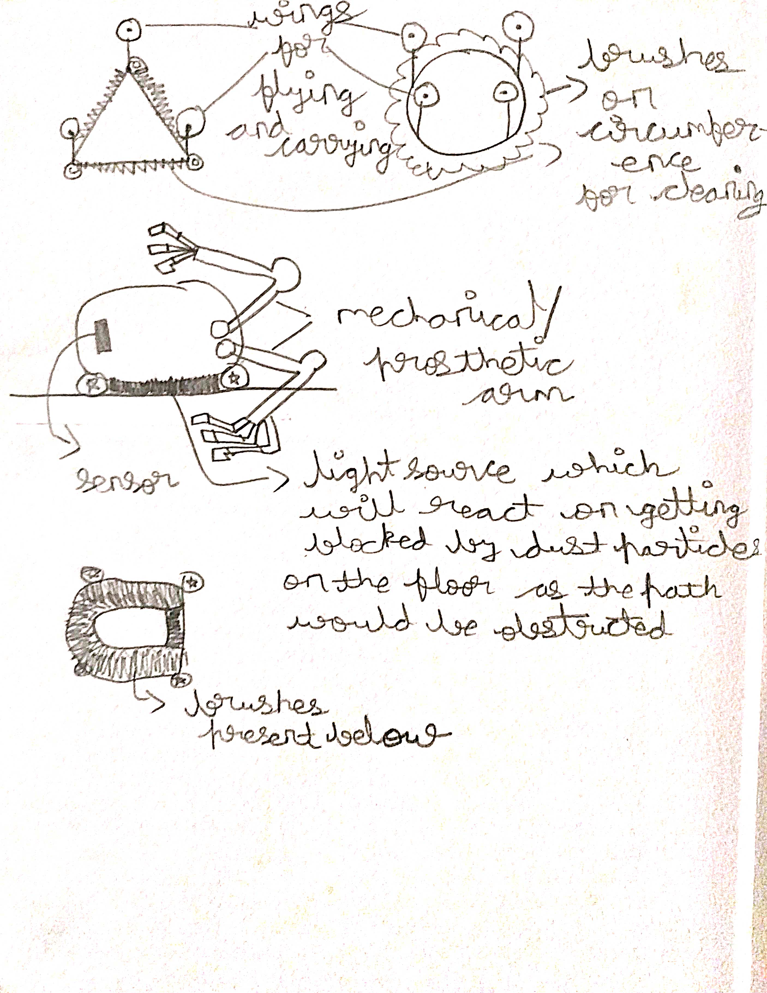

Jatin Madineni 20BCT0154

