Q1. 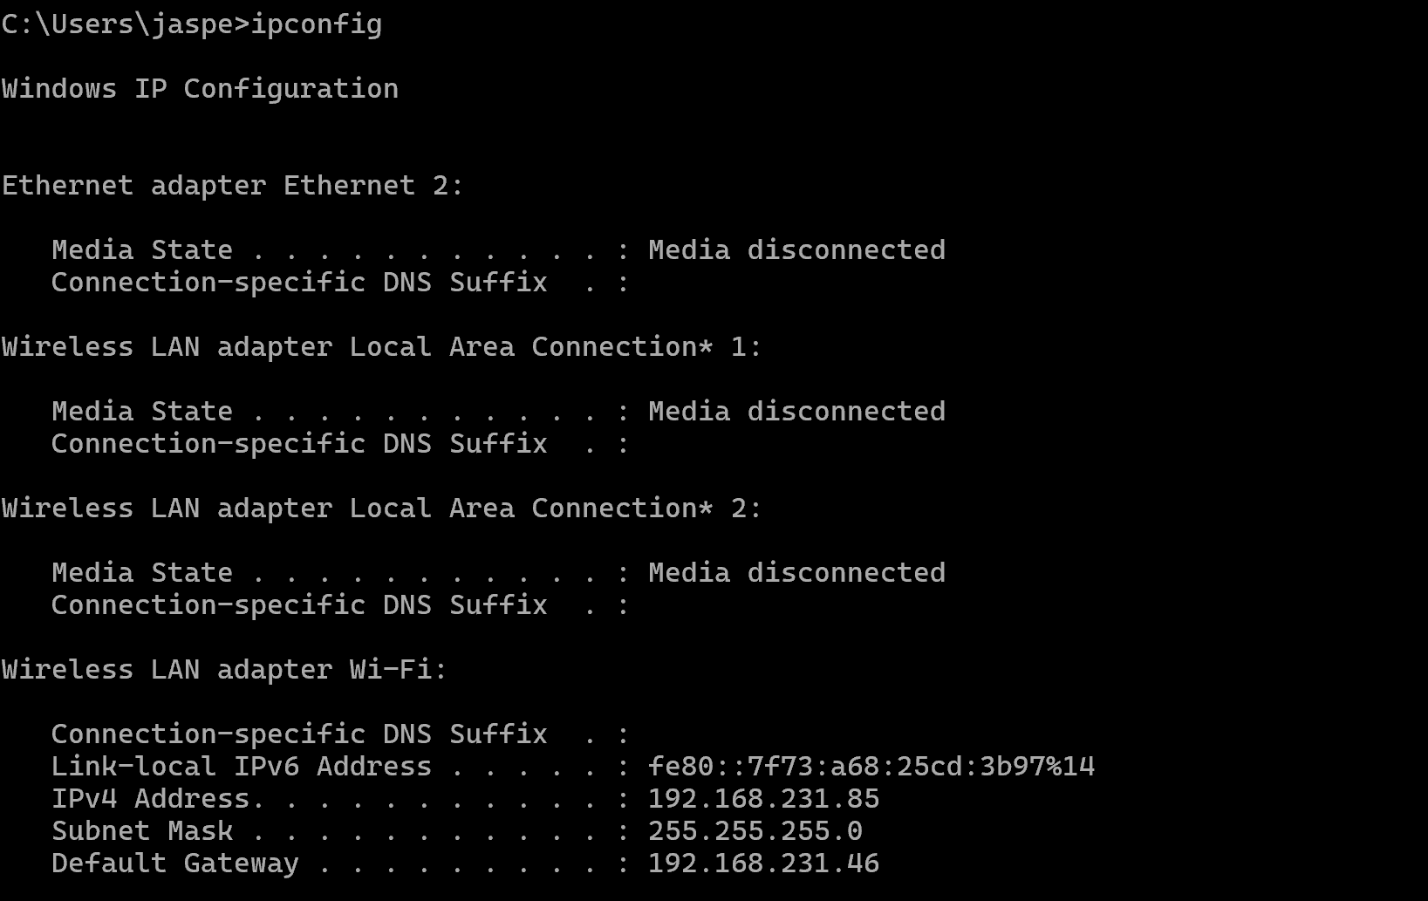

IP Address: **192.168.231.85**

This indicates I am connected to the internet using 192.168.231.85 as my primary IP address for this interface and the one that is communicating within my local network.

Q2. The public IPv4 address is 122.11.246.147. This is a different IPv4 address as it’s a public IPv4 address and not a private IPv4 address. The public IPv4 address is assigned by my ISP or internet service provider while the private IPv4 address is assigned by my own local network.

Q3. According to the geolocation service by keycdn.com , my ipv4 address is the same and my location and city is also the same.

Q4. When nslookup google.com, it has an ip address of 192.168.231.46 with server location unknown.