Username: JT713

Github is a web based version of git that is mainly used for code development. Development began in October 2007. The site was launched in October 2008 by Tom Preston-Werner and Chris Wanstrath. Similar platforms include GIST, pastebin, and Speaker Deck. This platform would be used for coding and documentation. It is very easy when there is a centralized point of access and easy ways to keep track of changes.

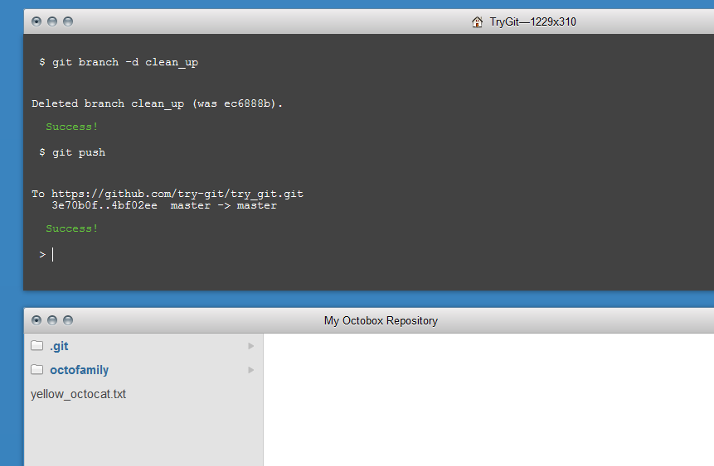

* Repository: Central location where data is stored
* Commit: To save changes
* Push: To push your document up to the repository
* Branch: Parallel version of your repository, still contained within your master repository
* Fork: Personal copy of another person’s repository
* Merge: Taking changes from one branch and applying them to another
* Clone: Local copy of repository
* Pull: Fetching changes from repository
* Pull request: Request to repository for latest changes