**CMPS 300 – Programming Languages**

**Fall 2019**

**Assignment 1**

**Due Date: Thursday, September 12, 2019 at 11:55 pm on Moodle.** **I will NOT accept any assignment emailed to me. Late submission will receive a zero. Make sure that you attach the file, submit and confirm your submission. Failure to confirm your submission by selecting the confirmation checkbox provided, your submission will be marked by Moodle as late. Therefore, you will receive a zero on the assignment. Please ask me if you do not understand what I mean. Do not wait the last minutes as I may not be available to assist you.**

**Please fully read this assignment 1 file and follow the provided instructions. ALL your answers MUST be typed. No handwriting. You are required to use this file to provide the answers as specified in the “Submission Requirements” section below. Please remove unnecessary spacing, use proper English writing, and keep your work organized. DO NOT delete any part of this file. Use the specified font and size of the text.**

**------------------------------------------------------------------------------------------------------------------------------------------------------------------------------------------------**

**Objectives**

Compare the readability, writability, reliability, and cost criteria of three programming languages (PLs): C++, Java, Python, and R.

**Programming Requirements**

Write a program in C++, Java, Python, and R that prompts the user of the program to enter two integer values then the program computes & displays their sum. **Use online software development tools to write your programs**. **DO NOT install the software development tools on your computer unless you know exactly what you are doing**.

**Submission Requirements**

Using the default Windows’ (**not Mac or others**) compression or zipping (please ask me in class if you do not know how to do this), provide the following files in a zipped folder:

1. The source codes (4 of them, one for each PL). Make sure you provide each program file with the proper extension: **.cpp** for C++, **.java** for Java, **.py** for Python, and **.r** or **.R** for R. I should be able to run each program without any problem. Each program should compile/translate, run, and accomplish its purpose as described above in the Programming Requirements. Name each program as follows: **LastFirstnamesAssignment1** with the proper extension. For example, I would name my C++ program as: **KouroumaMathieuAssignment1.cpp**

Notice that there is no spacing. **DO NOT copy and past your programs in a Word document**. These source codes should be in a text editor (Notepad++, for example that I recommend) or a text editor which is part of an integrated development environment (IDE), such Microsoft Visual Studio, NetBeans, etc.

1. Provide the screenshots of the outputs of your program execution for each PL in this assignment file in the sections provided below. There should be four (4) different screenshots one for each program run/execution.
2. Compare the four PLs in terms of readability, writability, reliability, and cost. Provide your answer to this question in this assignment file in the specified section provided below.
3. For Parts 2 and 3 above, use this Word document file. Rename this file as: **LastFirstnamesAssignment1**. For example, , I would name my Word document file as: **KouroumaMathieuAssignment1**. In total, you should have five (5) files (4 program files and 1 Word file) in the zipped folder. Name your zipped folder as: **LastnFirstnamesAssignment1**. For example, , I would name my zip folder as: **KouroumaMathieuAssignment1**. **Keep in mind that you are required only one submission in Moodle and you will be allowed to submit ONLY one .zip folder**. As a result, you are required to zip all the five (5) files.

**Restrictions**

Students are NOT allowed to share their work, but may discuss the software tools used. This is NOT a group assignment. Please avoid any situation that may lead to **cheating** or **plagiarism**. Students in violation will receive a zero (0) for this assignment and be subject to a disciplinary action.

Software & Software Info Tools/Websites Used:

<https://www.upwork.com/hiring/data/r-vs-java-vs-python-which-is-best/>

<https://www.javatips.net/blog/c-vs-java-vs-python-a-comparison>

<https://www.tutorialspoint.com/execute_r_online.php>

<https://www.onlinegdb.com/online_c++_compiler>

**Provide here the answer to Submission Requirements 2**

Provide here the screenshot for your **C++** program compilation and execution in the selected software development tool. Please provide the screenshot of the whole IDE window so that I know the type of tool you used to write, compile, and run your program.

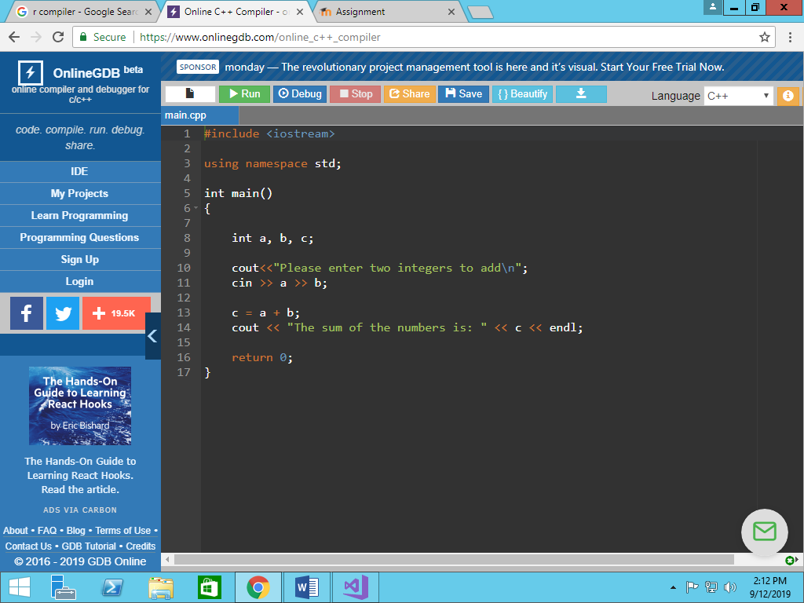

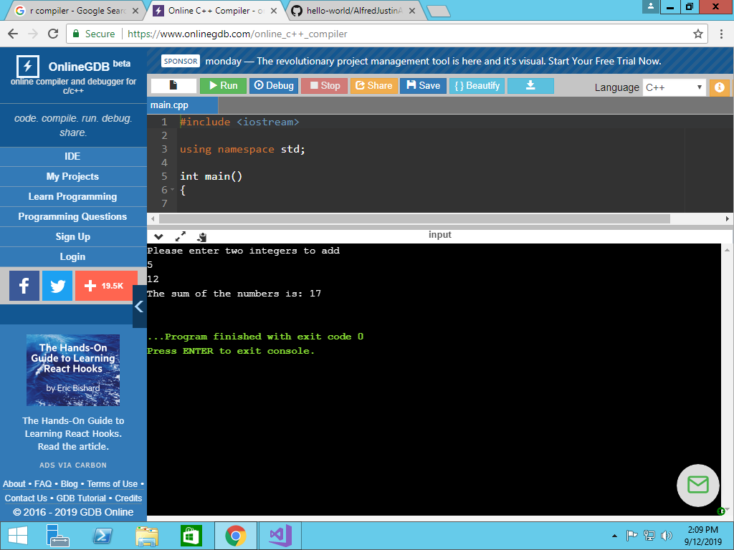

Provide here the screenshot for your **Java** program compilation and execution. Please provide the screenshot of the whole IDE window so that I know the type of tool you used to write, compile, and run your program.

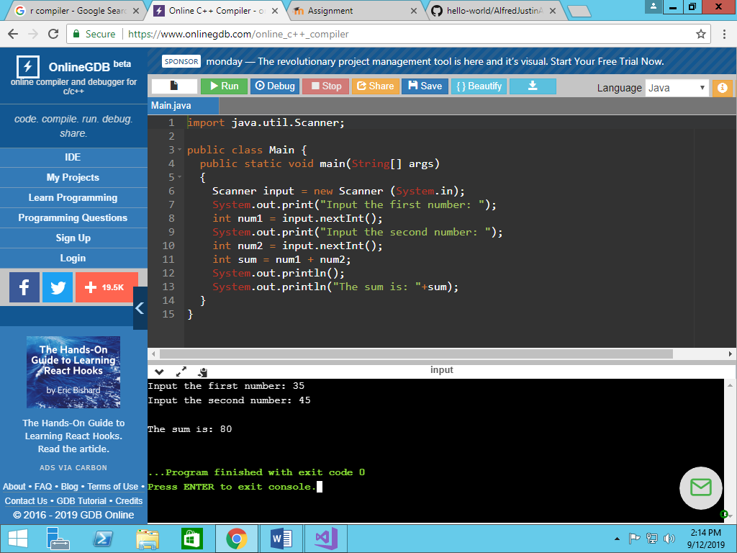

Provide here the screenshot for your **Python** program compilation/translation and execution. Please provide the screenshot of the whole IDE window so that I know the type of tool you used to write, compile/translate, and run your program.

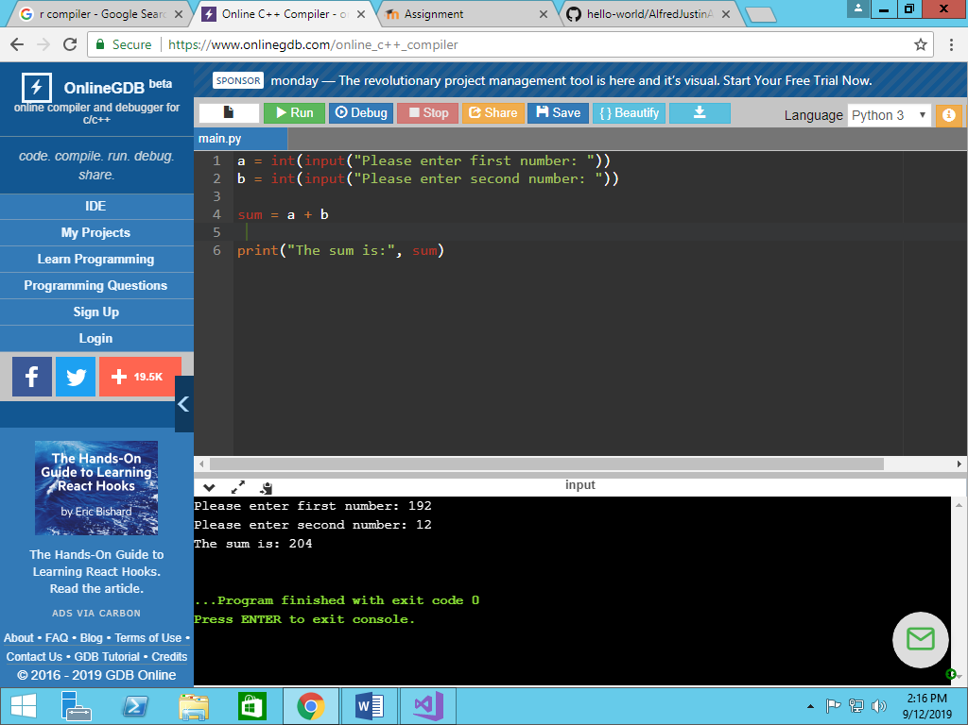

Provide here the screenshot for your **R** program compilation/translation and execution. Please provide the screenshot of the whole IDE window so that I know the type of tool you used to write, compile/translate, and run your program.

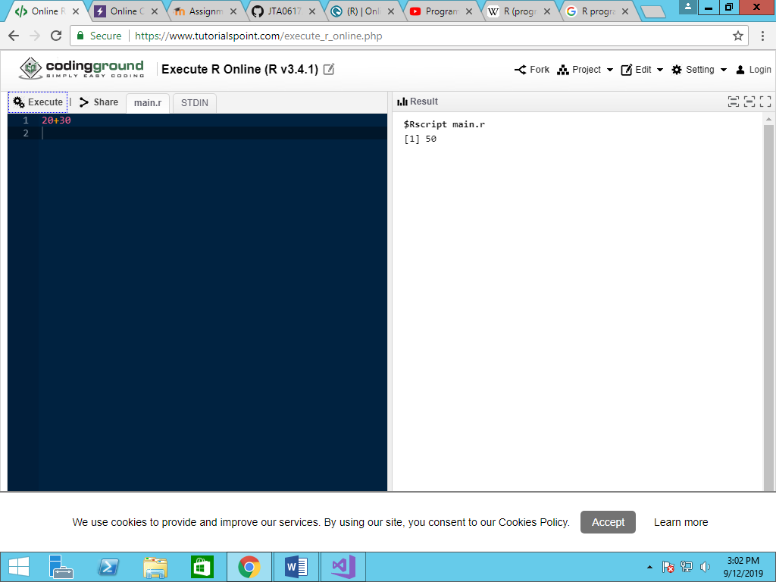

*Notes: Command line interpret. Integers entered directly into program and output was sum.

**Provide here the answer to Submission Requirements 3**

Compare the four PLs in terms of readability, writability, reliability, and cost. You need to explain, for example, why one program X is more readable, writability, reliability, and cost efficient than program Y or programs Y and Z. Please proper English writing. Everything must be typed here.

*The Programming Languages C++, Java, & Python are all very similar in the fact that they are object oriented and easy to learn, read, and write. R is what is known as a procedural language, or a language that has numerous step by step sub routines.

*Java is more portable than C++ due to the fact that C++ code has to be recompiled. Also, documentation commenting can be done in Java more seamlessly than C++.

*Python, unlike C++ can be run on all operating systems. C++ does not have that capability. Also, variable(s) do not have to be declared in Python, and the fact that they must be declared in C++ can make the code longer and more extensive. However, C++’s declaration requirement makes it easier to deal with errors.

* Due to the fact that it is exact when it comes to data defining , Java is significantly faster than Python. Python is dynamic, and therefore the exact data typing of variables does not to be defined

* Java is more syntactically complex than python.\

*R’s Data Analysis capabilities are wide, and it is used heavily with data & statistics. However, it’s syntax and character encoding is very messy.