Supplementary material: Event-linked coastal bird checklist associations with recorded Pacific herring spawning in British Columbia
Jacob T. Dingwall
Table of contents
1. Scope and reading guide 1
2. Estimand and engine detail 2
3. Descriptive outputs and availability 2
4. Complete species evidence 4
5. Guild synthesis 6
6. Event windows, distance rings, and temporal support 6
7. Specificity, sensitivity, and placebos 7
8. Completion, geometry, and warning states 8
9. Positive-count sensitivity and ambiguity 9
10. Compatible-family pooling repair 9
11. Figure and table provenance 9
12. Reproducibility and governance statement 9
13. Supplementary file inventory 10

1. Scope and reading guide
This supplement preserves complete released evidence and technical qualification for the v3 manuscript. It was assembled from tracked privacy-safe aggregate outputs. No protected response table, checklist coordinate, observer identity, locality, event token, model object, or transformation mapping was opened. No response model was fitted or refitted.
The main manuscript leads with selected individual species. Supplementary CSV files retain all 49 support-qualified species, all released event-window and distance-ring support, complete model and sensitivity components, failed and non-estimable states, singular and rank-deficient warnings, the zero-truncated count sensitivity, pooling-repair records, validation, and provenance.

2. Estimand and engine detail
The primary coding audit is supplied as audits/primary_estimand_and_engine_audit_v3.md. The exact M01/M02/M29 coefficient is active-near versus the omitted other class. M08 is active minus contemporaneous reference. Active and reference are mutually exclusive, while time and distance terms are additive counts over concurrent links.
The final M01_PRIMARY_v2, M27/M28, WCVI 2-km, and dominant-observer components used sparse lme4 mixed models without simplified fallback. Legacy M02, M05, M08, and M29 code attempted mgcv::bam and permitted fixed-effect fallback. The public aggregate release does not identify the engine used by each legacy component. V3 therefore avoids calling those components uniformly mixed-model estimates.
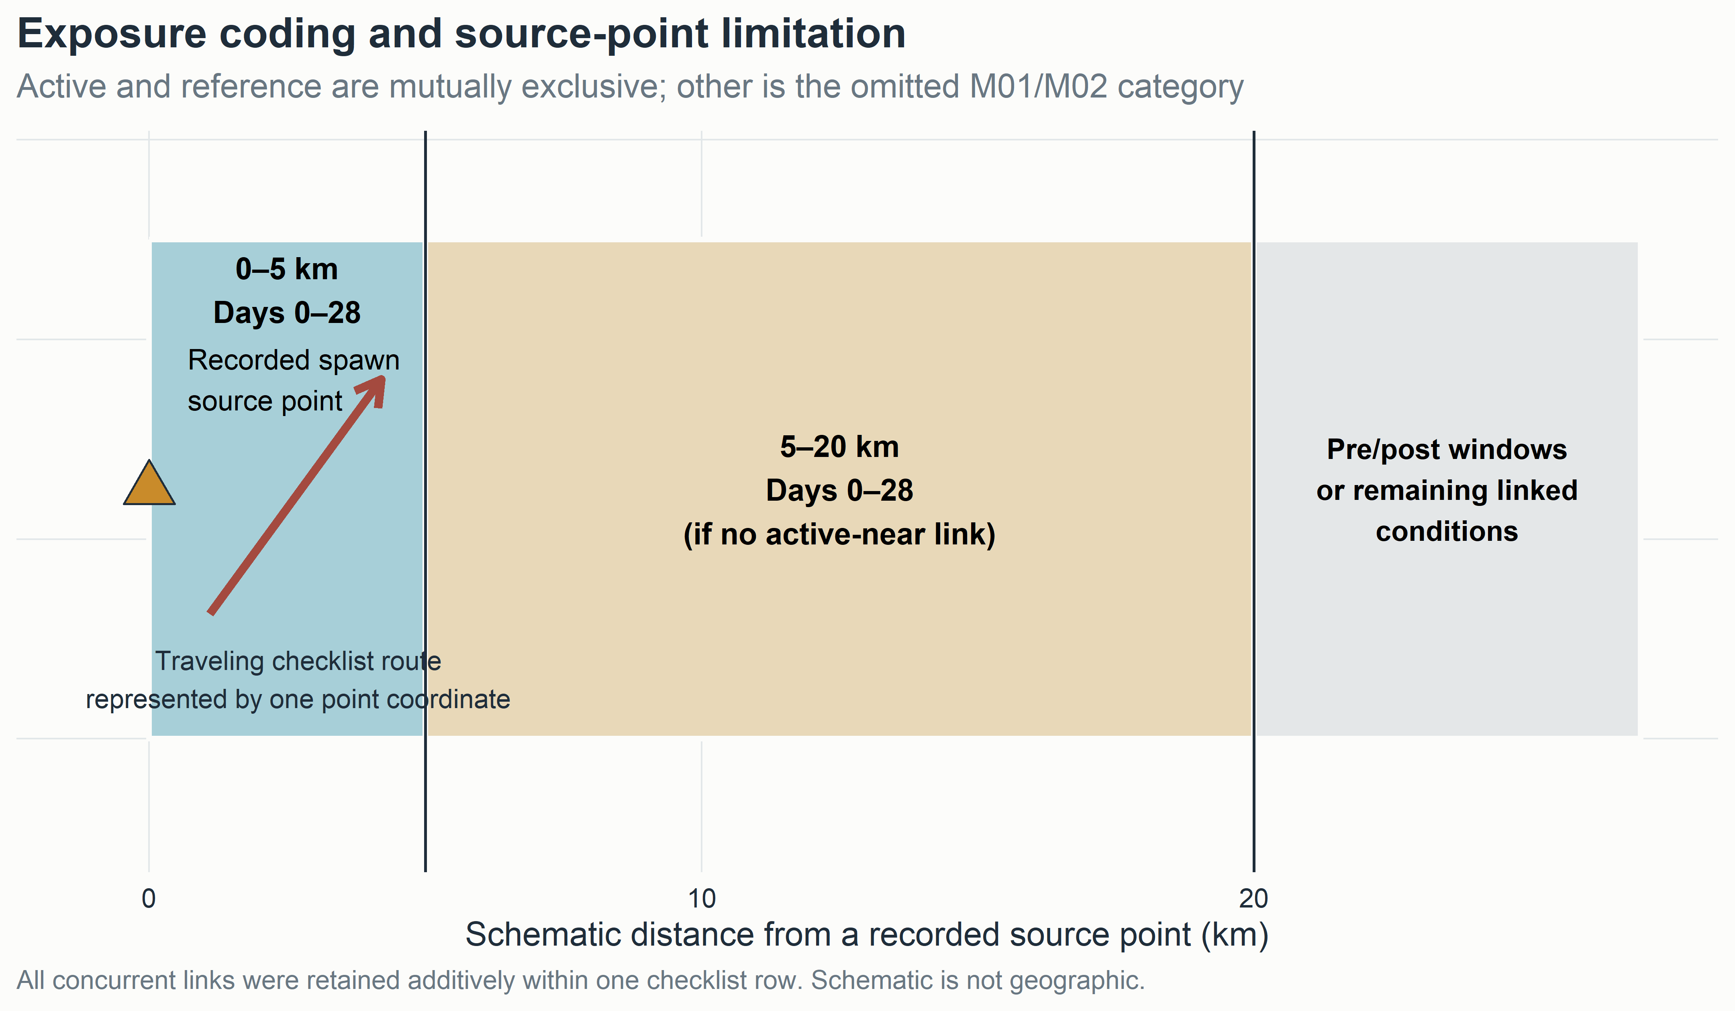
Figure S1. Exposure design and geometry limitation. The schematic contains no spatial records.

3. Descriptive outputs and availability
Four machine-readable v3 tables distinguish available summaries from fields that would require a new aggregate-only authorization:
- tables_v3/descriptive_statistics_v3.csv: 128 region-metric rows for checklist, exposure, event, observer, effort, window, and ring support;
- tables_v3/species_descriptive_summary_v3.csv: 196 region-by-species rows for 49 species in four released regions;
- tables_v3/guild_descriptive_summary_v3.csv: 32 region-by-guild rows for eight guilds; and
- tables_v3/herring_event_descriptive_summary_v3.csv: 92 region-metric rows for recorded-event support.
Regional positive-count quartiles, regional X/lower-bound/ambiguity counts, taxon-by-exposure raw prevalence and counts, concurrent-link distributions, event-date distributions, and fine spatial cells were not in the public release. Those fields remain explicitly unavailable. Pooled Stage 2 count quantiles are labeled support-only and are not described as regional Stage 4A summaries.
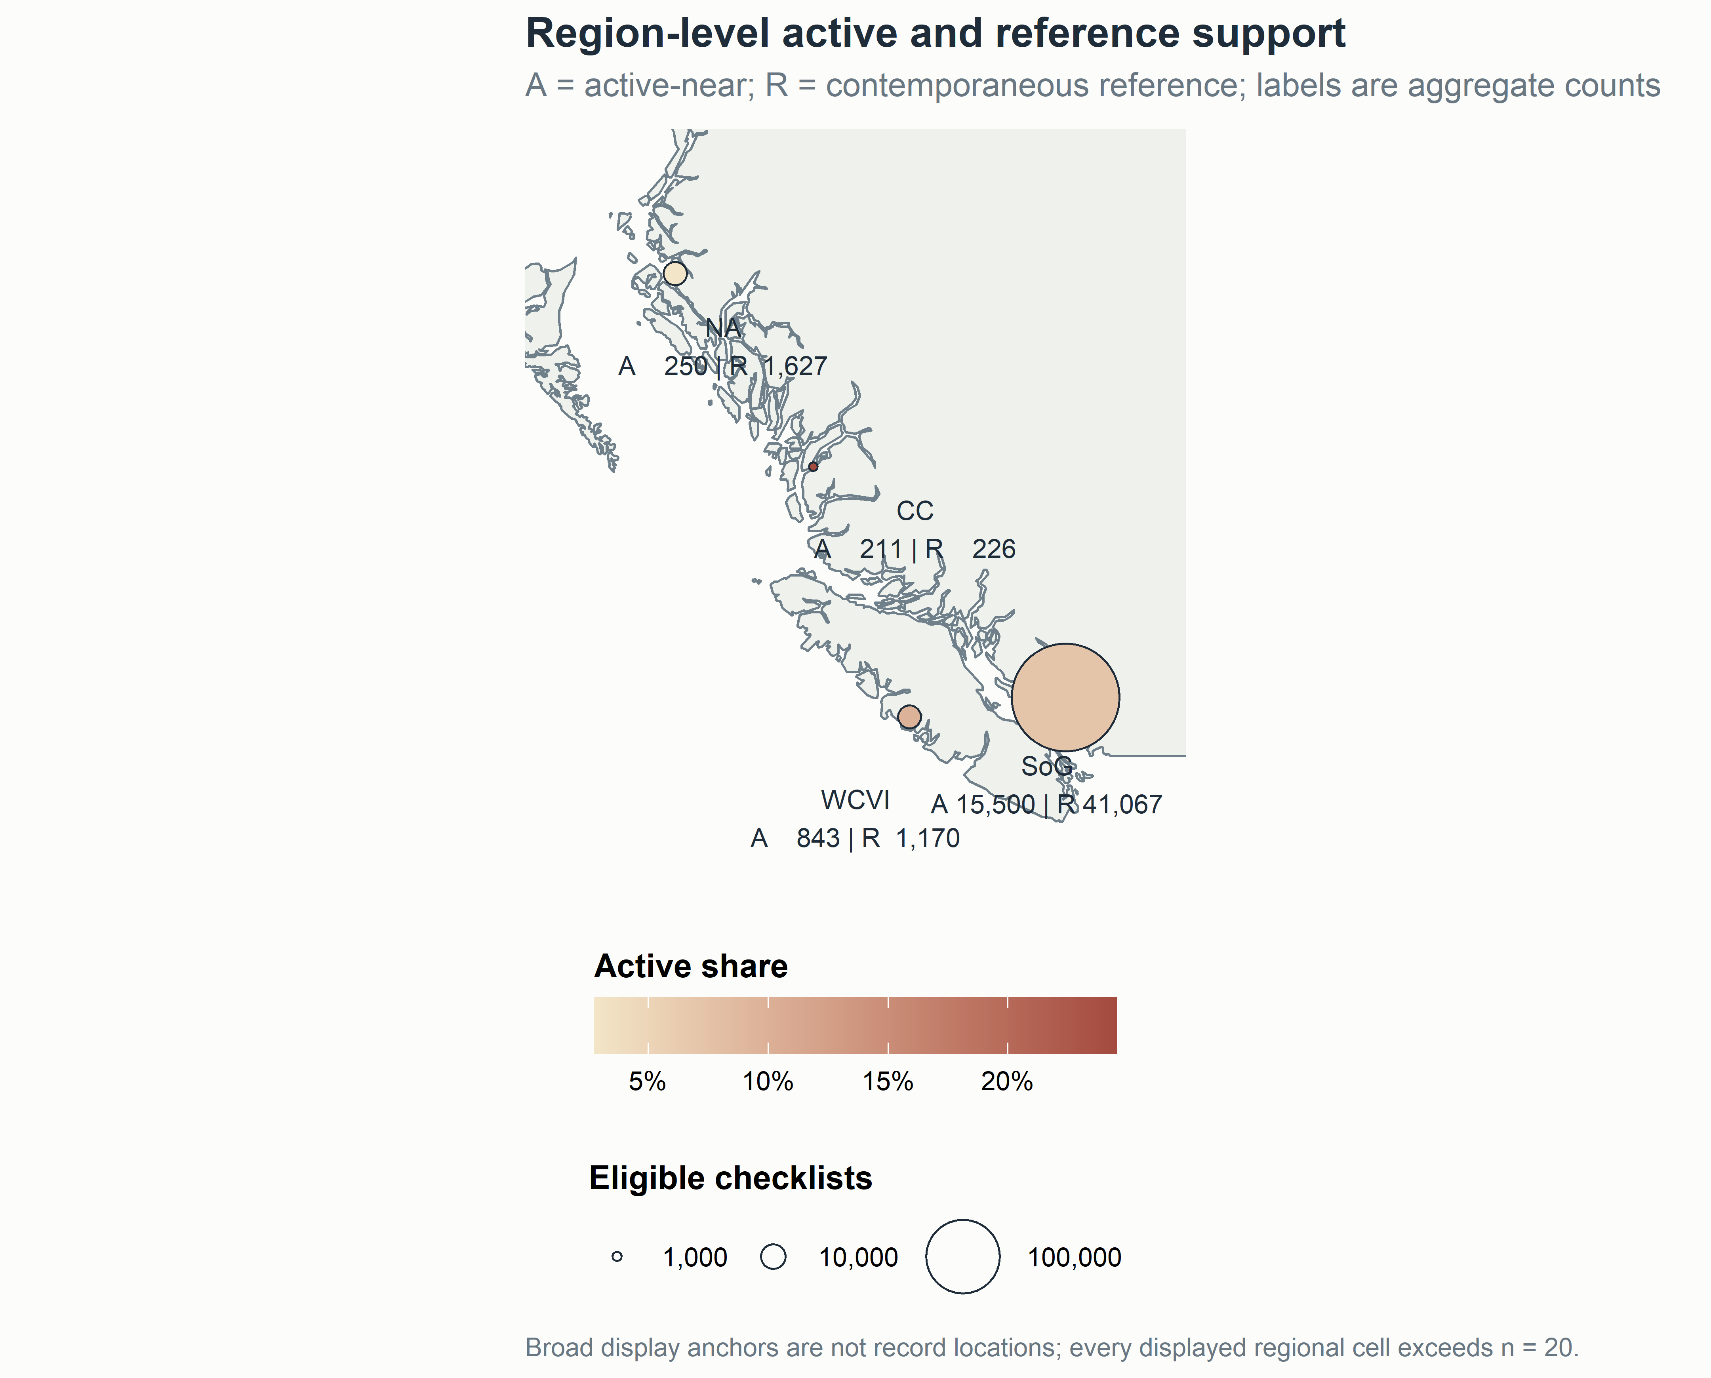
Figure S2. Region-level active and reference support. Display anchors are not data coordinates. All displayed regional cells exceed n = 20.

4. Complete species evidence
The full M02 effect table is versioned as tables_v3/Table_S1_all_species_effects_v3.csv. It retains 49 species, four released regions, two response components where estimable, BH q-values, component sample sizes, and explicit noncompletion. The descriptive companion contains detection prevalence and numeric availability by region plus pooled X, ambiguity, support, and flock-size quantiles.
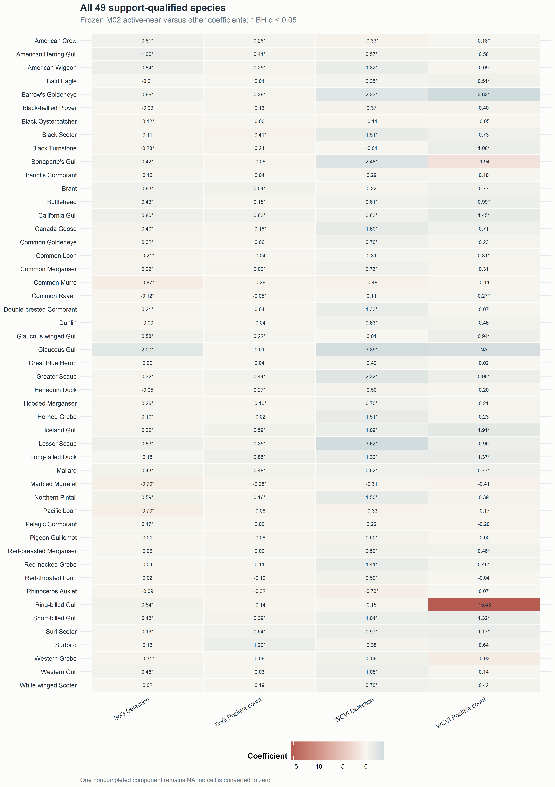
Figure S3. Complete 49-species coefficient matrix. Values are frozen M02 coefficients for active-near versus other. An asterisk indicates BH q < 0.05. The noncompleted component remains NA.
Negative values, broad intervals, failed components, and taxa without a dedicated herring literature remain visible. The matrix is a completeness display, not an ecological mechanism assignment.

5. Guild synthesis
Guild membership and mechanism descriptions are in metadata/species_primary_guild.csv and metadata/canonical_guild_registry.csv. Each species has one primary guild for aggregation, preventing duplicate contribution to guild totals. Multi-label mechanism traits remain separate metadata for future work.
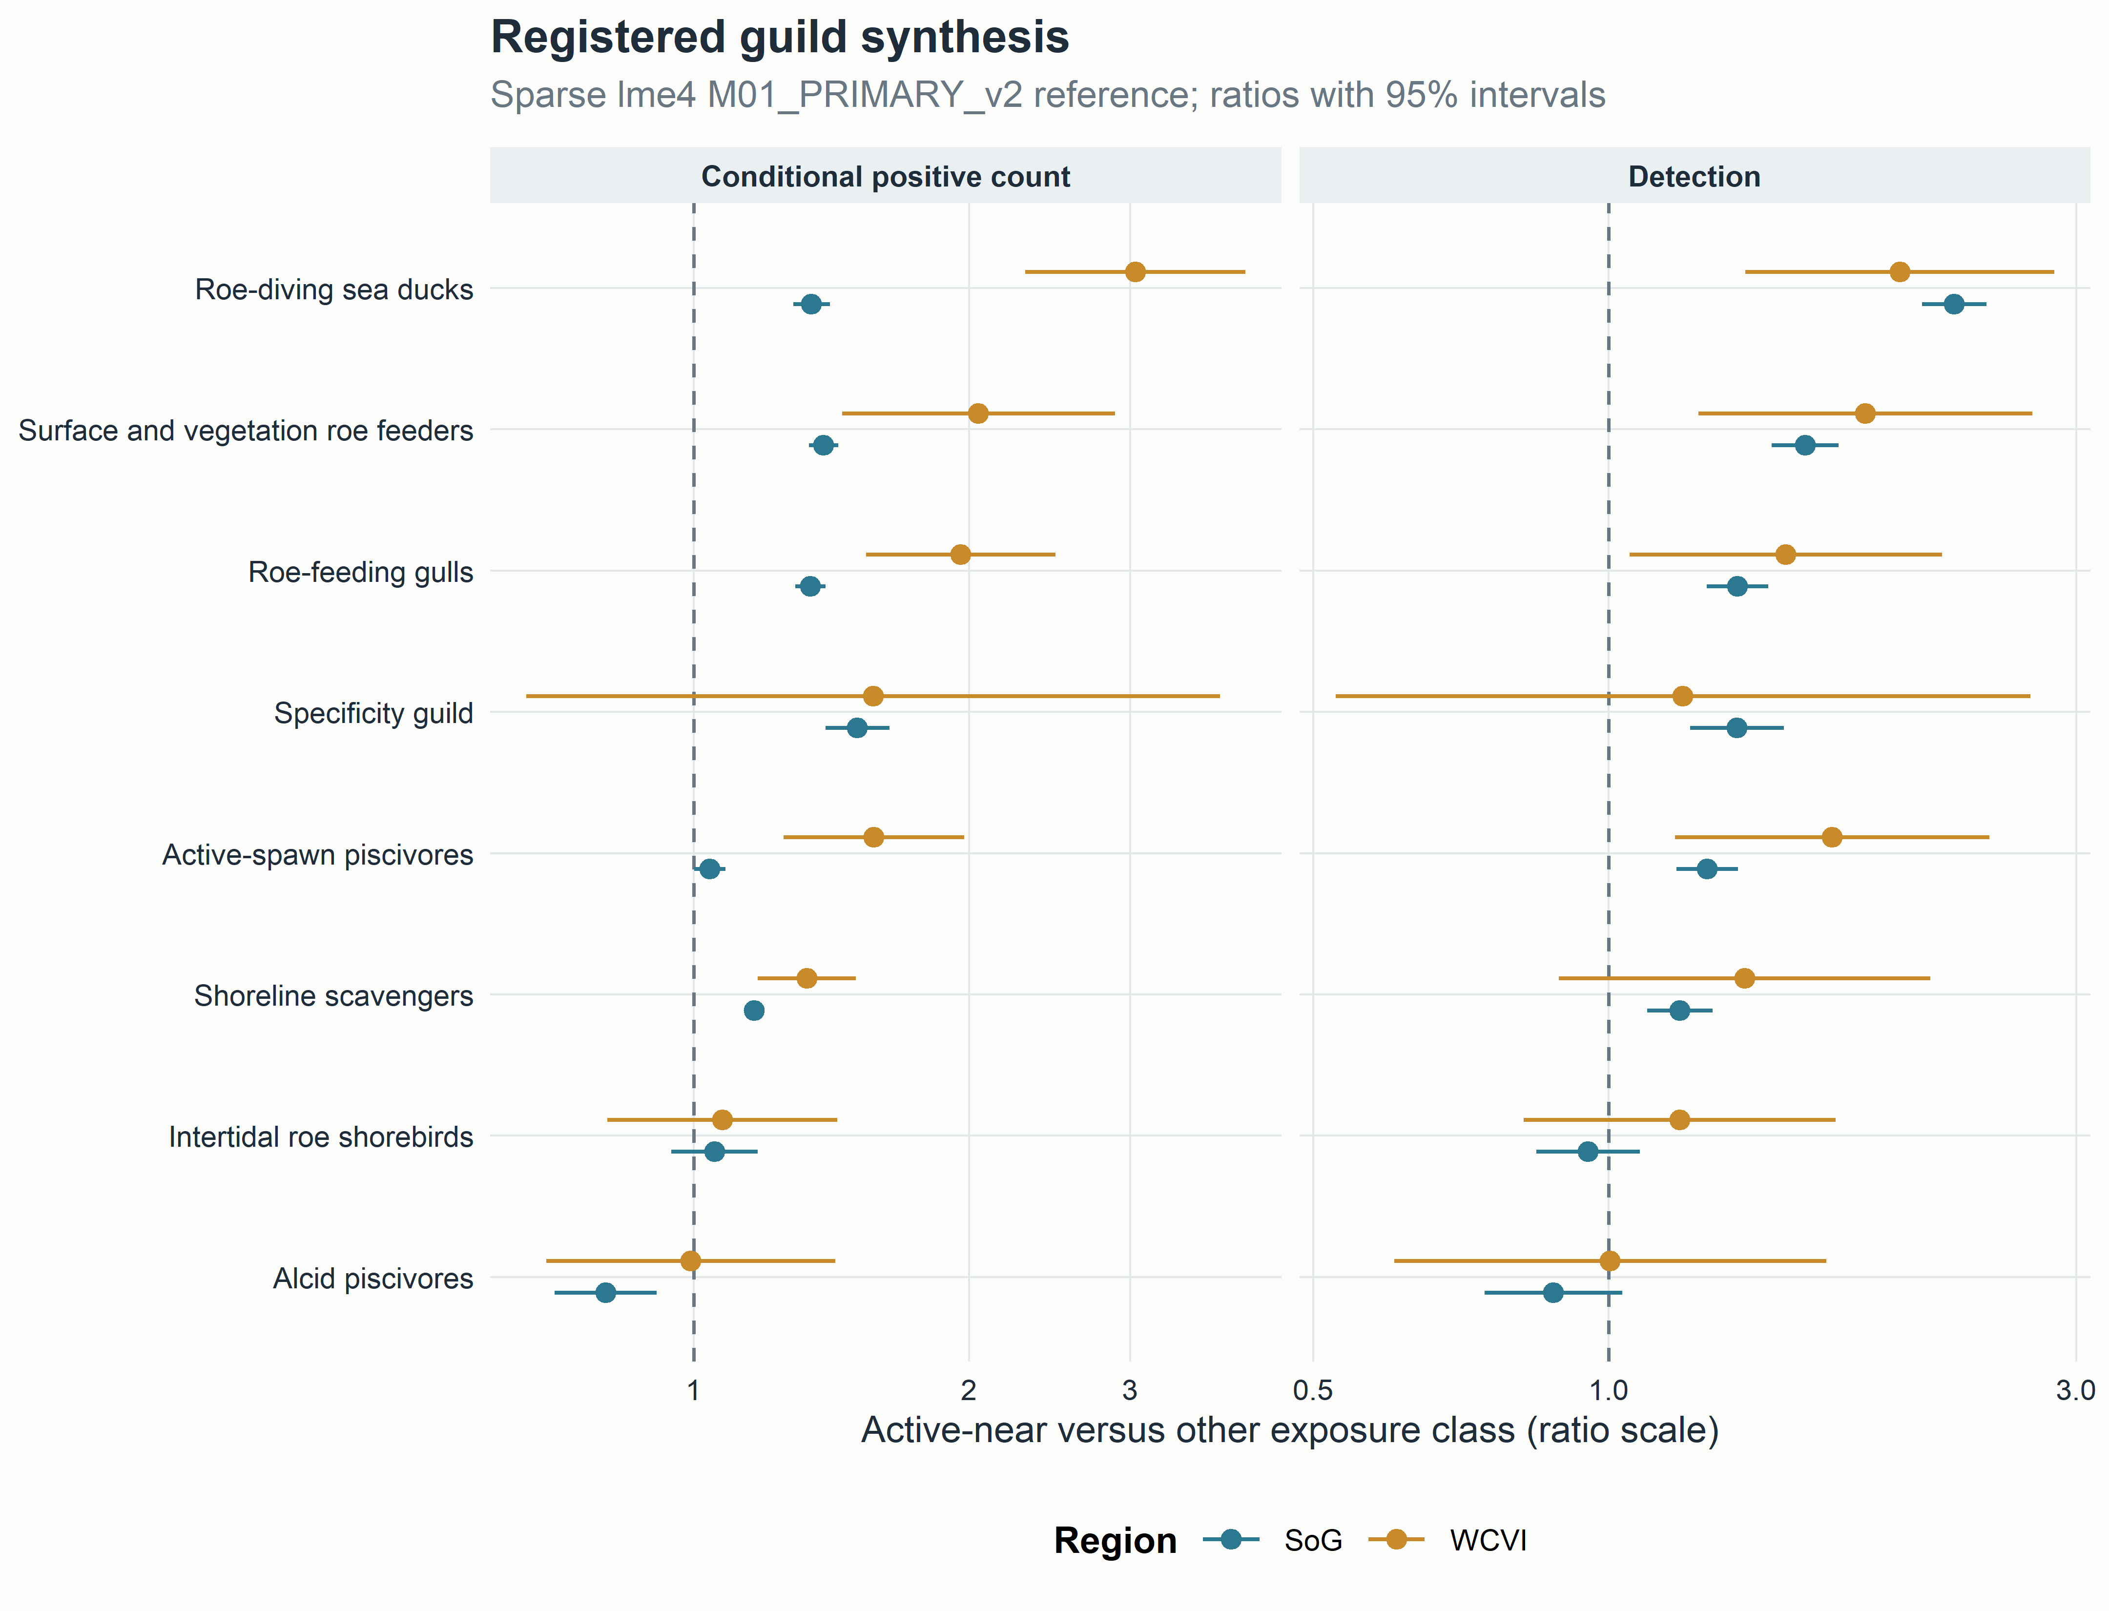
Figure S4. Sparse M01 guild synthesis. Ratios compare active-near with other. Guild averages complement rather than replace species evidence.

6. Event windows, distance rings, and temporal support
The executed six windows were early pre-spawn (−42 to −29 d, baseline), late pre-spawn (−28 to −1), spawn start (0–3), early egg (4–14), late egg (15–28), and post-spawn (29–56). The complete 160-row guild M05 family contains five nonbaseline coefficients for eight guilds, two regions, and two response components. It is versioned as tables_v3/Table_S2a_guild_event_time_effects_v3.csv.
The eight distance rings were 0–<0.5, 0.5–<1, 1–<2, 2–<3, 3–<4, 4–<5, 5–<10, and 10–20 km, with the final ring omitted from the fixed formula. All released M05 time and distance components are retained in tables_v3/Table_S2_all_M05_time_distance_effects_v3.csv; stratum support is retained in descriptive_statistics_v3.csv. Because all concurrent links were retained, window and ring counts can overlap and must not be summed as a composition.
The response-free region-year support table is copied as tables_v3/Table_S3_temporal_sampling_support_v3.csv. It describes sampling support, not bird-response estimates.

7. Specificity, sensitivity, and placebos
The M29 SoG specificity panel was non-null for Gadwall and Northern Shoveler. Their coefficients, intervals, p-values, q-values, and transformed odds ratios are retained in Table_4_specificity_sensitivity_v3.csv.
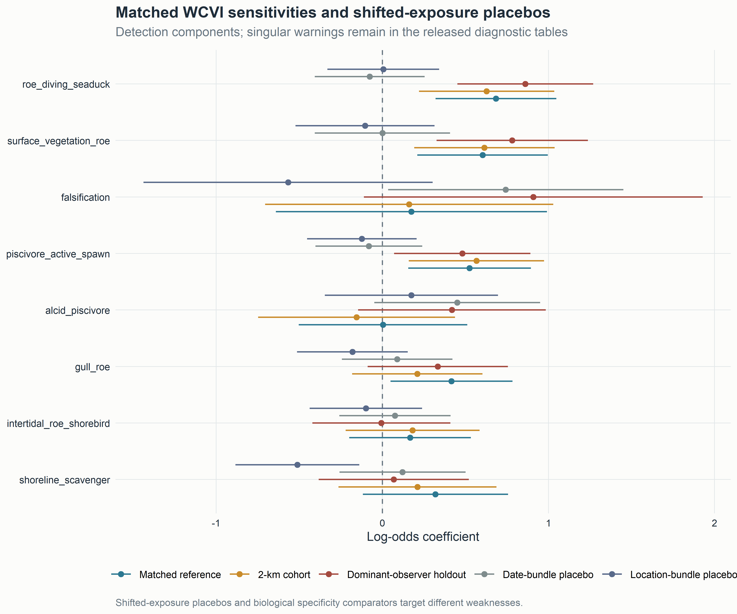
Figure S5. Matched sensitivities and shifted-exposure placebos. Placebos and biological comparators target different weaknesses. Null shifted bundles do not erase the non-null specificity panel.
All 128 protected v2 reference, sensitivity, and placebo components are supplied in tables_v3/Table_S4_all_sensitivity_effects_v3.csv. Complete validation is in Table_S5_all_validation_v3.csv. The WCVI 2-km and dominant-observer restrictions each preserved the matched-reference sign in 15 of 16 components. Forty-three components carried singular warnings.

8. Completion, geometry, and warning states
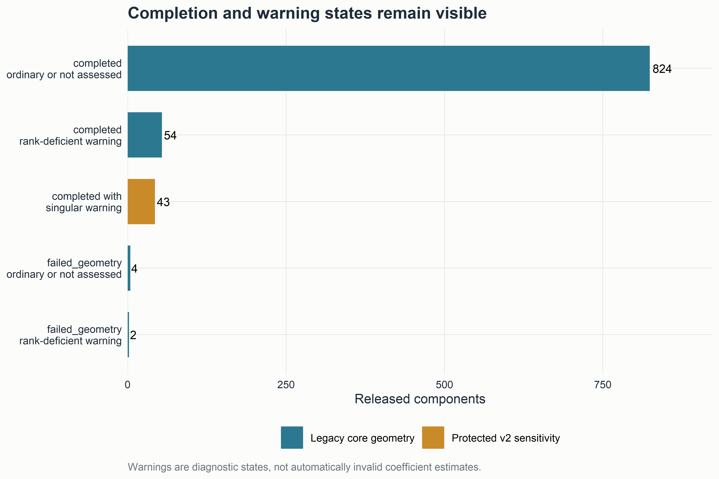
Figure S6. Completion and warning states. Singularity indicates limited support for part of a variance structure, not automatically an invalid coefficient. Rank-deficient, failed, and non-estimable components remain explicit.
The complete legacy geometry table is tables_v3/Table_S6_model_geometry_v3.csv; the component singularity audit is Table_S7_singular_fit_audit_v3.csv; and the registered model-disposition table is Table_S8_model_disposition_v3.csv. No failed value is converted to zero. No headline claim depends exclusively on a singular component.

9. Positive-count sensitivity and ambiguity
The registered zero-truncated negative-binomial sensitivity is copied as tables_v3/Table_S9_zero_truncated_nb2_v3.csv. It preserves explicit engine/support and numerical failure states. Detection, finite numeric count, X, lower-bound count, ambiguity, and structural unknown remain distinct throughout the descriptive and inferential records.

10. Compatible-family pooling repair
The v2 compatible-family repair did not change any coefficient, standard error, interval, p-value, q-value, model status, or component sample size. It audited 6,562 finite historical rows in 112 families, yielded 162 estimable compatible families, retained 439 duplicate M11/M12 representations as explicit NA, and retained 38 noncompleted rows as explicit NA.
The complete family table is copied as tables_v3/Table_S10_pooling_families_v3.csv; exclusion accounting is Table_S11_pooling_exclusions_v3.csv. V1 and v2 artifacts remain unchanged.

11. Figure and table provenance
audits/figure_table_provenance_v3.csv records each v3 figure and table, deterministic source, SHA-256 hash, generation script, filter, model/family identifiers, caption purpose, and privacy class. audits/spatial_figure_privacy_audit_v3.csv separately records the map source, broad aggregation unit, threshold, suppression rule, coordinate class, projection, date range, layer meaning, and limitation.

12. Reproducibility and governance statement
V3 manuscript assembly:
- used no response year after 2025;
- opened no protected response cache or row-level spatial derivative;
- exposed no checklist, observer, locality, exact coordinate, event-token, or transformation-mapping identifier;
- fitted no response model;
- changed no frozen v1 or v2 analysis artifact; and
- created versioned v3 files only.
The analysis freeze remains commit c54b8e7f95a2fe3573e2e38633079cd223c5a783, tag stage4a-publication-v2-analysis-freeze.

13. Supplementary file inventory
Identifier | File | Contents
Table S1 | Table_S1_all_species_effects_v3.csv | complete M02 species effects
Table S2 | Table_S2_all_M05_time_distance_effects_v3.csv | all released M05 time and distance components
Table S2a | Table_S2a_guild_event_time_effects_v3.csv | complete 160-row guild event-window family
Table S3 | Table_S3_temporal_sampling_support_v3.csv | response-free region-year support
Table S4 | Table_S4_all_sensitivity_effects_v3.csv | 128 protected v2 components
Table S5 | Table_S5_all_validation_v3.csv | matched four-fold validation
Table S6 | Table_S6_model_geometry_v3.csv | legacy convergence and rank states
Table S7 | Table_S7_singular_fit_audit_v3.csv | all 43 singular component warnings
Table S8 | Table_S8_model_disposition_v3.csv | model disposition and replacements
Table S9 | Table_S9_zero_truncated_nb2_v3.csv | count-family sensitivity
Table S10 | Table_S10_pooling_families_v3.csv | 162 compatible family records plus nonestimable families
Table S11 | Table_S11_pooling_exclusions_v3.csv | explicit exclusion and NA accounting
Table S12 | Table_S12_M08_active_minus_reference_v3.csv | direct active-minus-reference contrasts
Table S13 | Table_S13_all_M29_components_v3.csv | complete M29 release, including noncompleted WCVI rows
Table S14 | Table_S14_complete_effect_release_v3.csv | complete frozen aggregate effect release

