Event-linked changes in coastal-bird checklist reporting and counts during Pacific herring spawning in the Strait of Georgia
  - Full-length Article
Affiliation: University of Victoria, [[AUTHOR INPUT REQUIRED: full postal address]], Canada
Corresponding author: Jacob T. Dingwall; dingwalljake@gmail.com; [[AUTHOR INPUT REQUIRED: telephone number]]
ORCID: 0009-0007-8389-6947

Abstract
Pacific herring (Clupea pallasii) spawning creates a brief coastal resource pulse, but spring migration, habitat, access, and observer behaviour can produce similar patterns in bird observations. In a post-result exploratory refinement of an earlier registered analysis, we linked 1,120 Fisheries and Oceans Canada spawning events to 217,200 complete eBird checklists from the Strait of Georgia, British Columbia (2005–2025). Checklists <5 km from recorded events were compared with contemporaneous checklists linked to events 5–20 km away. Separate mixed models described checklist reporting and conditional positive numeric reported counts. Primary predictors counted concurrent checklist-to-event links. The A14 contrast directly compared days 0–14 with days −14 to −1 after adjusting both periods for the near/reference difference during days −28 to −15. Among 49 support-qualified species, 13 of 48 estimable reporting contrasts and 18 of 46 count contrasts were BH-significant; all were positive. A deterministic nearest-event sensitivity produced 49 reporting and 41 count estimates; signs agreed with the primary analysis for 34 of 48 and 34 of 41 paired estimates, respectively. 4 component(s) met the prespecified material-change rule. These event-linked associations are compatible with local aggregation but do not establish herring consumption, herring-induced movement, or regional abundance change.
Keywords: Pacific herring; eBird; community science; resource pulse; coastal birds; checklist reporting; conditional count

1 Introduction
Ecological resource pulses are short-lived increases in resource availability that can reorganize consumer distributions and interactions. Their consequences depend on the amount, accessibility, and timing of the resource; the mobility and foraging traits of consumers; and the spatial scale at which redistribution is observed. In coastal systems, pulses can connect pelagic production to shallow subtidal, intertidal, terrestrial, and aerial consumers.
Pacific herring spawning is one such pulse. Adults enter coastal waters and deposit adhesive eggs on vegetation and other shallow substrates. Adults, eggs, milt, carcasses, and associated prey can then become available to consumers through different pathways and over different intervals (Haegele and Schweigert 1985; D. E. Hay and Kronlund 1987; Douglas E. Hay et al. 2009; Grinnell et al. 2023; Rooper et al. 2024). Recorded spawning is spatially patchy, and a recorded date and point do not describe the complete footprint of prey available to birds. Spawning depth, substrate, tides, weather, shoreline configuration, event duration, and egg survival all affect accessibility.
Coastal birds are expected to differ in how they encounter this pulse. Diving sea ducks can reach attached roe, piscivores can take adults or associated prey, gulls and corvids can exploit eggs, fish, carcasses, or exposed material, and raptors can hunt or scavenge. Field observations and telemetry show that some waterbirds aggregate near spawning areas, consume roe or adult fish, change foraging behaviour, or redistribute with spawn timing (Haegele 1993; T. M. Sullivan, Butler, and Boyd 2002; Rodway et al. 2003; Lewis, Esler, and Boyd 2007; Lok et al. 2008, 2012; Kelly, Rothenbach, and Weathers 2018). Harlequin Ducks aggregate at spawning sites in the Strait of Georgia (Rodway et al. 2003), and Surf and White-winged Scoters alter movement and foraging during spawning (Lewis, Esler, and Boyd 2007; Lok et al. 2008). Surf Scoters can track sequential spawning areas during spring migration (Lok et al. 2012). These studies establish plausible mechanisms for particular taxa and places, but they do not show that every regional near-spawn association is caused by herring.
The Strait of Georgia is well suited to examining this distinction. Recurrent spawning occurs within a mosaic of estuaries, rocky shores, eelgrass and macroalgal substrates, urban waterfronts, islands, and narrow channels. These environments differ both ecologically and observationally. Shorelines vary in prey access, bird habitat, roads, recreational use, visibility, and the likelihood that a checklist is submitted. Herring spawning and northward bird migration also occupy the same weeks. A comparison between spawning dates and earlier spring dates can therefore recover migration, persistent habitat differences, or changing observation patterns even when birds do not move toward spawning.
Complete eBird checklists provide broad coverage but remain a semi-structured observation process. A complete checklist means that observers reported all species they detected and identified, allowing a taxon omitted from the list to contribute a report/nonreport outcome under explicit taxonomic rules (B. L. Sullivan et al. 2009; Kelling et al. 2019). Protocol, duration, travel distance, and party size describe measured effort. However, participants choose when and where to observe, observers differ in identification and counting, and a reported X indicates that a species was observed without a numeric count (Johnston et al. 2018, 2021). These data therefore describe checklist reporting and reported counts, not occupancy or a probability-sampled census.
We asked whether the difference between checklists near recorded herring spawning and contemporaneous reference checklists changed after recorded onset relative to both the preceding 14 days and the spatial difference already present during days −28 to −15. We expected established or plausible herring-associated taxa to show positive event-linked associations in checklist reporting, conditional positive numeric count, or both, while recognising that associations need not be universal. The primary timing prediction was evaluated with a direct active-minus-pre contrast. We also expected two nominated comparator taxa not to show a coherent active-period association; that exploratory specificity expectation was contradicted.

2 Methods

2.1 Study area and data sources
The study was restricted to the Strait of Georgia, British Columbia, Canada. Bird observations came from the eBird Basic Dataset release EBD_relMay-2026, with responses restricted to 2005–2025 (eBird 2026). Taxa followed eBird/Clements taxonomy v2025. Herring information came from Fisheries and Oceans Canada Pacific Herring Spawn Index Data and its documented index construction (Fisheries and Oceans Canada 2026; Grinnell et al. 2023). The spawn index is relative rather than an estimate of absolute spawning biomass. Missing herring components were not treated as zero, unmonitored records were not converted to surveyed negatives, and spawning biomass was not included as an exposure.
The analytical population contained 217,200 eligible complete checklists. Stationary and travelling protocols were included when checklists lasted 5–300 min, travelled no more than 5 km, and represented parties of one to ten observers. The Strait of Georgia frame contained 1,120 recorded herring source events grouped into 58 event blocks, 29,248 observer clusters, and 22,980 generalized location clusters.
The checklist eligibility rules were inherited from an earlier registered analysis of the same linked data. Results from that earlier analysis had already been examined when the present event-link specification was developed. The present analysis is therefore a post-result exploratory refinement, not an independently preregistered analysis. Its specification was archived before this refinement was executed, and it did not overwrite or relabel the earlier registered results. [[AUTHOR INPUT REQUIRED: registration identifier and/or repository DOI]]

2.2 Checklist selection and response construction
Two outcomes represented different parts of the checklist observation process. Checklist reporting was one when a taxon was reported on an eligible complete checklist and zero when it was omitted under the fixed taxonomic and ambiguity rules. Omission from a complete checklist is useful for modelling reporting, but it is not proof that the species was biologically absent.
Every positive report retained its count state. A finite positive number contributed to both checklist reporting and the conditional numeric-count model. An unquantified X contributed to checklist reporting but not to the numeric-count model. Ambiguity-affected records, lower-bound reports, structural unknowns, and finite exact counts remained distinct and were not silently recoded as zeros or as exact counts. Taxonomic changes across the series—including the Mew-to-Short-billed Gull split, the Herring Gull complex split yielding American Herring Gull, and the Thayer’s-to-Iceland Gull lump—were resolved to fixed analysis concepts using versioned mapping.
The second outcome was the natural logarithm of the finite positive number reported for a taxon. It is therefore termed conditional positive numeric count. Exponentiated contrasts compare geometric mean reported counts among checklists on which the species was both reported and assigned a finite number. This is not a measure of abundance across all checklists, and a checklist total, particularly from a travelling route, need not represent one independent flock.

2.3 Herring events, timing, and spatial linkage
A source event was the recorded herring-spawning unit with an onset date and source point used to create checklist-to-event links. Source events linked concurrently to the same checklist were joined into a common event block. This unioning was used to keep connected events and checklists within one statistical dependency group; an event block should not be interpreted as a single biological spawning complex. A checklist linked to several source events remained one model row and carried the random effect of the event block formed by those connected links.
Event blocks were not matched treatment-control strata, and the model did not require every source event or block to contain both near and reference observations. The same source event or connected block could contribute observations in both zones: 850 source events and 51 event blocks did so. These counts describe representation, not proof of ecological exchangeability between the zones.
Six periods were defined relative to recorded onset: baseline (−28 to −15 d), early pre-spawn (−14 to −8 d), immediate pre-spawn (−7 to −1 d), spawn start (0–3 d), early egg (4–14 d), and late egg (15–28 d). The 14-day pre-spawn summary equally combined the two seven-day pre-spawn periods. The primary active summary combined spawn start and early egg in proportion to their durations: 4/15 and 11/15.
A checklist-to-event link was near when the checklist point was <5 km from the source point and reference when the distance was 5–20 km, inclusive at 20 km. Distances used the checklist’s point representation, including the point attached to a travelling checklist, rather than a reconstructed route or shoreline-access path. Approximately 12% of near-zone checklists travelled more than 2.5 km and approximately 3% travelled more than 4 km. Route representation can therefore contaminate the near/reference distinction; the direction of resulting bias is not guaranteed.
A checklist could link to several source events at different distances and event-relative dates. All eligible links were counted in their actual period-by-zone cells, producing 12 additive exposure variables: six periods crossed with two zones. Marginal time and distance totals were not multiplied because that could pair information from different events. Each checklist remained one model row regardless of the number of links. Consequently, baseline and active exposure were not mutually exclusive: 5,163 checklists, or 5.5% of those with any modelled exposure, contributed to both through different events. Collinearity among the 12 link-count predictors was low, with variance inflation factors from 1.22 to 1.26.

2.4 Statistical estimand and models
The analytical logic is most clearly expressed in terms of event links. For checklist (i), the conceptual model for each species was
gEYi=α+p,z​βp,zLi,p,z+γ⊤Ci+ubi+uoi+uli,
where $Y_{i}$ is checklist reporting or log conditional positive numeric count; $g$ is the logit link for checklist reporting and the identity link for log count; $L_{i,p,z}$ is the number of recorded source-event links for checklist $i$ in period $p$ and zone $z$; $β_{p,z}$ is the slope for one additional link in that cell; $C_{i}$ contains the adjustment variables; and the three $u$ terms are random intercepts for event block, observer cluster, and generalized location cluster.
For a period (p), the reported baseline-adjusted near/reference contrast was
$$θ_{p}=\left(β_{p,near}-β_{p,reference}\right)-\left(β_{baseline,near}-β_{baseline,reference}\right).$$
This is a difference-in-differences contrast applied to additive event-link slopes. We refer to it as a baseline-adjusted near/reference contrast of event-link slopes. Its unit is the change associated with one additional recorded event link, conditional on the other 11 link counts and the adjustment terms. It is not the raw difference between near and reference checklists, a percentage change in bird abundance, or a conventional binary treatment-versus-control effect.
For example, a checklist linked to two source events—one near event during the active period and one reference event during baseline—contributed one to each of those two predictors and zero to the other ten. The checklist was not duplicated. A checklist linked to two near active events contributed two to the near-active predictor. Its contribution therefore reflects the number of recorded links, not the presence of a mutually exclusive treatment.
Checklist reporting was fitted with a binomial generalized linear mixed model with logit link using lme4::glmer and nAGQ = 0; conditional log count was fitted with a Gaussian linear mixed model using restricted maximum likelihood and lme4::lmer (Bates et al. 2015). The reporting-model approximation can affect covariance estimates in sparse binomial mixed models. Validation therefore included a Laplace glmmTMB reporting refit for one representative species and a mixed zero-truncated negative-binomial count refit for one representative species. These checks assess directional stability but do not validate the complete family.
Fixed adjustment terms were checklist year, protocol, log checklist duration, log travel distance plus one, and observer count. Random intercepts represented event block, observer cluster, and generalized location cluster. Each of the 49 support-qualified species was fitted separately for both outcomes where support allowed. No simplified fallback replaced a failed model.
Eleven species were selected for detailed natural-history discussion before execution of this refinement: Surf Scoter, White-winged Scoter, Harlequin Duck, Common Merganser, Hooded Merganser, Glaucous-winged Gull, Short-billed Gull, Bald Eagle, Mallard, American Crow, and Common Raven. This panel was not selected from the refinement’s numerical results, but the same linked dataset had already informed development of the refinement. The criteria were not exhaustive, and six species emphasised by the earlier analysis were omitted without a recorded biological justification. The full support-qualified family is therefore the primary inferential set; the eleven species are illustrative examples.

2.5 Multiplicity, sensitivity analyses, and interpretation
For each period and outcome, Benjamini–Hochberg (BH) adjustment was applied across the 49 core species (Benjamini and Hochberg 1995). The primary timing test was A14 = Dactive − Dpre14, where Dactive combined days 0–14 in proportion to period duration and Dpre14 equally combined days −14 to −1. Standard errors used the complete fixed-effect covariance matrix, including covariance between active and pre-onset coefficients. A7 used days −7 to −1 as a secondary timing comparison. The finite-number-versus-X models formed a separate exploratory 49-species family. Gadwall and Northern Shoveler retained their separate two-species exploratory reporting analysis; its multiplicity threshold is not strong evidence of ecological specificity.
For A14 and A7, exponentiated checklist-reporting estimates are ratios of the active and pre-onset near/reference odds-ratio slopes per additional event link. Exponentiated conditional-count estimates are the analogous ratios of geometric-mean count-ratio slopes. Values above one indicate that the baseline-adjusted near/reference slope became more positive after recorded onset than before onset. These are per-link contrasts, not percentage changes in bird abundance.
Observed reporting proportions, finite positive-count medians and interquartile ranges, and proportions recorded as X were summarised without adjustment. Fixed-effect predictions were standardised over the observed checklist covariate distribution with all random intercepts and nonselected event-link predictors set to zero. Previously completed sensitivities evaluated binary any-link exposure and link-count linearity. For the present revision, a single conventional exposure sensitivity was chosen before fitting from support and geometry alone: complete single-event restriction retained 72,443 checklists and supported count models for 19 of 49 species, whereas deterministic nearest-event assignment retained all 217,200 checklists, full fixed-effect rank, and count-model support for 41 species. The nearest-event encoding retained one minimum-distance event for each checklist with modeled-window links, using a deterministic tie break; checklists without such a link retained all-zero exposure terms. No response estimate or fitted result informed this choice, and no other new sensitivity was fitted.

2.6 Reproducibility and data access
The analysis specification was archived before execution of this post-result refinement. Code and privacy-safe aggregate results are available in the associated repository, while the earlier registered analysis remains distinct and unchanged. Record-level eBird data, identifiers, and exact coordinates are not redistributed.

3 Results

3.1 Dataset and model completion
The final frame contained 217,200 complete checklists from 2005–2025, linked to 1,120 recorded source events in 58 event blocks. The data included 29,248 observer clusters, 22,980 generalized locations, and 49 support-qualified species. Global joint exposure support ranged from 2,992 near-zone checklists at spawn start to 28,655 reference-zone checklists in the late-egg period.
Checklist reporting was estimable for 48 core species and conditional positive numeric reported count for 46 in the primary analysis. Four primary components were non-estimable; one completed count fit was singular and one retained a convergence warning. The nearest-event sensitivity was estimable for 49 reporting and 41 count components. Figures and effect tables show only estimable fits; the synchronized Supplement retains every primary, finite-number-versus-X, and sensitivity component as an explicit status, so a failed component is not represented as a biological null result. BH adjustment retained the declared 49-species families.

3.2 Direct active-minus-pre results across the complete species family
The direct A14 contrast showed that days 0–14 were more positively associated with near event links than days −14 to −1 for a subset of the complete family (Figure 1; Tables 1–2). Checklist reporting was estimable for 48 species: 28 estimates were positive and 20 negative, with a median link-scale estimate of 0.022 (IQR −0.039 to 0.133). Thirteen positive contrasts survived BH adjustment. Conditional positive numeric count was estimable for 46 species: 42 estimates were positive and four negative, with a median of 0.070 (IQR 0.021 to 0.129). Eighteen positive contrasts survived BH adjustment.
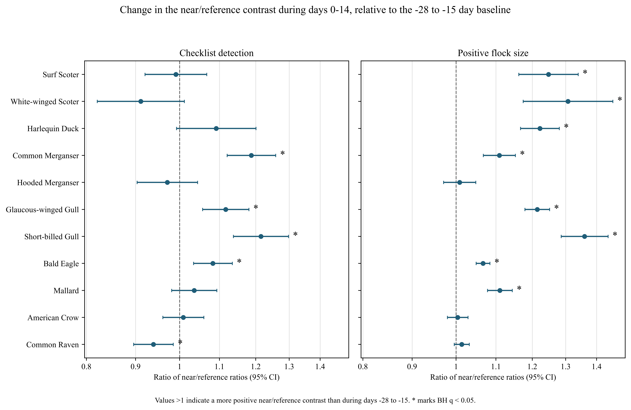
Figure 1. Direct active-minus-pre (A14) contrasts across the estimable components of the 49-species family. Points and 95% confidence intervals show the exponentiated difference between the duration-weighted active period (0–14 d) and the preceding 14 d (−14 to −1 d), after the same baseline-adjusted near/reference construction. Filled points have BH q < 0.05; open points do not. The diamond identifies a retained convergence-warning fit. Non-estimable components are not plotted. Ratios describe one additional recorded event link, not occupancy or abundance.
The largest BH-significant A14 checklist-reporting ratios were Bonaparte’s Gull at 1.48 (1.22–1.79), American Herring Gull at 1.39 (1.23–1.57), and California Gull at 1.32 (1.21–1.43). The largest conditional-count ratios were Long-tailed Duck at 1.43 (1.29–1.60), Surf Scoter at 1.30 (1.21–1.40), and Short-billed Gull at 1.30 (1.23–1.37). These ratios compare active with pre-onset event-link slopes and should not be read as proportional changes in regional abundance.
No negative A14 contrast survived BH adjustment. Negative point estimates occurred for 20 reporting and four count components, but the direct timing test did not distinguish them from zero after multiplicity correction. This differs from the original active-versus-baseline contrasts, for which several negative associations were reported.

3.3 Illustrative species profiles
Among the eleven illustrative species, Surf and White-winged Scoters had positive A14 conditional-count contrasts without corresponding reporting contrasts (Figure 2; Table 1). Harlequin Duck, Common Merganser, Glaucous-winged Gull, and Short-billed Gull increased in both outcomes. Bald Eagle and Mallard increased only in conditional count. Hooded Merganser and American Crow were null in both outcomes, and Common Raven’s reporting estimate was just above the BH threshold (q = 0.0507).
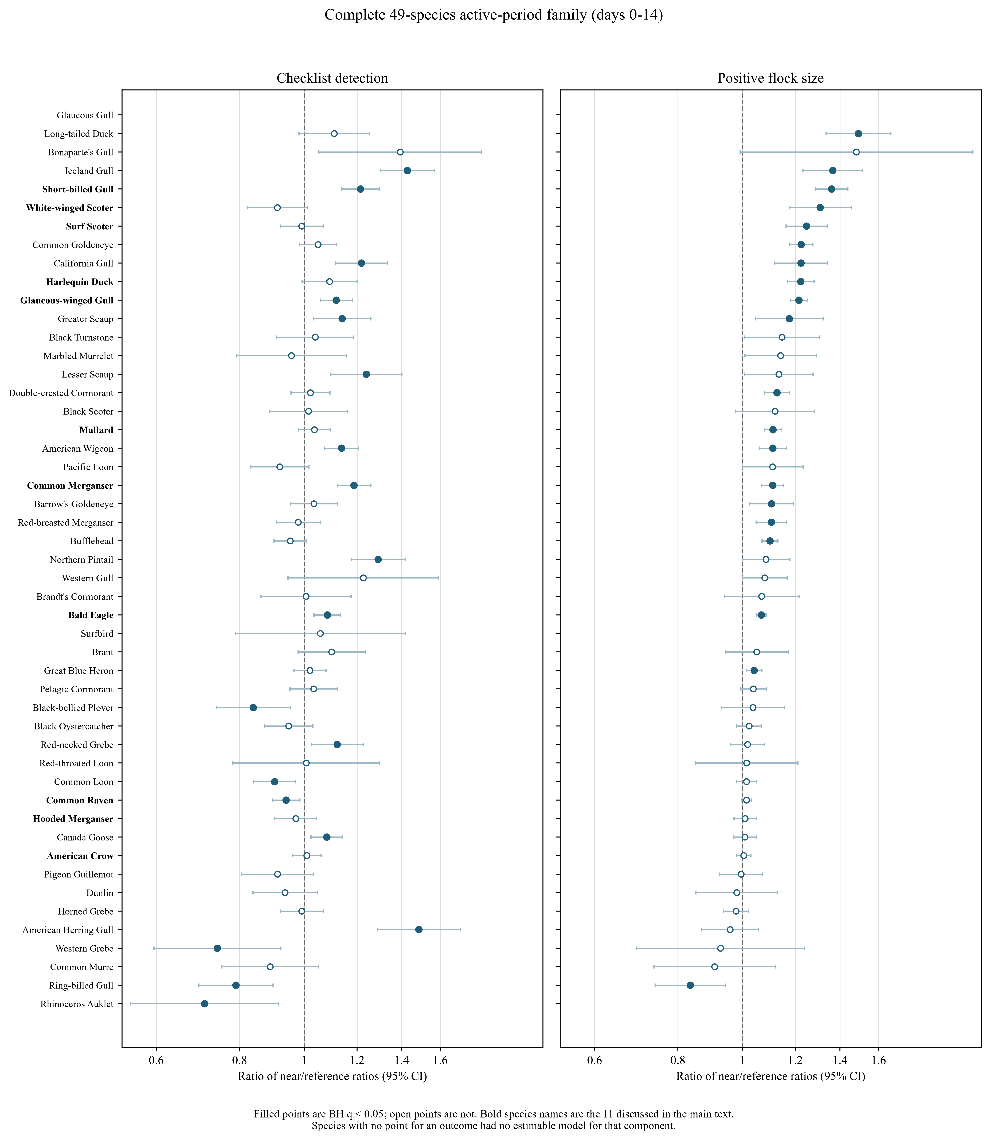
Figure 2. Direct active-minus-pre (A14) contrasts for the eleven illustrative species. Points and 95% confidence intervals are exponentiated active-minus-pre differences in baseline-adjusted near/reference event-link slopes. Filled points have BH q < 0.05 within the 49-species outcome family. Only estimable components are shown.
Table 1. Direct active-minus-pre (A14) contrasts for the eleven illustrative species. Values are ratios per additional recorded event link (95% CI) with BH q.
Species | Checklist reporting | Conditional positive numeric count
Surf Scoter | 1.00 (0.93–1.08), q = 0.948 | 1.30 (1.21–1.40), q = 2.32 × 10-12
White-winged Scoter | 1.08 (0.98–1.20), q = 0.26 | 1.17 (1.06–1.30), q = 0.0091
Harlequin Duck | 1.15 (1.05–1.26), q = 0.013 | 1.20 (1.15–1.26), q = 1.93 × 10-14
Common Merganser | 1.16 (1.10–1.23), q = 4.20 × 10-6 | 1.11 (1.07–1.16), q = 1.15 × 10-6
Hooded Merganser | 1.02 (0.95–1.10), q = 0.744 | 1.02 (0.98–1.06), q = 0.501
Glaucous-winged Gull | 1.14 (1.08–1.20), q = 5.01 × 10-5 | 1.17 (1.13–1.21), q = 1.67 × 10-22
Short-billed Gull | 1.25 (1.17–1.34), q = 1.28 × 10-9 | 1.30 (1.23–1.37), q = 1.02 × 10-18
Bald Eagle | 1.04 (0.99–1.09), q = 0.203 | 1.06 (1.05–1.08), q = 1.76 × 10-12
Mallard | 1.01 (0.96–1.07), q = 0.745 | 1.07 (1.04–1.10), q = 2.05 × 10-5
American Crow | 1.02 (0.98–1.08), q = 0.509 | 1.01 (0.98–1.03), q = 0.681
Common Raven | 0.94 (0.90–0.99), q = 0.051 | 1.00 (0.98–1.02), q = 0.954
Table 2. BH-significant A14 associations outside the eleven illustrative species. Only estimable components are displayed. † Retained convergence-warning fit.
Species | Outcome | Direction | A14 ratio (95% CI) | BH q
Bonaparte's Gull | Checklist reporting | positive | 1.48 (1.22–1.79) | 0.0003
American Herring Gull | Checklist reporting | positive | 1.39 (1.23–1.57) | 8.51 × 10-7
California Gull | Checklist reporting | positive | 1.32 (1.21–1.43) | 1.35 × 10-9
Iceland Gull | Checklist reporting | positive | 1.29 (1.18–1.41) | 5.05 × 10-7
Lesser Scaup | Checklist reporting | positive | 1.26 (1.11–1.44) | 0.0023
Northern Pintail | Checklist reporting | positive | 1.21 (1.10–1.32) | 0.0003
Brant | Checklist reporting | positive | 1.16 (1.04–1.30) | 0.026
Greater Scaup | Checklist reporting | positive | 1.13 (1.03–1.24) | 0.033
American Wigeon | Checklist reporting | positive | 1.11 (1.04–1.17) | 0.0044
Long-tailed Duck | Conditional positive numeric count | positive | 1.43 (1.29–1.60) | 4.06 × 10-10
Common Goldeneye | Conditional positive numeric count | positive | 1.20 (1.15–1.25) | 5.19 × 10-16
Greater Scaup | Conditional positive numeric count | positive | 1.16 (1.05–1.29) | 0.016
Pacific Loon† | Conditional positive numeric count | positive | 1.16 (1.04–1.29) | 0.028
California Gull | Conditional positive numeric count | positive | 1.15 (1.06–1.24) | 0.0028
Iceland Gull | Conditional positive numeric count | positive | 1.14 (1.03–1.26) | 0.028
Red-breasted Merganser | Conditional positive numeric count | positive | 1.13 (1.07–1.19) | 8.59 × 10-5
Bufflehead | Conditional positive numeric count | positive | 1.12 (1.09–1.15) | 3.15 × 10-15
Double-crested Cormorant | Conditional positive numeric count | positive | 1.10 (1.05–1.15) | 0.0002
Common Loon | Conditional positive numeric count | positive | 1.05 (1.01–1.08) | 0.041
Within the illustrative panel, four reporting contrasts and eight conditional-count contrasts were BH-significant. Table 2 lists the remaining significant A14 estimates from the complete support-qualified family.

3.4 Timing and standardised magnitudes
The A14 calculation formally tested whether each species’ active-period event-link contrast exceeded its preceding 14-day contrast using the full fixed-effect covariance matrix. The secondary A7 comparison, which used only days −7 to −1 as the pre-onset period, produced 11 BH-positive reporting contrasts and 13 BH-positive conditional-count contrasts. The narrower period-specific estimates in Figure 3 remain useful for locating associations around spawn start and egg availability.
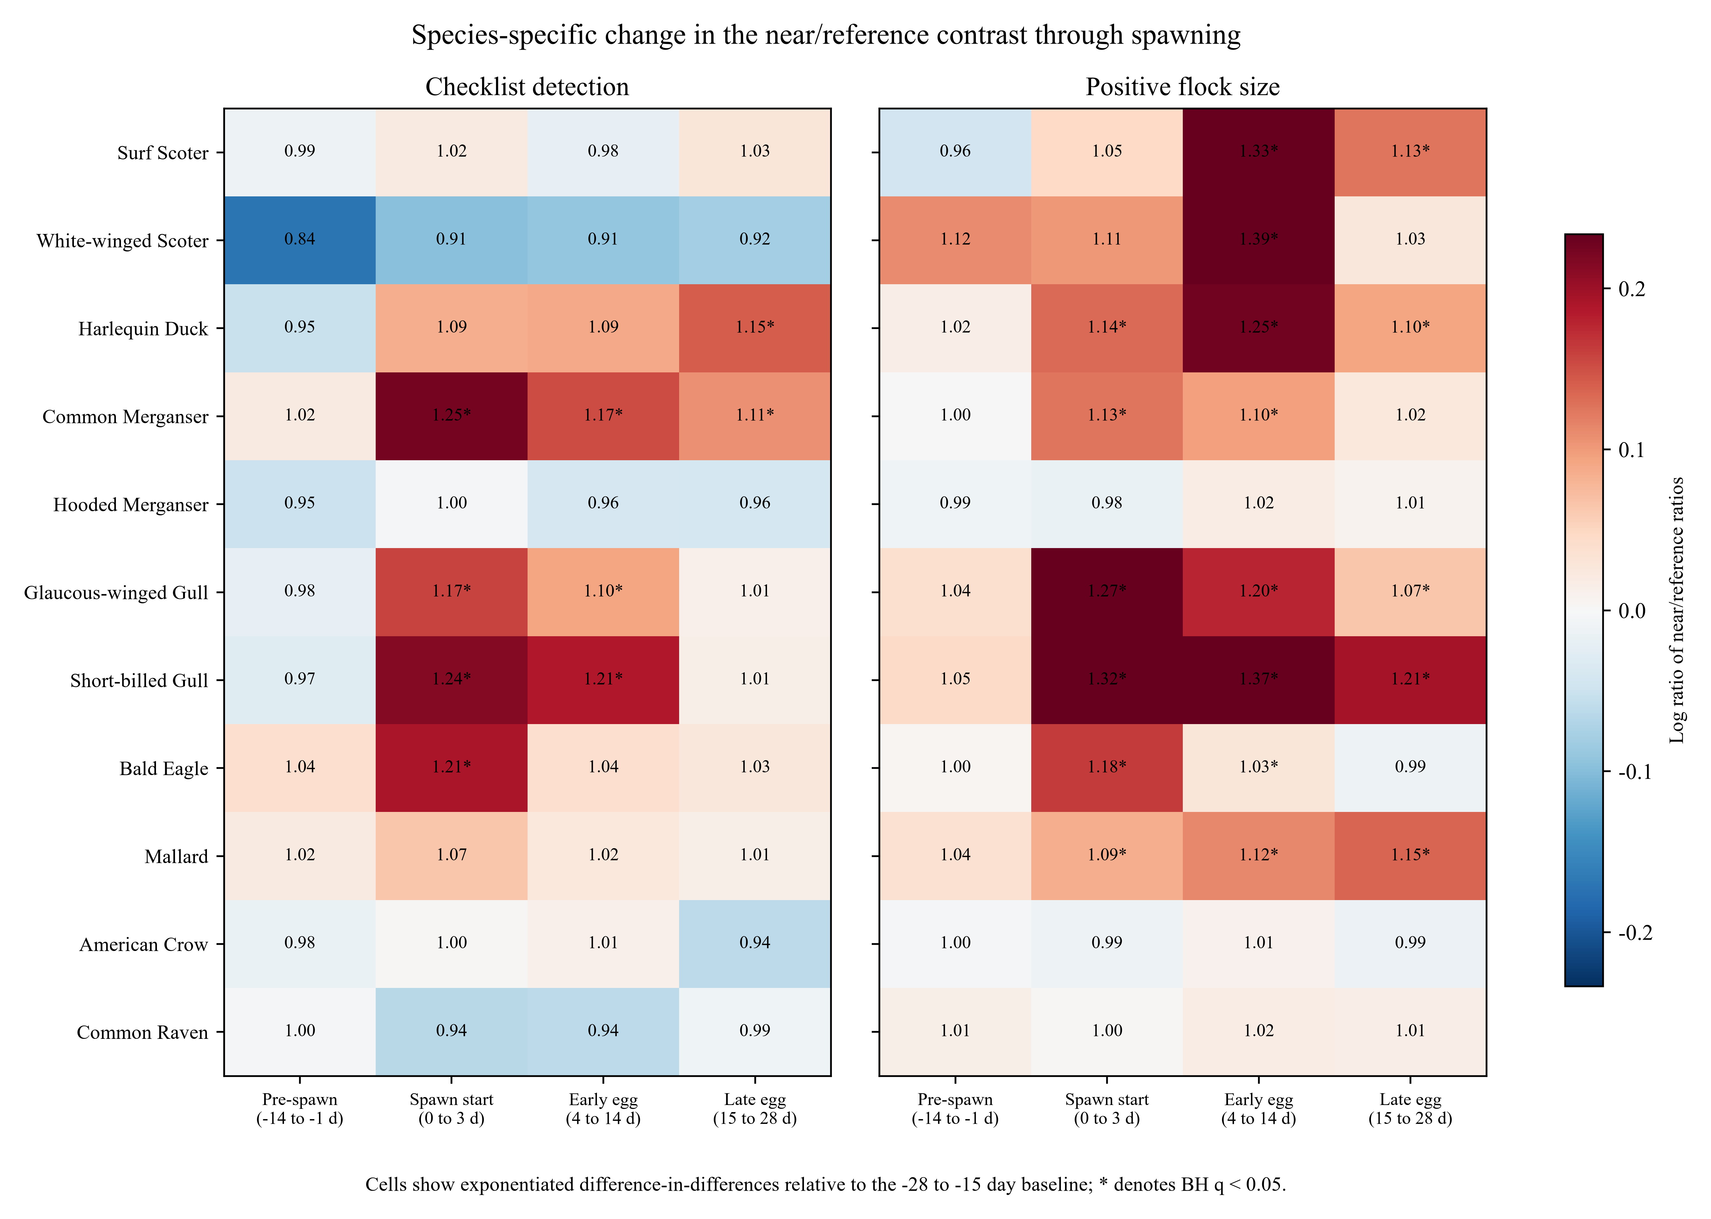
Figure 3. Descriptive period-specific near/reference event-link contrasts for eleven illustrative species. Cells show exponentiated baseline-adjusted contrasts for the 14-day pre-spawn summary (−14 to −1 d), spawn start (0–3 d), early egg (4–14 d), and late egg (15–28 d), each relative to the −28 to −15 d baseline. Asterisks denote BH q < 0.05. The formal active-minus-pre result is reported separately as A14.
The 13 reporting and 18 count results are species-level A14 tests. Because species share checklists, event blocks, observers, and locations, they do not constitute an independence-based test of a single family-wide mean shift. No dependence-preserving family-level bootstrap was completed.
Standardised fixed-effect predictions placed selected ratios on absolute scales. Averaging over the observed covariate distribution, the Glaucous-winged Gull A14 reporting contrast was 2.00 percentage points (95% CI 1.10–2.91), and the Short-billed Gull conditional-count contrast was 3.34 birds among quantified positive reports (2.59–4.09). All random intercepts and nonselected link predictors were set to zero, so these are standardised fixed-effect predictions rather than fully marginal population averages.
The absolute scale depended strongly on the species and response component. For example, the observed-covariate Surf Scoter A14 contrast was 10.94 birds among quantified positive reports (7.43–14.46), whereas its reporting-probability contrast was effectively zero. This contrast reinforces the distinction between more frequent checklist reporting and larger numeric reports conditional on reporting.

3.5 Specificity and contradictory results
Gadwall had a negative baseline near/reference reporting difference of 0.88 (0.80–0.97; q = 0.024) and an active-period contrast of 1.03 (0.90–1.17; q = 0.704). Northern Shoveler had a baseline difference of 1.00 (0.90–1.11) and a positive active-period contrast of 1.24 (1.08–1.43; q = 0.0056). Its early-egg contrast was 1.25 (1.07–1.46; q = 0.011), and its late-egg contrast was 1.27 (1.10–1.46; q = 0.0025).
The broader family retained evidence of residual ecological and observation-process structure after the direct timing comparison. Northern Pintail and American Wigeon had positive A14 reporting contrasts, and Mallard had a positive A14 conditional-count contrast. Together with the exploratory Northern Shoveler active-period result, these patterns prevent the positive associations in piscivores and roe-feeding taxa from being treated as specific evidence of herring consumption.

3.6 Observation-process and sensitivity analyses
Among reports with either a finite number or X, the finite-number-versus-X model was estimable for 41 species. Eighteen A14 point estimates were positive and 23 negative, but none survived BH adjustment (minimum q ≈ 0.545). Thirty fits were singular. Failed components remain explicit in the Supplement's component-status table rather than being displayed as estimates. The analysis therefore found no multiplicity-adjusted timing signal in numeric-versus-X assignment, but it does not establish that selection into the numeric-count model is ignorable or has a known direction of bias.
Replacing additive event-link counts with binary any-link indicators preserved the primary A14 sign for 35 of 48 reporting estimates and 40 of 46 count estimates. Under deterministic nearest-event assignment, signs agreed for 34 of 48 paired reporting estimates and 34 of 41 paired count estimates. Signs of primary BH-significant results were preserved for 11 of 13 paired reporting and 18 of 18 paired count components; 7 and 17, respectively, remained BH-significant. The nearest-event analysis produced 9 BH-significant reporting and 19 BH-significant count contrasts (7 positive and 2 negative for reporting; 19 positive and 0 negative for reported count). 4 component(s) met the prespecified material-change rule: Surf Scoter (checklist reporting); Harlequin Duck (checklist reporting); American Wigeon (checklist reporting); Barrow's Goldeneye (conditional positive numeric reported count). BH-threshold crossing alone was not treated as a material scientific reversal; same-direction interval nonoverlap was also not treated as material because exposure units differ. Alternative-engine checks remained limited to the two previously completed representatives; no new engine or model family was run.

4 Discussion

4.1 Main findings
Direct comparison of the active period with the preceding 14 days produced 13 positive checklist-reporting and 18 positive conditional-count A14 contrasts after BH adjustment in the primary analysis. The nearest-event sensitivity preserved 11 of 13 primary-BH reporting signs and all 18 primary-BH count signs; 7 reporting and 17 count contrasts, respectively, remained BH-significant. It produced seven positive and two negative BH-significant reporting contrasts and 19 positive count contrasts. Four components met the fixed material-reversal rule: Surf Scoter (checklist reporting); Harlequin Duck (checklist reporting); American Wigeon (checklist reporting); Barrow's Goldeneye (conditional positive numeric reported count). The conditional reported-count conclusion is therefore substantially more robust to exposure encoding than the species-specific checklist-reporting conclusion.
These A14 estimates are differences between two baseline-adjusted near/reference contrasts of additive event-link slopes. They show whether the association with one additional recorded link became more positive during days 0–14 than during days −14 to −1, conditional on other recorded links and adjustment variables. They do not directly compare mutually exclusive groups of near and control checklists.
The contemporaneous reference comparison adjusts for seasonal changes shared by near and reference areas, while baseline subtraction removes a stable average spatial difference. It does not control migration, habitat use, access, event classification, or observer behaviour that changes differently between the two zones. The dabbling-duck and goose results show that such residual structure is present in the observed family.

4.2 Ecological interpretation
In the primary analysis, Surf and White-winged Scoters had positive A14 conditional reported-count contrasts without corresponding reporting contrasts, while Harlequin Duck increased in both outcomes. Under nearest-event assignment, all three reported-count signs remained positive; the White-winged Scoter count remained BH-significant and Surf Scoter and Harlequin Duck count evidence strengthened. In contrast, Surf Scoter reporting became negative and BH-significant, and Harlequin Duck reporting reversed sign without remaining significant. The reported-count pattern is compatible with larger reported groups at a subset of used sites, but the reporting component is exposure-encoding-sensitive and does not identify individual movement or demonstrate consumption.
Common Merganser showed positive A14 contrasts in both checklist reporting and conditional count, compatible with a piscivore encountering adult fish or associated prey near spawning onset. Glaucous-winged and Short-billed Gulls also increased in both outcomes. Bald Eagle increased only in conditional count under A14. Targeted observer visitation to conspicuous events remains an alternative explanation, especially for eagles and large gull gatherings.
Gulls did not show a uniform pattern. Direct A14 reporting contrasts were positive for Bonaparte’s, American Herring, Iceland, California, Glaucous-winged, and Short-billed Gulls; several also increased in conditional count. By contrast, the original active-versus-baseline analysis identified a decline for Ring-billed Gull, but its direct A14 contrast was null. Marine, agricultural, inland, and urban habitat use may contribute to this heterogeneity.
The dabbling-duck findings continue to limit trophic interpretation, but their reporting details are exposure-encoding-sensitive. Northern Pintail's reporting sign remained positive under nearest-event assignment but no longer passed BH adjustment. American Wigeon reporting reversed from a primary positive BH result to a near-zero negative estimate, a material reversal under the fixed rule; its reported-count estimate remained positive and became BH-significant. Mallard's positive primary reported-count result was also preserved. These patterns still show that an event-linked coefficient is not specific evidence of herring consumption or movement.
No direct negative A14 estimate survived BH adjustment, despite negative point estimates for 20 reporting and four count components. Earlier negative active-versus-baseline results therefore should not be interpreted as evidence that post-onset associations were lower than immediately pre-onset associations. A negative estimate is no more automatically causal than a positive one.

4.3 Observation-process and design limitations
Both outcomes depend on observer decisions. Checklist reporting is not occupancy or formal detection probability. Conditional positive numeric count excludes reports recorded as X, ambiguity-affected observations, and all checklists on which the species was not reported. When checklist reporting itself changes with exposure, the positive-count model also conditions on a changing set of checklists. The reporting and count estimates should therefore be interpreted as complementary observation outcomes rather than independent confirmation of abundance change.
Assignment of a finite number versus X is a third observation process. The direct A14 model found no BH-significant change in this assignment, but 30 of 41 estimable fits were singular. An observer may use X because a group is large, distant, mobile, mixed, difficult to identify, or poorly visible, or because of personal reporting practice. The omitted values could be larger or smaller than the quantified subset.
The finite-versus-X result therefore provides no evidence for a systematic family-wide timing shift at the selected threshold, but it does not prove that conditioning on finite counts is unbiased or conservative.
Spatial exposure remains approximate. Distances run from a checklist point to a recorded source point, not from the complete travelled route to the realized prey footprint. Additive event-link counts measure recorded linkage, not prey quantity. Binary-any-link and deterministic nearest-event results were directionally concordant for many, but not all, estimable components. This shows that exposure encoding is a substantive assumption. The main interpretation therefore requires the species- and outcome-specific qualifications reported in the Supplement.
The reporting models used nAGQ = 0, and the higher-accuracy nAGQ = 1 probe was computationally infeasible. One glmmTMB reporting refit and one mixed zero-truncated count refit were directionally concordant with their primary models, but four other frozen representative checks were not completed. Event-block resampling, leave-one-block-out influence analysis, alternative radii, stationary or travel restrictions, observer restrictions, placebo analyses, and hierarchical models were not run in this revision. Complete single-event restriction was not fitted because the prefit support comparison left only 19 of 49 count species supported.
Finally, the design cannot establish changes in the total number of birds in the Strait of Georgia. Birds could move from reference shorelines toward recorded spawning, enter both zones from elsewhere, redistribute among nearby sites, or form larger local groups without changing the regional total. Overlapping checklists and mobile birds also prevent checklist totals from being interpreted as independent groups. The analysis does not observe diet, individual trajectories, demographic effects, or direct use of herring.

4.4 Implications and future work
The most defensible use of these results is to identify taxa, periods, and response components for structured follow-up. Repeated surveys at habitat-matched near and reference shorelines could estimate local numbers under a controlled observation schedule. Behavioural scans and prey sampling could distinguish feeding from resting or passage. Tracking could test movement among successive spawning sites, and observations spanning tide, daylight, and weather could separate prey availability from visibility and access.
Prospective confirmation should preserve the current primary contrast and complete species family, use the complete planned 2026–2028 release without interim inspection, and retain all named outcomes regardless of direction. Agreement in effect direction, timing, and response component would be more informative than replication of a q-value threshold alone. Environmental covariates and comparator taxa should be chosen from external ecological reasoning before prospective outcomes are examined.
The remaining statistical work named in earlier versions—including representative alternative-engine checks, event-block uncertainty, stationary or short-travel restrictions, alternative radii, observer overlap, and placebo analyses—was not part of this single-sensitivity revision. These analyses must not be implied to have been completed. Any future addition requires separate authorization and versioned reporting.

5 Conclusion
After accounting for seasonal changes shared by near and reference areas and for the spatial difference present during baseline, 13 species showed a positive active-minus-pre change in checklist reporting and 18 showed a positive change in conditional positive numeric reported count after BH adjustment. The deterministic nearest-event sensitivity retained all checklists and showed sign agreement for 34 of 48 paired reporting and 34 of 41 paired count estimates. The main interpretation therefore requires the species- and outcome-specific qualifications reported in the Supplement. These are species-level event-linked contrasts; shared checklists and clusters prevented a dependence-aware test of one family-wide mean shift. Habitat, migration, access, event classification, exposure encoding, and observer behaviour prevent attribution specifically to herring consumption or herring-induced movement. The results identify taxon- and response-specific patterns for prospective confirmation and structured field study.

6 Data availability
Bird observations were obtained from the eBird Basic Dataset EBD_relMay-2026, with analysed records restricted through 2025, and herring-spawn records were obtained from Fisheries and Oceans Canada (eBird 2026; Fisheries and Oceans Canada 2026). Record-level eBird data, identifying fields, and exact coordinates cannot be redistributed under the applicable data-use terms. Privacy-safe aggregate results and analysis materials are archived at [[AUTHOR INPUT REQUIRED: repository DOI]].

7 Code availability
Code for data processing, taxonomic harmonisation, model fitting, statistical contrasts, diagnostics, and figures is archived at [[AUTHOR INPUT REQUIRED: repository DOI]]. The earlier registered analysis and the later post-result exploratory refinement are retained as distinct analysis records.

8 Declarations
Funding: [[AUTHOR INPUT REQUIRED: funding statement]]
Competing interests: The author declares no competing interests.
Ethics: The study used existing biodiversity and fisheries-monitoring records and involved no direct handling of animals.
Author contributions: Jacob T. Dingwall: Conceptualization, Methodology, Software, Formal analysis, Investigation, Data curation, Visualization, Writing – original draft, Writing – review and editing.
Use of generative AI: [[AUTHOR INPUT REQUIRED: journal-compliant disclosure]]

9 Acknowledgements
We thank the eBird participants, data reviewers, and Fisheries and Oceans Canada personnel whose observations and monitoring made this analysis possible. [[AUTHOR INPUT REQUIRED: additional acknowledgements]]

References
Bates, Douglas, Martin Maechler, Ben Bolker, and Steve Walker. 2015. “Fitting Linear Mixed-Effects Models Using Lme4.” J. Stat. Softw. 67 (1): 1–48. https://doi.org/10.18637/jss.v067.i01.
Benjamini, Yoav, and Yosef Hochberg. 1995. “Controlling the False Discovery Rate: A Practical and Powerful Approach to Multiple Testing.” J. R. Stat. Soc. Ser. B Stat. Methodol. 57 (1): 289–300. https://doi.org/10.1111/j.2517-6161.1995.tb02031.x.
eBird. 2026. “eBird Basic Dataset, Version EBD_relMay-2026.” Cornell Lab of Ornithology, Ithaca, New York. https://support.ebird.org/en/support/solutions/articles/48000838205-download-ebird-data.
Fisheries and Oceans Canada. 2026. “Pacific Herring Spawn Index Data.” Open Government Portal, record d892511c-d851-4f85-a0ec-708bc05d2810. https://open.canada.ca/data/en/dataset/d892511c-d851-4f85-a0ec-708bc05d2810.
Grinnell, M. H., J. F. Schweigert, M. Thompson, S. Hawkshaw, and J. S. Cleary. 2023. “Calculating the Spawn Index for Pacific Herring (Clupea Pallasii) in British Columbia, Canada.” Canadian Technical Report of Fisheries and Aquatic Sciences 3489. Fisheries; Oceans Canada. https://publications.gc.ca/site/eng/9.912189/publication.html.
Haegele, C. W. 1993. “Seabird Predation of Pacific Herring, Clupea Pallasi, Spawn in British Columbia.” Can. Field-Nat. 107 (1): 73–82. https://doi.org/10.5962/p.357075.
Haegele, C. W., and J. F. Schweigert. 1985. “Distribution and Characteristics of Herring Spawning Grounds and Description of Spawning Behavior.” Can. J. Fish. Aquat. Sci. 42 (S1): s39–55. https://doi.org/10.1139/f85-261.
Hay, D. E., and A. R. Kronlund. 1987. “Factors Affecting the Distribution, Abundance, and Measurement of Pacific Herring Spawn.” Can. J. Fish. Aquat. Sci. 44 (6): 1181–94. https://doi.org/10.1139/f87-141.
Hay, Douglas E., P. Bruce McCarter, Kristen S. Daniel, and Jacob F. Schweigert. 2009. “Spatial Diversity of Pacific Herring Spawning Areas.” ICES J. Mar. Sci. 66 (8): 1662–66. https://doi.org/10.1093/icesjms/fsp139.
Johnston, Alison, Daniel Fink, Wesley M. Hochachka, and Steve Kelling. 2018. “Estimates of Observer Expertise Improve Species Distributions from Citizen Science Data.” Methods Ecol. Evol. 9 (1): 88–97. https://doi.org/10.1111/2041-210X.12838.
Johnston, Alison, Wesley M. Hochachka, Matthew E. Strimas-Mackey, Viviana Ruiz Gutierrez, Orin J. Robinson, Eliot T. Miller, Tom Auer, Steve T. Kelling, and Daniel Fink. 2021. “Analytical Guidelines to Increase the Value of Community Science Data: An Example Using eBird Data to Estimate Species Distributions.” Divers. Distrib. 27 (7): 1265–77. https://doi.org/10.1111/ddi.13271.
Kelling, Steve, Alison Johnston, Aletta Bonn, Daniel Fink, Viviana Ruiz-Gutierrez, Rick Bonney, Miguel Fernandez, et al. 2019. “Using Semistructured Surveys to Improve Citizen Science Data for Monitoring Biodiversity.” BioScience 69 (3): 170–79. https://doi.org/10.1093/biosci/biz010.
Kelly, Jeffrey P., Carol A. Rothenbach, and Wesley W. Weathers. 2018. “Echoes of Numerical Dependence: Responses of Wintering Waterbirds to Pacific Herring Spawns.” Mar. Ecol. Prog. Ser. 597: 243–57. https://doi.org/10.3354/meps12594.
Lewis, Tyler L., Daniel Esler, and W. Sean Boyd. 2007. “Foraging Behaviors of Surf Scoters and White-Winged Scoters During Spawning of Pacific Herring.” Condor 109 (1): 216–22. https://doi.org/10.1093/condor/109.1.216.
Lok, Erika K., Daniel Esler, John Y. Takekawa, Susan E. W. De La Cruz, W. Sean Boyd, David R. Nysewander, Joseph R. Evenson, and David H. Ward. 2012. “Spatiotemporal Associations Between Pacific Herring Spawn and Surf Scoter Spring Migration: Evaluating a Silver Wave Hypothesis.” Mar. Ecol. Prog. Ser. 457: 139–50. https://doi.org/10.3354/meps09692.
Lok, Erika K., Molly Kirk, Daniel Esler, and W. Sean Boyd. 2008. “Movements of Pre-Migratory Surf and White-Winged Scoters in Response to Pacific Herring Spawn.” Waterbirds 31 (3): 385–93. https://doi.org/10.1675/1524-4695-31.3.385.
Rodway, Michael S., Heidi M. Regehr, John Ashley, Peter V. Clarkson, R. Ian Goudie, Douglas E. Hay, Cyndi M. Smith, and Kenneth G. Wright. 2003. “Aggregative Response of Harlequin Ducks to Herring Spawning in the Strait of Georgia, British Columbia.” Can. J. Zool. 81 (3): 504–14. https://doi.org/10.1139/z03-032.
Rooper, Christopher N., Jennifer L. Boldt, Jaclyn Cleary, Angelica M. Pena, Matt Thompson, and Matthew Grinnell. 2024. “Evaluating Factors Affecting the Distribution and Timing of Pacific Herring Spawn in British Columbia.” Mar. Ecol. Prog. Ser. 741: 251–69. https://doi.org/10.3354/meps14274.
Sullivan, Brian L., Christopher L. Wood, Marshall J. Iliff, Rick E. Bonney, Daniel Fink, and Steve Kelling. 2009. “eBird: A Citizen-Based Bird Observation Network in the Biological Sciences.” Biol. Conserv. 142 (10): 2282–92. https://doi.org/10.1016/j.biocon.2009.05.006.
Sullivan, Terrance M., Robert W. Butler, and W. Sean Boyd. 2002. “Seasonal Distribution of Waterbirds in Relation to Spawning Pacific Herring, Clupea Pallasi, in the Strait of Georgia, British Columbia.” Can. Field-Nat. 116 (3): 366–70. https://doi.org/10.5962/p.363475.

