Supplementary material
Coastal bird responses to Pacific herring spawn revealed by two decades of eBird records in the Strait of Georgia
Jacob T. Dingwall

All values are read directly from the archived analysis outputs. Ratios are exponentiated contrasts on the model link scale and refer to one additional recorded checklist-to-event link; they are not percentage changes in the number of birds present. Counts below the release threshold of 20 are suppressed rather than printed. Section references are to the main article.

Table S1. Active-minus-pre-onset contrast for the complete 49-species family
The primary estimand for every species and both outcomes, corresponding to Figure 2 of the main article. The contrast compares the duration-weighted days 0 to 14 association with the days −14 to −1 association. Benjamini–Hochberg q-values are adjusted within the 49-species family for that outcome. n is the number of model rows: all eligible checklists for checklist reporting, and quantified positive reports for reported number.
Species | Outcome | Ratio | 95% CI | q | n | Fit status
American Crow | Checklist reporting | 1.025 | 0.976–1.076 | 0.509 | 217,200 | completed
American Crow | Reported number | 1.008 | 0.984–1.033 | 0.681 | 112,180 | completed
American Herring Gull | Checklist reporting | 1.391 | 1.233–1.568 | 8.5e-07 | 217,179 | completed
American Herring Gull | Reported number | 1.034 | 0.956–1.117 | 0.564 | 1,851 | completed
American Wigeon | Checklist reporting | 1.106 | 1.042–1.173 | 0.00436 | 217,190 | completed
American Wigeon | Reported number | 1.056 | 1.008–1.107 | 0.052 | 34,665 | completed
Bald Eagle | Checklist reporting | 1.041 | 0.993–1.091 | 0.203 | 217,199 | completed
Bald Eagle | Reported number | 1.063 | 1.045–1.080 | 1.8e-12 | 83,359 | completed
Barrow's Goldeneye | Checklist reporting | 1.053 | 0.968–1.145 | 0.396 | 216,814 | completed
Barrow's Goldeneye | Reported number | 1.100 | 1.013–1.193 | 0.0521 | 10,960 | completed
Black Oystercatcher | Checklist reporting | 0.961 | 0.885–1.044 | 0.524 | 217,200 | completed
Black Oystercatcher | Reported number | 0.993 | 0.952–1.036 | 0.804 | 13,626 | completed
Black Scoter | Checklist reporting | 1.134 | 0.997–1.291 | 0.142 | 217,178 | completed
Black Scoter | Reported number | 1.012 | 0.886–1.156 | 0.879 | 1,684 | completed
Black Turnstone | Checklist reporting | 0.956 | 0.837–1.092 | 0.671 | 217,200 | completed
Black Turnstone | Reported number | 1.119 | 0.980–1.277 | 0.184 | 4,421 | completed
Black-bellied Plover | Checklist reporting | 0.943 | 0.830–1.070 | 0.527 | 217,200 | completed
Black-bellied Plover | Reported number | 0.963 | 0.863–1.075 | 0.68 | 3,973 | completed
Bonaparte's Gull | Checklist reporting | 1.481 | 1.224–1.792 | 0.000321 | 217,200 | completed
Bonaparte's Gull | Reported number | 1.163 | 0.869–1.556 | 0.476 | 4,025 | completed
Brandt's Cormorant | Checklist reporting | 0.991 | 0.850–1.155 | 0.946 | 217,200 | completed
Brandt's Cormorant | Reported number | 1.026 | 0.894–1.178 | 0.803 | 2,573 | completed
Brant | Checklist reporting | 1.163 | 1.043–1.296 | 0.026 | 217,200 | completed
Brant | Reported number | 1.069 | 0.965–1.184 | 0.339 | 3,796 | completed
Bufflehead | Checklist reporting | 0.943 | 0.891–0.997 | 0.11 | 217,200 | completed
Bufflehead | Reported number | 1.120 | 1.090–1.151 | 3.2e-15 | 50,039 | completed
California Gull | Checklist reporting | 1.315 | 1.212–1.428 | 1.3e-09 | 217,200 | completed
California Gull | Reported number | 1.148 | 1.059–1.243 | 0.00276 | 6,644 | completed
Canada Goose | Checklist reporting | 0.991 | 0.940–1.045 | 0.857 | 217,083 | completed
Canada Goose | Reported number | 1.043 | 1.005–1.083 | 0.0565 | 68,271 | completed
Common Goldeneye | Checklist reporting | 0.996 | 0.934–1.062 | 0.946 | 216,892 | completed
Common Goldeneye | Reported number | 1.196 | 1.147–1.247 | 5.2e-16 | 21,195 | completed
Common Loon | Checklist reporting | 0.941 | 0.875–1.013 | 0.226 | 217,199 | completed
Common Loon | Reported number | 1.045 | 1.008–1.083 | 0.0414 | 15,359 | completed
Common Merganser | Checklist reporting | 1.163 | 1.097–1.234 | 4.2e-06 | 217,093 | completed
Common Merganser | Reported number | 1.111 | 1.068–1.156 | 1.1e-06 | 27,776 | completed
Common Murre | Checklist reporting | 0.873 | 0.724–1.051 | 0.291 | 217,200 | completed
Common Murre | Reported number | 0.850 | 0.673–1.073 | 0.307 | 2,023 | completed
Common Raven | Checklist reporting | 0.943 | 0.899–0.988 | 0.0507 | 217,200 | completed
Common Raven | Reported number | 0.999 | 0.982–1.018 | 0.954 | 60,940 | completed
Double-crested Cormorant | Checklist reporting | 1.030 | 0.961–1.103 | 0.571 | 217,200 | completed
Double-crested Cormorant | Reported number | 1.096 | 1.049–1.146 | 0.000164 | 29,011 | completed
Dunlin | Checklist reporting | 0.962 | 0.862–1.074 | 0.671 | 217,200 | completed
Dunlin | Reported number | 1.015 | 0.880–1.172 | 0.872 | 5,908 | completed
Glaucous Gull | Checklist reporting | not estimable | not estimable | not estimable | 217,200 | failed numerical fit no fallback
Glaucous Gull | Reported number | not estimable | not estimable | not estimable | 185 | failed insufficient support
Glaucous-winged Gull | Checklist reporting | 1.137 | 1.076–1.203 | 5.0e-05 | 217,037 | completed
Glaucous-winged Gull | Reported number | 1.169 | 1.135–1.205 | 1.7e-22 | 85,053 | completed
Great Blue Heron | Checklist reporting | 1.010 | 0.955–1.069 | 0.839 | 217,200 | completed
Great Blue Heron | Reported number | 1.003 | 0.976–1.031 | 0.871 | 50,285 | completed
Greater Scaup | Checklist reporting | 1.130 | 1.031–1.239 | 0.0326 | 216,227 | completed
Greater Scaup | Reported number | 1.162 | 1.046–1.292 | 0.016 | 4,514 | completed
Harlequin Duck | Checklist reporting | 1.150 | 1.048–1.262 | 0.0134 | 217,200 | completed
Harlequin Duck | Reported number | 1.203 | 1.149–1.259 | 1.9e-14 | 12,030 | completed
Hooded Merganser | Checklist reporting | 1.021 | 0.948–1.099 | 0.744 | 217,200 | completed
Hooded Merganser | Reported number | 1.019 | 0.980–1.060 | 0.501 | 20,340 | completed
Horned Grebe | Checklist reporting | 0.934 | 0.867–1.006 | 0.163 | 217,142 | completed
Horned Grebe | Reported number | 1.020 | 0.977–1.066 | 0.526 | 13,054 | completed
Iceland Gull | Checklist reporting | 1.291 | 1.179–1.413 | 5.0e-07 | 217,184 | completed
Iceland Gull | Reported number | 1.141 | 1.032–1.263 | 0.0276 | 4,317 | completed
Lesser Scaup | Checklist reporting | 1.262 | 1.109–1.437 | 0.00228 | 216,290 | completed
Lesser Scaup | Reported number | 1.088 | 0.963–1.230 | 0.307 | 9,378 | completed
Long-tailed Duck | Checklist reporting | 1.139 | 1.012–1.282 | 0.0915 | 217,200 | completed
Long-tailed Duck | Reported number | 1.432 | 1.286–1.595 | 4.1e-10 | 2,946 | completed
Mallard | Checklist reporting | 1.014 | 0.960–1.071 | 0.745 | 217,200 | completed
Mallard | Reported number | 1.072 | 1.041–1.105 | 2.0e-05 | 81,526 | completed
Marbled Murrelet | Checklist reporting | 0.935 | 0.764–1.145 | 0.671 | 217,200 | completed
Marbled Murrelet | Reported number | 1.076 | 0.937–1.235 | 0.476 | 3,103 | completed
Northern Pintail | Checklist reporting | 1.205 | 1.101–1.320 | 0.000321 | 217,200 | completed
Northern Pintail | Reported number | 1.082 | 0.999–1.173 | 0.113 | 14,278 | completed
Pacific Loon | Checklist reporting | 0.937 | 0.846–1.037 | 0.368 | 217,200 | completed
Pacific Loon | Reported number | 1.157 | 1.036–1.292 | 0.0276 | 6,049 | completed with convergence warning
Pelagic Cormorant | Checklist reporting | 1.048 | 0.964–1.140 | 0.435 | 217,200 | completed
Pelagic Cormorant | Reported number | 1.024 | 0.978–1.072 | 0.476 | 18,881 | completed
Pigeon Guillemot | Checklist reporting | 0.990 | 0.878–1.115 | 0.943 | 217,200 | completed
Pigeon Guillemot | Reported number | 1.018 | 0.943–1.098 | 0.772 | 6,342 | completed
Red-breasted Merganser | Checklist reporting | 0.991 | 0.919–1.069 | 0.92 | 217,092 | completed
Red-breasted Merganser | Reported number | 1.128 | 1.067–1.192 | 8.6e-05 | 13,364 | completed
Red-necked Grebe | Checklist reporting | 1.064 | 0.972–1.165 | 0.327 | 217,200 | completed
Red-necked Grebe | Reported number | 1.018 | 0.958–1.081 | 0.702 | 8,109 | completed
Red-throated Loon | Checklist reporting | 0.999 | 0.760–1.312 | 0.993 | 217,200 | completed
Red-throated Loon | Reported number | 1.045 | 0.868–1.258 | 0.772 | 1,488 | completed
Rhinoceros Auklet | Checklist reporting | 0.751 | 0.570–0.989 | 0.111 | 217,200 | completed
Rhinoceros Auklet | Reported number | not estimable | not estimable | not estimable | 1,816 | failed insufficient support
Ring-billed Gull | Checklist reporting | 0.968 | 0.850–1.102 | 0.745 | 217,200 | completed
Ring-billed Gull | Reported number | 1.028 | 0.905–1.167 | 0.775 | 4,549 | completed
Short-billed Gull | Checklist reporting | 1.251 | 1.171–1.336 | 1.3e-09 | 217,200 | completed
Short-billed Gull | Reported number | 1.300 | 1.229–1.375 | 1.0e-18 | 22,003 | completed
Surf Scoter | Checklist reporting | 1.003 | 0.933–1.080 | 0.948 | 217,183 | completed
Surf Scoter | Reported number | 1.304 | 1.214–1.400 | 2.3e-12 | 16,632 | completed
Surfbird | Checklist reporting | 1.373 | 0.974–1.935 | 0.163 | 217,200 | completed
Surfbird | Reported number | not estimable | not estimable | not estimable | 1,063 | failed insufficient support
Western Grebe | Checklist reporting | 0.768 | 0.610–0.967 | 0.0798 | 217,186 | completed
Western Grebe | Reported number | 1.118 | 0.788–1.586 | 0.681 | 1,346 | completed
Western Gull | Checklist reporting | 1.166 | 0.903–1.504 | 0.396 | 216,824 | completed
Western Gull | Reported number | 1.073 | 0.993–1.159 | 0.149 | 712 | completed with singular warning
White-winged Scoter | Checklist reporting | 1.082 | 0.977–1.197 | 0.26 | 217,199 | completed
White-winged Scoter | Reported number | 1.171 | 1.056–1.299 | 0.00912 | 4,706 | completed

Table S2. Per-species support and fit status
Support for each species in the frame of 217,200 eligible complete checklists. Prevalence is the percentage of those checklists on which the species was reported. Quantified positive reports are those carrying a finite number and form the sample for the reported-number model. Section 4.4 notes that the nAGQ = 0 approximation is least reliable for the sparsest taxa.
Species | Reports | Prevalence | Quantified positive | Reporting fit | Count fit
American Crow | 116,210 | 53.50% | 112,180 | completed | completed
Glaucous-winged Gull | 89,556 | 41.23% | 85,053 | completed | completed
Mallard | 85,899 | 39.55% | 81,526 | completed | completed
Bald Eagle | 84,220 | 38.77% | 83,359 | completed | completed
Canada Goose | 71,195 | 32.78% | 68,271 | completed | completed
Common Raven | 61,628 | 28.37% | 60,940 | completed | completed
Bufflehead | 51,310 | 23.62% | 50,039 | completed | completed
Great Blue Heron | 51,018 | 23.49% | 50,285 | completed | completed
American Wigeon | 36,606 | 16.85% | 34,665 | completed | completed
Double-crested Cormorant | 29,460 | 13.56% | 29,011 | completed | completed
Common Merganser | 28,183 | 12.98% | 27,776 | completed | completed
Short-billed Gull | 23,236 | 10.70% | 22,003 | completed | completed
Common Goldeneye | 21,750 | 10.01% | 21,195 | completed | completed
Hooded Merganser | 20,644 | 9.50% | 20,340 | completed | completed
Pelagic Cormorant | 19,153 | 8.82% | 18,881 | completed | completed
Surf Scoter | 17,168 | 7.90% | 16,632 | completed | completed
Common Loon | 15,581 | 7.17% | 15,359 | completed | completed
Northern Pintail | 15,322 | 7.05% | 14,278 | completed | completed
Black Oystercatcher | 13,761 | 6.34% | 13,626 | completed | completed
Red-breasted Merganser | 13,631 | 6.28% | 13,364 | completed | completed
Horned Grebe | 13,259 | 6.11% | 13,054 | completed | completed
Harlequin Duck | 12,221 | 5.63% | 12,030 | completed | completed
Barrow's Goldeneye | 11,234 | 5.17% | 10,960 | completed | completed
Lesser Scaup | 9,786 | 4.51% | 9,378 | completed | completed
Red-necked Grebe | 8,232 | 3.79% | 8,109 | completed | completed
California Gull | 7,038 | 3.24% | 6,644 | completed | completed
Pigeon Guillemot | 6,406 | 2.95% | 6,342 | completed | completed
Pacific Loon | 6,182 | 2.85% | 6,049 | completed | completed with convergence warning
Dunlin | 6,089 | 2.80% | 5,908 | completed | completed
White-winged Scoter | 4,935 | 2.27% | 4,706 | completed | completed
Iceland Gull | 4,763 | 2.19% | 4,317 | completed | completed
Ring-billed Gull | 4,754 | 2.19% | 4,549 | completed | completed
Greater Scaup | 4,708 | 2.17% | 4,514 | completed | completed
Black Turnstone | 4,492 | 2.07% | 4,421 | completed | completed
Bonaparte's Gull | 4,132 | 1.90% | 4,025 | completed | completed
Black-bellied Plover | 4,054 | 1.87% | 3,973 | completed | completed
Brant | 3,917 | 1.80% | 3,796 | completed | completed
Marbled Murrelet | 3,120 | 1.44% | 3,103 | completed | completed
Long-tailed Duck | 3,070 | 1.41% | 2,946 | completed | completed
Brandt's Cormorant | 2,610 | 1.20% | 2,573 | completed | completed
Common Murre | 2,062 | 0.95% | 2,023 | completed | completed
American Herring Gull | 1,957 | 0.90% | 1,851 | completed | completed
Rhinoceros Auklet | 1,833 | 0.84% | 1,816 | completed | failed insufficient support
Black Scoter | 1,781 | 0.82% | 1,684 | completed | completed
Red-throated Loon | 1,494 | 0.69% | 1,488 | completed | completed
Western Grebe | 1,365 | 0.63% | 1,346 | completed | completed
Surfbird | 1,079 | 0.50% | 1,063 | completed | failed insufficient support
Western Gull | 727 | 0.34% | 712 | completed | completed with singular warning
Glaucous Gull | 189 | 0.09% | 185 | failed numerical fit no fallback | failed insufficient support

Table S3. Distribution of event links per checklist, by period and zone
The per-link form of the exposure assumes a constant additive effect for each further link on the link scale (Section 2.5). This table shows how much of the data sits above one link. Percentages are of exposed checklists within each period-by-zone cell. The smallest cell, near-zone spawn start at 2,992 checklists, is the minimum support behind any exposure term.
Period | Zone | Exposed checklists | 1 link | 2 links | 3 or more | Maximum
Baseline (−28 to −15 d) | Near | 8,077 | 59.6% | 21.7% | 18.7% | 9
Baseline (−28 to −15 d) | Reference | 25,992 | 56.4% | 15.6% | 28.0% | 20
Early pre-spawn (−14 to −8 d) | Near | 4,512 | 69.9% | 14.8% | 15.3% | 10
Early pre-spawn (−14 to −8 d) | Reference | 15,467 | 64.6% | 12.0% | 23.4% | 19
Immediate pre-spawn (−7 to −1 d) | Near | 4,587 | 71.4% | 13.7% | 14.9% | 10
Immediate pre-spawn (−7 to −1 d) | Reference | 15,169 | 64.2% | 11.5% | 24.3% | 20
Spawn start (0–3 d) | Near | 2,992 | 68.2% | 15.7% | 16.1% | 8
Spawn start (0–3 d) | Reference | 9,759 | 65.0% | 12.6% | 22.5% | 18
Early egg (4–14 d) | Near | 7,018 | 63.1% | 18.2% | 18.7% | 11
Early egg (4–14 d) | Reference | 22,927 | 59.8% | 13.7% | 26.5% | 20
Late egg (15–28 d) | Near | 8,712 | 59.3% | 22.0% | 18.7% | 10
Late egg (15–28 d) | Reference | 28,655 | 55.8% | 16.9% | 27.3% | 23

Table S4. Binary any-link exposure sensitivity
Every one of the twelve additive link-count predictors was replaced by a binary indicator for whether the checklist had at least one link in that period-and-zone cell. All other model terms, contrasts and multiplicity procedures were unchanged, and all 217,200 checklists were retained. Magnitudes are not comparable between encodings and are not expected to agree; the question is whether the direction and the adjusted conclusions hold. Reported in Section 3.6.
Outcome | Estimable species | Same direction | Adjusted-significant in primary | Direction kept | Still adjusted-significant
Checklist reporting | 48 | 35 | 13 | 13 | 9
Reported number | 46 | 40 | 18 | 18 | 17

Species quoted in the main article, under both encodings:
Species | Outcome | Primary ratio (95% CI) | Binary ratio (95% CI) | Binary q | Direction agrees
Surf Scoter | Reported number | 1.30 (1.21–1.40) | 2.24 (1.88–2.67) | 5.7e-18 | yes
Long-tailed Duck | Reported number | 1.43 (1.29–1.60) | 3.51 (2.52–4.90) | 1.7e-12 | yes
American Herring Gull | Checklist reporting | 1.39 (1.23–1.57) | 1.61 (1.15–2.25) | 0.0212 | yes
California Gull | Checklist reporting | 1.32 (1.21–1.43) | 1.55 (1.26–1.89) | 0.00033 | yes
Short-billed Gull | Reported number | 1.30 (1.23–1.37) | 1.80 (1.57–2.05) | 1.3e-16 | yes
Bonaparte's Gull | Checklist reporting | 1.48 (1.22–1.79) | 2.09 (1.44–3.05) | 0.00103 | yes

Table S5. Paired comparison of the two outcomes
The 46 species for which both models were estimable, cross-classified by the direction of the primary active-minus-pre-onset contrast in each outcome (Section 3.2). Pairing matters: the same species appears on both sides, so treating the two outcomes as independent samples is the wrong structure. Every discordant species runs the same way. The exact two-sided McNemar p-value on the 15 discordant pairs is 0.00006; it corrects the pairing but not the dependence between species, which share checklists, events, observers and locations.
Checklist reporting | Reported number positive | Reported number negative | Total
Positive | 27 | 0 | 27
Negative | 15 | 4 | 19
Total | 42 | 4 | 46
Two reporting-estimable species are excluded from the paired set because their count models are not estimable: Surfbird, whose reporting contrast is positive, and Rhinoceros Auklet, whose reporting contrast is negative. Removing them changes the reporting marginal from 28 of 48 to 27 of 46 and leaves the count marginal at 42 of 46.

Table S6. Guild timing contrasts and meta-regression
A test of the timing heterogeneity reported in Section 3.3. For each species the timing contrast is its spawn-start estimate minus its early-egg estimate on the link scale, so positive values indicate a larger near/reference association at spawn start than during early egg availability. Guild assignments were fixed in the species registry on 19 July 2026, four days before the event-study results were produced, and were used without alteration. Means are inverse-variance weighted using the exact variance of each timing contrast, computed against the fitted coefficient covariance matrix.
Outcome | Guild | Species | Mean timing contrast | 95% CI | Ratio | Excludes zero
Checklist reporting | Alcid piscivores | 4 | -0.0613 | -0.179 to 0.056 | 0.941 | no
Checklist reporting | Gulls, roe and strandline | 8 | 0.0520 | 0.007 to 0.097 | 1.053 | yes
Checklist reporting | Intertidal roe shorebirds | 5 | -0.0620 | -0.139 to 0.015 | 0.940 | no
Checklist reporting | Piscivores at active spawn | 12 | -0.0012 | -0.037 to 0.035 | 0.999 | no
Checklist reporting | Roe-feeding diving sea ducks | 10 | 0.0161 | -0.022 to 0.055 | 1.016 | no
Checklist reporting | Shoreline scavengers | 4 | 0.0635 | 0.026 to 0.101 | 1.066 | yes
Checklist reporting | Surface and vegetation roe users | 5 | 0.0052 | -0.038 to 0.049 | 1.005 | no
Reported number | Alcid piscivores | 3 | -0.0640 | -0.151 to 0.023 | 0.938 | no
Reported number | Gulls, roe and strandline | 8 | 0.0087 | -0.021 to 0.038 | 1.009 | no
Reported number | Intertidal roe shorebirds | 4 | -0.0516 | -0.106 to 0.002 | 0.950 | no
Reported number | Piscivores at active spawn | 12 | 0.0024 | -0.020 to 0.024 | 1.002 | no
Reported number | Roe-feeding diving sea ducks | 10 | -0.1152 | -0.141 to -0.089 | 0.891 | yes
Reported number | Shoreline scavengers | 4 | 0.0462 | 0.031 to 0.061 | 1.047 | yes
Reported number | Surface and vegetation roe users | 5 | -0.0144 | -0.044 to 0.015 | 0.986 | no

Omnibus tests. The approximate columns set the covariance between the two period estimates to zero; the exact columns use the archived covariance. The approximation is conservative, and for checklist reporting it was conservative enough to reverse the conclusion at the 0.05 level.
Outcome | Species | df | Approximate Q between | Exact Q between | Approx. residual I² | Exact residual I²
Checklist reporting | 48 | 6 | 10.98, p = 0.089 | 14.97, p = 0.0205 | 0.0% | 38.5%
Reported number | 46 | 6 | 76.82, p = 1.6e-14 | 117.34, p = 5.9e-23 | 62.7% | 75.6%

Covariance between the spawn-start and early-egg estimates, which the approximation set to zero:
Outcome | Components | Mean covariance | Median covariance | Positive | Mean exact SE / approximate SE
All components | 94 | 0.002310 | 0.001101 | 94 of 94 | 0.801
Checklist reporting | 48 | 0.002496 | 0.001307 | 48 of 48 | 0.803
Reported number | 46 | 0.002116 | 0.000766 | 46 of 46 | 0.799

Table S7. Specificity comparators across the six periods
Gadwall and Northern Shoveler were carried as specificity comparators in a separate two-species exploratory family, so their multiplicity threshold differs from that of the 49-species family (Section 2.5). The first block gives the near/reference reporting ratio within each period, which is a level rather than a contrast. The second gives the contrasts measured against the days −28 to −15 baseline, which is the quantity q-values refer to. Section 4.2 discusses why the pair does not establish specificity.
Species | Period | Near/reference ratio | 95% CI | q
Gadwall | Baseline (−28 to −15 d) | 0.884 | 0.803–0.973 | 0.0238
Gadwall | Early pre-spawn (−14 to −8 d) | 0.802 | 0.700–0.919 | 0.00302
Gadwall | Immediate pre-spawn (−7 to −1 d) | 0.856 | 0.744–0.985 | 0.059
Gadwall | Spawn start (0–3 d) | 0.899 | 0.765–1.058 | 0.2
Gadwall | Early egg (4–14 d) | 0.909 | 0.815–1.015 | 0.0902
Gadwall | Late egg (15–28 d) | 0.924 | 0.842–1.015 | 0.0987
Northern Shoveler | Baseline (−28 to −15 d) | 0.997 | 0.895–1.110 | 0.949
Northern Shoveler | Early pre-spawn (−14 to −8 d) | 1.006 | 0.847–1.196 | 0.943
Northern Shoveler | Immediate pre-spawn (−7 to −1 d) | 1.127 | 0.966–1.315 | 0.129
Northern Shoveler | Spawn start (0–3 d) | 1.231 | 1.030–1.471 | 0.044
Northern Shoveler | Early egg (4–14 d) | 1.241 | 1.113–1.384 | 0.000209
Northern Shoveler | Late egg (15–28 d) | 1.262 | 1.148–1.387 | 2.8e-06

Contrasts against the days −28 to −15 baseline:
Species | Contrast against baseline | Ratio | 95% CI | q
Gadwall | early pre | 0.908 | 0.766–1.076 | 0.528
Gadwall | immediate pre | 0.968 | 0.815–1.150 | 0.713
Gadwall | spawn start | 1.018 | 0.842–1.230 | 0.856
Gadwall | early egg | 1.029 | 0.889–1.190 | 0.701
Gadwall | late egg | 1.046 | 0.916–1.194 | 0.506
Gadwall | active 0 14 day | 1.026 | 0.899–1.170 | 0.704
Northern Shoveler | early pre | 1.010 | 0.818–1.247 | 0.928
Northern Shoveler | immediate pre | 1.131 | 0.937–1.366 | 0.401
Northern Shoveler | spawn start | 1.235 | 1.004–1.520 | 0.0917
Northern Shoveler | early egg | 1.246 | 1.066–1.455 | 0.0114
Northern Shoveler | late egg | 1.266 | 1.097–1.461 | 0.00246
Northern Shoveler | active 0 14 day | 1.243 | 1.078–1.433 | 0.00564

Table S8. Checklist effort before and after recorded onset
Duration, travel distance and observer count are adjustment variables measured on the same checklist as the outcome, so they are not guaranteed to be pre-exposure (Section 2.4). If a conspicuous aggregation lengthened checklists or extended routes, these distributions would shift more in the near zone than in the reference zone after onset. Cells are checklist-level and nonexclusive where a checklist has qualifying links in more than one zone or window.
Zone | Window | Variable | Checklists | Mean | Median [IQR]
Near | Days −14 to −1 | Duration, min | 8,160 | 53.10 | 40.00 [20.00, 70.00]
Near | Days −14 to −1 | Travel distance, km | 8,160 | 1.03 | 0.56 [0.00, 1.68]
Near | Days −14 to −1 | Observers | 8,160 | 1.38 | 1.00 [1.00, 2.00]
Near | Days 0 to 14 | Duration, min | 9,143 | 54.71 | 41.00 [20.00, 73.00]
Near | Days 0 to 14 | Travel distance, km | 9,143 | 1.03 | 0.60 [0.00, 1.67]
Near | Days 0 to 14 | Observers | 9,143 | 1.41 | 1.00 [1.00, 2.00]
Reference | Days −14 to −1 | Duration, min | 26,544 | 54.92 | 41.00 [20.00, 75.00]
Reference | Days −14 to −1 | Travel distance, km | 26,544 | 1.08 | 0.60 [0.00, 1.80]
Reference | Days −14 to −1 | Observers | 26,544 | 1.36 | 1.00 [1.00, 2.00]
Reference | Days 0 to 14 | Duration, min | 28,855 | 56.37 | 44.00 [20.00, 76.00]
Reference | Days 0 to 14 | Travel distance, km | 28,855 | 1.11 | 0.66 [0.00, 1.87]
Reference | Days 0 to 14 | Observers | 28,855 | 1.39 | 1.00 [1.00, 2.00]

Table S9. Pre-onset windows, summarized
An empirical check on the parallel-trends assumption (Section 3.6). Under that assumption both pre-onset windows should sit near one. Drift away from one, especially drift in the same direction as the active-period result, would mean the near/reference gap was already moving before recorded onset.
Outcome | Window | Species | Median ratio | q < 0.05 | Smallest q
Checklist reporting | Days −14 to −8 | 48 | 0.9875 | 0 | 0.324
Checklist reporting | Days −7 to −1 | 48 | 0.9896 | 0 | 0.0912
Reported number | Days −14 to −8 | 46 | 1.0085 | 0 | 0.513
Reported number | Days −7 to −1 | 46 | 1.0211 | 2 | 0.00944

Figure S1. Pre-onset windows against the baseline
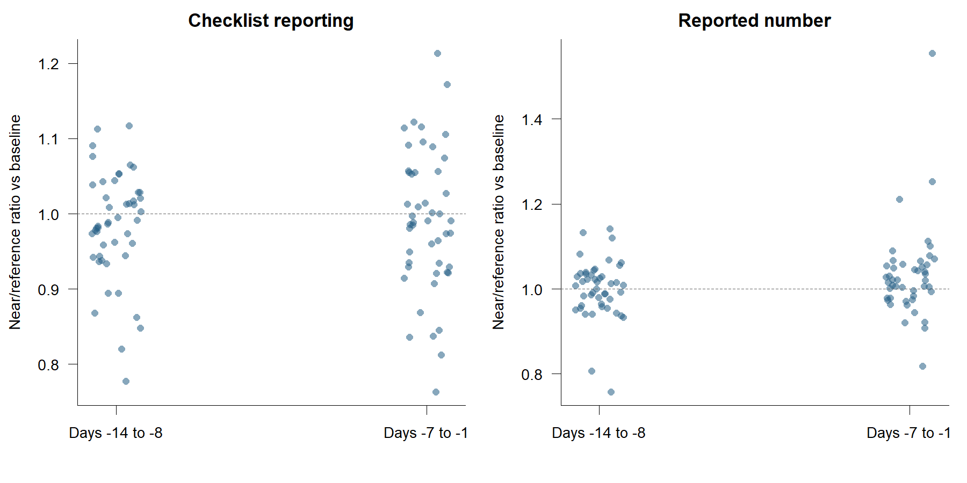
Figure S1. Each point is one species. The two pre-onset windows, days −14 to −8 and days −7 to −1, are plotted as ratios against the days −28 to −15 baseline, separately for each outcome. The reference line marks a ratio of one, meaning no drift in the near/reference gap before recorded onset. Medians across species and the number of species clearing adjustment are in Table S8.

Figure S2. Count response profiles
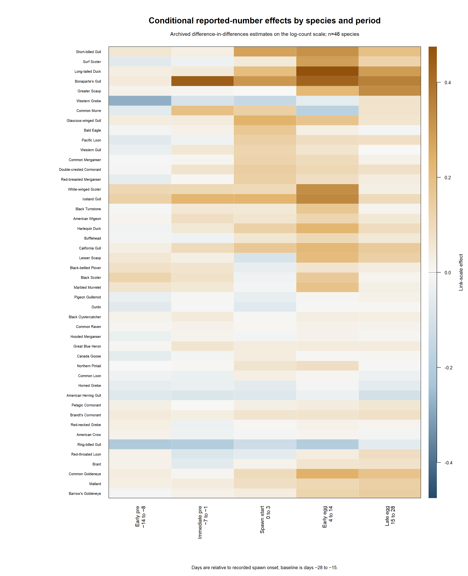
Figure S2. Reported-number effect for each of the 46 species with an estimable count model, across the five event periods, against the days −28 to −15 baseline. Row order is a display aid from Ward.D2 linkage; no clusters were cut, selected or tested. Section 3.4 gives the family-level summary.

Figure S3. Count response profiles
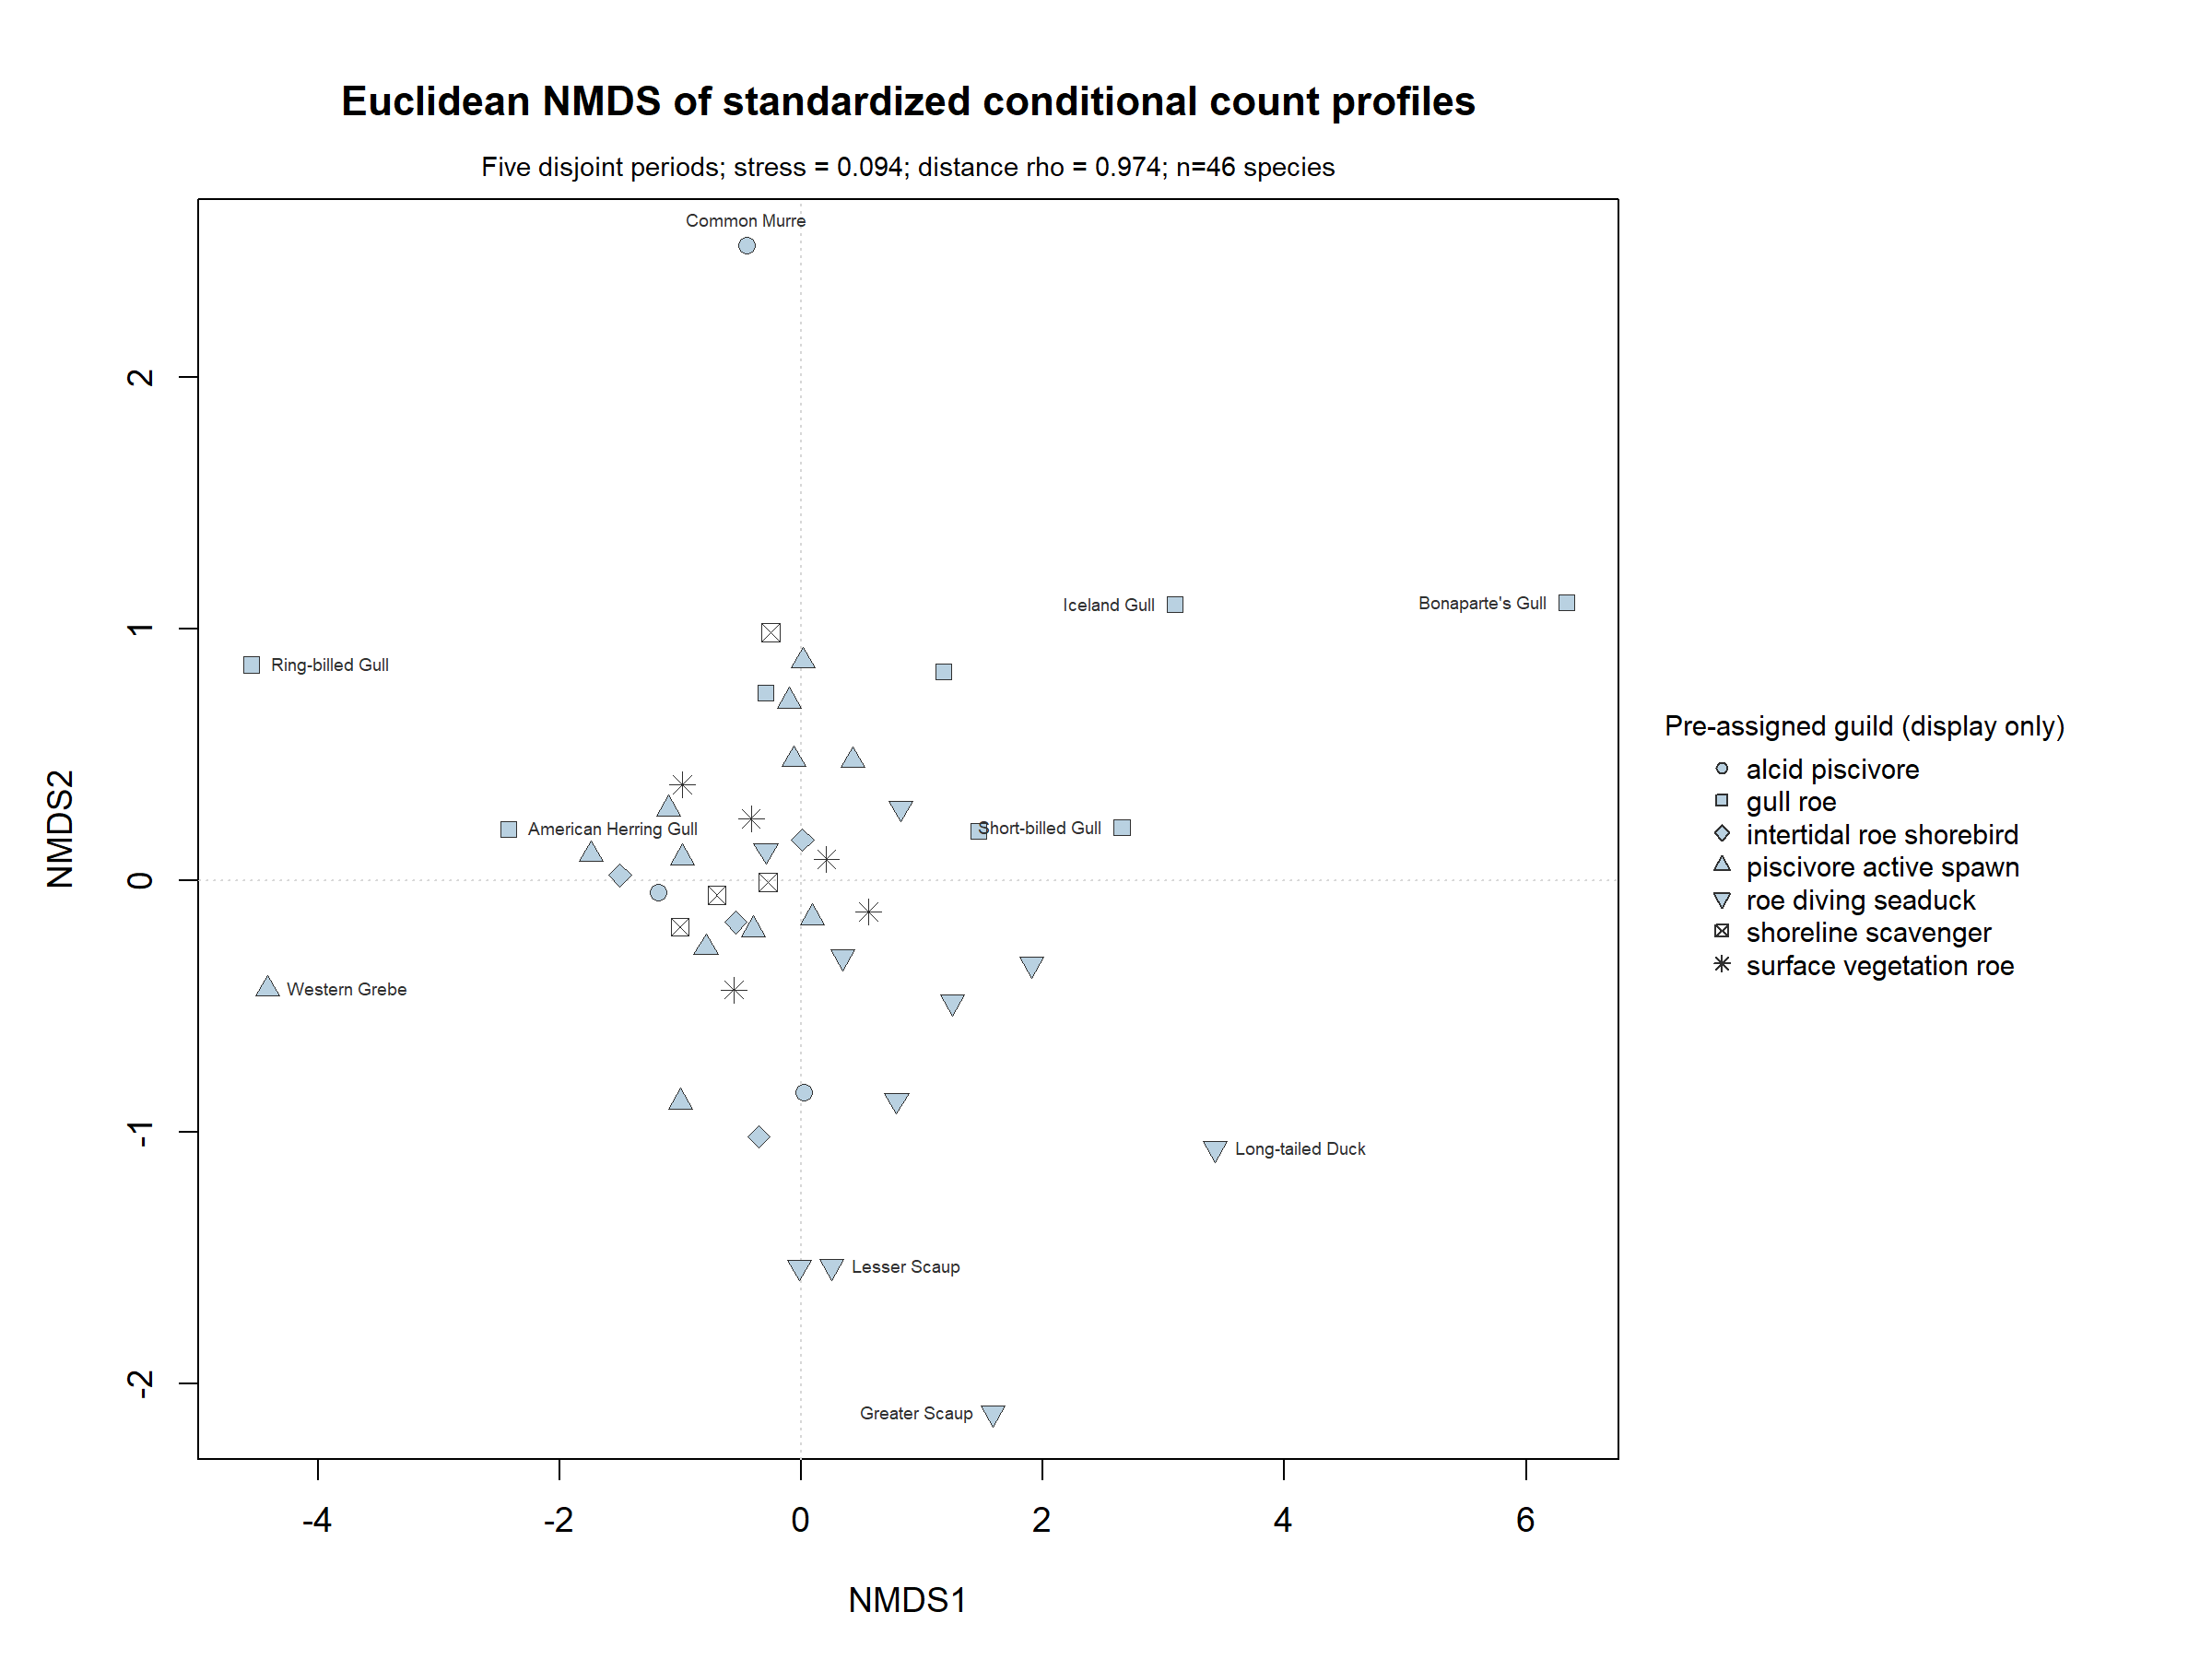
Figure S3. Non-metric multidimensional scaling of the five-period profiles after standardizing each period across species, with pre-assigned feeding groups joined only after the ordination was fixed and used as plotting symbols. Stress is 0.094 and the Spearman correlation between original and two-dimensional distances is 0.974. The feeding groups overlap: the species do not form discrete response types.

