Coastal bird responses to Pacific herring spawn revealed by two decades of citizen science records in the Strait of Georgia
  - Jacob T. Dingwall
University of Victoria, 800 Finnerty Road, Victoria, BC V8P 5C2, Canada
Corresponding author: Jacob T. Dingwall; dingwalljake@gmail.com
ORCID: 0009-0007-8389-6947

Abstract
Each spring, Pacific herring (Clupea pallasii) crowd into shallow water along the coast of British Columbia, Canada and attach their eggs to intertidal vegetation, concentrating a large marine food subsidy onto a narrow strip of shoreline for a few weeks. Adult fish, attached eggs and stranded carcasses become reachable in that order, so birds that feed by different means should arrive at different points in an event. To test this idea across a whole coastal community, 1,120 recorded spawning events were linked to 217,200 bird checklists collected in the Strait of Georgia between 2005 and 2025. For each of 49 species, shorelines within 5 km of a recorded spawn were compared against shorelines 5 to 20 km away, before and after spawning began, treating how often a species was listed and how many birds were counted as separate responses. Counts rose for 18 species and reporting rose for 13, and no species was counted in significantly smaller numbers. Long-tailed Duck (Clangula hyemalis) and Surf Scoter (Melanitta perspicillata) showed the largest increases, at 1.43-fold and 1.30-fold; eBird checklists near a spawn carried roughly eleven more Surf Scoters and three more Short-billed Gulls (Larus brachyrhynchus). Feeding groups also separated in time. Diving sea ducks reached their largest counts once eggs were available, gulls and shoreline scavengers responded as spawning began, and alcids, piscivores, shorebirds and dabbling ducks showed nothing. That ordering follows the sequence in which each kind of food becomes reachable, and indicates a shoreline pulse partitioned among consumers by feeding method. The sustained management and conservation of herring spawn remains a key priority for retaining coastal ecosystem function.
Keywords: Pacific herring; eBird; citizen science; resource pulse; coastal birds; checklist reporting

1 Introduction
Resource pulses are brief concentrations of food separated by much longer periods when that food is scarce. They can change where animals feed and which habitats they use within hours, while effects on survival or reproduction appear later, if at all. The form and strength of the response depend on how much food arrives, how long it remains, how predictably it returns and how quickly consumers can reach it (Yang et al. 2008; Holt 2008; Nowlin, Vanni, and Yang 2008). For a mobile consumer, a pulse need not occur in one place at one time. When similar events recur across a region and shift in date, an animal can extend the feeding opportunity by finding one event after another (Armstrong et al. 2016). Birds can search over large areas and change sites quickly, but species differ in the distances they travel and in how they locate an event.
Pacific herring (Clupea pallasii) spawning is one of the largest recurrent food pulses in in the Strait of Georgia, Canada. Adults crowd into shallow water in late winter and early spring and attach adhesive eggs onto marine vegetation in the intertidal and shallow subtidal (Haegele and Schweigert 1985; Dingwall et al. 2026). Spawning at any one shoreline can pass quickly, and on the day of spawn the fish are vulnerable and very close to shore. The eggs then remain on marine vegetation for approximately two weeks before hatching or washing away. The same general regions are used again from year to year, but the exact shoreline, extent and date shift among years (Hay and Kronlund 1987; Hay et al. 2009; Rooper et al. 2024). The pulse is therefore predictable at the scale of a coastal region and much less so at any particular beach. What is available also changes as an event proceeds. Adult fish create a short feeding opportunity when they enter the shallows. Attached eggs persist after the adults have left, and eggs on floating vegetation or exposed by a falling tide remain reachable by other routes.
Access to this food varies by bird taxa. . Surf Scoter (Melanitta perspicillata), White-winged Scoter (Melanitta deglandi) and Harlequin Duck (Histrionicus histrionicus) dive for attached eggs, whereas loons, mergansers, grebes and cormorants pursue fish and are therefore expected to concentrate on adults, although they may take eggs as well. Gulls are more flexible, taking eggs from floating vegetation and herring pushed to the surface or into very shallow water, as well as eggs and spent fish stranded along the shore. Bald Eagles (Haliaeetus leucocephalus) and corvids take eggs and adult fish exposed by a falling tide, and alcids pursue fish in open water and have little reason to gather at a shoreline deposit at all.
Birds can remove a large share of a season's egg deposition (Haegele 1993; Bishop and Green 2001). Harlequin Ducks gather at spawning sites in the Strait of Georgia (Rodway et al. 2003), while Surf and White-winged Scoters change their foraging and move beyond ordinary wintering areas when herring spawn (Lewis, Esler, and Boyd 2007; Lok et al. 2008). Surf Scoters can also follow successive spawning areas during spring migration (Lok et al. 2012). At a broader scale, wintering waterbird distributions track the timing and location of herring spawn (T. M. Sullivan, Butler, and Boyd 2002; Kelly, Rothenbach, and Weathers 2018). Many other vertebrates use the same pulse (Willson and Womble 2006).
This evidence is strong for particular birds and places, but it leaves the regional community poorly described and quantified. Focused field studies usually follow species already known to gather at a small number of spawning sites. They can show that a bird eats herring, changes its foraging or moves toward a spawn, but not which species carry an association across many events and years. They also cannot show whether the published specialists have the strongest regional signal, whether feeding groups respond at different points in an event, or which plausible consumers show nothing.
Two records overlap in the Strait of Georgia more than anywhere else on this coast, which is why the study is set there. Fisheries and Oceans Canada has surveyed and mapped herring spawn here for decades (Grinnell et al. 2023), and eBird contributors have recorded birds along the same coastline. eBird is a citizen science programme built around semi-structured checklists that retain information about where, when and how an observer watched (B. L. Sullivan et al. 2009; Kelling et al. 2019). Complete checklists and their effort information make repeated comparisons possible across places and years, provided that variation among observers and visits is carried into the analysis (Bird et al. 2014; Johnston et al. 2021).
This study links the two records for 49 coastal bird species. It asks whether the difference between checklists within 5 km of a recorded spawning event and those 5 to 20 km away widened after the event date, compared with the preceding two weeks. Whether a species appeared on a checklist and how many birds were counted when an observer supplied a number are examined separately, because a species can become more widespread among checklists without forming larger recorded groups, or form larger groups without appearing on more checklists.
Species with established or plausible herring links were expected to be reported more often, counted in larger numbers, or both once spawning began, and the feeding groups were expected to differ in when they responded. Gulls and shoreline scavengers should respond near the event date. Diving ducks that feed on attached roe should respond once eggs are available. Alcids feed away from the shoreline deposit and were expected to show little response at all. Testing all 49 species places the well-studied birds inside a broader coastal community and identifies which species, and which time windows, would repay focused fieldwork. Herring on this coast are managed from spawn surveys that were never designed to describe the predators a deposit supports. A regional account of which species track spawning, and when, would give fisheries management and coastal bird conservation a shared description of what a spawning event is worth.

2 Methods

2.1 Study Area
Fieldwork and observation both concentrate in the Strait of Georgia, British Columbia, Canada, a semi-enclosed coastal sea between Vancouver Island and the mainland. The region was chosen because it has the largest overlap between the long-running DFO spawn record and eBird checklist coverage.
[[AUTHOR INPUT REQUIRED: insert a study-area map showing the Strait of Georgia, recorded spawning areas, and verified seasonal timing of major coastal bird movements, including shorebirds.]]

2.2 Data Sources

2.2.1 eBird Data
eBird is a global citizen-science platform. Volunteers submit checklists recording the birds they encountered, the number of individuals when they choose to count, and the location, date and effort of the visit (B. L. Sullivan et al. 2009). Standard protocols and recorded duration, distance and party size make these submissions a semi-structured survey (Kelling et al. 2019).Records came from the eBird Basic Dataset released in May 2026 and covered 2005 to 2025 (eBird 2026). Eligible checklists used stationary or travelling protocols, lasted 5 to 300 minutes, covered no more than 5 km, and had one to ten observers. Only complete checklists were retained, because marking a checklist complete means the observer reported every species they detected and identified, so a species that does not appear on one can be treated as a genuine non-detection rather than as missing information.

2.2.2 Herring Data
Herring records came from the Pacific Herring Spawn Index, compiled by Fisheries and Oceans Canada (Fisheries and Oceans Canada 2026; Grinnell et al. 2023). Surveyors work the coast through the spawning season and record where spawn has been deposited, using surface surveys that measure the length of shoreline spawned and the extent of eggs on vegetation, and dive surveys that additionally record egg layering and depth. Each record therefore carries a location together with the dates over which spawn was observed at that place. The resulting index is relative rather than absolute, because it describes what surveyors found, and coastline that was not surveyed yields no record rather than a zero. Only the presence, location and timing of a recorded event entered the models – estimated spawner biomass was not included.

2.2.3 Linking Bird and Herring Records
Linking the two data sources produced 217,200 complete eBird checklists and 1,120 recorded spawning events, which fell into 58 event blocks, 29,248 observer clusters and 22,980 generalized location clusters. An event block groups recorded spawning events that are connected because they link to the same checklists at the same time, which keeps those events and the checklists that reach them under a single random effect. Two events in the same block need not belong to one spawning population. A checklist linked to several events remained one row in the model and carried the random effect for its block.
Day 0 was the midpoint between the first and last dates on which spawn was recorded at a location, rounded down to a whole day, or that single date where only one was available. It is an event-date anchor and not an observed biological onset, and it is dated more precisely for some events than for others: among the 1,144 events in the wider linked frame, 466 had spawn recorded on a single day and the median span between first and last date was one day. Six periods were defined around that anchor, and Table 1 gives their limits, their durations and the food expected to be available in each.
Period | Days from anchor | Days | Expected food
Baseline | −28 to −15 | 14 | No spawn recorded
Early pre-spawn | −14 to −8 | 7 | No spawn recorded
Immediate pre-spawn | −7 to −1 | 7 | Adults aggregating nearshore.
Spawn | 0 to 3 | 4 | Adults in the shallows; eggs being laid
Early egg | 4 to 14 | 11 | Eggs on vegetation and along the shore
Late egg | 15 to 28 | 14 | Eggs largely hatched or washed away
Table 1. Periods defined relative to the recorded event date. The pre-spawn summary weights the two pre-spawn periods equally. The active summary weights the spawn and early egg periods by their durations, 4/15 and 11/15.
A checklist was defined as “near” when it lay within 5 km of a recorded event and in the reference zone at 5 to 20 km. These bounds were set by judgement before fitting. The reference zone is not assumed to be spawn-free. The distance between a checklist and spawn, however, can be fuzzy. Checklists are often assigned a location at a “hotspot” but can in reality traverse several km over the checklist duration. Herring spawning locations are also not precise, as their locations are assigned to nearest pre-defined locations typically on the size range of a bay or point. Moreover herring spawns can range in length, further confounding distance linking. Distances ran from the checklist point location to the event point, including for travelling checklists. About 12% of near-zone checklists travelled more than 2.5 km and about 3% more than 4 km. A route that crossed a zone boundary was still represented by one point, which blurs the zones. Because that blur does not depend on event timing, it is expected to weaken a localized response more often than create one
A checklist could link to several events at different distances and dates. All eligible links were counted in the period and zone where they fell, giving twelve exposure variables from six periods and two zones. Each checklist stayed one row however many links it carried. Baseline and active exposure were not mutually exclusive: 5,163 checklists, 5.5% of those with any exposure, contributed to both through different events. Variance inflation among the twelve exposure variables ranged from 1.22 to 1.26.
The models did not require every event or block to contain checklists in both zones. Of 1,120 events, 850 contributed links in both zones, as did 51 of 58 blocks. In total, 99.8% of exposed checklists were in a block represented in both zones, so most of the comparison was made within blocks.

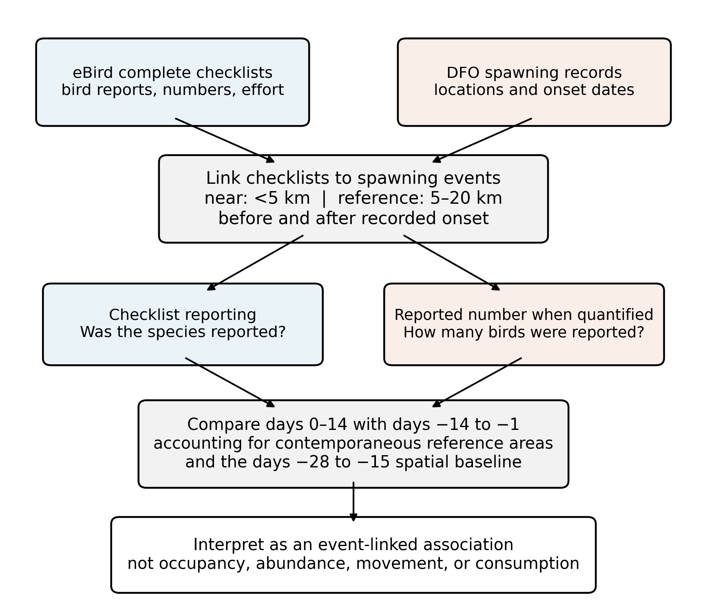
Figure 1. The design in ecological terms. Complete eBird checklists were linked to recorded spawning events by distance and by date relative to the event-date anchor. Whether a species was reported and how many were counted were modelled separately. The main comparison asks whether the near-to-reference relationship during days 0 to 14 became stronger than during days −14 to −1. The days −28 to −15 baseline enters through the model and not through that comparison, in which its two terms cancel.

2.3 Response Variables
Two outcomes represent different parts of the checklist record. Checklist reporting was equal to one when a species was reported on an eligible complete checklist and was equal to zero when it was omitted (although an omission is informative about reporting it does not prove that the species was absent). Every positive report kept its count state, so a finite number contributed to both outcomes while an unquantified “X” contributed only to whether the species was reported. Observers enter “X” when they know a bird is present but cannot or do not want to count it, most often when the number of individuals is large.
Reported number, the second outcome, entered the models as a natural logarithm. Exponentiated estimates therefore compare geometric mean counts among those records. The two outcomes answer different questions. The first asks whether a species appeared on a checklist at all, whereas the second asks whether the number an observer supplied was larger, and a species can change on one without changing on the other. Because the count outcome is measured only among birds that were both reported and counted, however, it is conditioned on something the reporting models themselves show to be responsive, which is a selection problem and not only a difference of question.

2.4 Model Structure and the Difference-in-Differences Contrast
For checklist (i), the model for each species was
gEYi=α+p,z​βp,zLi,p,z+γ⊤Ci+ubi+uoi+uli,
where $Y_{i}$ is checklist reporting or log reported count; $g$ is the logit link for checklist reporting and the identity link for log count; $L_{i,p,z}$ is the number of recorded source-event links for checklist $i$ in period $p$ and zone $z$; $β_{p,z}$ is the slope for one additional link in that cell; $C_{i}$ contains the adjustment variables; and the three $u$ terms are random intercepts for event block, observer cluster, and generalized location cluster.
For a period (p), the reported baseline-adjusted near/reference contrast was
$$θ_{p}=\left(β_{p,near}-β_{p,reference}\right)-\left(β_{baseline,near}-β_{baseline,reference}\right).$$
This compares the near-to-reference relationship in a given period against the same relationship at baseline. In plain terms, it asks whether a checklist's association with one more nearby spawning event grew stronger after onset than before it, allowing for the same change in the reference zone. It is not a percentage change in the number of birds present.
Because the comparison is a difference of differences in event time, it rests on an assumption that cannot be verified directly. However,it can be probed: without spawning, the near-to-reference gap would have carried on evolving the same way in both zones. This is the parallel-trends assumption familiar from quasi-experimental designs in ecology and policy evaluation (Larsen, Meng, and Kendall 2019; Wing, Simon, and Bello-Gomez 2018). The baseline period is there so that a standing difference between near and far shorelines cannot masquerade as a response to spawning.
Whether a species was reported was fitted with a binomial mixed model, and log count with a Gaussian mixed model, both using the nAGQ = 0 approximation for the binomial fits (Bates et al. 2015). Confidence intervals are Wald intervals on the model scale, built from the exact variance of each comparison against the full fixed-effect covariance matrix and then exponentiated. Both the estimates and their intervals inherit that approximation.
Models adjusted for year as a factor, protocol, log duration, log of one plus distance travelled, and number of observers. Random intercepts were includedfor event block, observer and location. DThe three effort terms warrant their own caution. Duration, distance and observer count are measured on the same checklist as the outcome. A conspicuous flock may itself lengthen a visit, extend a route or draw a second observer, in which case adjusting for them removes part of the response. Their distributions barely move across the event date, however: median near-zone duration rises by one minute and median near-zone distance by 0.04 km between the two windows, with slightly larger shifts in the reference zone. That is reassuring without being decisive, since a covariate can respond to exposure without its marginal distribution shifting.

2.5 Multiple Testing and Sensitivity Analyses
For each period and outcome, Benjamini and Hochberg (1995) correction was applied across all 49 species, so every adjusted p-value below belongs to that set. The main test compares the duration-weighted days 0 to 14 estimate directly against the mean estimate for days −14 to −1, using the full fixed-effect covariance matrix, so it is not a naive difference of two independent ratios. The two baseline terms enter with equal and opposite weight. They thus cancel exactly and the baseline period acts through the model and not through the comparison. Models for whether a record carried a number instead of an “X” formed a separate exploratory set.T
Gadwall (Mareca strepera) and Northern Shoveler (Spatula clypeata) were carried as comparators in a separate two-species exploratory analysis, so their correction threshold differs from that of the 49 and clearing it is not by itself evidence of specificity. Their adjusted p-values also refer to the comparison against baseline and not to the main before-and-after comparison used for the 49. Released counts below 20 are suppressed, and no figure quoted in this article falls under that threshold.
Exponentiated estimates are ratios of near-to-reference slopes per additional recorded event link. A value above one means the near-to-reference relationship grew stronger after onset than before. These are per-link quantities and not percentage changes in how many birds were present.
Predictions on the natural scale were standardized over the observed checklist covariates with random intercepts set to zero, so they describe a typical site, observer and event. The per-link form carries an assumption worth naming, since every ratio here is expressed per additional link: each further link is taken to add the same amount on the model scale. That is what makes a ratio comparable between species whose checklists carry different numbers of links, and if the response saturates instead, the fitted slope averages over an unmodelled curve. Multiple links are common. Between 29% and 44% of exposed checklists carry two or more, and the largest carries 23. A binary any-link version was fitted as a sensitivity and is reported in Section 3.7, but no spline, quadratic or capped alternative, so the shape of that response is described and not estimated. One conventional alternative encoding was also chosen before fitting, on support and geometry alone. Restricting the data to checklists linked to a single event left 72,443 checklists and supported count models for only 19 of the 49 species, so deterministic nearest-event assignment was used instead, which retained all 217,200 checklists and supported count models for 41. All other terms and procedures were unchanged.
To test whether the 5 km near-zone boundary concealed a shorter-range pattern, Bald Eagle and Glaucous-winged Gull (Larus glaucescens) were examined in thirteen 2 km bands from 0 to 26 km, with American Robin (Turdus migratorius) as a terrestrial control. Each band was compared with its own days −28 to −15 baseline. Separate comparisons tested days 0 to 3 against days −7 to −1, and a 13-coefficient test compared the full days 0 to 3 profile with the two equally weighted pre-spawn windows. Benjamini-Hochberg correction was applied within each species, outcome and period across the 13 bands.

3 Results

3.1 Coverage and Model Convergence
In total, 217,200 complete eBird checklists collected between 2005 and 2025 entered the analysis, linked to 1,120 recorded spawning events that formed 58 blocks. The degree of evidence behind each species varies enormously, since American Crow (Corvus brachyrhynchos) appeared on 53.5% of checklists and carried 112,180 counted records, whereas in contrast, Glaucous Gull (L. hyperboreus) appeared on 0.09% and carried 185.
Of 100 models across 49 species, two outcomes and two comparators, 96 fitted. Whether a species was reported (presence/absence) could be estimated for 48 of the 49, and how many were counted for 46. The four failures were both models for Glaucous Gull, a scarce visitor with 185 counted records, and the count models for Surfbird (Calidris virgata) and Rhinoceros Auklet (Cerorhinca monocerata), with 1,063 and 1,816. One further count model, Western Gull (L. occidentalis), converged but is statistically insignificant (p>0.05). All four failures fall among the least frequently counted birds in the family.Per-species estimates, intervals, adjusted p-values, sample sizes and fit status for all 49 species and both outcomes are available in the supplementary material.

3.2 Responses During the Active Spawning Period
Birds were counted in larger numbers far more consistently than they were reported more often (Figure 2). Reporting rose for 28 of 48 species and fell for 20, with 13 of those increases surviving correction for multiple testing. Counts rose for 42 of 46 and fell for four, with 18 increases surviving. No decrease survived in either outcome. The gap between the two outcomes is wider than those tallies suggest. Among the 46 species with both models, 27 rose in both and 15 rose only in counts. Four rose in neither. None rose only in reporting, so every species that disagreed with itself disagreed in the same direction. An exact paired test on those 15 gives p = 0.00006, although species share checklists, events and observers, so the figure describes how lopsided the pattern is more than it tests it.
Gulls dominated the reporting results, with Bonaparte's Gull (Chroicocephalus philadelphia) reported 1.48 times as often per nearby spawn (95% CI 1.22–1.79), American Herring Gull (L. smithsonianus) 1.39 (1.23–1.57), California Gull (L. californicus) 1.32 (1.21–1.43), Iceland Gull (L. glaucoides) 1.29 (1.18–1.41) and Short-billed Gull (L. brachyrhynchus) 1.25 (1.17–1.34). These are not 48% or 39% increases in the number of gulls on the coast, since each describes how much more strongly a checklist's reporting of that species tracked a nearby spawning event after the event date than before it. Outside the gulls the largest reporting increases came from Lesser Scaup (Aythya affinis) at 1.26 (1.11–1.44) and Northern Pintail (Anas acuta) at 1.21 (1.10–1.32), neither of which is a bird the herring literature would nominate first.
The largest count increases were Long-tailed Duck (Clangula hyemalis) at 1.43 (1.29–1.60), Surf Scoter at 1.30 (1.21–1.40), Short-billed Gull at 1.30 (1.23–1.37), Harlequin Duck at 1.20 (1.15–1.26) and Common Goldeneye (Bucephala clangula) at 1.20 (1.15–1.25), although increases were far more widespread than that significant subset conveys. Of 46 species, only Common Murre (Uria aalge), Black-bellied Plover (Pluvialis squatarola), Black Oystercatcher (Haematopus bachmani) and Great Blue Heron (Ardea herodias) were counted in smaller numbers at all, and none of those four significantly. Precision tracks how often a species is counted rather than how large its estimate is. Bald Eagle's count increase of 1.063 (1.045–1.080) is modest in size and among the most precise in the family, resting on 83,359 counted records, whereas Bonaparte's Gull's count increase of 1.16 spans 0.87 to 1.56 on 4,025.
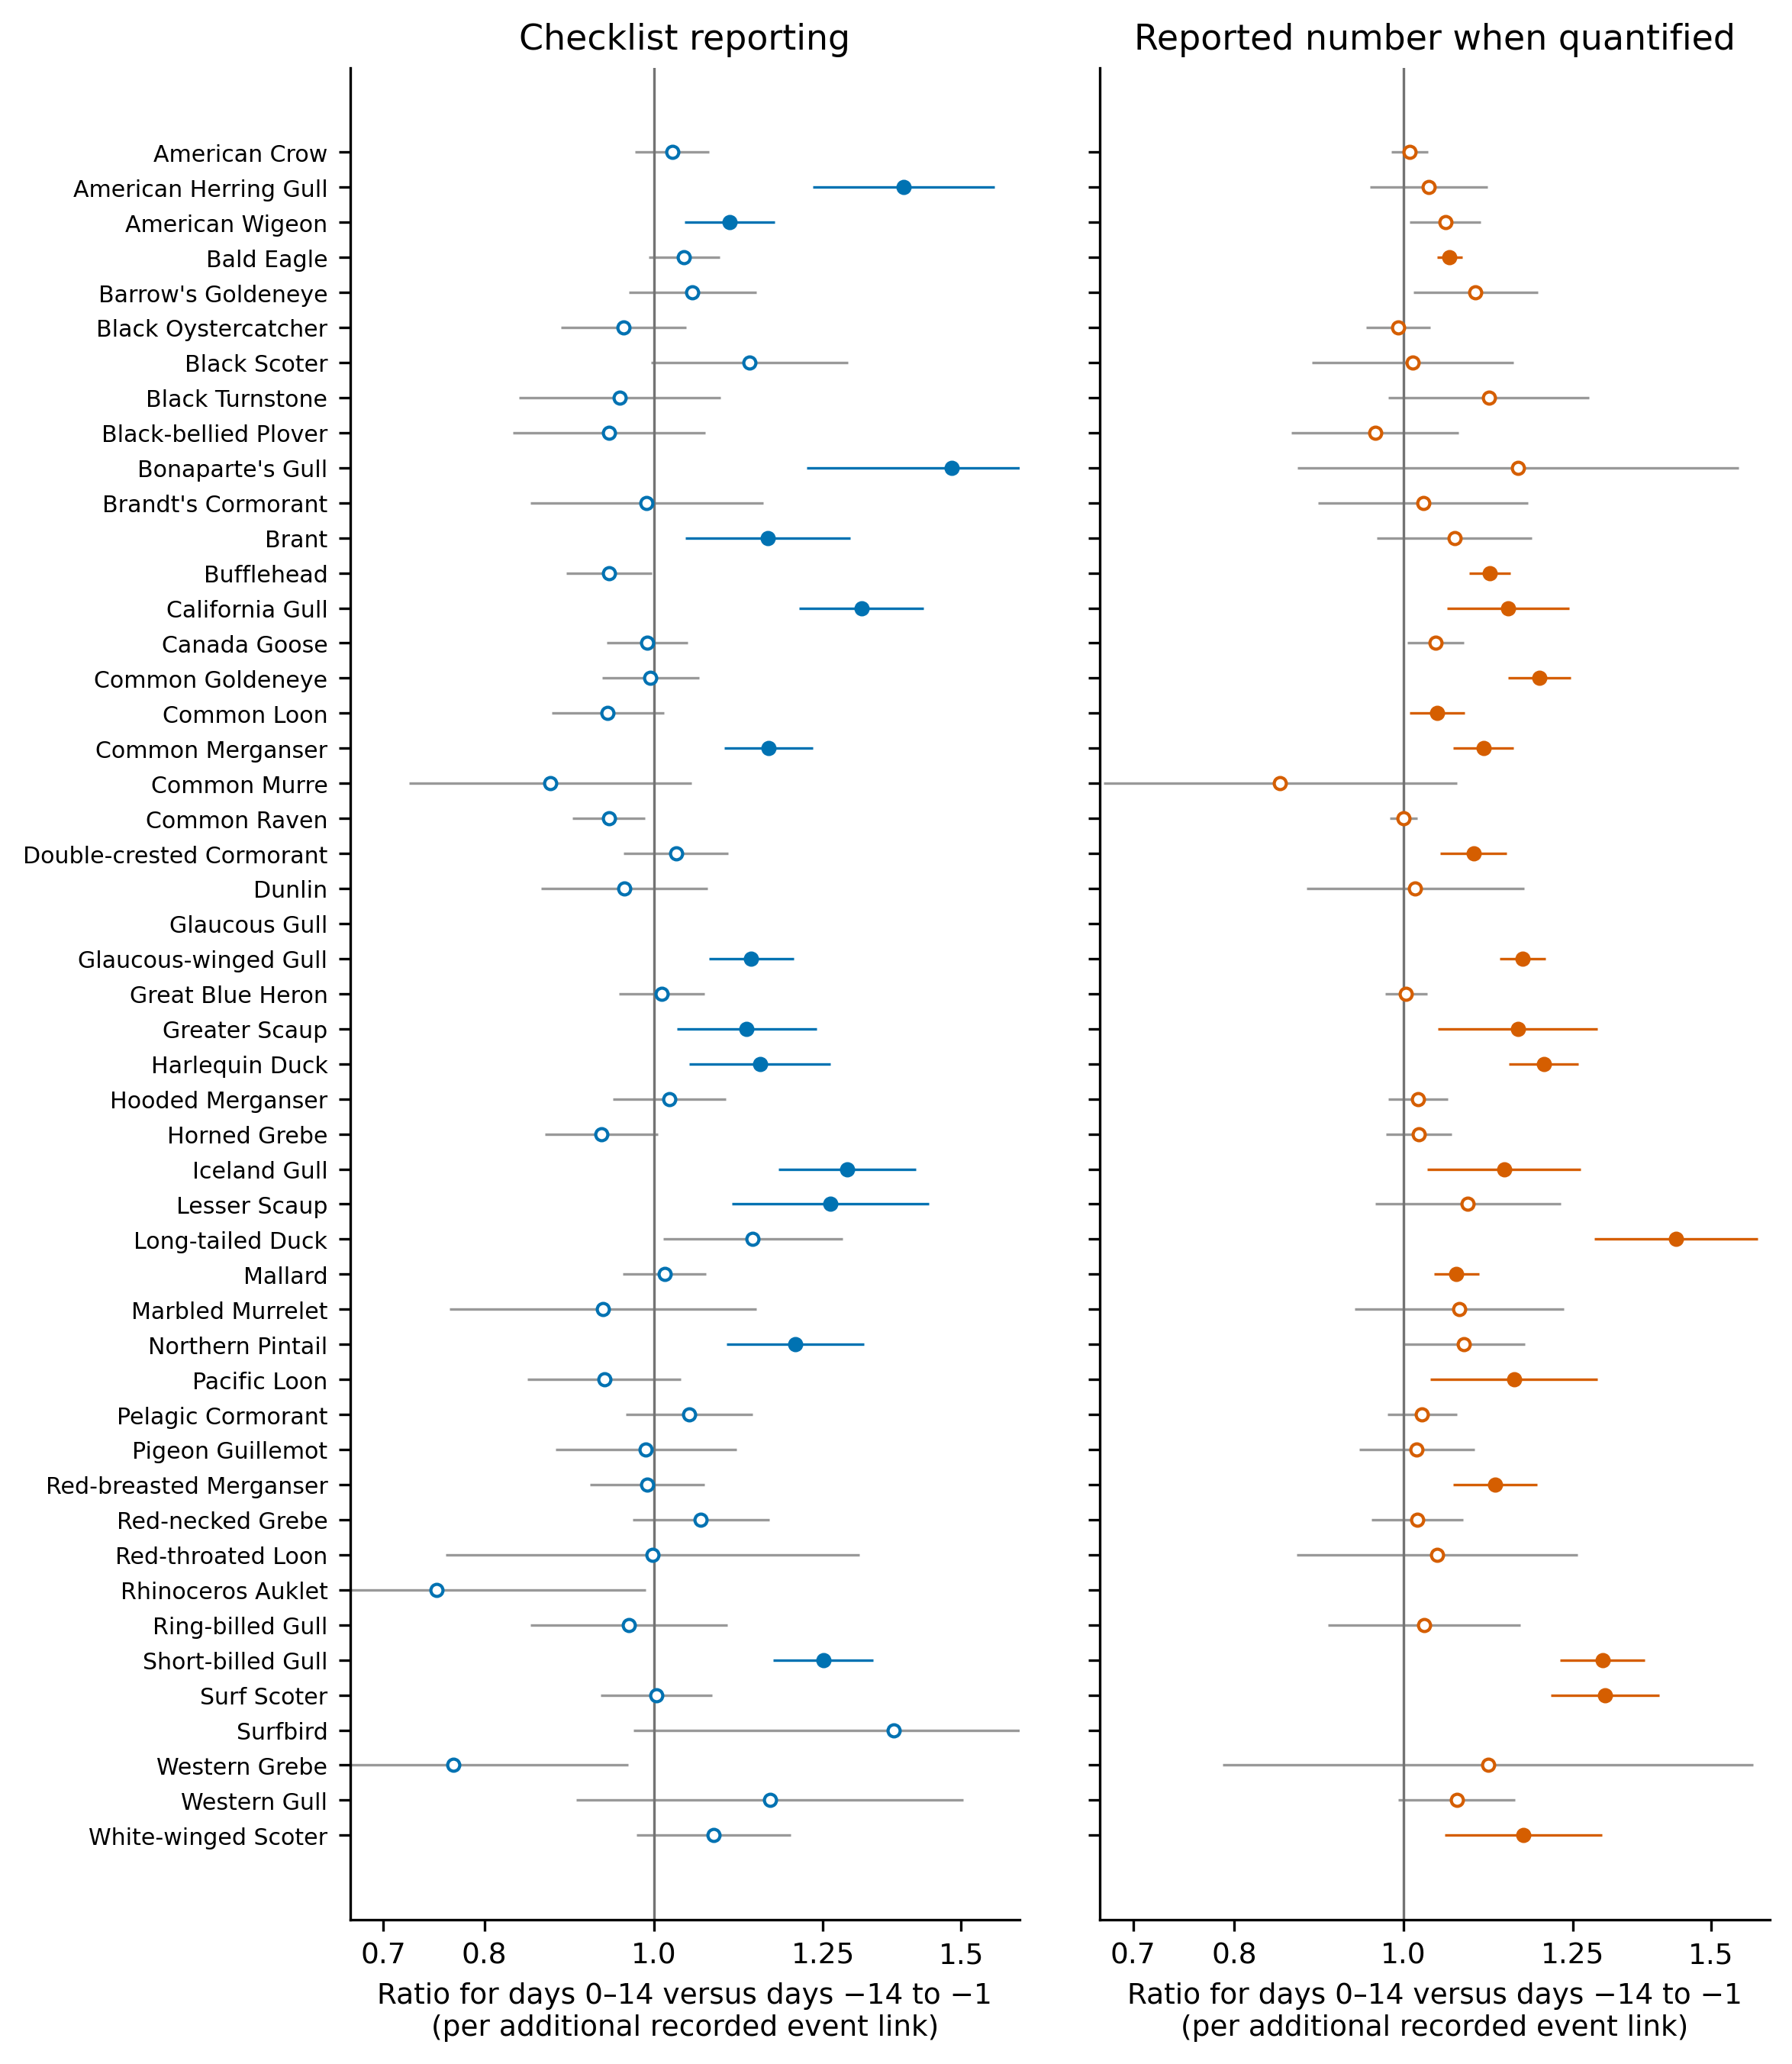
Figure 2. Before-and-after change for all 49 species. Points and 95% intervals compare the duration-weighted active period (days 0 to 14) with the preceding 14 days. The days −28 to −15 baseline enters through the model and not through this comparison, in which its two terms cancel exactly. Filled points survive correction for multiple testing within the 49 species for that outcome; open points do not. Blue marks whether a species was reported, orange how many were counted. Species whose model would not estimate have no point. Ratios refer to one additional recorded spawning event nearby. Figure 3 uses a different reference point, plotting each period against the days −28 to −15 baseline.

3.3 Responses by Feeding Group
The 49 species were sorted into seven feeding groups in the species registry before any model was fitted, and those groups diverged sharply, with two producing nothing at all. Roe-feeding diving sea ducks, the group with the strongest prior expectation, gave the clearest count result, since seven of ten were counted in significantly larger numbers: Long-tailed Duck 1.43 (1.29–1.60), Surf Scoter 1.30 (1.21–1.40), Harlequin Duck 1.20 (1.15–1.26), Common Goldeneye 1.20 (1.15–1.25), White-winged Scoter 1.17 (1.06–1.30), Greater Scaup (A. marila) 1.16 (1.05–1.29) and Bufflehead (B. albeola) 1.12 (1.09–1.15), while Barrow's Goldeneye (B. islandica) at 1.10 (1.01–1.19) fell just outside and only Black Scoter (Melanitta americana) was flat. Reporting behaved quite differently in the same birds, because only Lesser Scaup 1.26 (1.11–1.44), Harlequin Duck 1.15 (1.05–1.26) and Greater Scaup 1.13 (1.03–1.24) cleared correction, and Surf Scoter reporting sat at 1.00. Birds that already winter on these shorelines and then concentrate where roe is reachable would produce exactly this shape.
Gulls were the mirror image, and the only group in which reporting was the stronger outcome. Six of eight were reported significantly more often, from Bonaparte's Gull at 1.48 down to Glaucous-winged Gull at 1.14 (1.08–1.20), with only Ring-billed and Western Gull outside, and four were also counted in larger numbers, led by Short-billed Gull at 1.30 and Glaucous-winged Gull at 1.17 (1.13–1.21). Bonaparte's Gull, which had the largest reporting increase in the study, nonetheless had a count estimate of 1.16 spanning 0.87 to 1.56, so its numbers did not detectably change. Gulls are also the group where an observation effect is hardest to rule out, because a feeding flock is visible from a long way off and easy to record without counting.
Fish-chasing piscivores showed a narrower version of the sea duck pattern, with five of twelve counted in larger numbers: Pacific Loon (Gavia pacifica) 1.16 (1.04–1.29), Red-breasted Merganser (Mergus serrator) 1.13 (1.07–1.19), Common Merganser (M. merganser) 1.11 (1.07–1.16), Double-crested Cormorant (Nannopterum auritum) 1.10 (1.05–1.15) and Common Loon (G. immer) 1.05 (1.01–1.08). Only Common Merganser at 1.16 (1.10–1.23) was also reported more often, and seven of the twelve, including all three grebes, showed nothing at all. Shoreline scavengers were narrower still, because Bald Eagle's count increase of 1.06 (1.05–1.08) was the group's only significant result, while American Crow, Common Raven (C. corax) and Great Blue Heron stayed flat in both outcomes despite being three of the four most frequently reported birds in the family. Since their estimates are precise, those flat results carry information.
Two groups produced nothing, and one of them had a reason to respond. No alcid cleared correction in either outcome. Pigeon Guillemot (Cepphus columba), Marbled Murrelet (Brachyramphus marmoratus), Common Murre and Rhinoceros Auklet had reporting estimates of 0.99, 0.94, 0.87 and 0.75, three of the four below one, with intervals too wide to separate from no change. Birds that chase fish in open water should not gather at a shoreline deposit, so that is the expected answer. Shorebirds are the harder case. They are documented consumers of herring eggs on exposed substrate (Bishop and Green 2001), yet Black Oystercatcher, Dunlin (C. alpina), Black Turnstone (Arenaria melanocephala) and Black-bellied Plover were all reported slightly less often, between 0.94 and 0.96 and none significantly. None was counted in larger numbers either. Surfbird had the group's largest reporting estimate at 1.37 but an interval from 0.97 to 1.94 and no count model. Egg availability to a wader depends on the tide, and these models carry no tidal or diel term. A response confined to the hours around low water would wash out across every other checklist. Shorebird use of spawn here may also be too local to register across a whole strait. The models fitted and simply found nothing.
Dabbling ducks and geese responded mainly through reporting, with Northern Pintail 1.21 (1.10–1.32), Brant (B. bernicla) 1.16 (1.04–1.30) and American Wigeon (Mareca americana) 1.11 (1.04–1.17) clearing correction, as did Mallard (A. platyrhynchos)'s count increase of 1.07 (1.04–1.10), while Canada Goose (Branta canadensis) stayed flat. This is the group in which a herring-specific reading of the family is hardest to defend.

3.4 Timing of Response
Averaging over the active period hides patterns that differ through time (Figure 3), and the difference between groups can be tested. For each species, the estimate at the event date minus the estimate during early egg gives a timing score, with its variance taken from the fitted covariance matrix. Regressing that score on the feeding groups, weighted by precision, tests whether the groups differ. Those groups were fixed before any model was run. Both outcomes say they do, counts far more decisively than reporting (Q = 117.3 and Q = 15.0, each on 6 degrees of freedom, p < 0.001 and p = 0.02). The two outcomes separate different groups. In counts the result comes from roe-feeding divers, which peak once eggs are available, and from shoreline scavengers, which peak at the event date. In reporting the two groups whose intervals exclude zero are gulls and shoreline scavengers, both peaking early. The divers that dominate the count result are flat. Feeding group therefore explains part of the variation and not most of it, leaving 76% of the residual heterogeneity unexplained for counts and 39% for reporting.
Adult fish and spent carcasses come first, attached eggs later, and the groups separate in that order. Shoreline scavengers are the only group peaking at onset in both outcomes, which is when adult fish are present and when spent adults first wash up. Gulls peak at onset in reporting but show no timing difference in counts, the pattern expected if they arrive abruptly and their flock sizes are recorded too inconsistently to carry a timing signal. Roe-feeding divers are the only group counted in larger numbers later, once the eggs are attached and the adult fish have gone. Piscivores, alcids, shorebirds and dabbling ducks were flat in both outcomes. Three groups of seven carry the separation, and its shape follows how a bird feeds and not how large its response was.
Individual species show the same division. Common Merganser rose in both outcomes with both peaks close to the event date, Glaucous-winged and Short-billed Gull rose in both with the reporting change concentrated early, and Bald Eagle rose briefly near the event date in both. Surf Scoter reporting stayed at one throughout while its counts peaked during early egg availability, and White-winged Scoter and Harlequin Duck traced the same shape with smaller amplitude. Figure 3 shows these eight, chosen to span the feeding groups.
American Wigeon appears in Figure 3 as a counterpoint, since its estimates were modestly positive after the event date even though no direct herring link is established for it, and its profile lacks the late peak that the roe-feeding divers show.
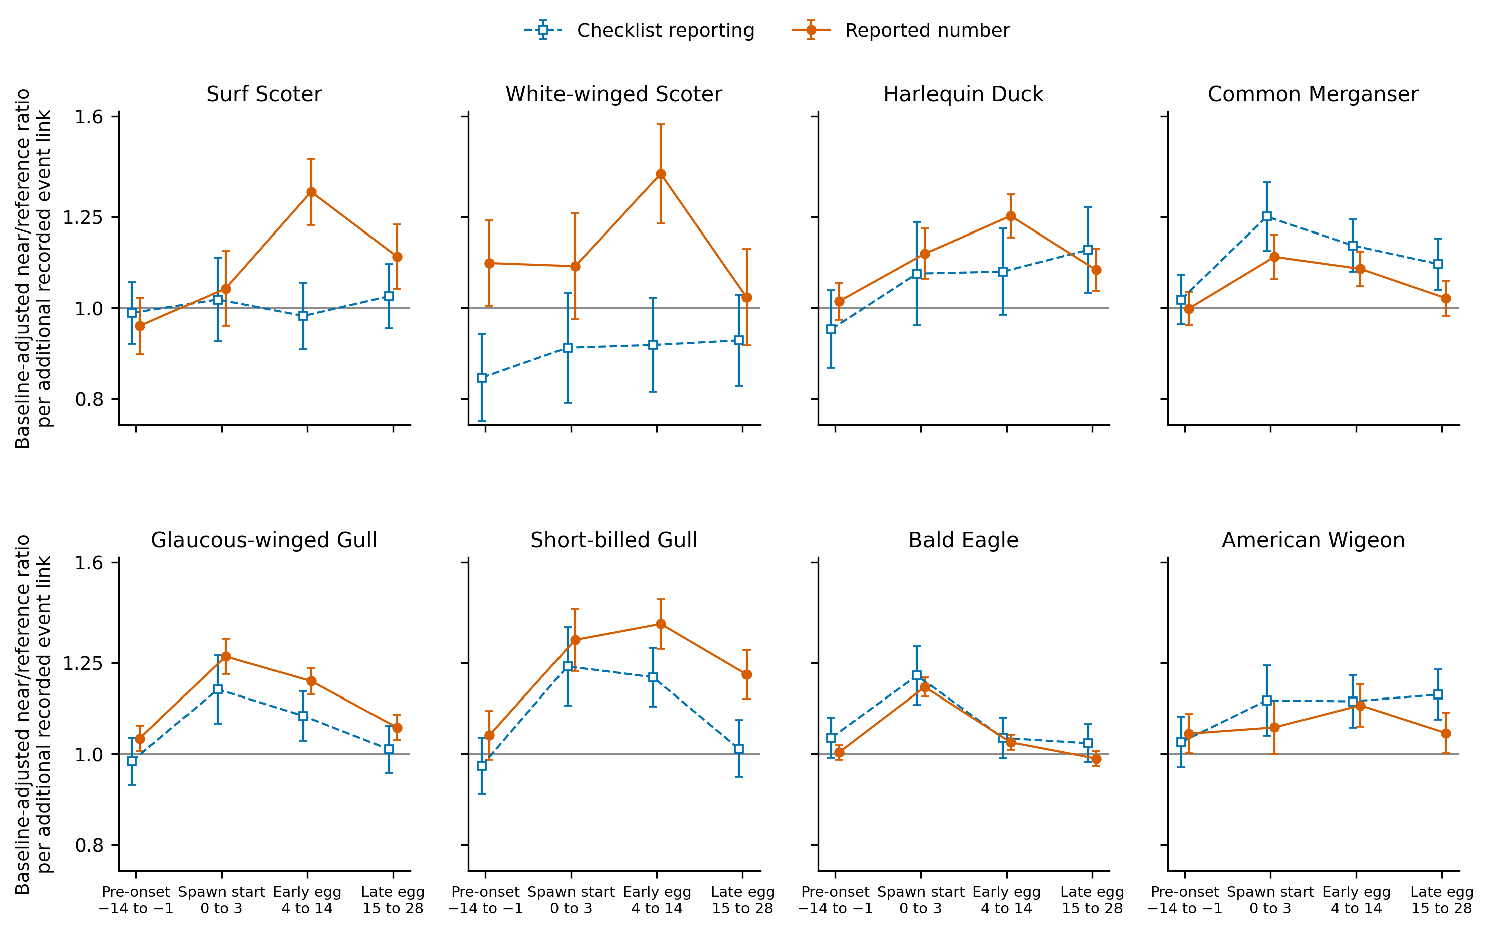
Figure 3. Change through time for eight species chosen to span the feeding groups. Blue dashed lines with open squares show whether a species was reported; orange solid lines with filled circles show how many were counted. Points are exponentiated estimates against the days −28 to −15 baseline, per additional recorded event link, with 95% intervals. The horizontal line at one means no change relative to baseline. Periods are days −14 to −1 before onset, days 0 to 3 at spawn start, days 4 to 14 during early egg availability and days 15 to 28 during late egg availability. These describe timing; the formal before-and-after test is the quantity shown in Figure 2.
Widening from eight species to the whole family gives the same shape. Averaging across the 46 species with an estimable count model, each species carrying equal weight, reported numbers sat at the baseline through early pre-spawn, at a geometric mean ratio of 1.00 against days −28 to −15, rose to 1.03 in the week before onset and 1.06 at spawn start, peaked at 1.11 during early egg availability, then fell back to 1.07 during late egg availability (Figure 4). The share of species above one moved the same way, from 24 of 46 in early pre-spawn to 39 of 46 during early egg availability. The rise belongs to the family and not to a handful of large responders.
Species do not, however, fall into discrete response types. Residual heterogeneity after fitting the feeding groups remains large in both outcomes, so the group differences reported above describe average timing and not a partition of the family.
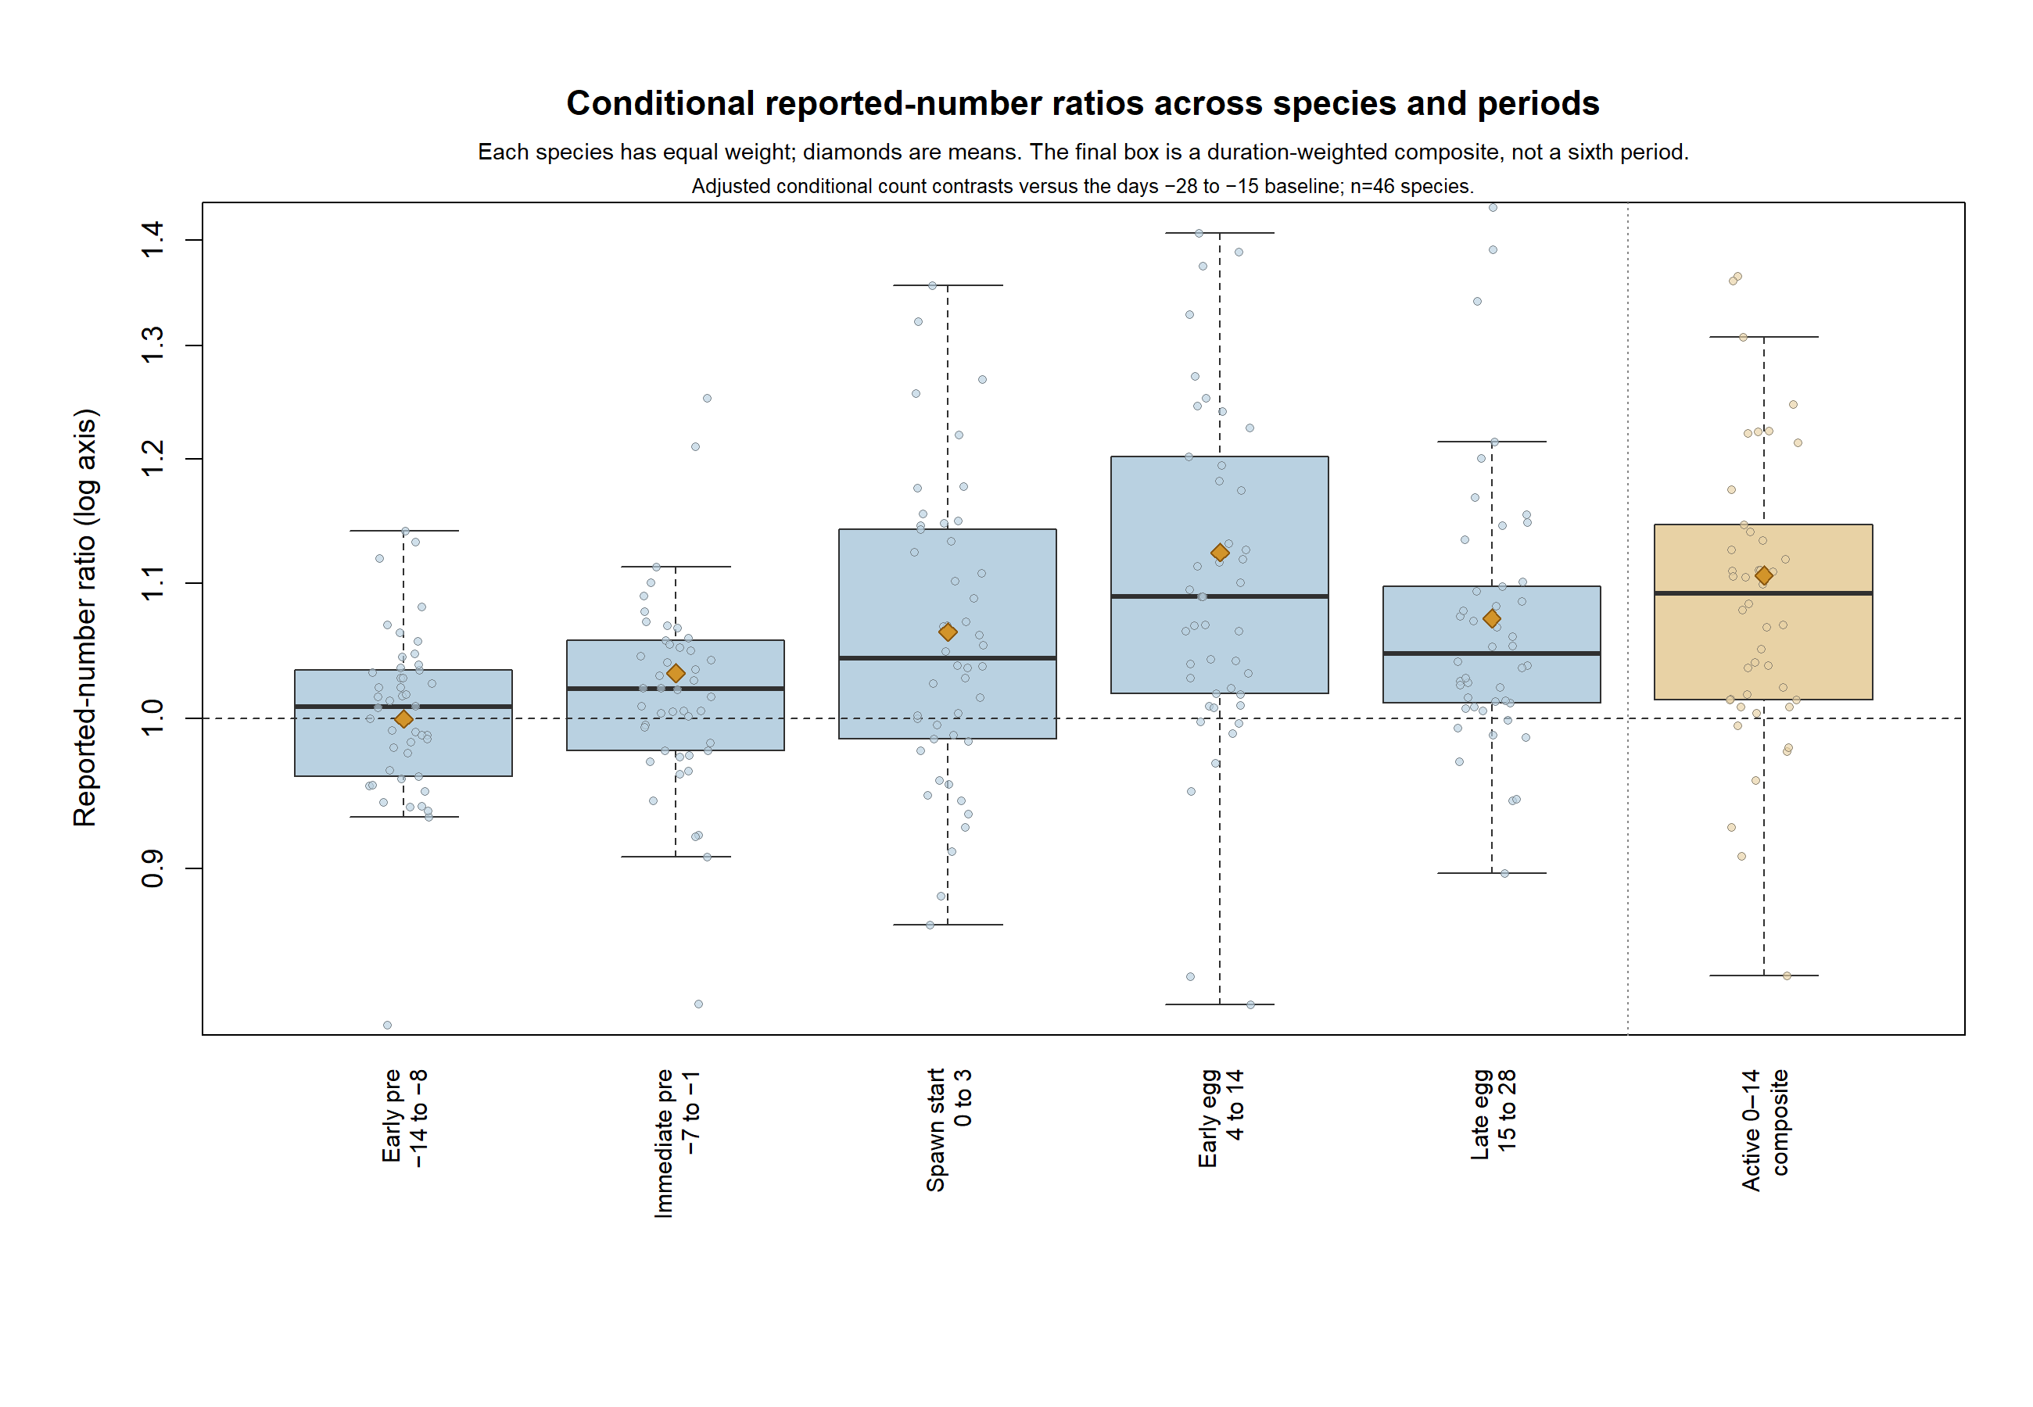
Figure 4. Reported-number ratios across the five event periods, one point per species, for the 46 species with an estimable count model. Each species carries equal weight and diamonds mark means. Ratios are relative to the days −28 to −15 baseline on a logarithmic axis. The final box is the duration-weighted composite of spawn start and early egg availability, not a sixth period.

Fine-Scale Timing in Two Waterbirds and a Terrestrial Control
The three species separate a localized waterbird response from broader event-time structure (Figure 5). The 0 to 2 km days 0 to 3 cell contained 1,166 exposed checklists, about half the support in the 8 to 12 km bands. Across 312 waterbird comparisons, 84 survived correction.
Within 2 km, Glaucous-winged Gull reporting rose 1.31-fold and counts rose 1.40-fold from days −7 to −1 to days 0 to 3. Bald Eagle counts rose 1.22-fold and reporting rose 1.23-fold. Both gull changes and the eagle count change survived Benjamini-Hochberg correction within their respective 13-band sets; eagle reporting did not. The full 13-band profile changed at the anchor for both outcomes in both waterbirds.
American Robin showed neither an upward nor a downward 0 to 2 km spike at the anchor under the same rule. Robin reporting instead was 1.149-fold above its same-band baseline during days −7 to −1 (BH q = 0.039). Its full reporting profile changed at the anchor (p = 0.00349), while its count profile did not (p = 0.458).

Figure 5. Placeholder. Event-time profiles at 2 km resolution for Bald Eagle, Glaucous-winged Gull and American Robin across the 13 distance bands from 0 to 2 km out to 24 to 26 km. Reporting and count ratios are shown against the same-band baseline, so each band carries its own reference and the comparison is within band rather than between bands. The final figure will be produced from the distance-band output.

3.5 Effect Sizes on the Observed Scale
Standardized predictions convert several of these ratios into birds on a checklist and percentage points. For Glaucous-winged Gull, the predicted chance of appearing on a near-zone checklist rose from 21.6% before onset to 22.6% after, while the reference-zone prediction fell from 20.8% to 19.8%, a net change of 2.00 percentage points (95% CI 1.10–2.91). For Short-billed Gull the predicted count on a near-zone checklist rose from 10.7 to 14.5 birds against a reference change from 10.8 to 11.3, a net difference of 3.34 birds (2.59–4.09). For Surf Scoter the predicted change in reporting was effectively zero, while the predicted count rose from 34.2 to 46.7 birds near a spawn against 33.0 to 34.6 further away, a net difference of 10.94 birds (7.43–14.46).
These numbers show why the two outcomes should not be collapsed into one. A species can appear on much the same proportion of checklists while turning up in larger flocks where it is seen, which is what Surf Scoter did, or appear on more checklists with no detectable change in flock size, which is what Bonaparte's Gull did. The predictions are standardized comparisons for a typical site and observer. They do not estimate how many birds the Strait gained.

3.6 Results Inconsistent with a Herring-Specific Response
Dabbling ducks and geese also responded. Northern Pintail and American Wigeon were reported more often, Mallard was counted in larger numbers, and Brant was reported more often. The two comparators do not behave alike once uncertainty is attached. Gadwall's near-to-reference reporting ratio was 0.88 (95% CI 0.80–0.97) at baseline and 0.92 (0.84–1.01) during late egg availability, a climb indistinguishable from flat, and neither its active-period value of 1.03 (0.90–1.17) nor its late-egg value of 1.05 (0.92–1.19) differed from one. Northern Shoveler climbed from 1.00 (0.90–1.11) at baseline to 1.26 (1.15–1.39) during late egg availability, and both its active value of 1.24 (1.08–1.43) and its late-egg value of 1.27 (1.10–1.46) exceeded one, the later of the two being larger. Only Northern Shoveler cleared correction. The full period series for both is in the supplementary material.
Mallard, American Wigeon and Northern Pintail were assigned before fitting to a weak surface-feeding roe-use group, and dabbling ducks have been seen taking stranded and drifting eggs on spawning beaches in this region (J. T. Dingwall, personal observation), so a feeding route is open to them even though the published record does not document it. The group responded through reporting and not counts, the opposite of the sea ducks, and its timing was flat, without the late peak the divers show. The cleaner comparison is Gadwall and Northern Shoveler, neither of which has an established herring association: one responded and one did not, which is the level of specificity these data support.

3.7 Sensitivity Analyses
Without spawning, the design assumes, the gap between near and reference shorelines would have gone on evolving the same way in both. That cannot be verified, but the two pre-onset windows offer a partial check. If the gap were already drifting, the estimates for days −14 to −8 and days −7 to −1 should depart from the baseline. They did not. No reporting estimate in either window survived correction, and the largest median across species in any window and outcome was 1.021, for counts during days −7 to −1. Two count estimates did survive in that window, Great Blue Heron at 1.07 and Iceland Gull at 1.25, both at q = 0.009. Iceland Gull also rose during the active period, so part of its post-onset pattern may have begun before recorded onset. Within the 49 species the pre-onset windows show no systematic drift. The two comparators form a separate set, and Section 4.2 takes them up.
Whether an observer wrote a number instead of an X was examined as a third observation process. It could be estimated for 41 species: 18 estimates were positive and 23 negative, none survived correction, and 30 fits were singular. Those singular fits belong to this exploratory set alone and do not affect the primary models. There is no sign of a family-wide shift in whether observers counted their birds, though with that many singular fits the check has little power.
Every eligible link between a checklist and an event entered the main models, so those models were compared against the alternative encoding chosen in advance and described in Section 2.5, which assigns each checklist to its nearest event.
Counts held up well under that change. Signs agreed for 34 of 41 paired estimates (82.9%), all 18 significant directions were preserved, and 17 stayed significant. Reporting was less stable: signs agreed for 34 of 48 (70.8%), 11 of 13 significant directions were preserved, and seven stayed significant. Four species changed materially. Surf Scoter reporting moved from 1.00 to 0.71, Harlequin Duck reporting from 1.15 to 0.84, American Wigeon reporting from 1.11 to 0.99, and Barrow's Goldeneye counts from 1.10 to 0.95. Those four mark conclusions that depend heavily on how overlapping events are represented.
Replacing the link count with a simple present-or-absent indicator changed every estimate in size, as it must, but left the adjusted conclusions largely intact. Signs agreed for 40 of 46 species in counts and 35 of 48 in reporting. All 18 significant count directions held and 17 stayed significant; all 13 reporting directions held and nine stayed significant. Every species quoted above kept its direction. Counts were again the more stable outcome, the same asymmetry the nearest-event comparison produced.

4 Discussion

4.1 Principal Findings
Coastal birds were recorded differently around herring spawning events, and the clearest signal was in how many birds observers wrote down rather than in how often they wrote anything at all. That distinction is the main result. It survived every change in how overlapping events were represented, and it is the outcome for which the timing test is most decisive. It is also the harder of the two to produce through observer behaviour alone, since writing a larger number means seeing more birds. Writing a species name does not.
Timing adds detail that a single before-and-after number cannot. Diving sea ducks reached their largest counts once eggs were available, whereas shoreline scavengers peaked as spawning began in both outcomes, and gulls peaked early in reporting while showing no timing difference in counts. A test on feeding groups fixed before fitting rejects equal timing in both outcomes, and the groups it separates differ between them. This is what a spawn should look like if it is not one uniform meal, because adult fish, attached eggs, dislodged eggs, carcasses and the scavengers those attract become available to different birds at different times and depths, and because a gull flock is conspicuous enough to change whether a checklist mentions the species while a raft of scoters changes how many get counted. The count evidence is much the stronger of the two, however, and the reporting result should be read as its weaker companion.
The analysis remains observational. It accounts for seasonal change shared by near and far shorelines and for their average difference before the event date, and it never observes a bird eating herring or moving toward a spawn. What it observes is what people wrote on checklists.

4.2 Ecological Interpretation by Feeding Group

Sea Ducks
Scoters fit local aggregation most closely. Surf and White-winged Scoters were counted in larger numbers, 1.30 and 1.17, without being reported more often, and both peaked once eggs were available instead of at onset. That is what birds already in the area concentrating over accessible roe would look like, and it matches the diving and foraging behaviour recorded during spawning events elsewhere on this coast (Lewis, Esler, and Boyd 2007; Lok et al. 2008). Whether the same individuals then move on to later spawns, as the resource-wave reading suggests (Lok et al. 2012; Armstrong et al. 2016), is a question about trajectories this design cannot answer. A bird that followed successive spawns and a bird that gathered locally at each one would leave the same trace here.
Scoter reporting depended on how concurrent events were encoded. Surf Scoter reporting was flat in the main analysis and negative under nearest-event assignment, so that component should not be treated as settled. The count result held under both encodings and under the binary version, which is the pattern across the whole family and the reason counts carry more of the argument here.
Harlequin Duck responded strongly in both outcomes, 1.20 in counts and 1.15 in reporting, with increases around spawn start and early egg availability. Earlier work in this strait documented aggregation and site use by this species during spawning (Rodway et al. 2003), and it is the bird for which the regional record and the focused fieldwork agree most closely. Long-tailed Duck produced the largest count increase in the study at 1.43, which is more surprising. It is scarce here, on 1.4% of checklists, and the regional herring literature does not nominate it.
Bufflehead, Common Goldeneye and Greater Scaup were also counted in larger numbers, 1.12, 1.20 and 1.16, which extends the pattern well beyond the three best-known roe feeders and gives the group seven significant count results out of ten. Two readings are available and these data do not separate them. These birds may be reaching the same roe by the same route, which their diving habit makes physically possible, or they may simply share the sheltered shallows where spawn is deposited during the same weeks. The timing result gives weak support to the first, since the late peak belongs to the group and not to the scoters alone.

Piscivores, Gulls and Raptors
Common Merganser rose in both outcomes with both peaks close to onset, and Red-breasted Merganser, Pacific Loon, Common Loon and Double-crested Cormorant were counted in larger numbers. That is what pursuit divers meeting adult herring, or prey concentrated around a spawn, would produce in the first days of an event, and several profiles decline afterwards as a short opportunity would. The dates alone cannot say whether the fish stayed accessible or the birds left. What weakens the reading is that seven of the twelve species in this group showed nothing, including all three grebes, and the group's timing was flat, so the early peak belongs to particular species and not to pursuit-diving as a strategy.
Gulls produced the strongest reporting changes in the study. Bonaparte's, American Herring, California, Iceland, Short-billed and Glaucous-winged Gull were all reported significantly more often, and four were also counted in larger numbers. Gulls take eggs, adults, carcasses and displaced invertebrates, they feed at the surface and along the strandline without diving, and they are the largest avian consumers of deposited spawn in comparable systems (Haegele 1993; Bishop and Green 2001). A response concentrated at onset, which is what the timing test finds for reporting, fits birds arriving quickly at a conspicuous event.
Gulls show the limits of community-science data as clearly as its strengths. A large feeding flock is conspicuous, it may draw observers and generate extra checklists, and a gull flock is far easier to report than to count. Bonaparte's Gull, with the largest reporting increase in the study at 1.48, has a count estimate spanning 0.87 to 1.56, so nothing about its recorded flock sizes changed detectably. A reporting increase with no matching count increase is what an observation effect would produce. It is also what a genuine increase in the number of sites holding a few birds would produce.
Bald Eagle rose briefly near onset and was counted in larger numbers, 1.06, a small increase and among the most precise in the family. Eagles take spawning herring directly, scavenge carcasses and displaced fish, and gather where other predators concentrate prey (Willson and Womble 2006). They were the only one of four shoreline scavengers to show anything, which matters because American Crow, Common Raven and Great Blue Heron are among the most frequently reported birds in the family and their flat estimates are precise. If strandline scavenging drove a broad response, those three are the birds best placed to show it.
At 2 km resolution, the eagle, robin and gull comparison narrows what observer behaviour can explain. Both waterbirds changed at the recorded event-date midpoint in the innermost band, and counts rose for each. The robin did not show an anchor spike under the same rule, which weighs against a general increase on all checklists close to recorded spawning points. Its reporting rose during the preceding week and its wider profile changed, so the control does not remove species-specific seasonality or every change in observer behaviour. The result is a localized waterbird pattern, not a causal distance threshold.

Expected Responders That Did Not Respond
Shorebirds take herring eggs from exposed substrate (Bishop and Green 2001), yet Black Oystercatcher, Dunlin, Black Turnstone and Black-bellied Plover were all reported slightly less often, none significantly, and none was counted in larger numbers. Surfbird's apparently large reporting estimate of 1.37 spans 0.97 to 1.94. Two explanations fit and these data cannot choose between them. Eggs reach a wader only when the tide uncovers them, and these models carry no tidal or diel term, so a response confined to a few hours around low water would be diluted across every checklist submitted at other states of the tide. Alternatively, shorebird use of spawn here may be real but too localized to appear in a comparison drawn across a whole strait. Either way this is a limit on what a regional record can detect, not evidence that shorebirds ignore spawn.
Alcids are the cleaner negative. None of Pigeon Guillemot, Marbled Murrelet, Common Murre or Rhinoceros Auklet came close to significance in either outcome, and three of the four were reported slightly less often. These birds chase fish in open water instead of working a shoreline deposit, so the absence of a response is what their ecology predicts. A design that found something in every group would be more troubling than one that finds nothing here.

Taxa Without an Established Herring Association
Positive results for American Wigeon, Northern Pintail, Mallard, Brant and, in the exploratory comparison, Northern Shoveler cannot be attributed with any confidence. Three were assigned before fitting to a weak surface-feeding roe-use group, and dabbling ducks have been seen taking stranded and drifting eggs on spawning beaches here (J. T. Dingwall, personal observation), so a feeding route is open to them even though the published record does not document it. Equally, these are abundant birds on sheltered shorelines in late winter, and a process with nothing to do with herring would put them in the same places at the same time. Their group responded through reporting and not counts, and its timing was flat, which separates it from the roe-feeding divers without identifying what produced it.
That leaves the comparators carrying less weight than expected, though not for the obvious reason. Gadwall and Northern Shoveler are the only birds here with no established herring association, and they split on significance and, once intervals are attached, on shape. Gadwall's profile is flat within its own uncertainty and neither of its baseline-referenced values differs from one, so it contributes nothing in either direction. Northern Shoveler climbs from baseline through late egg availability, exceeds one, and reaches its largest value in the late-egg window instead of during spawning. A gradient still rising four weeks after onset is what a seasonal process such as migration timing would produce, not what a two-week food pulse would produce. The pair therefore does not establish specificity, and it shows that a directional seasonal difference between near and far shorelines can arise in a bird with no herring link, though one species cannot say how common such structure is.

4.3 Divergence Between the Count and Reporting Outcomes
Reporting and counting sit at different stages of the same process. Reporting needs a bird to be present, available, detected, identified and written down. The count model starts after all of that, and only when the observer supplied a number. A species can therefore turn up in larger flocks without appearing on more checklists, as Surf Scoter did, or the reverse. That ordering matters for the outcome carrying the main conclusion. Counts are measured among records that were made and quantified, and reporting itself rose for 13 species. For those species the checklists contributing counts after the event date are not the set that would have contributed before. Part of the count increase may therefore describe which checklists carried a number rather than how many birds were on them. The concern is weakest where reporting did not move. Surf Scoter, flat in reporting and up 1.30 in counts, is the clearest such case. Where both outcomes moved, the direction of the bias is unknown.
Switching to nearest-event assignment overturned more reporting conclusions than count conclusions. One reading is that flock size at a heavily used site is a more concentrated signal than the line between reporting and not reporting across a varied coastline, while another is that reporting odds are simply more sensitive to how overlapping event footprints are assigned. These data cannot say which dominates, but they do mark the species whose results should be quoted carefully.
An entry of X adds a third stage, because observers may write X when a flock is large, distant, mobile, mixed or simply not counted. There was no family-wide shift in that habit around spawning, which is mildly reassuring, but 30 of 41 of those fits were singular and the check has little power. Excluding X records does not make the count estimates conservative. If observers write X more often when a flock is large, the counted subset systematically misses the biggest groups, and misses them most often when the birds are most concentrated. That would pull the count estimates down. If X instead marks distant or hard-to-identify birds, the omission has no particular relationship to flock size, and these data cannot separate the two cases.

4.4 Strengths and Limitations
Framing the comparison in both space and time is what keeps two confounds out of it. A before-and-after comparison at spawning sites alone would confound herring timing with spring migration and with standing differences between shorelines. Comparing near and far shorelines inside the same event window removes seasonal change common to both. The design also uses every eligible link between a checklist and an event instead of forcing overlapping events into one arbitrary exposure, at the cost of a less familiar quantity.
Two limitations bear on these results. First, the 58 event blocks enter the models through a random intercept, which absorbs differences in level between blocks but not correlated departures in the period-by-zone slopes, and the comparison is defined on those slopes. The intervals reported here may therefore be narrower than a block-aware calculation would give. Two facts bound that concern without substituting for the calculation. Almost all exposed checklists, 99.8%, sit in a block represented in both zones, so the comparison is made within blocks. The one model whose block variance was separately estimable put it at zero. The counts of 13 and 18 are species-level tallies and not a test of one community-wide mean, since species share checklists, events, observers and locations. Second, the design cannot say what changed. More birds recorded near a spawn may mean that birds arrived, that birds already there gathered, or that observers looked harder and counted more carefully. Nothing here observes diet, individual movement, energetic benefit or breeding consequence.
Whether a species was reported was fitted with the nAGQ = 0 approximation and its intervals inherit it, which matters most where it is least comfortable, because the strongest reporting results are in gulls appearing on a small fraction of checklists, American Herring Gull at 0.9% and Iceland Gull at 2.2%. That is the sparse regime in which the approximation is least reliable. A Laplace refit across the family is not feasible at this scale. No single species fit completed within an hour on four parallel workers, so that check is outstanding. Derivative-based convergence checking was disabled to control run time, and a later reproduction run could not compute gradients at all, so no model here has passed a gradient check. One count model, Western Gull, converged to a singular fit. The counts, which carry the main conclusion, come from Gaussian models and are unaffected by the reporting approximation.
Measurement and coverage are approximate in ways the covariates only partly absorb. Distances ran from checklist points to recorded event points, not from travelling routes to a real spawning footprint, and a point with an event-date anchor cannot describe the extent, duration, depth or intensity of eggs and fish. The 5 km and 20 km bounds were set by judgement for the primary 49-species analysis, and the 5 to 20 km reference band is not a spawn-free control. With 1,120 recorded events in a semi-enclosed sea, many reference links fall within the daily range of eagles, gulls and mergansers. A response in the reference zone would pull the comparison toward one. Shoreline access, visibility, weather, weekends and conspicuous flocks all affect whether a checklist is submitted, and neither day of year nor time of day reached the models, so seasonal balance between the zones and daily variation in detectability are unaddressed. At 2 km resolution, Bald Eagle and Glaucous-winged Gull already rose at the anchor within the innermost band despite pre-anchor spatial structure, so the 5 km near bound dilutes that local signal instead of creating it.

4.5 Implications and Future Work
Each of the strongest candidates differs in timing and in which outcome moved, so each calls for different fieldwork. Scoters, Harlequin Duck, Common Goldeneye, Bufflehead and Long-tailed Duck want counts at known spawning sites during days 4 to 14, with flock size rather than presence as the response, because that is where and when this analysis puts the signal. Gulls want a different design. Their signal is in reporting, concentrated at onset, and theirs is the group where an observation effect is hardest to exclude from records alone, so the informative comparison is between what observers report and what a standardized count at the same site and hour finds. Bald Eagle wants attention at onset. Shorebirds want tide-stratified survey, because the null result here is exactly what a real but tidally restricted response would produce in a record carrying no tidal information. Long-tailed Duck deserves specific attention as the largest count increase in the study and the one the existing literature least anticipated.
Prospective work should fix the species list and both outcomes in advance, whichever way the results fall. Agreement in direction, timing and outcome between a regional record and a focused field study would be far more informative than one confirmed species, and disagreement would be more informative still, because it would show where the community-science record misleads. The feeding groups used here supply a ready set of predictions: roe-feeding divers should peak once eggs are available, scavengers at onset, and alcids not at all.
Three analytical extensions would change how much weight this design can bear. Intervals that account for dependence among the 58 event blocks would show whether the counts of 13 and 18 are stable. Letting the response to link count curve would show whether the quantity means the same thing for species whose checklists carry different numbers of links, which matters because between 29% and 44% of exposed checklists carry two or more. Extending the 2 km distance-band analysis beyond Bald Eagle and Glaucous-winged Gull would show whether the same spatial concentration is shared across the 49 species. All three are computationally substantial at this scale.

5 Conclusion
Herring spawning changed what observers of these 49 coastal birds wrote down, in both which species they listed and how many they counted. The stronger and more consistent signal was in the counts: 18 species were counted in larger numbers after correction for multiple testing, and all 18 kept their direction, with 17 still significant, whether each checklist was tied to its nearest event or simply marked as near one or not. Reporting changes were narrower, more sensitive to that choice, and concentrated in gulls. Timing separated the feeding groups in both outcomes, against groups fixed before fitting: diving sea ducks were counted in their largest numbers once eggs were available, while gulls and shoreline scavengers responded as spawning began. Two groups showed nothing, and one of them, the shorebirds, had a documented reason to respond.
These results fit local aggregation and several routes into a herring-spawning food web. They are not specific evidence of herring consumption or of herring-induced movement. Habitat, migration, shoreline access, the encoding of overlapping events and observer behaviour could all contribute, and the dabbling ducks show that some of that structure survives the design. What the study offers is two decades of what observers actually recorded near spawning events, a difference in timing among feeding groups that was tested rather than asserted, and a short list of places to go and look.

Data Availability
Bird observations were obtained from the eBird Basic Dataset released in May 2026, with analysed records restricted through 2025, and herring-spawn records were obtained from Fisheries and Oceans Canada (eBird 2026; Fisheries and Oceans Canada 2026). Record-level eBird data, identifying fields and exact coordinates cannot be redistributed under the applicable data-use terms. Privacy-safe aggregate results and analysis materials are archived at [[AUTHOR INPUT REQUIRED: repository DOI]].

Code Availability
Code for data processing, taxonomic harmonization, model fitting, statistical contrasts, diagnostics and figures is archived at [[AUTHOR INPUT REQUIRED: repository DOI]]. The archive includes the active-minus-pre-onset contrast estimates with standard errors, confidence intervals and adjusted p-values for all 49 species and both outcomes, the standardized absolute-scale predictions on both sides of each contrast, the alternative-exposure sensitivity outputs including the binary any-link encoding, the per-species timing contrasts and guild meta-regression, and the supporting distributions reported here, so every value quoted in this article can be checked directly.

Funding
[[AUTHOR INPUT REQUIRED: funding statement, including grant numbers and the role of any sponsor]]

Declaration of Competing Interest
The author declares that he has no known competing financial interests or personal relationships that could have appeared to influence the work reported in this paper.

Ethics
The study used existing biodiversity and fisheries-monitoring records and involved no direct handling of animals.

CRediT Authorship Contribution Statement
Jacob T. Dingwall: Conceptualization, Methodology, Software, Formal analysis, Investigation, Data curation, Visualization, Writing – original draft, Writing – review and editing.

Declaration of Generative AI and AI-assisted Technologies in the Writing Process
[[AUTHOR INPUT REQUIRED: journal-compliant declaration naming each tool, its version, and the purpose for which it was used, followed by the standard statement that the author reviewed and edited the output and takes full responsibility for the content of the publication]]

Acknowledgements
I thank the eBird participants and data reviewers, and the Fisheries and Oceans Canada personnel whose spawn surveys made this analysis possible. [[AUTHOR INPUT REQUIRED: additional acknowledgements]]

References
Armstrong, Jonathan B., Gaku Takimoto, Daniel E. Schindler, Matthew M. Hayes, and Matthew J. Kauffman. 2016. “Resource Waves: Phenological Diversity Enhances Foraging Opportunities for Mobile Consumers.” Ecology 97 (5): 1099–1112. https://doi.org/10.1890/15-0554.1.
Bates, Douglas, Martin Maechler, Ben Bolker, and Steve Walker. 2015. “Fitting Linear Mixed-Effects Models Using Lme4.” J. Stat. Softw. 67 (1): 1–48. https://doi.org/10.18637/jss.v067.i01.
Benjamini, Yoav, and Yosef Hochberg. 1995. “Controlling the False Discovery Rate: A Practical and Powerful Approach to Multiple Testing.” J. R. Stat. Soc. Ser. B Stat. Methodol. 57 (1): 289–300. https://doi.org/10.1111/j.2517-6161.1995.tb02031.x.
Bird, Tomas J., Amanda E. Bates, Jonathan S. Lefcheck, Nicole A. Hill, Russell J. Thomson, Graham J. Edgar, Rick D. Stuart-Smith, Simon Wotherspoon, Martin Krkosek, Jemina F. Stuart-Smith, Gretta T. Pecl, Neville Barrett, and Stewart Frusher. 2014. “Statistical Solutions for Error and Bias in Global Citizen Science Datasets.” Biological Conservation 173: 144–154. https://doi.org/10.1016/j.biocon.2013.07.037.
Bishop, Mary Anne, and Shawn P. Green. 2001. “Predation on Pacific Herring (Clupea pallasi) Spawn by Birds in Prince William Sound, Alaska.” Fish. Oceanogr. 10 (s1): 149–58. https://doi.org/10.1046/j.1054-6006.2001.00038.x.
Clements, J. F., P. C. Rasmussen, T. S. Schulenberg, M. J. Iliff, T. A. Fredericks, J. A. Gerbracht, D. Lepage, A. Spencer, S. M. Billerman, B. L. Sullivan, and C. L. Wood. 2025. “The eBird/Clements Checklist of Birds of the World: v2025.” Cornell Lab of Ornithology, Ithaca, New York. https://www.birds.cornell.edu/clementschecklist/.
Dingwall, Jacob T., Jessica Qualley, Matthew Thompson, Sydni Long, and Amanda E. Bates. 2026. “Vegetation Preference and the Puzzle of Abandonment: High-Quality Spawning Habitat Remains Unused by Pacific Herring (Clupea pallasii).” Marine Environmental Research, 108067.
eBird. 2026. “eBird Basic Dataset, Version EBD_relMay-2026.” Cornell Lab of Ornithology, Ithaca, New York. https://support.ebird.org/en/support/solutions/articles/48000838205-download-ebird-data.
Fisheries and Oceans Canada. 2026. “Pacific Herring Spawn Index Data.” Open Government Portal, record d892511c-d851-4f85-a0ec-708bc05d2810. https://open.canada.ca/data/en/dataset/d892511c-d851-4f85-a0ec-708bc05d2810.
Grinnell, M. H., J. F. Schweigert, M. Thompson, S. Hawkshaw, and J. S. Cleary. 2023. “Calculating the Spawn Index for Pacific Herring (Clupea Pallasii) in British Columbia, Canada.” Canadian Technical Report of Fisheries and Aquatic Sciences 3489. Fisheries and Oceans Canada. https://publications.gc.ca/site/eng/9.912189/publication.html.
Haegele, C. W. 1993. “Seabird Predation of Pacific Herring, Clupea Pallasi, Spawn in British Columbia.” Can. Field-Nat. 107 (1): 73–82. https://doi.org/10.5962/p.357075.
Haegele, C. W., and J. F. Schweigert. 1985. “Distribution and Characteristics of Herring Spawning Grounds and Description of Spawning Behavior.” Can. J. Fish. Aquat. Sci. 42 (S1): s39–55. https://doi.org/10.1139/f85-261.
Hay, D. E., and A. R. Kronlund. 1987. “Factors Affecting the Distribution, Abundance, and Measurement of Pacific Herring Spawn.” Can. J. Fish. Aquat. Sci. 44 (6): 1181–94. https://doi.org/10.1139/f87-141.
Hay, Douglas E., P. Bruce McCarter, Kristen S. Daniel, and Jacob F. Schweigert. 2009. “Spatial Diversity of Pacific Herring Spawning Areas.” ICES J. Mar. Sci. 66 (8): 1662–66. https://doi.org/10.1093/icesjms/fsp139.
Holt, Robert D. 2008. “Theoretical Perspectives on Resource Pulses.” Ecology 89 (3): 671–681. https://doi.org/10.1890/07-0348.1.
Isaac, Nick J. B., and Michael J. O. Pocock. 2015. “Bias and Information in Biological Records.” Biological Journal of the Linnean Society 115 (3): 522–531. https://doi.org/10.1111/bij.12532.
Johnston, Alison, Daniel Fink, Wesley M. Hochachka, and Steve Kelling. 2018. “Estimates of Observer Expertise Improve Species Distributions from Citizen Science Data.” Methods Ecol. Evol. 9 (1): 88–97. https://doi.org/10.1111/2041-210X.12838.
Johnston, Alison, Wesley M. Hochachka, Matthew E. Strimas-Mackey, Viviana Ruiz Gutierrez, Orin J. Robinson, Eliot T. Miller, Tom Auer, Steve T. Kelling, and Daniel Fink. 2021. “Analytical Guidelines to Increase the Value of Community Science Data: An Example Using eBird Data to Estimate Species Distributions.” Divers. Distrib. 27 (7): 1265–77. https://doi.org/10.1111/ddi.13271.
Kelling, Steve, Alison Johnston, Aletta Bonn, Daniel Fink, Viviana Ruiz-Gutierrez, Rick Bonney, Miguel Fernandez, et al. 2019. “Using Semistructured Surveys to Improve Citizen Science Data for Monitoring Biodiversity.” BioScience 69 (3): 170–79. https://doi.org/10.1093/biosci/biz010.
Kelly, Jeffrey P., Carol A. Rothenbach, and Wesley W. Weathers. 2018. “Echoes of Numerical Dependence: Responses of Wintering Waterbirds to Pacific Herring Spawns.” Mar. Ecol. Prog. Ser. 597: 243–57. https://doi.org/10.3354/meps12594.
Laney, Jesse A., Tyler A. Hallman, Jenna R. Curtis, and W. Douglas Robinson. 2021. “The Influence of Rare Birds on Observer Effort and Subsequent Rarity Discovery in the American Birdwatching Community.” PeerJ 9: e10713. https://doi.org/10.7717/peerj.10713.
Larsen, Ashley E., Kyle Meng, and Bruce E. Kendall. 2019. “Causal Analysis in Control–Impact Ecological Studies with Observational Data.” Methods Ecol. Evol. 10 (7): 924–34. https://doi.org/10.1111/2041-210X.13190.
Lewis, Tyler L., Daniel Esler, and W. Sean Boyd. 2007. “Foraging Behaviors of Surf Scoters and White-Winged Scoters During Spawning of Pacific Herring.” Condor 109 (1): 216–22. https://doi.org/10.1093/condor/109.1.216.
Lok, Erika K., Molly Kirk, Daniel Esler, and W. Sean Boyd. 2008. “Movements of Pre-Migratory Surf and White-Winged Scoters in Response to Pacific Herring Spawn.” Waterbirds 31 (3): 385–93. https://doi.org/10.1675/1524-4695-31.3.385.
Lok, Erika K., Daniel Esler, John Y. Takekawa, Susan E. W. De La Cruz, W. Sean Boyd, David R. Nysewander, Joseph R. Evenson, and David H. Ward. 2012. “Spatiotemporal Associations Between Pacific Herring Spawn and Surf Scoter Spring Migration: Evaluating a Silver Wave Hypothesis.” Mar. Ecol. Prog. Ser. 457: 139–50. https://doi.org/10.3354/meps09692.
Nowlin, Weston H., Michael J. Vanni, and Louie H. Yang. 2008. “Comparing Resource Pulses in Aquatic and Terrestrial Ecosystems.” Ecology 89 (3): 647–659. https://doi.org/10.1890/07-0303.1.
Rodway, Michael S., Heidi M. Regehr, John Ashley, Peter V. Clarkson, R. Ian Goudie, Douglas E. Hay, Cyndi M. Smith, and Kenneth G. Wright. 2003. “Aggregative Response of Harlequin Ducks to Herring Spawning in the Strait of Georgia, British Columbia.” Can. J. Zool. 81 (3): 504–14. https://doi.org/10.1139/z03-032.
Rooper, Christopher N., Jennifer L. Boldt, Jaclyn Cleary, Angelica M. Pena, Matt Thompson, and Matthew Grinnell. 2024. “Evaluating Factors Affecting the Distribution and Timing of Pacific Herring Spawn in British Columbia.” Mar. Ecol. Prog. Ser. 741: 251–69. https://doi.org/10.3354/meps14274.
Sullivan, Brian L., Christopher L. Wood, Marshall J. Iliff, Rick E. Bonney, Daniel Fink, and Steve Kelling. 2009. “eBird: A Citizen-Based Bird Observation Network in the Biological Sciences.” Biol. Conserv. 142 (10): 2282–92. https://doi.org/10.1016/j.biocon.2009.05.006.
Sullivan, Terrance M., Robert W. Butler, and W. Sean Boyd. 2002. “Seasonal Distribution of Waterbirds in Relation to Spawning Pacific Herring, Clupea Pallasi, in the Strait of Georgia, British Columbia.” Can. Field-Nat. 116 (3): 366–70. https://doi.org/10.5962/p.363475.
Willson, Mary F., and Jamie N. Womble. 2006. “Vertebrate Exploitation of Pulsed Marine Prey: A Review and the Example of Spawning Herring.” Reviews in Fish Biology and Fisheries 16: 183–200. https://doi.org/10.1007/s11160-006-9009-7.
Wing, Coady, Kosali Simon, and Ricardo A. Bello-Gomez. 2018. “Designing Difference in Difference Studies: Best Practices for Public Health Policy Research.” Annu. Rev. Public Health 39: 453–69. https://doi.org/10.1146/annurev-publhealth-040617-013507.
Yang, Louie H., Jennifer L. Bastow, Kristin O. Spence, and Amber N. Wright. 2008. “What Can We Learn from Resource Pulses?” Ecology 89 (3): 621–634. https://doi.org/10.1890/07-0175.1.

