**Assignment 1**

Create a responsive navigation bar as below.

Desktop layout version is as below

@max-width: 768px



**Assignment 2**

Create a mobile first responsive photo gallery using Bootstrap

>=md version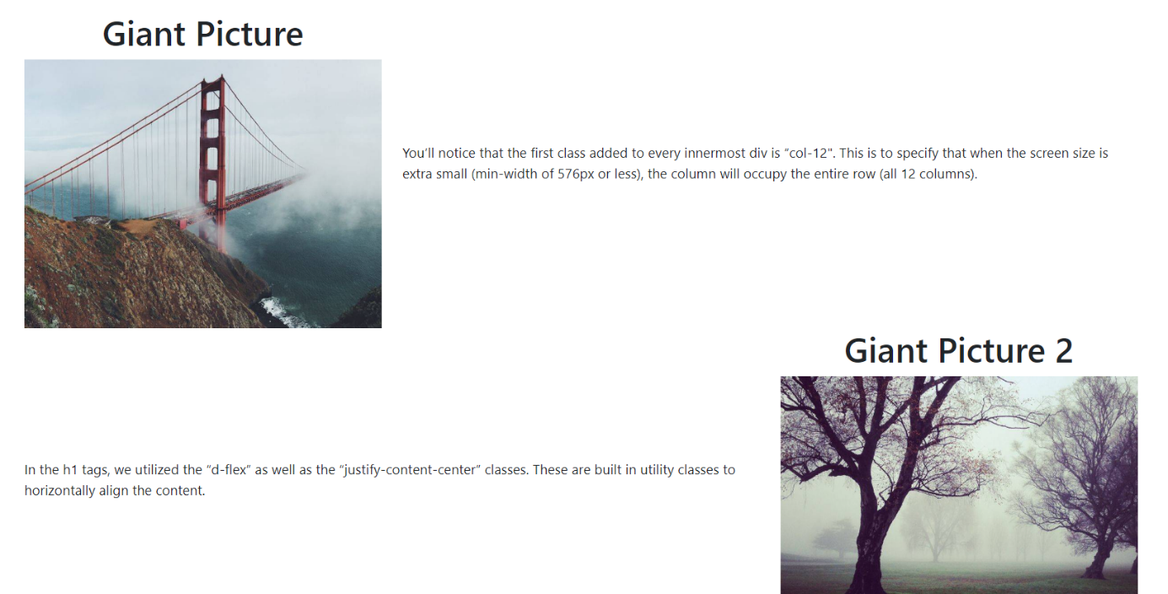

<md

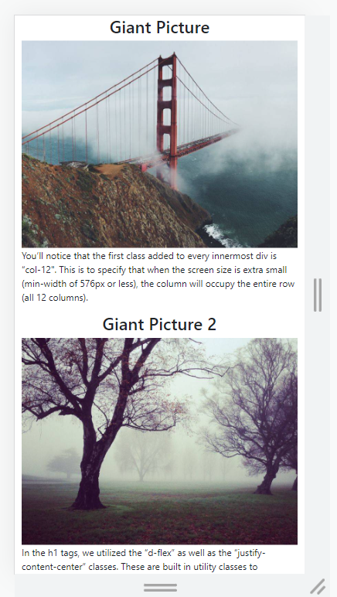

The code basis is found at canvas.