**Assignment 1**

Create below Calendar dropdown. When you click the dropdown button, the calendar will show.

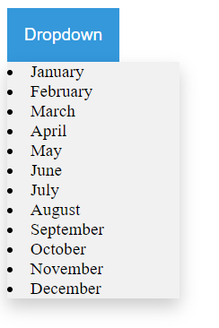

**Assignment 2**

Create below show movie page. When you click the “Show All Movies” button, below movies will show. And you can also make a responsive design!

