# Tasks Local Storage

Practical tasks

Note: note that you want to have control over what you have in localStorage during your work. Use the developer panel to find the status and contents of localStorage. Different browsers will have this available in slightly different places. Below are 2 screenshots respectively from Chrome and Firefox.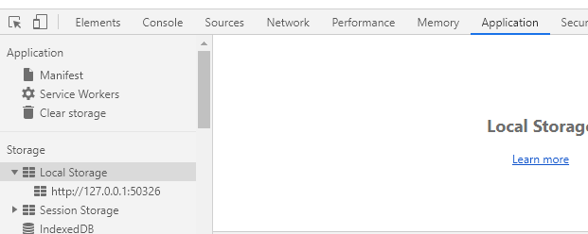

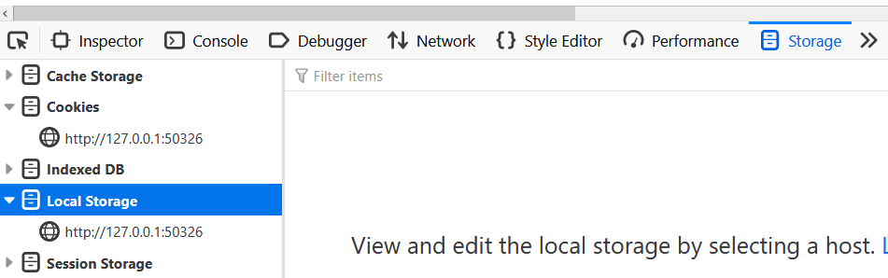

Below are three different tasks that you can practice with LocalStorage.

Remember to use IIFE function.

Previous ES6 techniques can be applied as well!

# Task 1. Remember User’s Favorite Food

Design below webpage to remember user’s favorite food. Use <fieldset> (https://www.w3schools.com/tags/tag_fieldset.asp) to create a field where the user enters their name and favorite food. Store the information in localStorage so that the browser remembers the information. The user must also be able to delete the contents of localStorage. You must use the setItem method 2 times: 1 for name and 1 for favoriteFood.

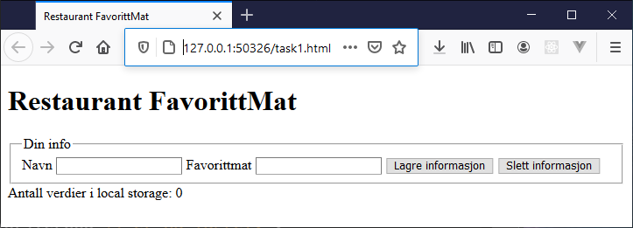

User has clicked on the button, but the fields are unfilled. A message is printed that the user must enter both their name and favorite food.

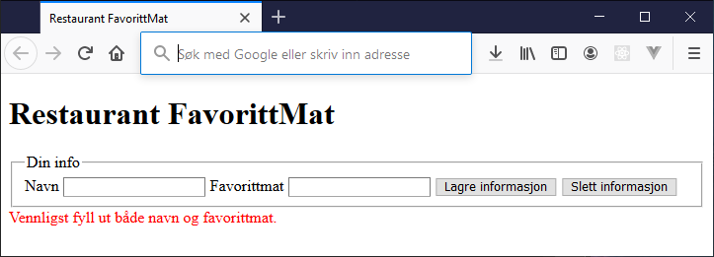

Users enter their name and favorite food. Then below message is shown.

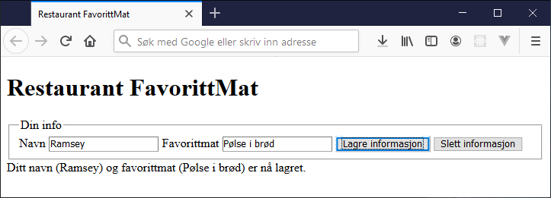

The user returns to the website (after closing the browser) and a welcome back message is shown.

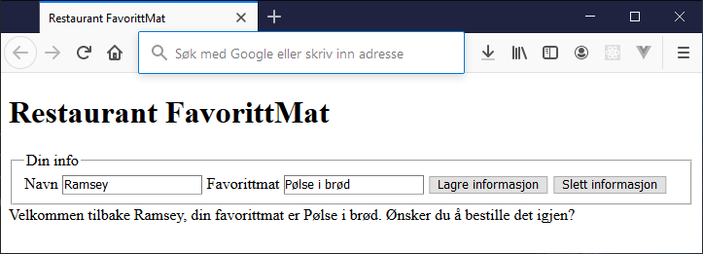

# Task 2. The user’s styling preferences

Create two web pages that link (<a>) to each other. On page 1, the user should be able to set the styling preferences and have the styling set on page 2. You should store one object in localStorage that contains the information. Start by setting the text color and background color and then expand with font-family and any other properties you can think of to set.

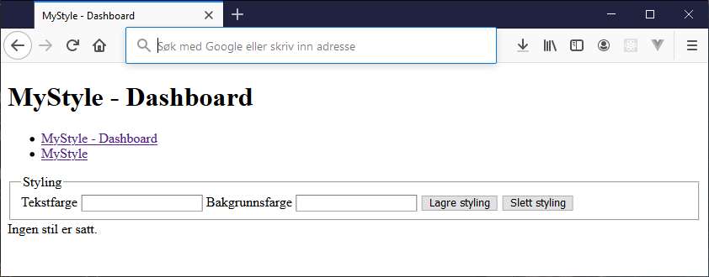

Page 2 informs that no style has been selected yet.

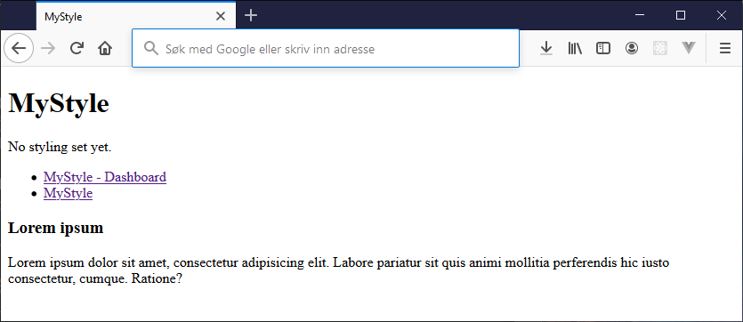

User saves text color and background color.

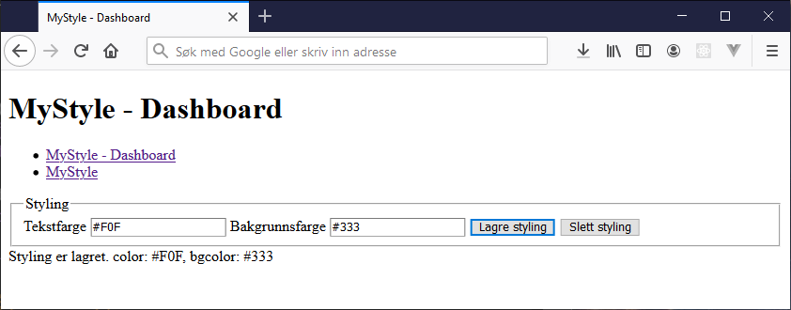

User goes to page 2 and gets the style setting that is specified.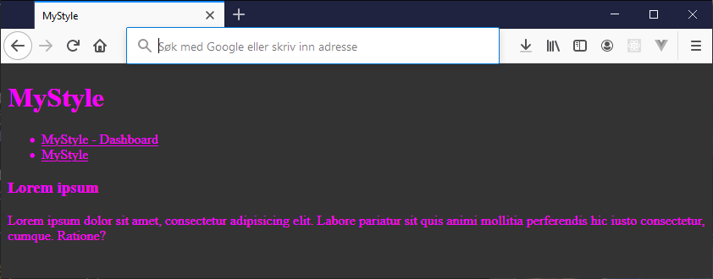

# Task 3. Books I must read this year.

The user wants to take notes about books she/he wants to read during the year. The user must be able to expand this list of books over time, so there is a need to take care of this information even if the user closes the browser. Here you will work with an array of objects that are stored in localStorage. Remember to test that the solution works by closing the browser and/or reloading the website.

{ title: "title ", author: "author " }

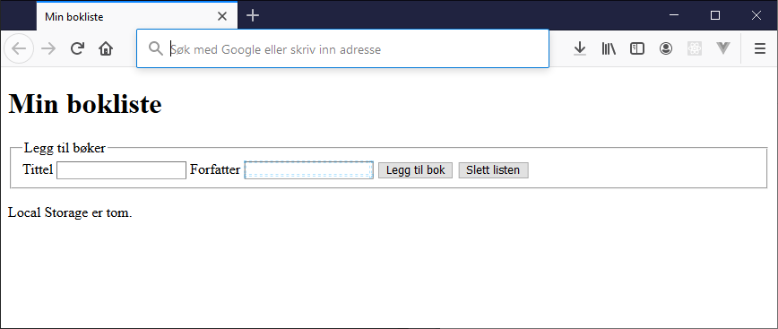

When a user adds a book, the book list shows up.

