# Today’s lecture – Create Menu and Shopping Cart for a Pizza Store

We are going to create below webpage

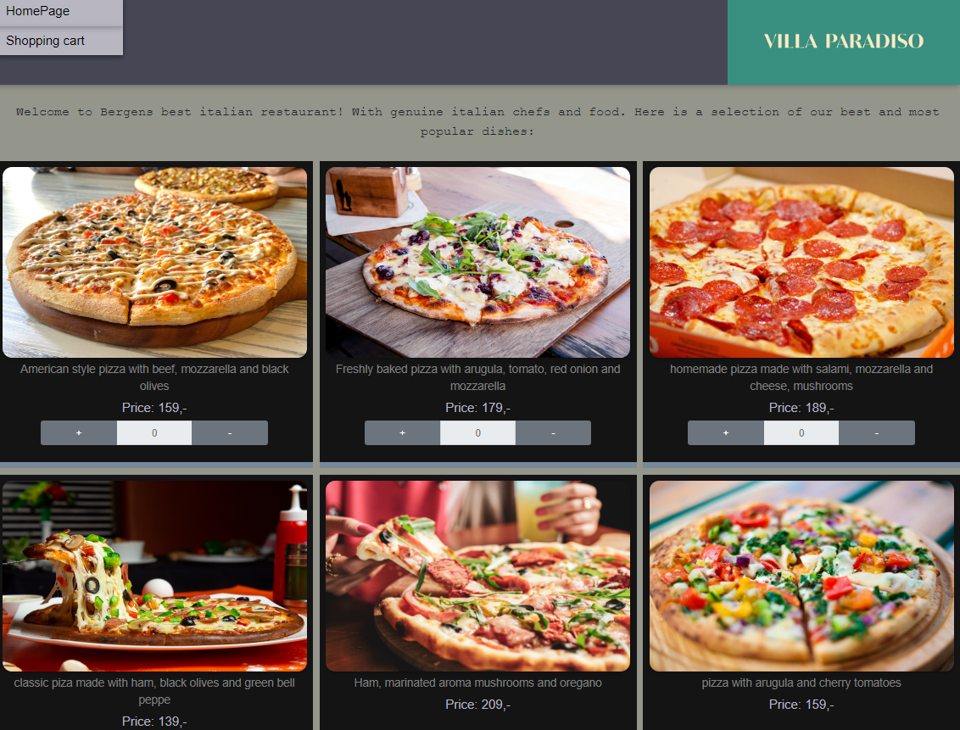

We will use React .

Tips:

No need to create any order/add to shopping cart function

However, you can try to get input and buttons work.