Design below pizza order menu

Task 1:

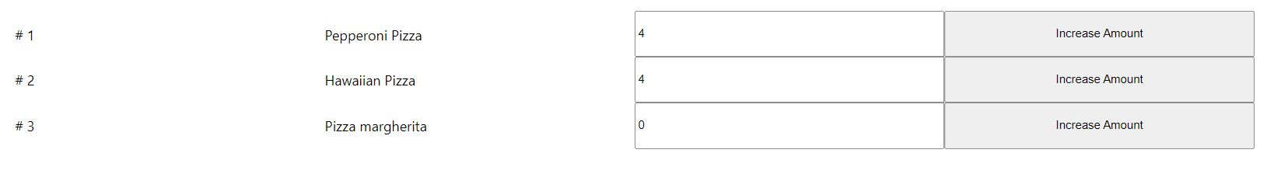

When you click the ‘Increase Amount’ button, the amount will be increased by 1.

Please use object.assign or spread operator to finish the task.

Task 2:

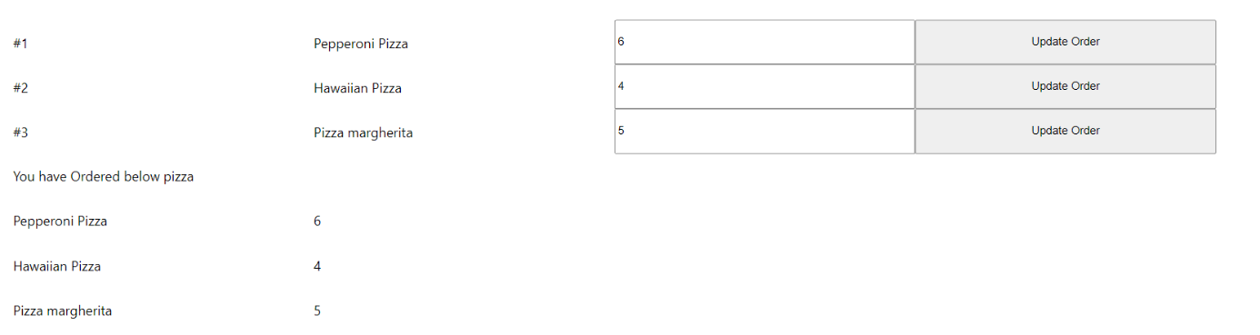

When you click ‘Update Order’ button, Both textbox and order list shall be updated.

1. Use object.assign or spread operator to finish the task.
2. Use form submit