#Assignment 1
#Stats Recap

library(tidyverse)
library(tidyquant)
library(ggplot2)
####Data Type
int <- c(5, 6, 7, 8)
typeof(int)

Output:
"double"

double <- c(1.2, 2.5, 3.5, 4.1)
typeof(double)

Output:
"double"

char <- c("Gokhan", "loves", "painting")
typeof(char)

Output:
"character"

logi <- c(T, F, T)
typeof(logi)

Output:
"logical"

comb1 <- c(double, char)
print(comb1)
typeof(comb1)

Output:
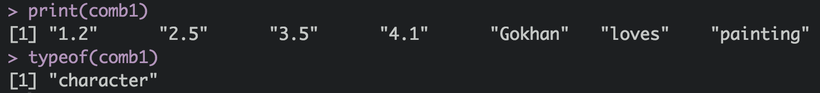

comb2 <- c(int, double)
typeof(comb2)

Output:
"double"

comb3 <- c(char, int)
typeof(comb3)

Output:
"character"

comb4 <- c(char, logi)
typeof(comb4)

Output:
"character"

comb5 <- c("Gokhan", "Painting", 35, TRUE)
typeof(comb5)
Output:
"character"
#A vector with 1 string (char) element will be of type: character

comb7 <- c( TRUE, FALSE, 35)
typeof(comb7)
Output:
"double"
# A vector with logical and numerical elements, will be of type: double

####Create a vector x storing the sequence
#10, 11, 12, 13, 14, 15, 16, 17, 18, 19, 20.
x <- c(10:20)

#Add 2 to it. Save the result into a variable called y.
y <- x + 2

#Multiply y by 3. Save that into a variable called z.
z <- y*3

#Substract 6 from z and divide the result by 3.
#Save what you get into a variable called answer.
answer <- (z-6)/3

#Print your answer variable
print(answer)

#Try to do the entire operation in a single line of code.
answer2 <- ((c(10:20)+2)*3-6)/3
answer2

Output:

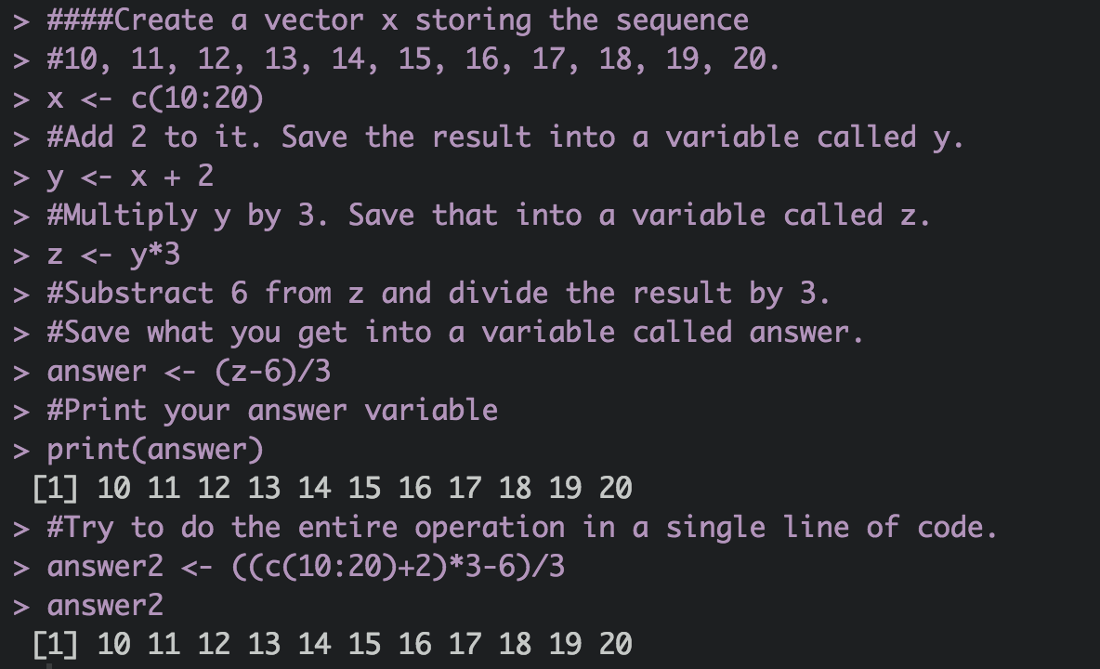

#Do you find out anything about the math operation?

#R use the Arithmetic Operators carry out mathematical
#operations such as addition (+), multiplication (*),
#subtraction (-), and division (/).

#Do they follow a specific order; how are they carried out?
#Yes, they do. All operations are carried out in element wise
#fashion. The complex calculations can be carried out with
#minimal code by using vectorized operators.

####Create a variable called Goku that contains the following value:
# 8, 10, 10, 1, 10, 10, 8, 12, 1, 12.
goku <- c(8, 10, 10, 1, 10, 10, 8, 12, 1, 12)
#Use the commands listed below to do the following operations:
#Find the sum of the elements in goku
sum(goku)
#Find the average of the elements in goku
mean(goku)
#Find the median of the elements in goku
median(goku)
#Get R to return the length of the goku variable
length(goku)
#find the trimmed mean by trimming 10% (80% og the mid
#data chunk will be used)
mean(goku, trim = 0.1)
#Find the standard deviation of the values in goku
sd(goku)
#find variance of goku
var(goku)
sd(goku)^2
#Find the standard deviation of the elements in goku,
#then round it to next integer; do it in a single command
round (sd(goku),0)
#find summary statistics of goku
summary(goku)
#find the range
range(goku)

Output:
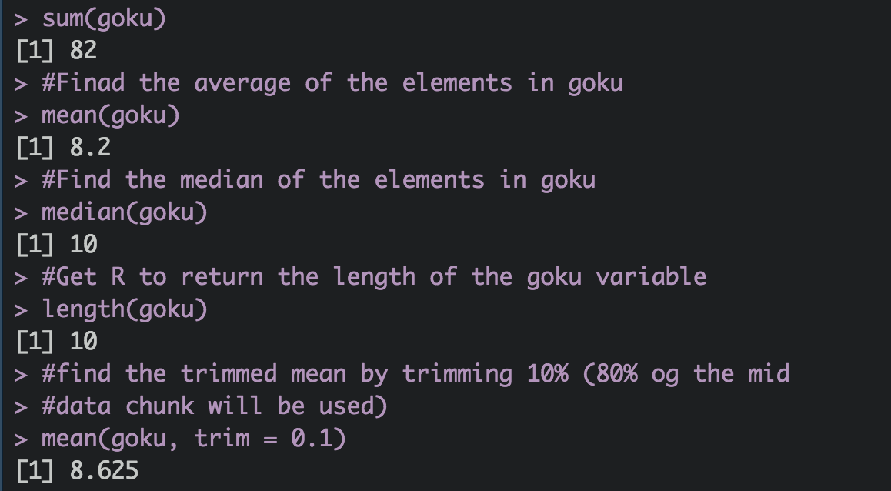
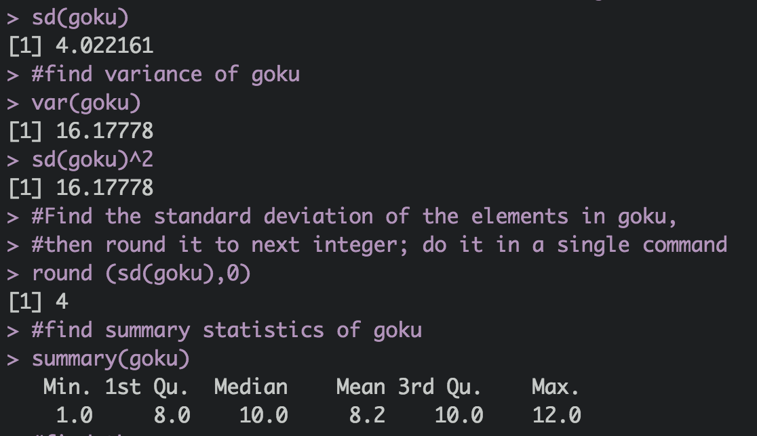
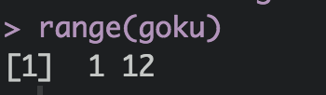

###Finding percentiles
examscores <- c(88, 84, 83, 80, 94, 90, 81, 79, 79, 81, 85, 87, 86, 89, 92)
quantile(examscores)
#15th, 25th, 35th and 95th% percentiles of examscores
quantile(examscores, probs = c (0.15, 0.25, 0.35, 0.95))
#Interquartile Range
IQR(examscores)
#skewness
skewness(examscores)
kurtosis(examscores)
#histogram
hist(examscores, freq = FALSE)
#More on histogram
#http://www.datamentor.io/r-programming/histogram/

Output:

#histogram
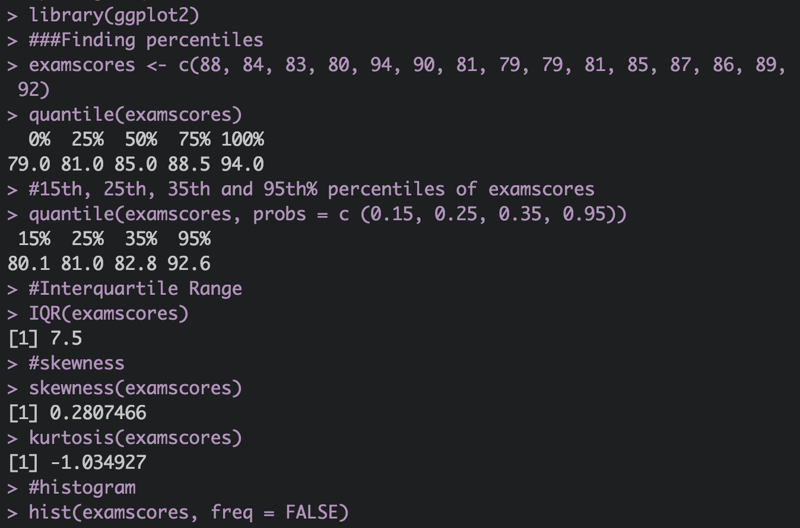

#histogram
Output:

###Find what arguments the sample() function takes.
args(sample)
#Find out what arguments the median function takes.
#While calling the median for goku object,
#try setting the na.rm = argument to TRUE.
args(median)
median(goku, na.rm = T)

Output:

