Joel Trainer
Assignment 4:

Before adding table entries. Sent 10 packets and got 10 packets back.

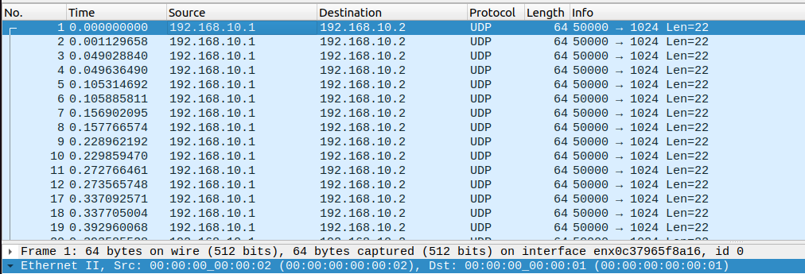

Half the packets are going from 02 to 01 and half from 01 to 02

Can I add table entries so code will drop packets I send?

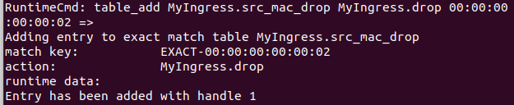

After dropping packets I sent:

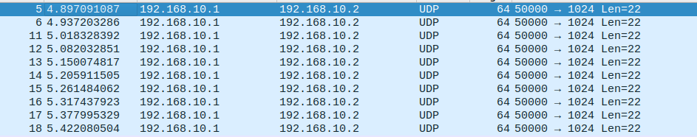
The source for these is only 02 as all the 01 packets were dropped.

