Joel Trainer
Assignment 2:

Ping from lab machine to raspberry pi 10 times, interval 0.2 seconds.
10 packets transmitted, 10 received, 0% packet loss, time 1834ms
rtt min/avg/max/mdev = 0.390/0.478/0.541/0.038 ms

Ping from raspberry pi to lab machine 10 times, interval 0.2 seconds.
10 packets transmitted, 10 received, 0% packet loss, time 1844ms
rtt min/avg/max/mdev = 0.358/0.513/0.579/0.082 ms

Ping from raspberry pi to lab machine 100 times, interval 0.001 seconds.
100 packets transmitted, 100 received, 0% packet loss, time 99ms
rtt min/avg/max/mdev = 0.191/0.337/0.474/0.030 ms

Ping from raspberry pi to lab machine 10000 times using flooding
10000 packets transmitted, 10000 received, 0% packet loss, time 3310ms
rtt min/avg/max/mdev = 0.180/0.291/0.521/0.011 ms, ipg/ewma 0.331/0.296 ms
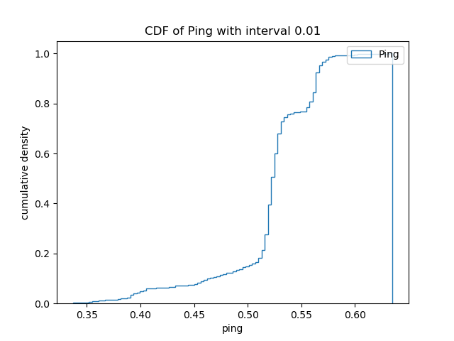

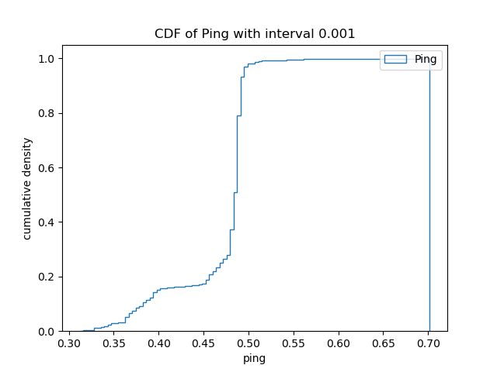

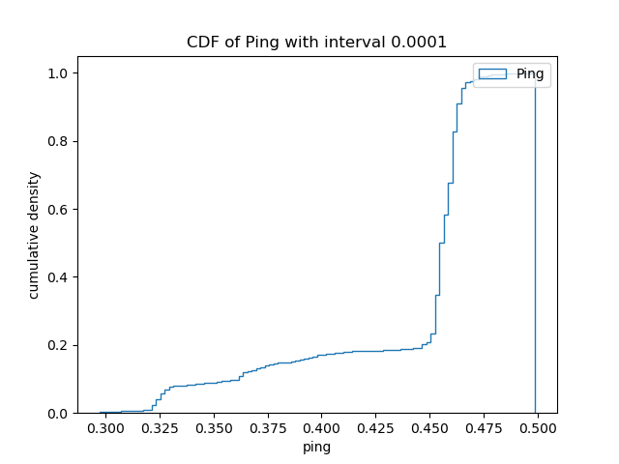

Can you speculate why different intervals lead to different round trip results?

I think that different intervals lead to different round trip results because for longer intervals, the computer will start doing other tasks which will lead to delays so the ping comes back lower for the shorter interval tests.

What do you estimate is the most accurate measured parameter that can be used to estimate propagation time between the two machines?

Although the min gives a theoretical best propagation time, the mean gives a better result for an estimate of the propagation time.

Lab machine as iperf server. Raspberry pi as client. Using TCP 10 seconds.

[ ID] Interval Transfer Bandwidth
[ 3] 0.0000-1.0000 sec 113 MBytes 951 Mbits/sec
[ 3] 1.0000-2.0000 sec 112 MBytes 941 Mbits/sec
[ 3] 2.0000-3.0000 sec 113 MBytes 945 Mbits/sec
[ 3] 3.0000-4.0000 sec 112 MBytes 935 Mbits/sec
[ 3] 4.0000-5.0000 sec 112 MBytes 941 Mbits/sec
[ 3] 5.0000-6.0000 sec 112 MBytes 943 Mbits/sec
[ 3] 6.0000-7.0000 sec 112 MBytes 944 Mbits/sec
[ 3] 7.0000-8.0000 sec 111 MBytes 934 Mbits/sec
[ 3] 8.0000-9.0000 sec 114 MBytes 952 Mbits/sec
[ 3] 9.0000-10.0000 sec 112 MBytes 935 Mbits/sec
[ 3] 10.0000-10.0024 sec 256 KBytes 877 Mbits/sec
[ 3] 0.0000-10.0024 sec 1.10 GBytes 942 Mbits/sec

Raspberry Pi as iperf server, lab machine as client. TCP 10 seconds, units Mbits/s.

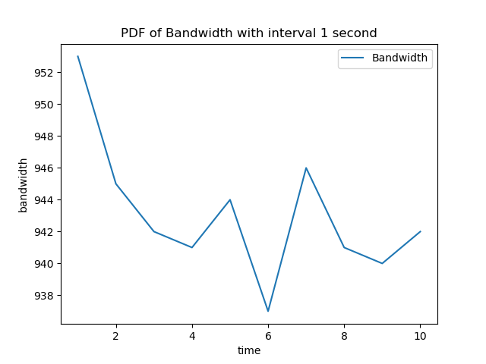

Raspberry Pi as iperf server, lab machine as client. TCP 10 seconds, bi directional, units Mbits/s.
