Joel Trainer
Assignment 6:

Initially I started off by making a copy of the calc code and I made a change so that it could send the packet with 9 numbers instead of 2 and checked it worked in the python and p4 code.
In the python code

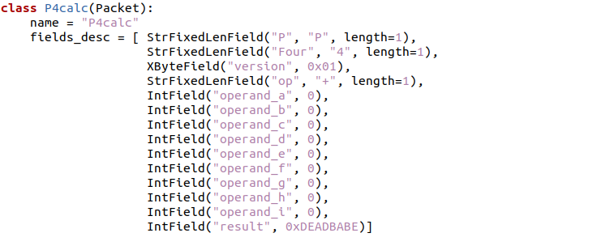

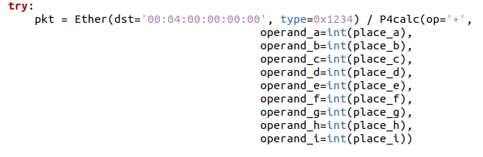
And on the p4 code
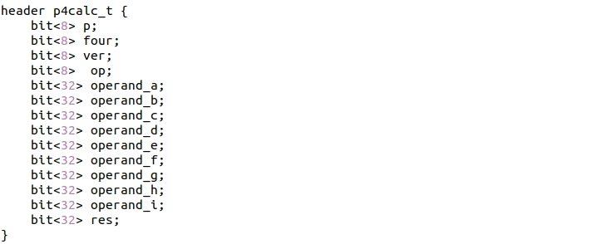

I then changed the conditions of a valid input from the user.
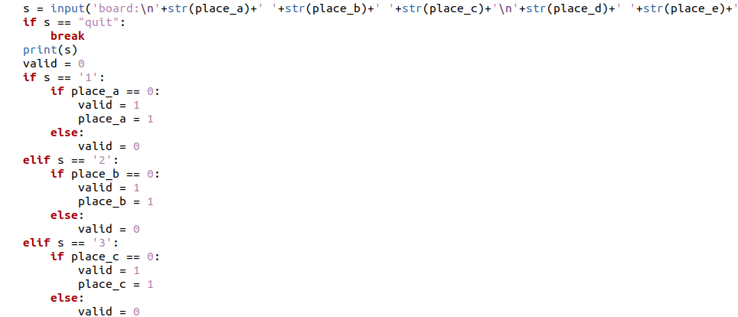
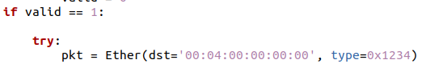

The code now checks if the input is just a 1-9, if so it sends the packet, else it will say invalid move.

Next I needed to make it send back a packet with the computer’s move.
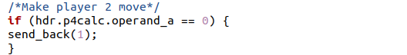

Using the same send back code as the calc code it sends back 1 as a result, if 1 was an available move.
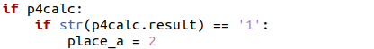

Now when the python code receives the packet it looks at result and changes the board.
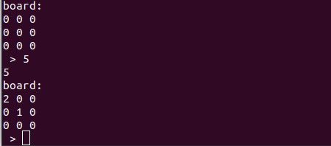

I then extended this code but for all the board positions so now the game can be played until the board is full.
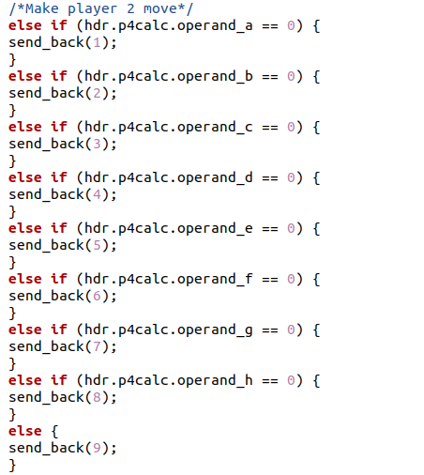

I then had to add a code to check if the player has won.
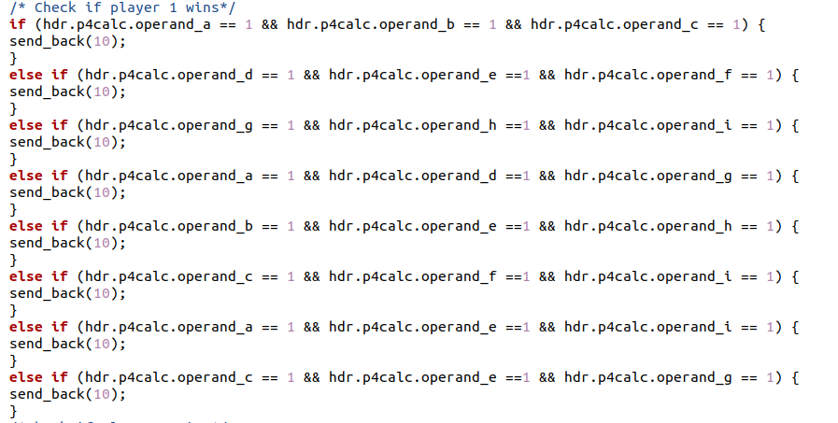

This sends back a result 10

So in the python I added this to show that you won.

I then added code to check if the computer could win in the next move and would return a win.

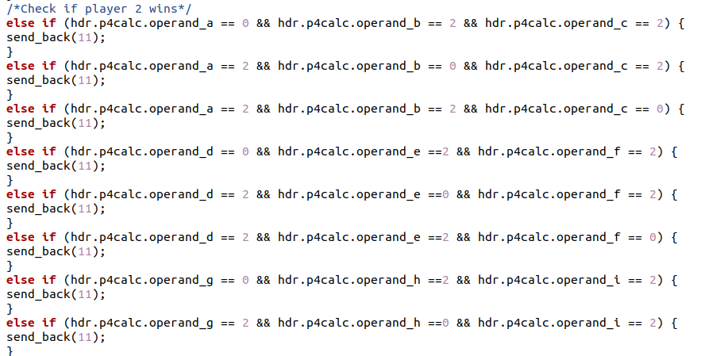

This now worked as a functional game, but it didn’t show the final board and it would just keep asking you for a move if it ended at a draw. To solve this I made new more streamlined versions of the code.
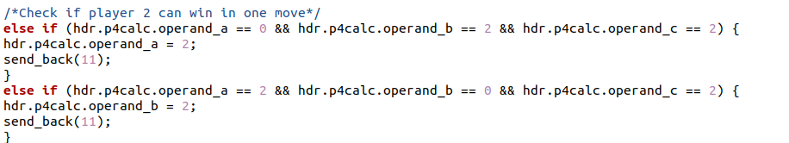
It now updates the board position that changed and sends back with updated board numbers

I also added in a draw result at the end if the computer couldn’t make a valid move.

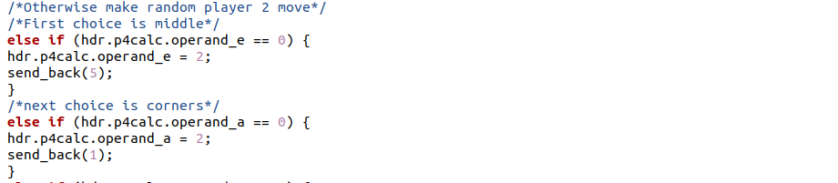

I also made it so the computer would pick moves starting with the middle and then the corners rather than just going from the top left in order.
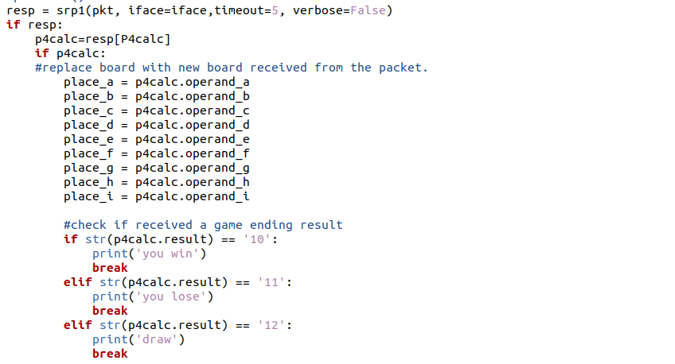
For the python code I now made it so that the packet sends back the board and it updates all its values, and then checks if a game ending result was received.

Also made some quality of life changes. For example explaining the rules.
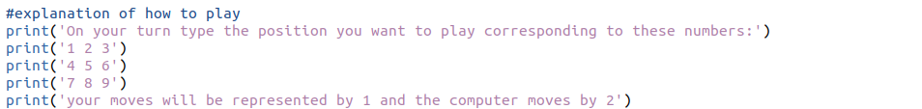
And showing the board at the end
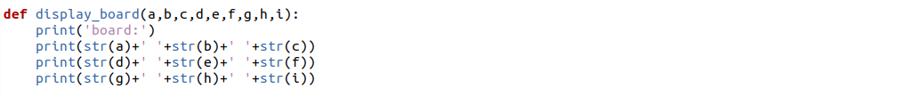

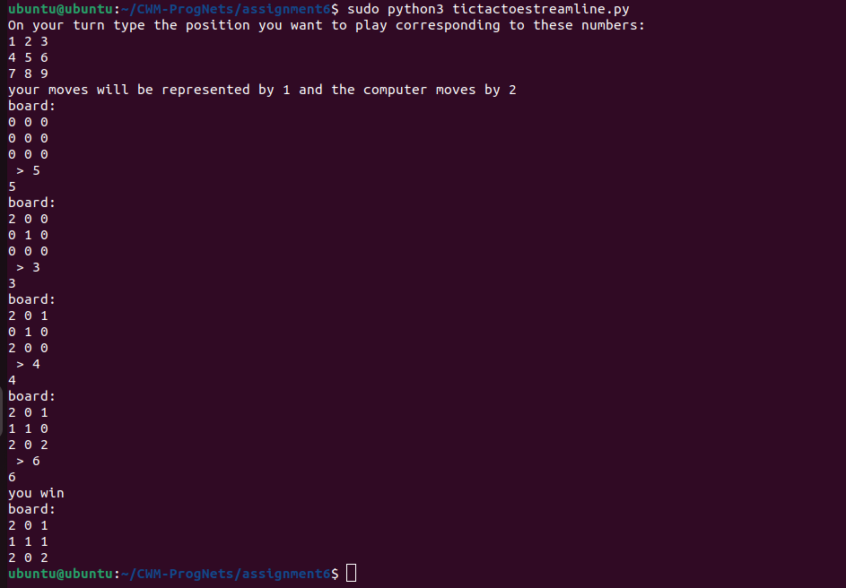

This is how the game ran in the streamlined version.

I then improved the computer’s choice of move further by making it block if the user is one move away from winning
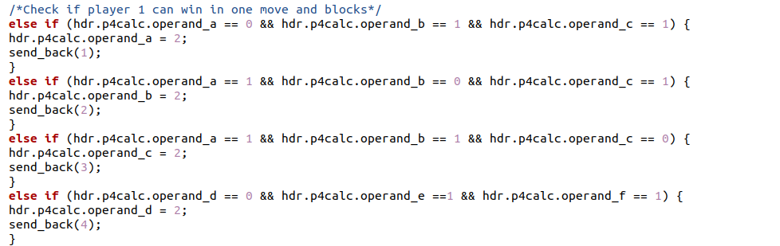

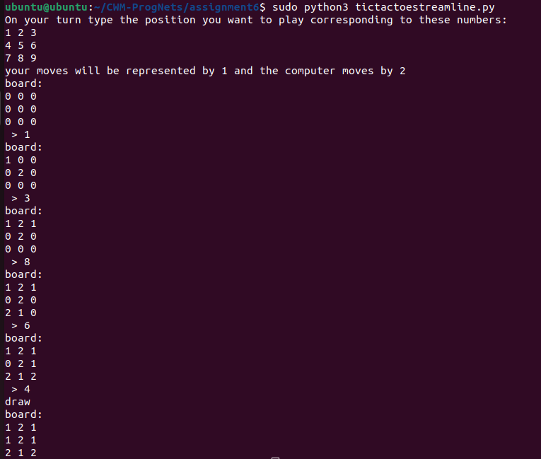
The code now fully works to play tic tac toe.

