

Practices for Secure Software Report

Table of Contents
Document Revision History 3
Client 3
Instructions 3
Developer 4
1. Algorithm Cipher 4
2. Certificate Generation 4
3. Deploy Cipher 4
4. Secure Communications 4
5. Secondary Testing 4
6. Functional Testing 4
7. Summary 4
8. Industry Standard Best Practices 4

Document Revision History

Version | Date | Author | Comments
1.0 | 4/19/2026 | Jesse Martin

Client



Instructions

Submit this completed practices for secure software report. Replace the bracketed text with the relevant information. You must document your process for writing secure communications and refactoring code that complies with software security testing protocols.

- Respond to the steps outlined below and include your findings.
- Respond using your own words. You may also choose to include images or supporting materials. If you include them, make certain to insert them in all the relevant locations in the document.
- Refer to the Project Two Guidelines and Rubric for more detailed instructions about each section of the template.

Developer
Jesse Martin

Algorithm Cipher

- A) Overview:
  - I would personally recommend AES-256 for confidentiality and SHA-256 for hardened integrity verification. Being that sensitive financial data is handled by Artemis Financial, a combination such as this which supports secure transfer and checksum validation is vital.
- B) Functions and Bit levels:
  - Since SHA-256 produces a 256-bit digest, it is suitable for the functionality of this system.
- C) Random numbers, Symmetric vs. Non-symmetric keys:
  - Symmetric encryption (such as AES) is efficient for bulk data protection, while asymmetric key cryptography is used in TLS certificate exchange and server identity validation. Secure random generation is essential for key and session material in production-grade systems (Oracle, n.d.; SSL Shopper, n.d.).
- D) History and current state of encryption algorithms:
  - Legacy algorithms and weaker hash approaches are no longer preferred in modern secure development. Current best practice is to use modern standards (for this project: SHA-256 + TLS certificate-based HTTPS) and continuously test dependencies for known vulnerabilities (Oracle, n.d.; OWASP Dependency-Check, n.d.-a).

Certificate Generation

Utilizing the key-tool in the Eclipse IDE, I was able to easily create the self-signed certificate:
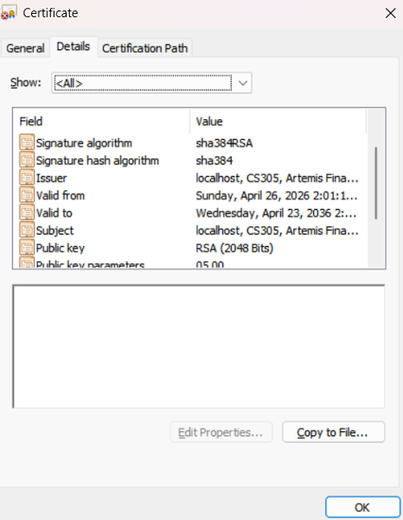

Deploy Cipher
*Had some trouble at this step, but it was remedied.
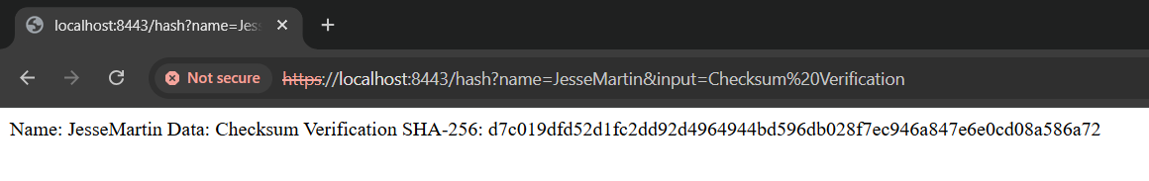

Secure Communications

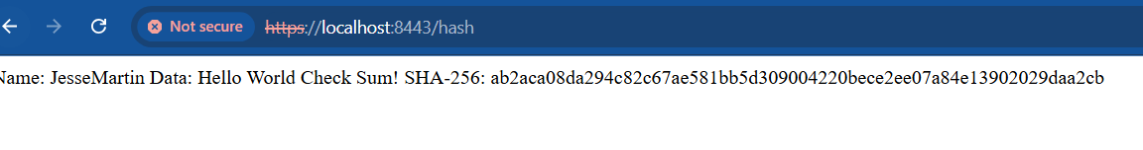
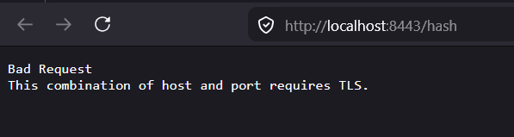
Although showing “Not secure”, the above image proves that HTTP requests are not accepted. Furthermore, by refactoring the code to implement a checksum endpoint at “/hash” using SHA-256, this further solidifies “cryptographic hash functionality with a checksum verification workflow” (Oracle, n.d.).

Secondary Testing

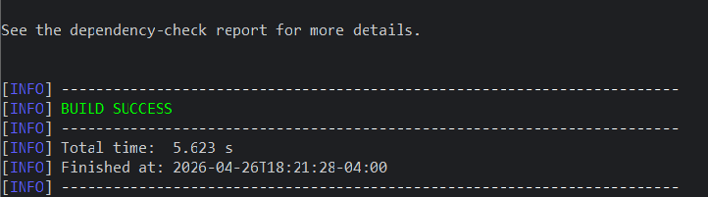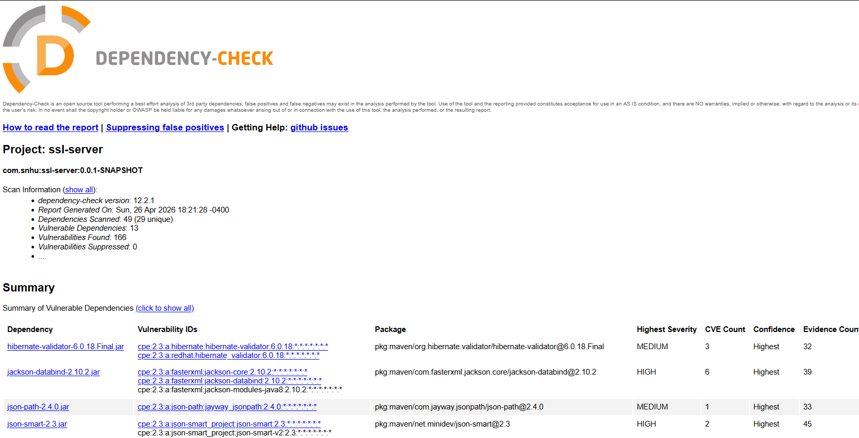

Functional Testing
Insert a screenshot below of the refactored code executed without errors.
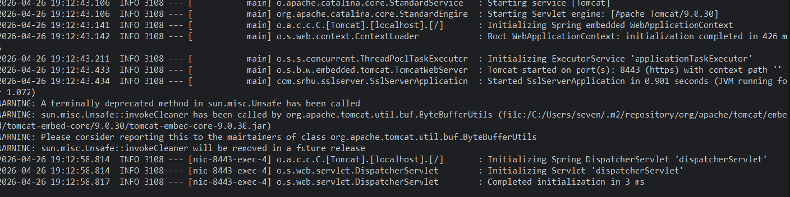

- The image above of course depicts a final successful run, but there were some improvements made upon the code for checksum output consistency, which was a problem at first. More specifically, I ensured that this system would be able to properly handle HTTPS transport for enhanced security as well as SHA-256 checksum correctness, and proper certificate usage.

Summary

- The vulnerability process flow diagram was an instrumental tool in performing rigorous and thorough testing. Key areas of focus throughout the process were the integration of the maven dependency check plugin in Eclipse, TLS/HTTPS configuration, testing of endpoint (SHA-256), and manual review. I repeated this process quite a few times to ensure I missed nothing; to the best of my ability.

Industry Standard Best Practices

- I made sure the system was up to date at many levels; the maven plugin was an out of support version, as were several of the systems core dependencies. The pom.xml was configured properly; to use an NVD API key safely as a call to an environment variable. Spring-boot-starter-rest was unused, therefore removed. I kept security scans active while handling instability at first, mostly related, as previously mentioned, to proper TLS configuration. Additionally, I added bounded input length checks in HashController to mitigate “oversized-input abuse”. The most important step, however, to ensuring the proper handling of data at the transport layer was by enabling HTTPS(port 8443).

References

National Institute of Standards and Technology. (n.d.). National vulnerability database. https://nvd.nist.gov/

Oracle. (n.d.). Java security standard algorithm names. https://docs.oracle.com/javase/9/docs/specs/security/standard-names.html#cipher-algorithm-names

Oracle. (n.d.). Keytool documentation. https://docs.oracle.com/javase/6/docs/technotes/tools/windows/keytool.html

OWASP Dependency-Check. (n.d.-a). Dependency-check Maven plugin. https://dependency-check.github.io/DependencyCheck/dependency-check-maven/

SSL Shopper. (n.d.). How to create a self-signed certificate using Java keytool. https://www.sslshopper.com/article-how-to-create-a-self-signed-certificate-using-java-keytool.html

