**PHASE 3:**

**PRODUCT SALES ANALYSIS**

**Step 1: Define Analysis Objectives**

Before you start, it's essential to clarify your analysis objectives. What do you want to achieve with your product sales analysis? Example objectives could include:

- Understanding sales trends over time.

- Identifying the top-performing products or regions.

- Forecasting future sales.

- Analyzing the impact of marketing campaigns.

- Monitoring inventory and stock levels.

Clearly defining your objectives will help shape your analysis and determine what data you need to collect.

**Step 2: Collect Sales Data**

To collect sales data, you need to identify and access the data sources. This might include databases, spreadsheets, or other data storage systems. You should have access to data on sales transactions, which typically include details like:

- Date of sale

- Product ID or name

- Sales quantity

- Sales revenue

- Customer information (if applicable)

Ensure you have the necessary permissions and access to this data.

**Step 3: Data Preprocessing and Cleaning**

Data preprocessing is a crucial step to ensure the accuracy and reliability of your analysis. Here's what you need to do:

Data Extraction: Extract the relevant data from your data sources. This might involve querying a database, exporting data from spreadsheets, or using ETL (Extract, Transform, Load) processes.

**Data Cleaning:**

Remove Duplicates: Check for and remove duplicate records, if any.

Handle Missing Data: Address missing values in the dataset. Depending on the extent of missing data, you can choose to fill in missing values with suitable defaults or remove rows with missing values.

Data Format Standardization: Ensure that data formats (e.g., date formats, currency symbols) are consistent throughout the dataset.

Data Integrity: Check for any anomalies or outliers in the data, and decide how to handle them (e.g., removing or transforming outliers).

Data Transformation:

- Create derived features if necessary (e.g., calculate total sales, profit margins).

- Aggregate data if needed, e.g., grouping sales by month, quarter, or year.

Data Integration: If you have data from multiple sources, integrate them into a single dataset for analysis.

Data Validation: Perform sanity checks to ensure that the data aligns with your defined objectives.

**Step 4: Load Data into IBM Cognos**

Once your data is cleaned and preprocessed, you can load it into IBM Cognos for analysis and visualization. This typically involves importing the data into Cognos' data modules or connecting to your data source directly.

**Step 5: Create Visualizations and Analysis**

In IBM Cognos, you can create various visualizations to analyze your sales data. You can design reports and dashboards that help you gain insights into yourdefined objectives. Some common visualizations include bar charts, line graphs, pie charts, and tables.

**Step 6: Interpret and Share Insights**

Finally, interpret the results and insights you've gathered from your analysis. What do the visualizations and reports tell you about your sales data and objectives? Use these insights to make informed business decisions. Share the results with stakeholders through reports, presentations, or interactive dashboards.

Remember to periodically update your analysis as new data becomes available to maintain the accuracy and relevance of your findings.

This process will help you begin your product sales analysis using IBM Cognos, ensuring that your data is clean and your objectives are well-defined.

**Bubble:**

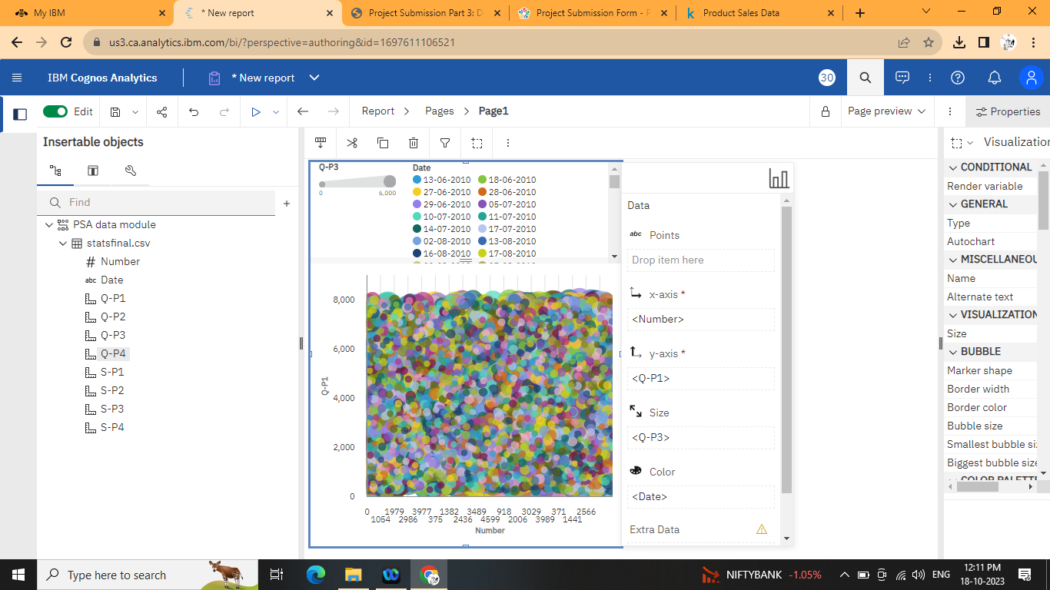

**Clustered column:**

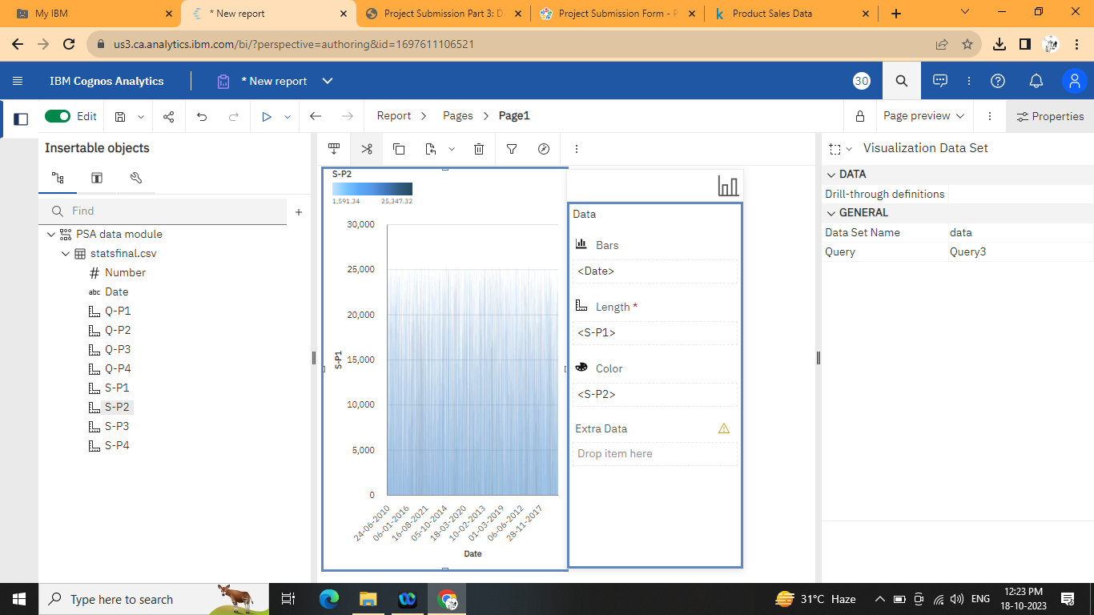

**Clustered bar:**

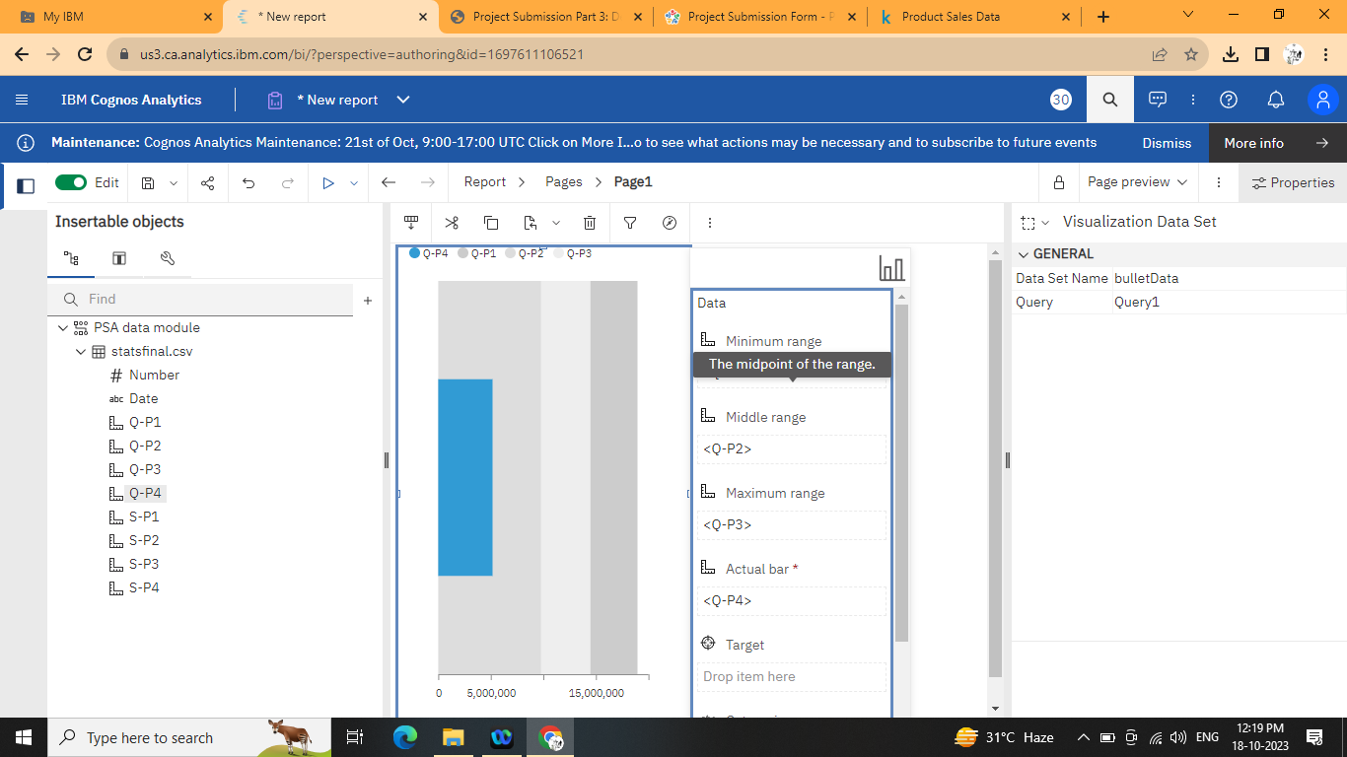

**Clustered rows:**

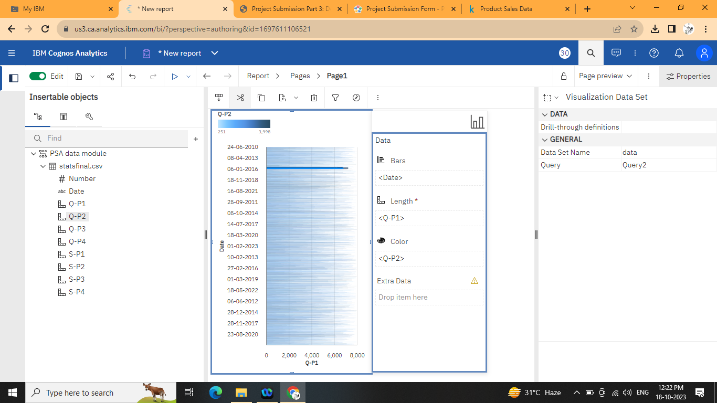

**Map:**

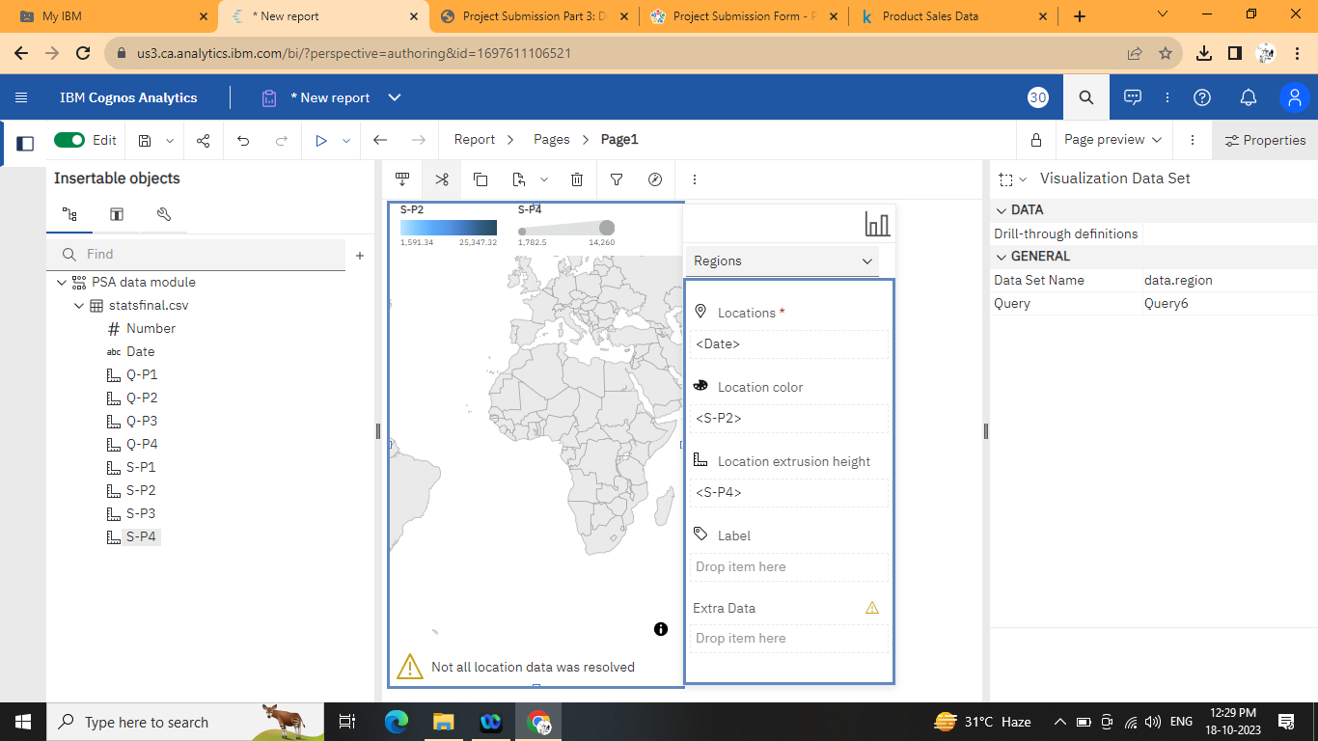

**Conclusion:**

In conclusion, embarking on a product sales analysis using IBM Cognos is a structured process that requires careful planning and execution. The key steps include defining clear analysis objectives, collecting and preprocessing sales data, and leveraging IBM Cognos for visualization and analysis.