RESUME-MATCHER PROJECT

What ? :

This project uses LLM to analyze and score resumes against the job description using responses derived from an agents orchestrator and additional relevant information scraped off the internet (like the college, degree, past projects, etc..), and give a score based on it so it is easy to conclude how well a candidate is suited for the respective job.

Why ? :

This project is primarily used to eliminate the massive time investment it takes to review the resumes and make a decision on the compatibility of each individual candidate for the job, this project aims to make this process quick, efficient and easier.

How ? :

- User provides a job description and resumes via the GUI.
- extract_text() pulls plain text from these documents.
- SerpAPI is called to evaluate college reputation.
- CrewAI agents feed the job + resume + search info into Groq’s LLM.
- Groq LLM returns a structured match score + analysis.
- Results are shown in the GUI.

Scoring System :
Scores are calculated based on these weighted criteria (total 100 points):
Criterion | Max Points
Technical Skills | 50
Experience | 20
Education | 10
Soft Skills | 10
Certifications | 10
Additional bonuses:
- College tier bonus (via SerpAPI)
- Personal projects, open-source, publications
Penalties and red flags include:
- Missing skills
- Falsified information
- Poor grammar

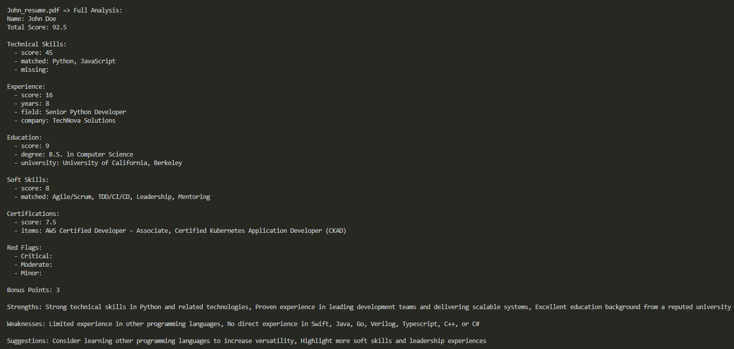

Deep dive :
Groq's LLM (like llama3-70b-8192) interprets both the resume and job description.

- It uses a system prompt (in groq_llm.py) to follow a strict scoring methodology.
- Returns a structured JSON with:
- Total match score (out of 100)
- Component scores (skills, experience, education, soft skills, certifications)
- Bonus points (e.g., for personal projects, publications)
- Red flags (e.g., missing required skills)
- Strengths, weaknesses, suggestions

CrewAI is used to orchestrate Groq’s LLM responses through agents.

In this project:
- You define two Agents:
  - JobParser() — extracts structured info from the job description.
  - ResumeAnalyzer() — evaluates the resume against the job, using the system prompt.
- Each agent is configured with a role, goal, and backstory to keep the LLM's behavior focused.
- CrewAI simplifies managing complex prompts by wrapping LLMs in task-specific agents.

SerpAPI is used to look up college reputation online, which affects the score.

In this project:
- The function serpapi_search() queries Google via SerpAPI to fetch snippets about each college mentioned in a resume.
- These snippets are passed to the LLM, which classifies the college into a tier (1 = top-tier, 2 = mid-tier, etc.).
- A bonus score is awarded based on the college's tier:
  - Tier 1: +2.5 pts
  - Tier 2: +2 pts
  - Tier 3: +1.5 pts

Extensibility
The project is modular and extensible:
- Add more scoring logic in matcher.py.
- Integrate embeddings and cosine similarity (partially stubbed in utils.py).
- Replace GUI with web frontend or CLI if needed.

