**RESUME- JOB DESCRIPTION USECASE- UI AND BACKEND**

**Overview:**

This document outlines the required modifications to the existing user interface (UI) to align with the enhanced functionality of evaluating multiple resumes against a single job description. These changes are aimed at improving scalability and usability by introducing bulk evaluation and candidate-specific analysis.

1. **Landing Page (Current: Add Resume & Add Job Description)**

**Existing Features:**

* Drag and drop box for uploading:

One Resume

One Job Description

* “Start Evaluation” button to trigger matching

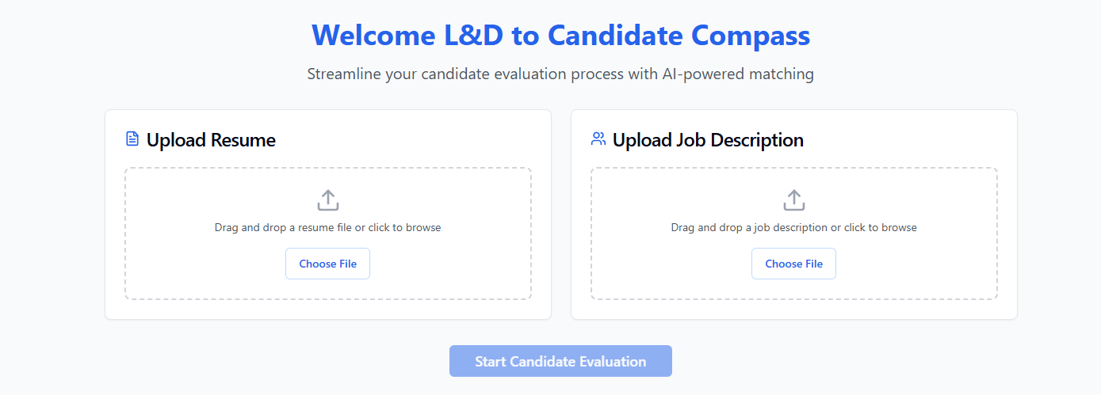

**Proposed Changes:**

* **Upload Job Description”** (single file input)
* **“Upload Resume Folder”** (to allow multiple resumes at once, ideally a folder or multi-file selector)

**Goal: Enable evaluation of multiple candidates against a single job description in one go.**

1. **Results Page (Post Evaluation)**

New Layout:

Display a **table or list view** summarizing all candidates evaluated.

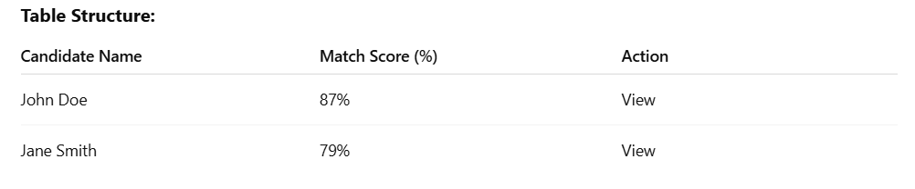

View button leads to detailed candidate evaluation

**Goal: Provide a high-level overview of all evaluated resumes and allow deep-dives into individual candidates.**

As an example:



Similarly, we need a page that displays a list of candidate names, their scores, and a "View" or "Review" button. Clicking this button should redirect to the third page, which presents the detailed candidate evaluation view.

1. **Candidate Evaluation Page**

Layout Structure:

Left Panel:

* + Candidate Name
  + Score Breakdown
    - Total Score (100)
    - Technical Skills (50)
    - Experience (20)
    - Soft skills (10)
    - Education (10)
    - Certifications (10)
  + Keyword highlighting is not required at this stage. Instead, the output should include an analysis section outlining the candidate's strengths, weaknesses, and suggestions for improvement.

Right Panel:

* + Resume Preview (render the resume document or show plain-text conversion)

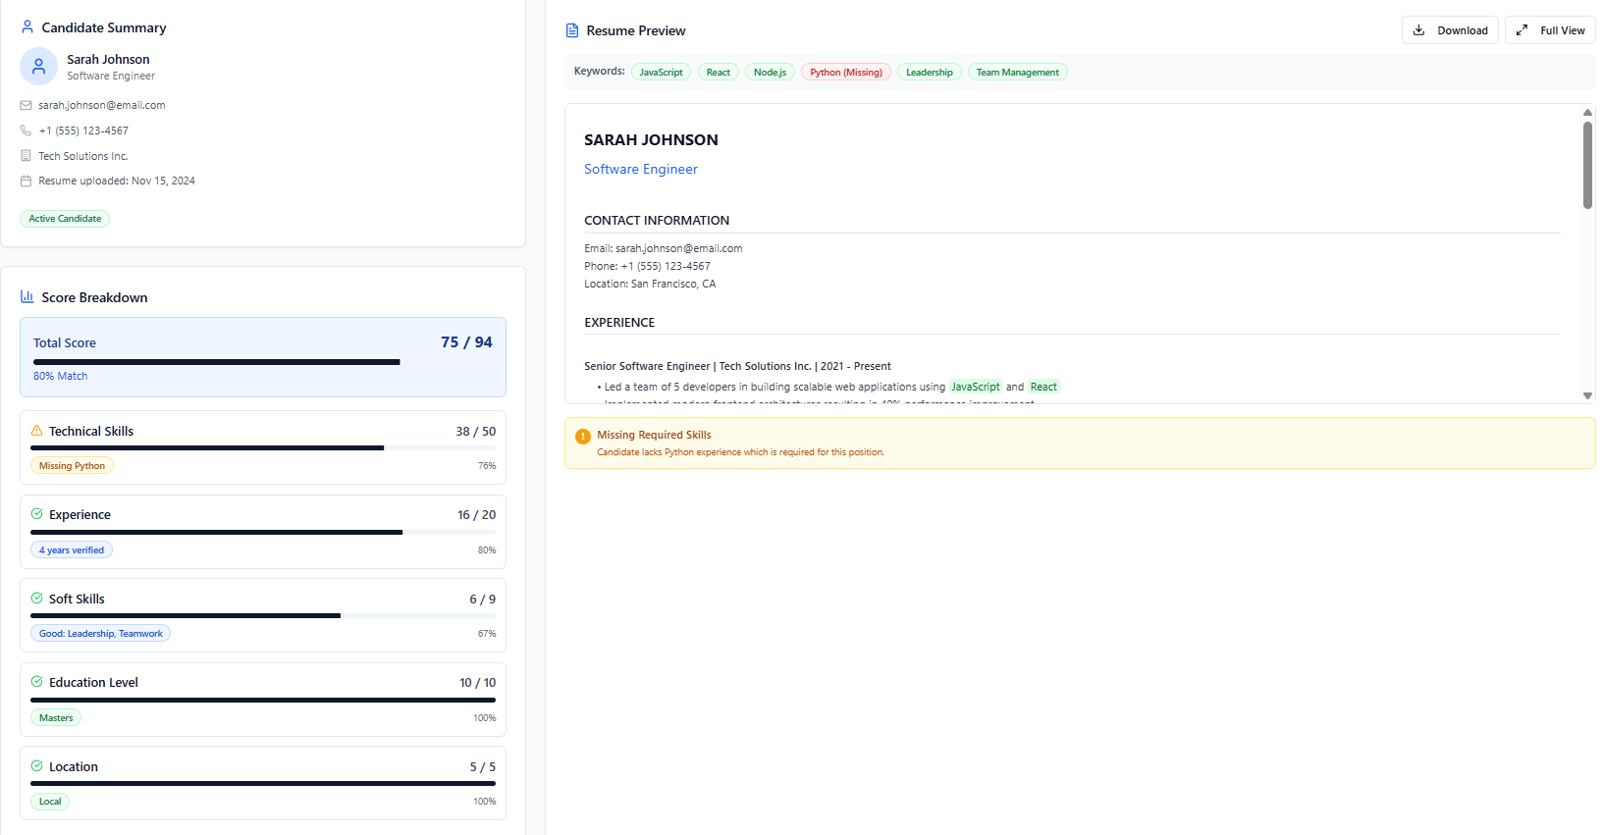

**Goal: Allow recruiters to quickly assess how a candidate matches a job description, with a side-by-side view of scores and resume.**