**学习进度**

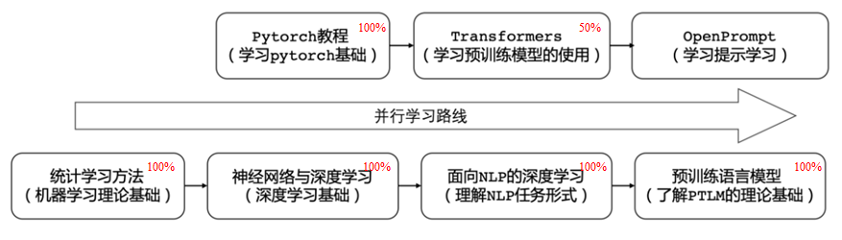

**本周学习内容**

阅读论文：CLEVE: Contrastive Pre-training for Event Extraction

* Paper： <https://aclanthology.org/2021.acl-long.491.pdf>
* Code：<https://github.com/THU-KEG/CLEVE>

1. Methods：
   1. How to take full advantage of large-scale unsupervised data?
   2. Use semantic parsers to get event structure information.
2. Experiments：
   1. Compare with various baselines, including:
      1. (1) feature-based method, the top-performing JointBeam (Li et al., 2013);
      2. (2) vanilla neural model DMCNN (Chen et al., 2015);
      3. (3) the model incorporating syntactic knowledge, dbRNN (Sha et al., 2018);
      4. (4) stateof-the-art models on ED and EAE respectively, including GatedGCN (Lai et al., 2020) and SemSynGTN (Pouran Ben Veyseh et al., 2020);
      5. (5) a stateof-the-art EE model RCEE ER (Liu et al., 2020), which tackle EE with machine reading comprehension (MRC) techniques.
   2. Evaluation method: p-values under the t-test
3. Writing：
   1. Clarify research motivation.
   2. Detailed analysis of experiment results.

**下周学习计划**

1. 继续学习Transformer教程
2. 继续学习【NLP最佳实践】Huggingface Transformers实战教程