**学习进度**

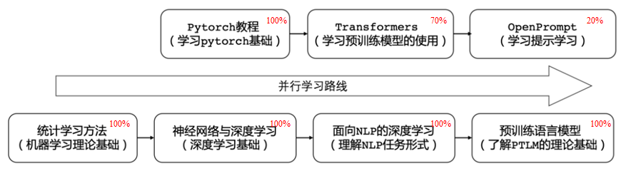

**本周学习内容**

1. OpenPrompt教程-Tutorial/basic.py和[mixed_template.py](https://github.com/thunlp/OpenPrompt/blob/main/tutorial/1.1_mixed_template.py).
2. A PromptModel has three modules: PLMs, Template and Verbalizer.
3. How to Write a Template?
   1. Special key：
      1. A meta key to denote the original text input, or the part of the input, or other key information.
      2. A mask key is used to denote the indices of the token that needs to be predicted.
      3. A soft key denotes soft tokens and textual tokens could be directly written down.
   2. Two Types:
      1. Textual Template
      2. Soft & Mix Template
   3. a textual template will be optimized with the model. And soft tokens will be separately optimized.
4. How to Write a Verbalizer?
   1. Input Label Words
      1. list
      2. dic
   2. Loading from File
      1. dict-like: .json or .jsonl
      2. list-like: .txt or.csv

**下周学习计划**

1. 继续学习【NLP最佳实践】Huggingface Transformers实战教程
2. 继续学习OpenPrompt教程