CONSULTATION PROCEDURE

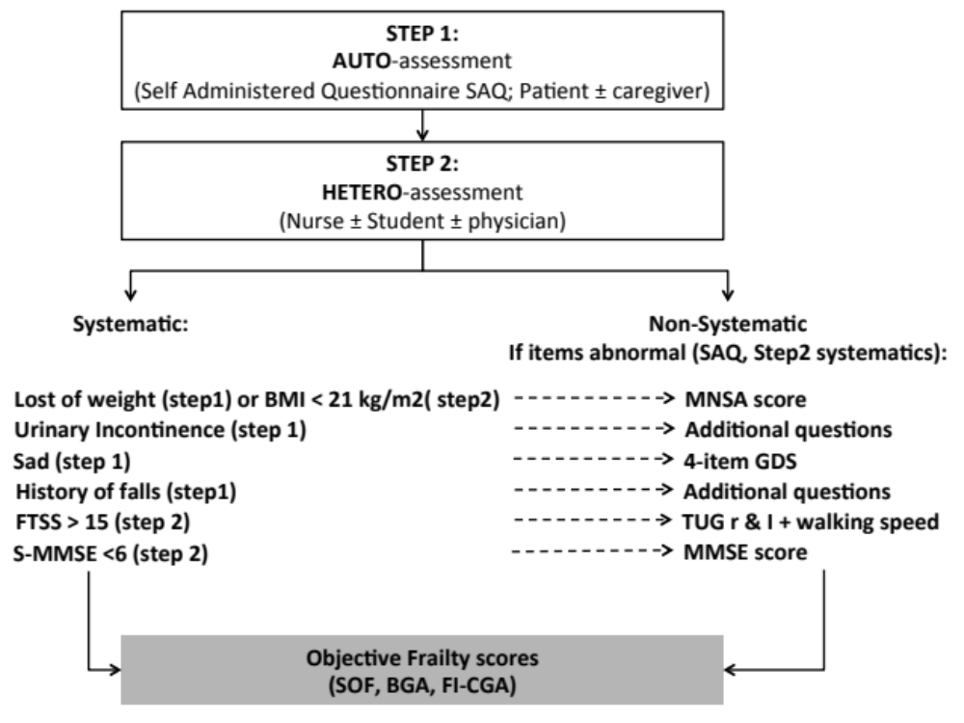

Madame, Monsieur,

Vous allez voir en consultation le Docteur Olivier Beauchet.

Avant de débuter la consultation, nous vous remercions de bien vouloir remplir le questionnaire ci-dessous, en cochant la case correspondant à votre état.

Vous pouvez être aidé par la personne qui vous accompagne.

- Avez-vous perdu involontairement du poids au cours de la  dernière année ?  Si oui, précisez si la perte de poids a été de plus de 3kg ? | ☐Non ☐Oui  ☐Non ☐Oui
2. Recevez-vous de l'aide dans votre vie pour faire les actes de vie de  tous les jours ? | ☐Non ☐Oui
Si oui, précisez s’il s’agit d'un : ☐Parent et/ou ☐Amis et/ou ☐Professionnels
3. Combien de médicaments différents prenez-vous par jour ? | ¦__¦¦__¦
4. Avez-vous des problèmes de vue ?  Si oui, portez-vous des lunettes ?  5. Avec des problèmes d’audition ?  Si oui, portez-vous un appareil auditif ? | ☐Non ☐Oui  ☐Non ☐Oui  ☐Non ☐Oui  ☐Non ☐Oui
6. Votre entourage vous a-t-il fait remarquer que vous aviez des  problèmes de mémoire ? | ☐Non ☐Oui
Avez-vous besoins d’aide pour  7 . Votre toilette ?  80. Vos soins d'apparence corporelle ?  90. Vous habiller vous seul ?  10. Vous déplacer (type canne ou autre) ?  11. Manger?  12. Perdez-vous vos urines ? | ☐Non ☐Oui  ☐Non ☐Oui  ☐Non ☐Oui  ☐Non ☐Oui  ☐Non ☐Oui
13. Utilisez-vous seul le téléphone ?  14. Utilisez-vous seul les moyens de transport ?  15. Prenez-vous seul vos médicaments ?  16. Gérez-vous seul votre argent ? | ☐Non ☐Oui  ☐Non ☐Oui  ☐Non ☐Oui  ☐Non ☐Oui
17. Vous sentez-vous aujourd’hui :
☐Malheureux ou ☐Heureux ou ☐Ni l’un ni l’autre

18. Vous sentez vous plein d’énergie ? | ☐Non ☐Oui
19. Avez-vous pratiqué une activité physique (marche, jardinage, vélo, etc…) au moins pendant 1 heure par semaine au cours du dernier mois ? | ☐Non ☐Oui
20. Avez-vous fait, au cours des 12 derniers mois, au moins une chute ? | ☐Non ☐Oui
Avez-vous rempli seul le questionnaire ?
☐Oui ☐Non, si vous avez coché non, qui vous a aidé ?
Mari (ou femme) Fille Fils Nièce Cousin Ami Autre:.............................................

Madam, Mister,

You will be seen in consultation by Dr. Olivier Beauchet.

Before starting the consultation, please complete the questionnaire below by filling in the appropriate box the way you perceive your own health.

The person accompanying you may help you.

- Have you involuntary lost weight in the past year?  If yes, was the lost of weight above 3 kg? |  | No Yes  No Yes
2. Do you receive home-help services? |  | No Yes
If yes from whom? Family, and/or Friend(s), and/or Professional(s)
3. How many different drugs do you take daily? |  | ¦__¦¦__¦
4. Have you visual problems?  If yes, do you wear glasses?  5. Do you have hearing problems?  If yes, do you wear a hearing aid? |  | No Yes  No Yes  No Yes  No Yes
6. Did someone in your environment note that you have memory problems? |  | No Yes
Do you need help for:  07. Toileting?  08. Bathing?  09. Dressing?  10. Walking and/or transferring?  11. Feeding?  12. Are you Incontinent? |  | No Yes  No Yes  No Yes  No Yes  No Yes  No Yes
Are you able to:  13. Use the phone independently?  14. Use transportation independently?  15. Manage your own medications independently?  16. Handle finances independently? |  |  | No Yes  No Yes No Yes  No Yes
17. Do you feel now?
Sad or Happy or Neither one nor the other

18. Do you feel energetic? |  | No Yes
19. Did you do regular physical activities (walking, bicycle, etc…) at least one hour a week in the past 4 months? |  | No Yes
20. Did you fall in the previous year (at least one fall)? |  | No Yes
Have you received help to complete the questionnaire?
☐Yes ☐No, if yes who helped you?
Husband (or wife) Daughter Son Niece Cousin Friend Other:.............................

Systematic examination:

21. Age (years) | ¦__¦¦__¦¦__¦
> 85 years old | ☐No ☐Yes
22. Sex | ☐Female ☐Male
23. Height (m) | ¦__¦, ¦__¦¦__¦
24. Weight (kg)  BMI | ¦__¦¦__¦¦__¦  ¦__¦¦__¦,¦__¦
25. Day’s date (ask question to patient):  Month (correct answer):  Year (correct answer): | ☐No ☐Yes  ☐No ☐Yes
26. Use of psychoactive drugs*  (*: Anti-depressant, benzodiazepine or neuroleptic) | ☐No ☐Yes
27. Five Time Sit-to-Stand (as quick as possible):  Able:  if yes, score: | ☐No ☐Yes [☐ hands help]  ¦__¦¦__¦¦__¦,¦__¦ (seconds)
28. S-MMSE score (/6) | ¦__¦

Non-systematic examination (depending on above items):

If involuntary lost weight (item 1 - self-questionnaire) year OR BMI <21 kg/m²:
29. Score Mini MNA | ¦__¦¦__¦
If score S-MMSE <5/6:
30. MMSE score (/30) | ¦__¦¦__¦
If previous falls (item 20 - self-questionnaire), please specify:
31. > 2 falls | ☐No ☐Yes
32. Physical trauma (head, skin, fractures) | ☐No ☐Yes
33. Staying on the ground > 1 hour | ☐No ☐Yes
34. Inability to stand up alone | ☐No ☐Yes
35. Consultation and/or Hospitalization | ☐No ☐Yes
If incontinence (item 12 - self questionnaire), please specify:
 | ☐Mild ☐Moderate ☐Severe
If FTSS score >15 s:
36. TUGr score (s): | ¦__¦¦__¦¦__¦,¦__¦
37. TUGi score (s): | ¦__¦¦__¦¦__¦,¦__¦
39. Waking speed (cm/s): | ¦__¦¦__¦¦__¦,¦__¦
If item 17 sad, please specify:
40. 4-item GDS score (/4) | ¦__¦

SCORING OF FRAILTY

Study of Osteoporotic Fracture (SFO) index score: item 2 (Yes) + item 18 (No) + item 27 (No)

- No item | Vigorous
- One item | Transitionally frail
- >2 items | Frail

Brief Geriatric Assessment (BGA) score: Item 2 (yes) + items 3 ( >5) + item 20 (yes) + item 21 (> 85yo) + item 22 (Male) + item 25 (at least one yes)

- Aucun item | Vigorous
- [20 ou 25] et/ou [2 et/ou 3 et/ou 21 et/ou 22] | Transitionally frail
- [20 et 25] et/ou [2 et 3 et 21 et 22] | Frail

Modified Frailty Index- Comprehensive Geriatric Assessment (FI-CGA) score:

Domain | Score (/18)
Domain | 0 | 1 | 2
Cognition | Item 6: No | - | Item 6: Yes
Mood | Item 17: Very happy or happy  OR  Item 18: Yes | Item 17: Neither one nor the other | Item 17: Sad or very sad  OR  Item 18: No
Communication | Items 4 AND 5: No | Items 4 OR 5: Yes | Items 4 AND 5: Yes
Mobility | Item 19: Yes  And Item 20: No | Item 19: No  And Item 20: No | Item 19: No  And/or Item 20: Yes
Nutrition | Item 1: No | - | Item 1: Yes
Continence | Item 12: No | - | Item 12: Yes
Multimorbidity | Item 3: <5 | Item 3: 5-8 | Item 3: >8
ADL | Items 7 to 12: >5 No | Items 7 to 12: 4-3 No | Items 7 to 12: <2 No
IADL | Items 13 to 16: 4 Yes | Items 13 to 17: 3 Yes | Items 13 to 17: <2 Yes

Frail level (/18):
Score from 0 to 7 : Mild
Score rom 8 to 12 : Moderate
Score >12 : Severe

Date | ¦__¦__¦__¦__¦ ¦__¦¦__¦ ¦__¦¦__¦ | Marital status:  Single Married/civil union Widower
Langage / Laterality | English French Other:....................................................... |  |  |  | Laterality:  Right Left
Educational level | Elementary Secondary College University
Ethinicity | Country birth:...............................................................................................................  Caucasian Hispanic Arabic Black Mulatto Asian
Refering person | MD, if checked: GP, Other:................................................................................  Family, if checked: Spouse Daughter Son Niece Cousin Other:...............................Friend Professional, if checked: Nurse PT OT Social worker Other:.............................................................................................
Acompagnied by | Nobody: Yes No, if no:  Family, if checked: Spouse Daughter Son Niece Cousin Other:...............................Friend Professional, if checked: Nurse PT OT Social worker Other:.............................................................................................
Confidential advisor: | No Yes, if checked :  Name :...........................................  .......................................................  ....................................................... |  | Relationship: Family (Spouse Daughter Son Niece CousinOther:.....................)  Friend Professional (Nurse PT OT Social worker Other:.................................)
Reason for referal: | ....................................................................................................................................  ....................................................................................................................................
Place of living | Home (House, Apartment (Level: ¦__¦), Lift), Home-care help, if checked:  Who? Family (Daughter Son Niece Cousin Other:…...........................)  Friend Professional (Nurse, PT, OT, Social worker  Other:..........................................................................................................)  Frequency? ¦__¦/day, ¦__¦/week  Residence, if checked: Autonomous residence, Intermediate residence,  Semi-autonomous residence, Nursing home, Long term care
Medication | 1) ..........................................................  2) ..........................................................  3) ..........................................................  4) ..........................................................  5) ..........................................................  6) .......................................................... |  |  | 7) .............................................................  8) .............................................................  9) .............................................................  10) ...........................................................  11) ...........................................................  12) ...........................................................
Personnal medical history | Allergies: No Yes, if checked specify:  ..............................................................  ..............................................................  .............................................................. |  |  | Active chronic diseases:  1) Vascular risk factors, if checked:  HBP Diabetes Dyslipidemia  2) Mobility disorders, if checked:  Gait and/or Balance  3) Neuropsychiatric disorders, if checked:  Dementia Depression  Anxiety Behaviors  4) CHF, Rhythm disturbance  5) COPD  5) CKD  6) Moderate to severe arthritis, if  checked:  Lumbar  Lower limbs  Upper limbs  7) Others, if checked specify beside:
Personnal medical history | Others active chronic diseases:  ...............................................................  ...............................................................  ...............................................................  ...............................................................  ..............................................................  ..............................................................  ..............................................................  ..............................................................  ..............................................................  ..............................................................
Personnal medical history | Past diseases:  1) ..........................................................  2) ..........................................................  3) ..........................................................  4) ..........................................................  5) ..........................................................  6) .......................................................... |  |  | Past surgical procedures :  1) .............................................................  2) .............................................................  3) .............................................................  4) ............................................................  5) .............................................................  6) .............................................................
Familial medical history |  No Yes, if yes:  1) Vascular risk factors, if checked: HBP Diabetes Dyslipidemia  2) Neuropsychiatric disorders, if checked: Dementia Depression  Behaviors, if checked specify:  3) CHF, Rhythm disturbance Hallucinations Delusional disorders Wandering  4) CKD  Restlessness, if checked: Motor, Psychic  5) COPD  5) Other:...................................................................................................................
Abus | Alcohol, if checked: Stopped Continue  Tobacco, if checked: Stopped Continue
Symptoms |  No Yes, if checked: Starting date: ¦__¦__¦__¦__¦ ¦__¦¦__¦  TYPE:  Neuropsychiatric disorders, if checked:  Memory disorders  Behaviour disorders, if checked specify:  Language disorders Hallucinations Delusional disorders Wandering  Temporal disorders  Restlessness, if checked: Motor, Psychic.  Spatial disorders   Attention disorders  Gait ± balance disorders if checked please see previously answers  Organ failure, if checked: Chronic disease decomposition New disease  Chronic disease evolution  EVOLUTION:  Progressive Fast  Continue Successive stages  TRIGGER FACTORS:  No Yes, if yes: Acute disease  Surgery Familial event (...........................)
Physical examination : | 1) Blood pressure: ¦__¦¦__¦¦__¦/ ¦__¦¦__¦ mmHg, Pulse: ¦__¦¦__¦¦__¦ pm  2) Personal hygiene: Normal Abnormal
Diagnosis | 1) Main diagnosis :

