Task 2: Development Documentation

Development Overview:
The purpose of this prototype is to bridge the local gap. Providing a digital storefront for local farmers who rely on their physical outlets to reach a larger customer base online therefore improving sales and creating that bridge for farmers and producers. Another purpose of having a digital solution would be to be inclusive and allow for accessible purchasing of organic produce from local farmers. It will demonstrate how the solution will be usable for everyone despite any physical or technical limitations they may have. For the producers, the solution will give them a personal dashboard that allows them to manage their stock and products efficiently without needing personal connections such as personal delivery drivers.

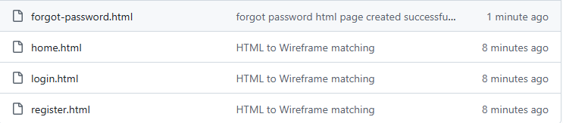
+ created images folder

