Jordan Taylor
Oct. 20, 2014

Analysis of Experiments for Download Accelerator

After finishing the download accelerator program at my home, I ran experiments.py from my personal desktop computer. I ran the tests on an Ubuntu 14.04 64-bit OS with an i7 processor and 16 Gb of RAM. The network connection is a wireless network connected to HousingWireless (BYU provided internet at Wymount Terrace). Here are the results of my initial tests:

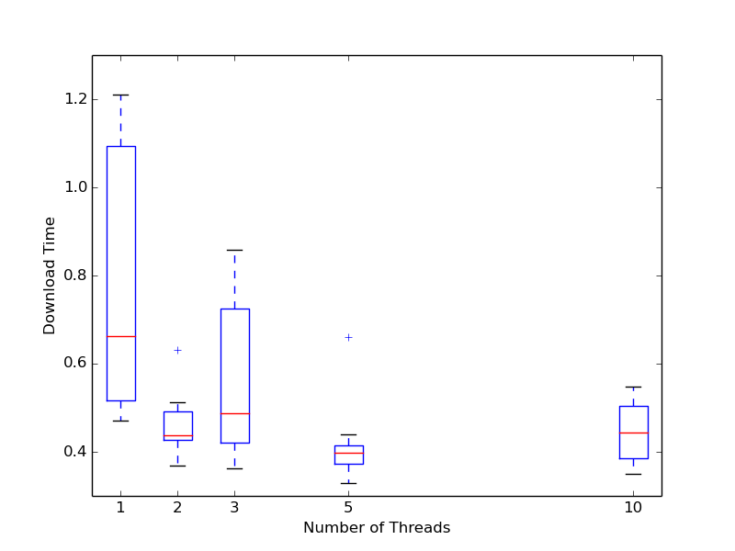
Figure 1.1 (1Mb file at home)
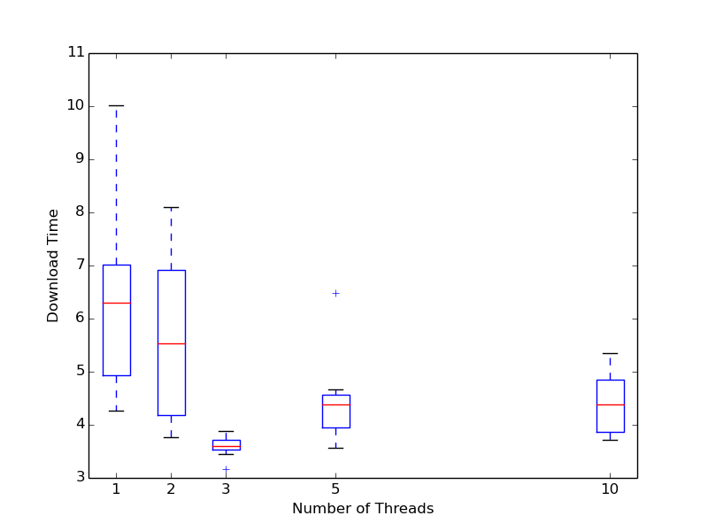
Figure 1.2 (10Mb file at home)

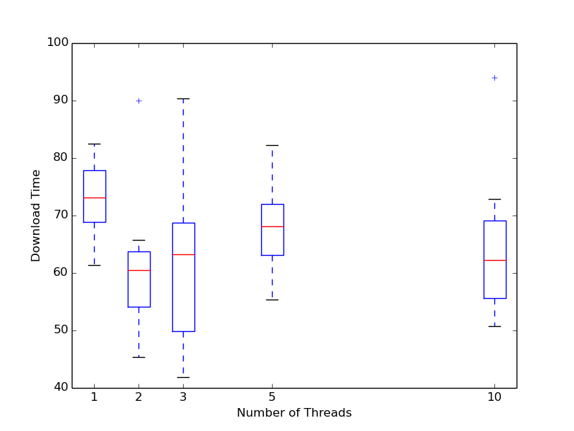
Figure 1.3 (100Mb file at home)
As you can see, there does not seem to be much difference between any number of threads. This puzzled me and so I did a few more tests of my own checking each threads download speed. As it turned out, with one thread I could get about 1.17 Mb/s speeds, but when I added more threads, their cumulative speed was about the same as 1 thread. I hypothesized that perhaps it was a limit of the wireless network I was on (my wife was also having connection issues on her laptop) and so I ssh'ed into a computer on campus and copied my code over to rerun the tests.
The tests on the machine on campus completed much quicker, which I attribute either to a much faster connection or perhaps the files were cached somewhere on the network. Either way, the results were much more agreeable with expected outcomes. And as such I shall be analyzing them as my results. Here are the results from the on campus testing:

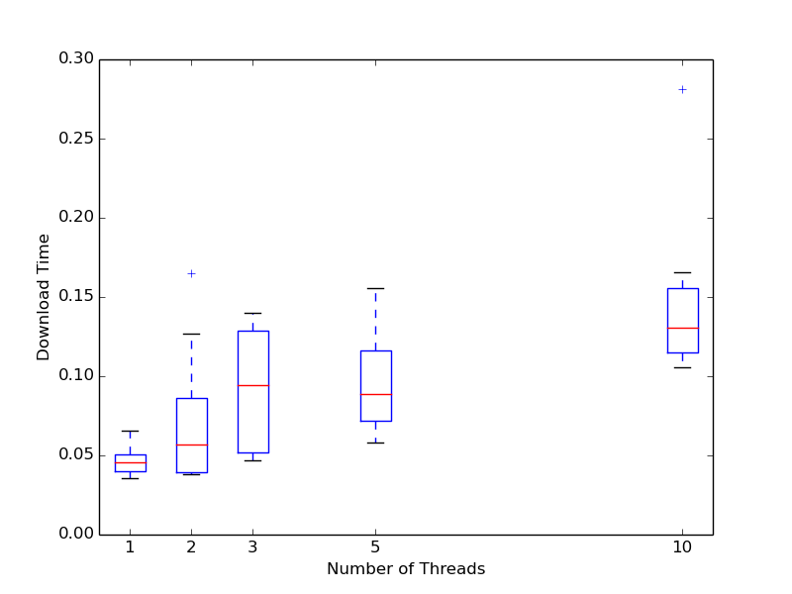
Figure 2.1 (1Mb file on campus)
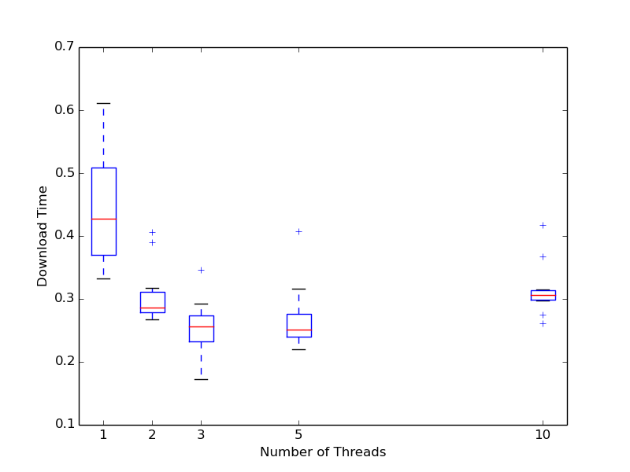
Figure 2.2 (10Mb file on campus)

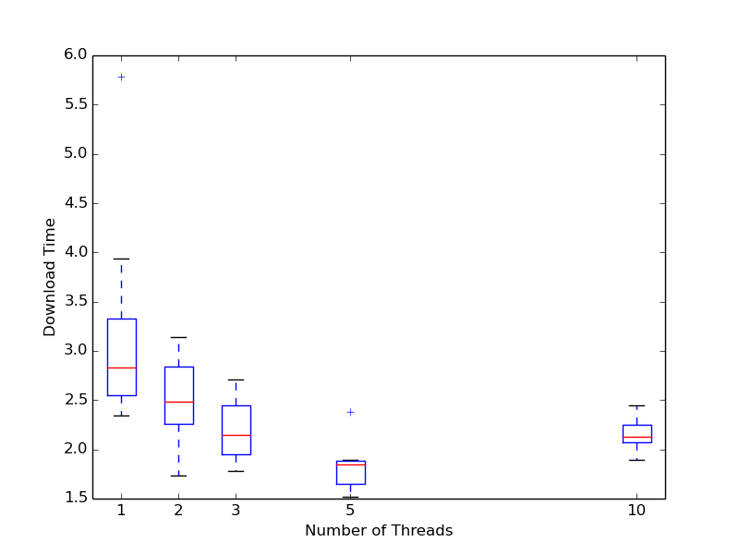
Figure 2.3 (100Mb file on campus)

From these results we can see that when the file size is small as in Figure 2.1, adding more threads actually slows down the overall process. Where as, in figures 2.2 and 2.3 we see measurable decreases in download time up to a certain point (3-5 threads in these examples) and then additional threads don't seem to give any benefit.
Looking back and comparing the results of my tests at home and those on the campus machine I can start recognize similar patterns in my home results. However, due to the unreliable network connection and speed, the results are far more erratic and less reliable.

