**Epic Hyperspace BI Viewer App.**

***Prototype application for embedding Power BI into Hyperspace***

This application is a modified version of Microsoft’s PowerBIEmbed_AppOwnsData application. The modifications include:

* Limit app to embedding Power BI reports
* Change method for identifying the report workspace ID and the report ID from being identified in the Web.Config file to being parameters in the EmbedReport URL

You will need to update the Web.Config file with the following values:

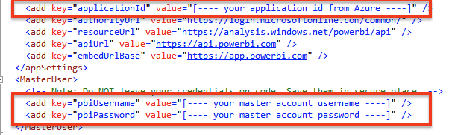

The applicationId value comes from your Web App registration within Azure

The pbiUsername and pbiPasswords are from the account you wish to use as the master account. Note: This is a prototype application. For production, you should not store raw credential values in your web.config file. At a minimum you should encrypt them and then create a helper function to decrypt them for use. Other options are also available including Azure Key Vault or AWS Secrets Manager to name a couple.