Comprehensive Report on Cancer and its Statistics
Cancer is a complex group of diseases characterized by the uncontrolled growth and spread of abnormal cells in the body. It is a leading cause of death globally, but ongoing research and advancements in treatment are continually improving outcomes.

What is Cancer?
Cancer begins when the orderly process of cell growth, division, and death breaks down. This malfunction is primarily due to genetic changes (mutations) in the cell's DNA, which control cell function.

How Cancer Develops:
- Genetic Changes: Mutations occur in genes that regulate cell growth and division. These can be inherited or acquired through environmental factors (e.g., tobacco smoke, UV radiation, viruses).
- Uncontrolled Proliferation: The mutated cells ignore the normal signals that tell them to stop dividing or to die (a process called apoptosis), leading to rapid, uncontrolled growth.
- Tumor Formation: These abnormal cells may clump together to form a mass of tissue called a tumor.
  - Benign Tumors are non-cancerous; they do not spread.
  - Malignant Tumors are cancerous; they can invade nearby tissues.
- Metastasis: Malignant cells can break away from the original (primary) tumor and travel through the blood or lymphatic system to form new tumors in distant parts of the body. This spread is called metastasis.
Cancer is typically named for the part of the body where it started. For instance, cancer that begins in the breast and spreads to the lung is still called metastatic breast cancer.
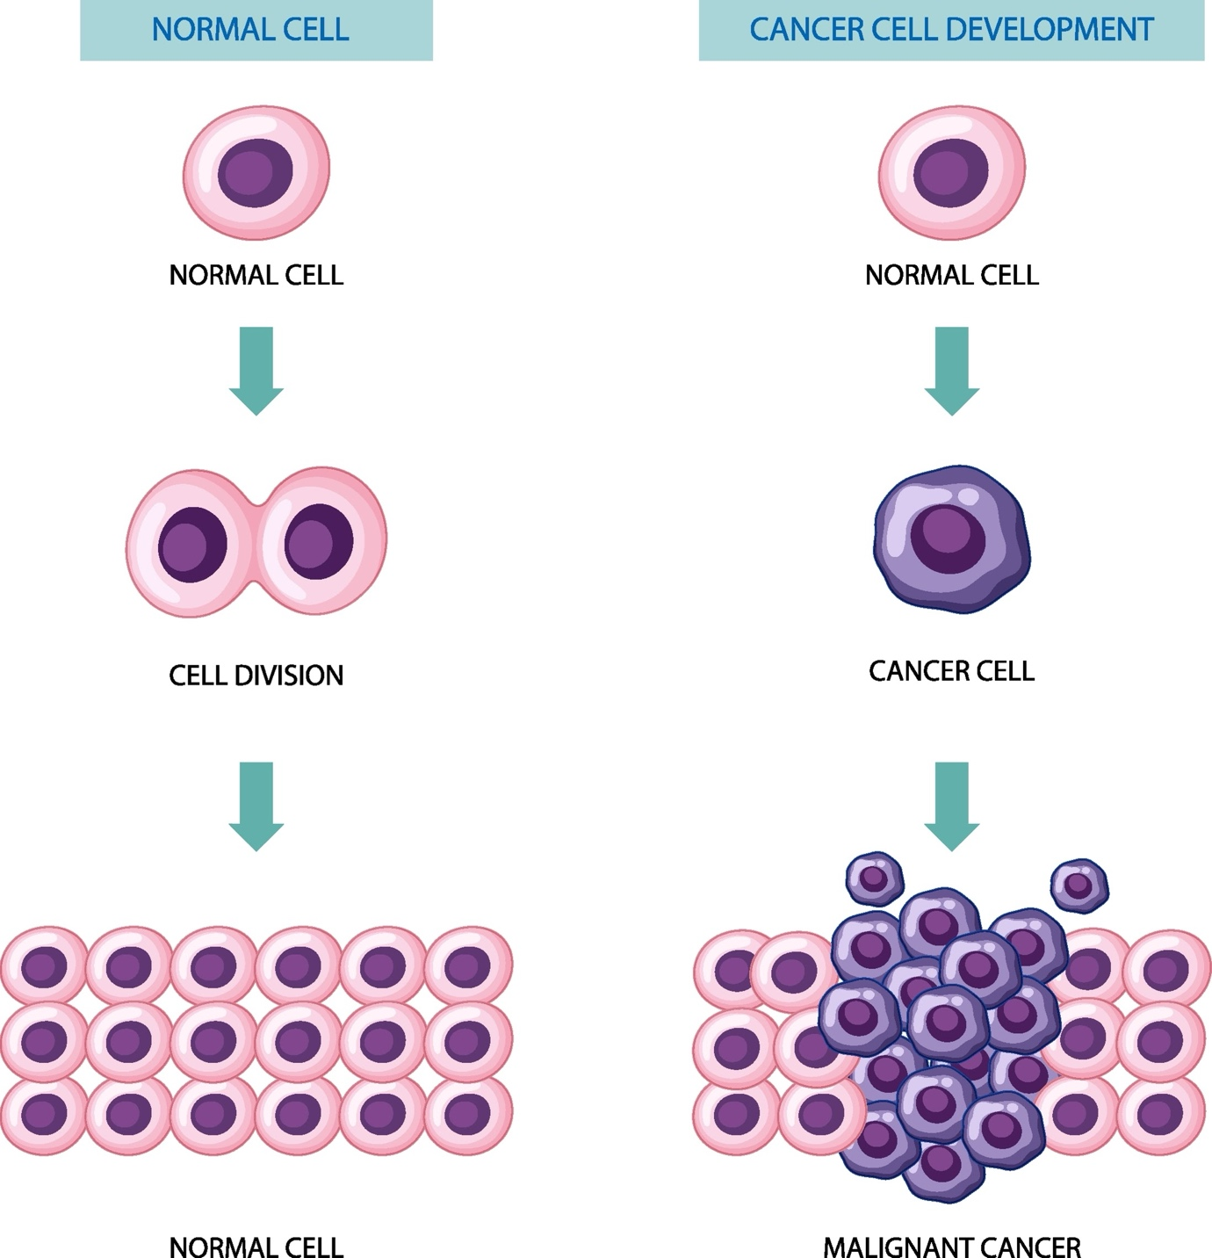
Shutterstock

Global Cancer Statistics (Based on Recent Data/Estimates)
Cancer represents a significant global health burden, with millions of new cases and deaths reported annually.

Global Estimates (Based on 2022 Data/Projections):
- New Cases: Approximately 20 million new cancer cases were diagnosed worldwide in 2022.
- Deaths: Around 9.7 million people died from the disease globally in 2022.
- Future Projection: Based on projected population growth, the number of new cancer cases is predicted to increase to 35 million by 2050.

Common Cancer Types by Incidence:
The most frequently diagnosed cancers globally vary slightly by sex:
Sex | Most Common Cancers (Incidence)
Men | Lung, Prostate, Colorectal, Stomach, Liver
Women | Breast, Colorectal, Lung, Cervical, Thyroid

Estimated Most Common Cancers (US Projections for 2025):
Rank (New Cases) | Cancer Type | Estimated New Cases (2025) | Estimated Deaths (2025)
1 | Breast (Female & Male) | 319,750 | 42,680
2 | Prostate | 313,780 | 35,770
3 | Lung & Bronchus | 226,650 | 124,730
4 | Colon and Rectum | 154,270 | 52,900
Note: Lung and bronchus cancer remains the leading cause of cancer death, accounting for about 20% of all cancer deaths.

Advances in Cancer Treatment and Research
Significant progress is continually being made in the diagnosis and treatment of cancer, leading to improved survival rates for many types.

Key Treatment Modalities:
- Surgery: Physically removing the tumor.
- Radiation Therapy: Using high-energy particles or waves to kill cancer cells.
- Chemotherapy: Using drugs to kill fast-growing cells, including cancer cells.

Modern Advancements:
- Targeted Therapy: Drugs that specifically target the genetic changes, proteins, or other molecules that drive cancer growth. These often have fewer side effects than traditional chemotherapy.
- Immunotherapy: Treatments that harness a patient's own immune system to fight cancer.
  - Immune Checkpoint Inhibitors (ICIs): Drugs that block proteins (checkpoints) on immune cells or cancer cells, effectively releasing the brakes on the immune system to allow it to attack the tumor.
  - CAR T-cell Therapy: A personalized treatment where a patient's T-cells (a type of immune cell) are collected, genetically engineered to target specific cancer cells, multiplied, and then infused back into the patient.
  - mRNA Technology: Research is exploring the use of mRNA technology (similar to COVID-19 vaccines) to create personalized cancer vaccines that train the immune system to recognize and attack tumor cells.
- Precision Medicine: The practice of using genetic sequencing of a patient’s tumor to identify specific mutations and select the most effective, personalized treatment plan.
Cancer mortality rates continue to decline in many countries due to a combination of lower smoking rates, earlier detection for certain cancers (like breast, colorectal, and prostate), and improved treatments. However, alarming disparities persist, with certain racial and socioeconomic groups experiencing higher mortality rates.

