ABSA DBaaS Delivery Platform
(Aligned to ABSA DBaaS Strategy 2026)

Document date: 2026-02-11
Version: 0.9 Draft
Owner: <ABSA_OWNER> | Delivery partner: RedMPS
ADO Org: https://dev.azure.com/absarails/ | ADO Project: <ADO_PROJECT>

Context
This document defines a reference architecture and delivery design for the ABSA DBaaS Delivery Platform. It covers Terraform, Huawei Cloud Stack (HCS), and Azure DevOps Services delivery patterns under enterprise banking constraints.
This is a technical design. It uses placeholders where ABSA confirmations are outstanding. It prioritises security, auditability, and automation.

Audience
ABSA platform engineering, DB engineering, security, risk, audit, and service management stakeholders. Delivery partner engineering teams supporting implementation.

Scope
- Azure DevOps Services setup for repos, pipelines, environments, approvals, evidence artifacts.
- Three pipelines: RBAC, INFRA, DB.
- Terraform module strategy to provision HCS RDS for PostgreSQL first, then MySQL.
- DRS migration factory approach for on-prem source migrations into HCS targets.
- Monitoring and observability approach with Prometheus and Grafana, with Huawei Cloud Eye integration where appropriate.
- Operational runbooks, examples, and evidence pack approach.

Out of scope
- Detailed application refactoring and application release management design.
- Detailed ABSA enterprise vault product selection and vendor-specific integration steps (vault platform name is pending).
- Exact HCS region naming, proxy allowlists, and egress IPs (pending ABSA network confirmation).
- Non-listed database engines.

Known context and placeholders

Recent discovery updates (as of 2026-02-12)
Discovery item | Confirmed value |  | Status |  | Design impact
Azure DevOps platform | Azure DevOps Services (SaaS) at https://dev.azure.com/absarails/ |  | Confirmed |  | Use ADO Environments for approvals. Use self-hosted agents in HCS for runtime.
Repo strategy preference | Option A preferred: three repos (rbac, infra, db). Option B supported. |  | Confirmed |  | Implement strict isolation, separate state, separate identities and approvals.
HCS tenancy | Shared tenant with separate projects for DEV, PREPROD, PROD |  | Confirmed |  | Use per-project agencies and per-env pipeline identities. Avoid cross-project drift.
Availability zones | SDC-AZ-1 and Alice Lane-AZ-2 are primary AZs. Quorum is a separate DR site. |  | Confirmed |  | Design for AZ-local HA. Treat Quorum as DR for evidence archives and optional monitoring.
Pipeline runtime | Self-hosted Azure DevOps agent on CentOS ECS inside HCS |  | Confirmed |  | Ansible and Terraform tooling installed via hardened baseline. Agent health monitored.
Credentials | Prefer temporary credentials. Secrets stored in ABSA enterprise vault platform (name pending). |  | Confirmed |  | No secrets in ADO at rest. Use vault retrieval and token exchange at runtime.
Terraform state | Current remote state hosted on Huawei-provisioned HCS instance. OBS is available. |  | Confirmed |  | Recommend migration to OBS backend with encryption and retention controls.
Migration tooling | DRS is available. First wave sources are on-prem. |  | Confirmed |  | Build DRS migration factory with validation, cutover, rollback, and evidence packs.
Configuration management | ABSA uses Ansible for OS and tooling configuration |  | New discovery |  | Add Ansible stages to INFRA and DB pipelines for agent/monitoring hosts and exporters.
Observability preference | Prometheus and Grafana are allowed. Retention strategy is unknown. |  | Confirmed |  | Provide central vs per-DC options and long-term storage selection criteria (Thanos/Cortex/VictoriaMetrics).
Item |  | Known |  | Placeholder or to confirm
ADO org |  | Azure DevOps Services |  | https://dev.azure.com/absarails/
ADO project |  | Shared project for repos and pipelines |  | <ADO_PROJECT>
Repo strategy |  | Provide Option A and Option B |  | Recommended: Option A for isolation
HCS tenancy |  | Shared tenant |  | Projects: <HCS_PROJECT_DEV>, <HCS_PROJECT_PREPROD>, <HCS_PROJECT_PROD>
Data centres / AZ |  | SDC-AZ-1, Alice Lane-AZ-2, Quorum |  | Confirm region mapping. Quorum is separate DR site.
Pipeline runtime |  | Self-hosted ADO agent |  | ECS VM (CentOS) at <AGENT_ECS_IP>, access via <JUMP_HOST>
Auth patterns |  | AK/SK and agency / assumed role |  | Prefer temporary credentials. Vault name to confirm.
Remote state |  | Hosted on Huawei provisioned HCS instance |  | Recommend OBS based backend with encryption, versioning, WORM, and lock strategy
Service management |  | ServiceNow used |  | Change ticket integration patterns to implement
Phase 1 |  | PostgreSQL RDS first, then MySQL |  | Instance sizing and HA posture to confirm in discovery
DRS |  | Available |  | On-prem sources. Stakeholder constraints to confirm

Document control
Classification: Internal Only.
Change control: update via pull request, with review by ABSA lead engineers and RedMPS, and approval via CAB process for PROD impacting changes.

13.1 Reference architecture (Diagrams)

13.1.1 Strategic alignment mapping (ABSA DBaaS Strategy 2026)
This mapping links ABSA DBaaS Strategy 2026 themes to explicit design decisions, implementable tasks, and measures of success.
Strategy theme | Design decision | Implementation tasks | Measures of success
Minutes-level provisioning and infrastructure delivery | Use Terraform modules and ADO YAML pipelines with PR plan and gated apply. Standardise templates and self-service request inputs. | Build module library for RDS and network. Implement PR validate and plan and environment gated apply stages. Automate evidence pack creation and retention. | Median time from approved request to provisioned DEV instance in minutes. Automated apply success rate. Reduced manual L1 and L2 tickets.
>=99.99% uptime aspiration for critical services by Q4 2027 | Design for HA at multiple layers. Multi-AZ RDS for critical tiers. Separate failure domains for agents and monitoring. | Define service tiers. Implement HA defaults in modules. Implement monitoring and SLO based alerting. Run restore tests and DR drills. | SLO compliance. RTO and RPO achieved in tests. Availability dashboards. Incident MTTR reduction.
Prioritise automation to reduce manual L1 and L2 work | Pipeline driven operations. Ansible for repeatable OS and DB runbooks. Standard evidence packs for audit and change. | Build Ansible roles for agent bootstrap, monitoring, DB validation. Integrate ServiceNow change checks. Capture logs and outputs. | Reduction in manual runbooks. Fewer repeat incidents. Measured automation coverage by runbook.
Product and engine focus and Oracle reduction | Standardise patterns for PostgreSQL and MySQL first. Provide governed migration factory. Sustain MSSQL only where needed. Reduce Oracle exposure via controlled migrations. | Phase plan for PostgreSQL then MySQL. Define Oracle sustain policies and migration playbooks. Track Oracle estate reduction as programme measure. | Percentage of workloads on open-source engines. Oracle instance count reduction. Audit of exceptions.
Migration to Huawei Cloud Stack at scale for open-source databases | Use DRS wave factory with standard prerequisites and validation gates. Separate migration identity and strict approvals. | Build DRS task templates. Build validation and cutover checklists. Standardise rollback approach. Operationalise wave reporting. | Predictable wave throughput. Migration success rate. Lag within thresholds. Reduced downtime.
Unified observability with AI-enabled monitoring direction | Prometheus and Grafana as baseline. Export to Huawei Cloud Eye where needed. Provide integration hooks to ABSA enterprise tools. | Deploy Prometheus and Grafana with HA options. Define exporters. Implement log correlation and evidence retention. Document integration APIs. | Coverage of golden signals. Alert fatigue reduction. Mean time to detect improved. Trend analytics and capacity forecasting.

13.1.2 End to end workflow: PR to plan to approval to apply to evidence pack
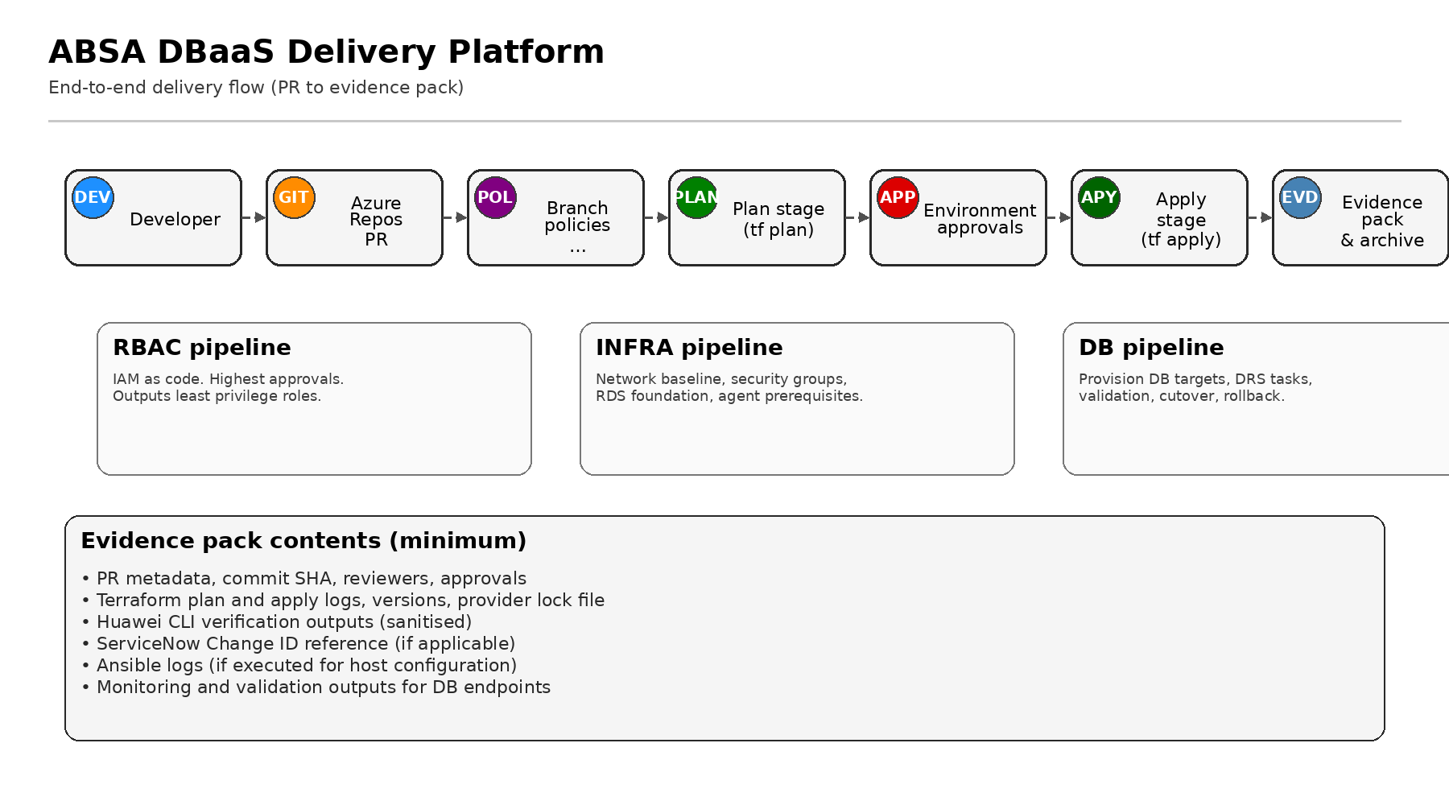
Figure 13.1.2: PR to plan to approval to apply to evidence pack

13.1.3 Identity model: humans vs pipeline identities
Principles: least privilege, separation of duties, and environment isolation. Use named human identities for interactive access. Use separate pipeline identities per pipeline and environment.
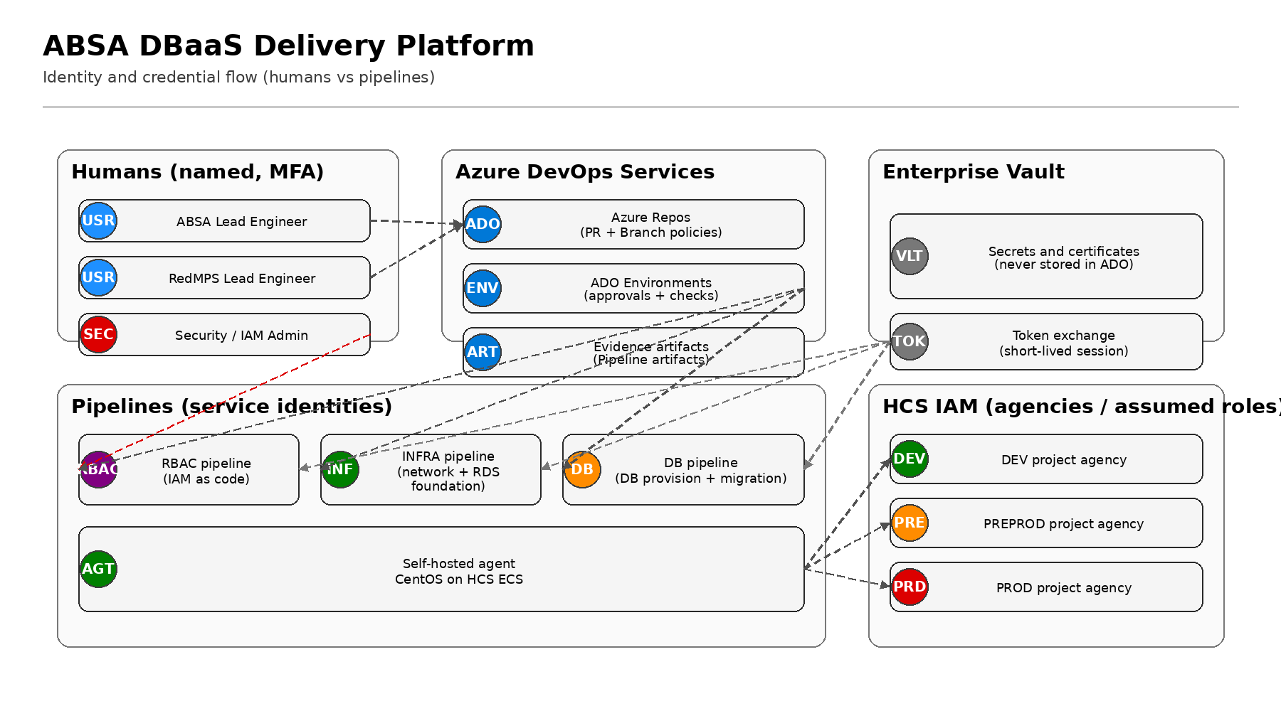
Figure 13.1.3: Humans vs pipeline identities and temporary credential flow

13.1.4 Network model: agent placement, connectivity, proxies, allowlists, DC flows
Assumptions: A self-hosted Azure DevOps agent runs on an HCS ECS CentOS VM in each major environment. Outbound access to Azure DevOps Services is required. Confirm proxy and allowlists with ABSA network teams.
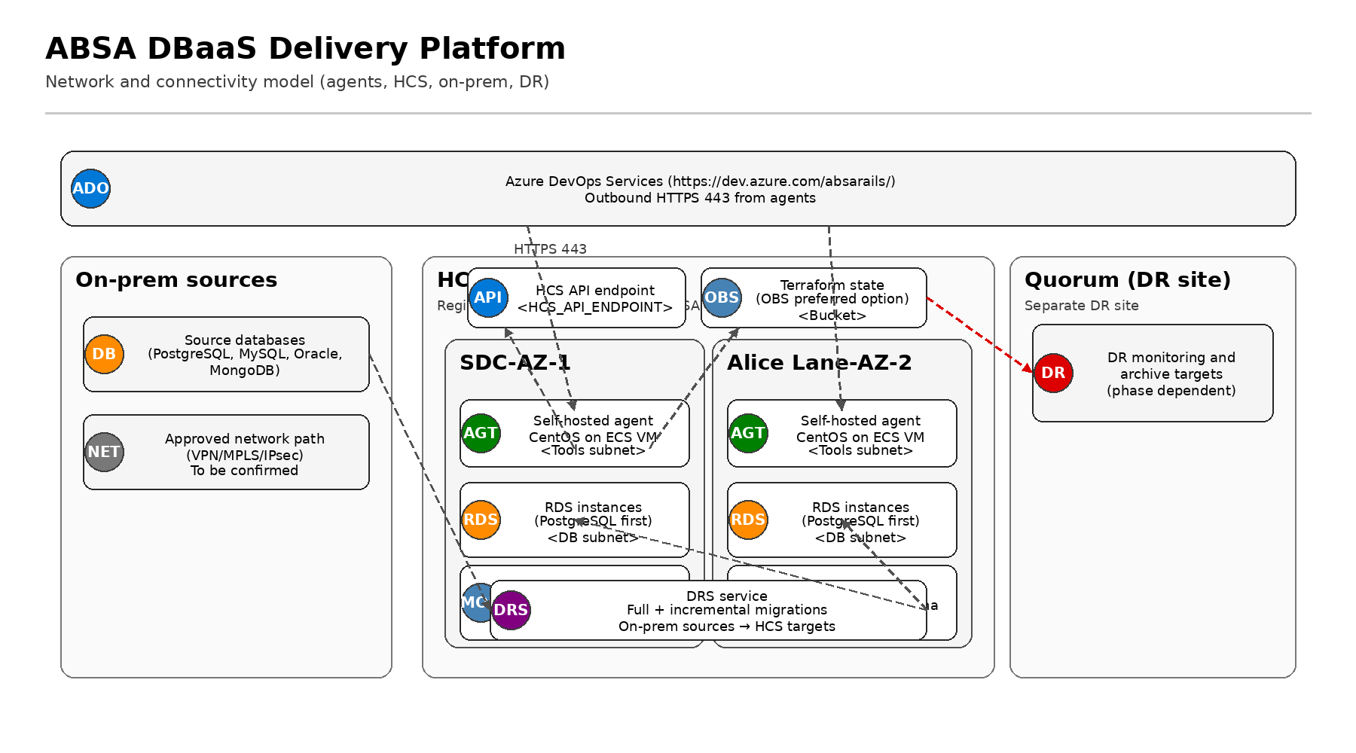
Figure 13.1.4: Network model and connectivity flows

13.1.5 State management: backend options, encryption, locking, retention, recovery
Current state hosting is on an HCS instance provisioned by Huawei. This design recommends a portable and auditable state backend. Recommended option is OBS with encryption and retention controls.
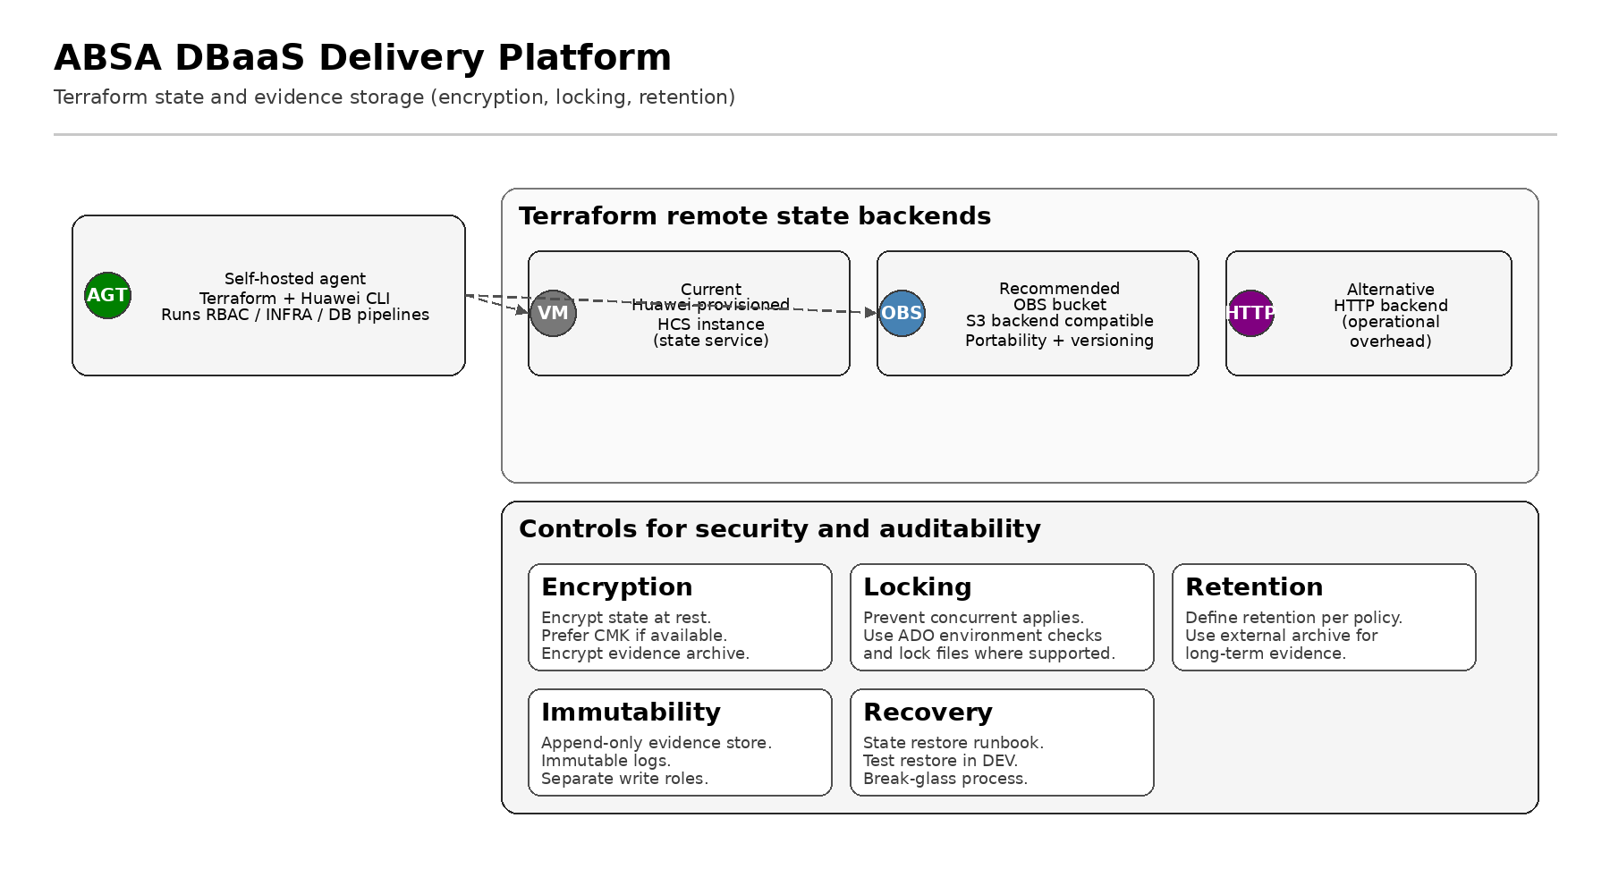
Figure 13.1.5: Terraform state backend options and control model

13.1.6 Observability reference architecture (Prometheus, Grafana, Huawei Cloud Eye)
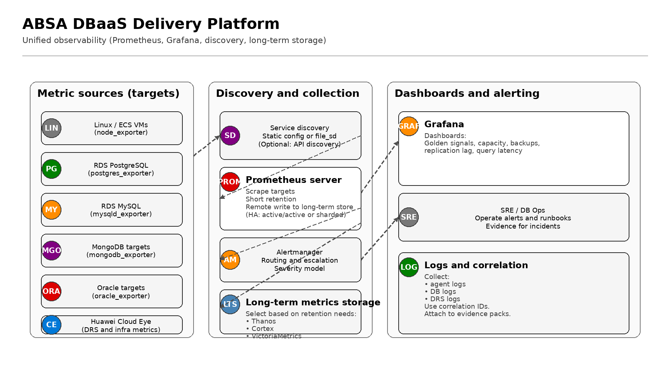
Figure 13.1.6: Observability architecture on white background (Prometheus and Grafana)

13.2 Azure DevOps setup guide (step by step with examples)

13.2.1 Recommended Azure DevOps project structure
Recommendation: one Azure DevOps project for the ABSA DBaaS Delivery Platform, hosting repos and pipelines together. This simplifies audit traceability and reduces cross-project permission complexity. The infra team will align to ABSA confirmation for the final project name and repo URLs.
Key control: implement strict repo and branch permissions, protected resources, and environment approvals. Azure DevOps permissions and security groups provide the base access model. (Ref: MS-PERMS)

13.2.2 Repo setup for both repo options
ADO Git repos are recommended. Azure Repos supports pull requests and branch policies for governance. (Ref: MS-BRANCH, MS-PR)
Placeholders: <ADO_PROJECT>, <REPO_URL>.
Option | Layout | Security posture and blast radius | Auditability and evidence traceability | Operational overhead | Recommended ownership and approvals
Option A (recommended default) | Three repos:  - absa-dbaas-rbac  - absa-dbaas-infra  - absa-dbaas-db | Strong isolation. Smaller blast radius. Clear separation of duties. Each repo can have distinct permissions and policies. | High. Evidence packs per pipeline and repo. Clear audit trail per domain. | Medium. Three repos and pipelines to manage. Clear ownership boundaries reduces incidents. | RBAC: ABSA security and IAM owners approve.  INFRA: ABSA platform and network owners approve.  DB: ABSA DB engineering owners approve.  RedMPS implements with ABSA lead engineer approvals.
Option B (alternative) | Single repo with folders:  /rbac  /infra  /db  Separate pipelines, state, identities. | Moderate. Isolation via folder permissions and CODEOWNERS. Risk if misconfigured. Larger repo-wide blast radius. | Medium. Still possible but requires strict folder governance and evidence discipline. | Lower. One repo, simpler administration. Requires stronger policy enforcement for folder boundaries. | Same functional owners, but approvals must be enforced via CODEOWNERS and branch policies. Folder boundaries must be reviewed by ABSA security.
Recommendation: implement Option A first for isolation. Maintain Option B pattern as a contingency if ABSA mandates a single repo for platform reasons.

13.2.3 Branching model and policy settings (banking constraints)
Recommended model: trunk-based delivery with short-lived feature branches and protected main branch. Release artefacts are promoted through environments using approvals and checks rather than long-lived release branches. This supports speed while maintaining strict change control.
Use pull requests to merge into main. Enforce branch policies on main. Azure Repos supports these branch policies. (Ref: MS-BRANCH)
Setting | Recommended value (main) | Rationale | Microsoft reference
Minimum reviewers | 3 for PREPROD/PROD repos. 2 for DEV if required. Block on failure. | Enforces peer review and segregation of duties. Azure DevOps supports minimum reviewer policies. (Ref: MS-BRANCH) | MS-BRANCH
Prohibit most recent pusher approving | On | Supports segregation of duties. Azure DevOps supports prohibiting the most recent pusher vote counting. (Ref: MS-BRANCH) | MS-BRANCH
Allow requestor approval counting | Off | Prevents self-approval. Azure DevOps allows control of requestor vote counting. (Ref: MS-BRANCH) | MS-BRANCH
Check for linked work items | Required in PREPROD/PROD. Optional in DEV during bootstrap. | Ensures traceability. Azure DevOps supports work item linking policy. (Ref: MS-BRANCH) | MS-BRANCH
Check for comment resolution | Required | Ensures review feedback is resolved. Azure DevOps supports comment resolution policy. (Ref: MS-BRANCH) | MS-BRANCH
Build validation | Required. Terraform fmt, validate, tflint, tfsec or equivalent, and terraform plan on PR. | Ensures code quality before merge. Branch policies can require build validation. (Ref: MS-BRANCH) | MS-BRANCH
Limit merge types | Squash merge only | Creates linear history and clearer audit. Azure DevOps can limit merge types. (Ref: MS-BRANCH, MS-SQUASH) | MS-BRANCH
Required status checks | Required. Use PR status policy for external scanners if used. | Integrates additional checks into PR workflow. Azure DevOps supports PR status policies. (Ref: MS-STATUS) | MS-STATUS
Bypass policies | Restricted to ABSA platform admins. Deny bypass pushing. Allow bypass completion only for break-glass with CAB evidence. | Azure DevOps repository permissions include bypass policies when completing PRs and when pushing. Split permissions allow safer break-glass. (Ref: MS-REPOPERM) | MS-REPOPERM

13.2.4 Environments and approvals (DEV, PREPROD, PROD)
Use Azure DevOps Environments for gated apply steps. Environments support approvals and checks that must be satisfied before a stage that consumes the environment can start. (Ref: MS-ENV, MS-APPROVALS)
Create three environments: ABSA-DBAAS-DEV, ABSA-DBAAS-PREPROD, ABSA-DBAAS-PROD.
Approver model:
- DEV: ABSA lead engineer + RedMPS lead engineer (two-person rule).
- PREPROD: ABSA lead engineer + ABSA change manager or delegate.
- PROD: CAB approval evidence required. Approvers exclude the author and most recent pusher. Use separate approver group.

13.2.5 Agent pools and self-hosted agents (CentOS on HCS ECS)
Self-hosted agents are managed by you and provide control to install required tooling. (Ref: MS-AGENTS)
Create an agent pool per failure domain or per environment if required, for example: ABSA-DBAAS-Agents-Shared or ABSA-DBAAS-Agents-PROD. Agent pools are an organisation-scoped collection of agents in Azure Pipelines. (Ref: MS-POOLS)
Install and register the Linux agent on the CentOS ECS VM following Microsoft guidance. (Ref: MS-LINUXAGENT)

13.2.6 Service connections, resources, and protected resource checks
Pipelines rely on resources such as environments, service connections, agent pools, variable groups, and secure files. Resource checks allow the resource owner to control if and when a stage can consume the resource. (Ref: MS-APPROVALS)
Because HCS is not a native Azure resource, use one of these patterns:
- Pattern 1 (preferred): no service connection. Use temporary HCS credentials retrieved from ABSA vault at runtime and use Huawei CLI and Terraform providers from the agent.
- Pattern 2: use a generic service connection type only if ABSA security approves. Still retrieve secrets from vault at runtime.

13.2.7 Variable groups and secret model with enterprise vault integration
Azure Pipelines can store secrets as encrypted secret variables, including in variable groups. (Ref: MS-SECRETS)
ABSA requirement: no secrets stored in Azure DevOps at rest. Therefore, use variable groups for non-secret configuration only.
Vault integration patterns to implement (vault product name pending):
- Agent-side login to vault using a short-lived identity, then retrieve secrets via CLI or REST, then export to pipeline environment variables for the job.
- Token exchange pattern: retrieve a vault token, then request short-lived HCS temporary credentials for the pipeline run.
- Mask secret output. Never write secrets into evidence packs.

13.2.8 Boards setup: area paths, iteration paths, columns, WIP limits
Use Area Paths to group work by team or product area, and Iteration Paths to group work into sprints. (Ref: MS-AREAIT)
Recommended Area Paths:
- ABSA DBaaS Delivery Platform\RBAC
- ABSA DBaaS Delivery Platform\INFRA
- ABSA DBaaS Delivery Platform\DB
- ABSA DBaaS Delivery Platform\DRS
- ABSA DBaaS Delivery Platform\OBSERVABILITY
Recommended Iteration Paths:
- ABSA DBaaS Delivery Platform\2026\Sprint-01
- ABSA DBaaS Delivery Platform\2026\Sprint-02
- Continue quarterly and yearly
Board columns should match the operating model. Azure Boards supports configuring columns and WIP limits. (Ref: MS-COLUMNS, MS-WIP)
Example Kanban columns and initial WIP limits (tune based on throughput):
Column | Definition of done (summary) | WIP limit (example)
New | Ticket created. Scope described. Change ID linked if required. | No limit
Ready | Refined. Dependencies clear. Acceptance criteria set. | 10
In progress | Work started. Pipeline run linked. | 6
Review | PR open. Evidence draft attached. | 6
Approved | All branch policies pass. Ready to merge or deploy. | 4
Done | Merged and deployed. Evidence pack stored and linked to work item. | No limit

13.2.9 Dashboards and reporting (DORA style metrics and operational views)
Azure DevOps provides dashboards, charts, and widgets for tracking status and trends. (Ref: MS-DASHOVERVIEW)
Use Lead Time and Cycle Time widgets for flow metrics. (Ref: MS-LEADCYCLE)
Recommended dashboards:
- Delivery dashboard: lead time, cycle time, deployment frequency (from pipeline runs), change failure rate (from incident tags), MTTR (from incident tracking).
- Platform health dashboard: agent availability, pipeline success rates, time to provision, Terraform drift signals.
- Migration dashboard: DRS task health, lag, cutover readiness per wave.
If ABSA enterprise observability tools exist, integrate by exporting alerts and dashboard links. Do not duplicate the single source of truth. Maintain Prometheus and Grafana as the platform baseline.

13.2.10 Operational grounding: HCS CLI discovery and CentOS checks
This section provides operational commands used for incident response and evidence packs. Use placeholders where values are unknown.
Huawei KooCLI can be used to call cloud service APIs. You can list ECS servers using a command pattern shown by Huawei. (Ref: HW-KOOCLI-CONCEPT)
Example KooCLI commands:
# List ECS servers (example)
hcloud ECS NovaListServers --cli-profile=default
# View supported services and operations
hcloud --help
hcloud ECS --help
# obsutil version check (example)
./obsutil version
obsutil is a command line tool for OBS operations. (Ref: HW-OBSUTIL)
Linux host checks on CentOS (collect outputs into evidence pack):
# CPU
top -b -n 1 | head -50
vmstat 1 5
mpstat -P ALL 1 5
# Memory
free -m
vmstat 1 5
# Disk
df -h
lsblk
iostat -xz 1 5
# Network
ss -tulpn
ip a
sar -n DEV 1 5
ethtool <INTERFACE>
# Process and service
systemctl status vsts.agent* --no-pager
journalctl -u vsts.agent* --since "1 hour ago" --no-pager
Interpretation guidance:
- CPU: sustained high run queue, high iowait, or CPU steal indicates contention.
- Memory: swapping or low available memory indicates risk for pipeline failures.
- Disk: >80% utilisation or high disk await in iostat indicates bottlenecks for Terraform and logs.
- Network: high retransmits or errors indicate proxy or routing issues.
- Services: agent service not active or repeated restarts indicate stability issues.
Include these command outputs in the evidence pack for audit and post-incident reviews.

13.3 Pipeline designs and YAML skeletons (RBAC, INFRA, DB)
All pipelines follow the same control pattern: PR runs validate and plan only. Main runs plan, then requires Environment approval, then apply, then publishes an evidence pack.
Azure Pipelines supports multi-stage YAML pipelines using the stages keyword. (Ref: MS-STAGES)
Approvals and checks can gate deployments to environments. (Ref: MS-APPROVALS, MS-ENV)
Evidence packs are published as pipeline artifacts. (Ref: MS-PUBART)

13.3.1 Common controls (applies to all three pipelines)
- Separate pipeline identities per environment and per pipeline. RBAC, INFRA, and DB do not share credentials.
- Store no secrets in Git or ADO at rest. Retrieve secrets at runtime from ABSA enterprise vault platform (name pending).
- Use temporary HCS credentials where possible. Huawei IAM supports temporary access keys and security tokens. (Ref: HW-KOOCLI-AKSK)
- Prefer agency or ecsAgency based temporary credentials on ECS when supported. KooCLI supports ecsAgency mode to automatically obtain temporary credentials. (Ref: HW-ECSAGENCY)
- Publish evidence pack containing plan files, apply logs, approvals, change ID references, and key outputs. Exclude secrets.
- Immutable retention: store evidence packs in OBS with encryption and WORM retention if required. OBS supports server-side encryption and WORM retention. (Ref: HW-OBS-SSE, HW-OBS-WORM)

13.3.2 Evidence pack standard (all pipelines)
Evidence pack minimum contents:
- PR link, commit SHA, build number, pipeline run ID, timestamp, actor identity.
- Terraform fmt and validate outputs.
- Terraform plan file and human readable plan summary.
- Approval record (ADO Environment approval).
- terraform apply logs and outputs (sanitised).
- Ansible logs if executed.
- Change ID and ServiceNow references if applicable.
- Post-deploy validation outputs.
- State backend pointers (bucket, key prefix, version ID if available).
Retention recommendation: align to ABSA audit policy. If unknown, design for 7 years for PROD evidence and state logs, with WORM controls for audit readiness. Confirm with ABSA risk and compliance.

13.3.3 RBAC pipeline (IAM and role bindings as code)
Purpose: manage IAM, agencies, and minimum role bindings required by INFRA and DB pipelines. Highest approvals and strict change control. Separate state from INFRA and DB.
Output: environment service identities and the minimum roles needed by INFRA and DB pipelines.
PR behaviour: validate and plan only. Main behaviour: gated apply per environment.

RBAC pipeline stage structure
- Validate: terraform fmt, validate, static checks.
- Plan: terraform plan with RBAC state backend.
- Approve: manual approval via ADO Environment (highest control).
- Apply: terraform apply using RBAC identity.
- Evidence: publish evidence pack to pipeline artifacts and optionally to OBS.

RBAC pipeline YAML skeleton (minimal)
trigger:
branches:
include:
- main
pr:
branches:
include:
- main
variables:
TF_VERSION: "1.6.x"
ENVIRONMENT: "$(Build.SourceBranchName)" # map main deployments to selected env via runtime parameter
stages:
- stage: Validate
jobs:
- job: validate
pool: "ABSA-DBAAS-Agents-Shared"
steps:
- checkout: self
- bash: |
set -euo pipefail
terraform fmt -check -recursive
terraform validate
displayName: "Terraform validate"
- stage: Plan
dependsOn: Validate
jobs:
- job: plan
pool: "ABSA-DBAAS-Agents-Shared"
steps:
- checkout: self
- bash: |
set -euo pipefail
# Retrieve temporary credentials from ABSA vault here
terraform init -backend-config="key=rbac/$(ENVIRONMENT)/terraform.tfstate"
terraform plan -out plan.tfplan
displayName: "Terraform plan"
- publish: plan.tfplan
artifact: rbac-plan
- stage: Apply
dependsOn: Plan
condition: and(succeeded(), eq(variables['Build.SourceBranch'], 'refs/heads/main'))
jobs:
- deployment: apply
environment: "ABSA-DBAAS-$(ENVIRONMENT)"
strategy:
runOnce:
deploy:
steps:
- checkout: self
- bash: |
set -euo pipefail
terraform init -backend-config="key=rbac/$(ENVIRONMENT)/terraform.tfstate"
terraform apply -auto-approve plan.tfplan | tee evidence/terraform-apply.log
displayName: "Terraform apply"
- publish: evidence
artifact: evidence-pack
Notes:
- The bash step is supported in YAML pipelines. (Ref: MS-BASH)
- The publish step is a shortcut for PublishPipelineArtifact task. (Ref: MS-PUBLISHSTEP, MS-PUBART)
- Environments can be protected with approvals and checks. (Ref: MS-ENV, MS-APPROVALS)

13.3.4 INFRA pipeline (baseline network and RDS components)
Purpose: deploy baseline network, security groups, agent runtime prerequisites, monitoring prerequisites, and HCS RDS components. Use least privilege identity per environment.
Ansible integration: post-apply, run Ansible to configure the agent host and monitoring VMs. Ansible runs only from pipeline jobs and is captured in evidence logs.

INFRA pipeline stage structure
- Validate: terraform fmt, validate, tflint, security scanning.
- Plan: terraform plan with infra state backend.
- Approve: manual approval via ADO Environment for target env.
- Apply: terraform apply using INFRA identity.
- Configure: Ansible bootstrap for CentOS agent host and monitoring hosts.
- Evidence: publish evidence pack and key outputs.

INFRA pipeline YAML skeleton (minimal)
stages:
- stage: Validate
jobs:
- job: validate
pool: "ABSA-DBAAS-Agents-Shared"
steps:
- bash: |
set -euo pipefail
terraform fmt -check -recursive
terraform validate
displayName: "Validate"
- stage: Plan
dependsOn: Validate
jobs:
- job: plan
pool: "ABSA-DBAAS-Agents-Shared"
steps:
- bash: |
set -euo pipefail
terraform init -backend-config="key=infra/<ENV>/terraform.tfstate"
terraform plan -out plan.tfplan
displayName: "Plan"
- publish: plan.tfplan
artifact: infra-plan
- stage: Apply
dependsOn: Plan
condition: and(succeeded(), eq(variables['Build.SourceBranch'], 'refs/heads/main'))
jobs:
- deployment: apply
environment: "ABSA-DBAAS-<ENV>"
strategy:
runOnce:
deploy:
steps:
- bash: |
set -euo pipefail
mkdir -p evidence
terraform init -backend-config="key=infra/<ENV>/terraform.tfstate"
terraform apply -auto-approve plan.tfplan | tee evidence/terraform-apply.log
displayName: "Apply"
- bash: |
set -euo pipefail
ansible-playbook -i evidence/inventory.ini ansible/playbooks/agent_bootstrap.yml | tee evidence/ansible-agent.log
displayName: "Ansible agent bootstrap"
- publish: evidence
artifact: evidence-pack

13.3.5 DB pipeline (DB provisioning plus DRS migration workflows)
Purpose: provision DB targets and operate migration workflows. Includes DRS task configuration, validations, cutover checklist, rollback, and evidence. Use a separate migration identity with minimum permissions.
DRS supported databases and metrics are documented by Huawei. (Ref: HW-DRS-SUPPORTED, HW-DRS-METRICS)

DB pipeline stage structure
- Validate: Terraform and Ansible lint. Connectivity pre-checks.
- Plan: Terraform plan for DB resources and DRS tasks.
- Approve: manual approval via ADO Environment plus ServiceNow change checks if required.
- Apply: Terraform apply to create DB target and DRS resources.
- Migrate: configure DRS full plus incremental, monitor lag, run validations.
- Cutover: controlled cutover checklist, app smoke tests, confirm acceptance.
- Rollback: prepared rollback steps and decision gates.
- Evidence: publish evidence pack including DRS status exports and validation outputs.

DB pipeline YAML skeleton (minimal)
stages:
- stage: Validate
jobs:
- job: validate
pool: "ABSA-DBAAS-Agents-Shared"
steps:
- bash: |
set -euo pipefail
terraform fmt -check -recursive
terraform validate
ansible-playbook --syntax-check ansible/playbooks/db_validate.yml
displayName: "Validate Terraform and Ansible"
- stage: Plan
dependsOn: Validate
jobs:
- job: plan
pool: "ABSA-DBAAS-Agents-Shared"
steps:
- bash: |
set -euo pipefail
terraform init -backend-config="key=db/<ENV>/terraform.tfstate"
terraform plan -out plan.tfplan
displayName: "Plan"
- publish: plan.tfplan
artifact: db-plan
- stage: ApplyAndMigrate
dependsOn: Plan
condition: and(succeeded(), eq(variables['Build.SourceBranch'], 'refs/heads/main'))
jobs:
- deployment: apply
environment: "ABSA-DBAAS-<ENV>"
strategy:
runOnce:
deploy:
steps:
- bash: |
set -euo pipefail
mkdir -p evidence
terraform init -backend-config="key=db/<ENV>/terraform.tfstate"
terraform apply -auto-approve plan.tfplan | tee evidence/terraform-apply.log
displayName: "Apply DB and DRS resources"
- bash: |
set -euo pipefail
# Run DRS validations and capture output
ansible-playbook -i evidence/inventory.ini ansible/playbooks/db_validate.yml | tee evidence/db-validate.log
displayName: "DB validations"
- bash: |
set -euo pipefail
# Placeholder: DRS start/monitor steps via API/CLI once ABSA confirms patterns
echo "DRS start and lag monitoring steps here" | tee evidence/drs-ops.log
displayName: "DRS operate"
- publish: evidence
artifact: evidence-pack
ServiceNow integration pattern (recommended):
- Pipeline requires a <CHANGE_ID> variable for PREPROD and PROD. Validate the format and presence in the validate stage.
- Optionally call ServiceNow API to confirm the change is approved before apply. Implement using a dedicated integration identity and ABSA approved network path.
- Attach evidence pack links back to the change record when ABSA confirms the attachment target.
13.4 Terraform module strategy (RDS first)

13.4.1 Repo layout standards
Apply consistent structure across RBAC, INFRA, and DB repos. Example layout for each repo:
/
README.md
/modules
/<module-name>
main.tf
variables.tf
outputs.tf
versions.tf
README.md
/environments
/dev
main.tf
backend.hcl
tfvars.example
/preprod
main.tf
backend.hcl
tfvars.example
/prod
main.tf
backend.hcl
tfvars.example
/pipelines
azure-pipelines.yml
/templates
/ansible # INFRA and DB repos only, if used
/runbooks
/scripts

13.4.2 Module interfaces for PostgreSQL RDS first, then MySQL
Module design principles:
- Stable interfaces. Avoid leaking provider-specific constructs to callers where possible.
- Defaults enforce ABSA naming and tagging. Inputs allow only controlled overrides.
- Validations reject non-compliant names, missing tags, and invalid environment values.
- Support separate projects per environment by parameterising <HCS_PROJECT_DEV> etc.
Example module interface (PostgreSQL RDS):
# modules/rds-postgresql/variables.tf (example)
variable "env" { type = string } # DEV, PREPROD, PROD
variable "project_id" { type = string } # <HCS_PROJECT_DEV> etc
variable "name" { type = string } # enforced pattern
variable "engine_version" { type = string } # to confirm supported versions
variable "instance_class" { type = string } # sizing from discovery
variable "storage_gb" { type = number }
variable "multi_az" { type = bool }
variable "subnet_id" { type = string }
variable "security_group_ids" { type = list(string) }
variable "kms_key_id" { type = string } # if CMK required
variable "maintenance_window" { type = string }
variable "backup_retention_days" { type = number }
variable "tags" { type = map(string) } # enforced minimum set
MySQL RDS module follows the same interface shape with engine-specific parameters. Keep the common baseline inputs consistent to reduce operational overhead.

13.4.3 Naming and tagging enforcement
Enforce naming and tagging at module boundary. Reject plans that miss minimum tags.
Minimum tags (extend as needed): env, owner, costCentre, changeId, dataClass, drTier, createdBy, repo, pipelineRunId.
Example validation pattern:
# Example Terraform validation (pseudo)
validation {
condition = can(regex("^absa-dbaas-[a-z0-9-]+$", var.name))
error_message = "Name must match absa-dbaas-<service>-<env>-<seq>."
}

13.4.4 Remote state separation and backend options
State separation is mandatory:
- RBAC state: separate backend key prefix rbac/<env>/terraform.tfstate
- INFRA state: separate backend key prefix infra/<env>/terraform.tfstate
- DB state: separate backend key prefix db/<env>/terraform.tfstate
Recommended backend option: OBS bucket with server-side encryption and retention controls.
OBS supports server-side encryption at rest. (Ref: HW-OBS-SSE)
OBS supports SSE-KMS using KMS keys. (Ref: HW-OBS-SSEKMS)
OBS supports bucket versioning and lifecycle management. (Ref: HW-OBS-VERSION, HW-OBS-LIFECYCLE)
OBS supports WORM retention to prevent tampering. (Ref: HW-OBS-WORM)
Locking:
- If using an S3-compatible backend, Terraform can support state locking with a separate lock store. Confirm available lock services in HCS.
- Alternative: implement a small HA lock service (for example, Consul) in a dedicated tools subnet. Restrict access to pipeline identities only.
- Document lock recovery steps and include in runbooks.

13.4.5 Pinned Terraform and provider versions plus offline distribution
Pin versions to reduce drift and support change control.
Recommendations:
- Pin Terraform version in versions.tf and in pipeline tool bootstrap.
- Pin provider versions. Test upgrades in DEV, then PREPROD, then PROD.
- Offline distribution strategy: host Terraform binaries and provider plugins in an ABSA approved artifact repository. Use a providers mirror to avoid internet dependency.
- Evidence: include tool versions in evidence pack output for audit.

13.5 RDS first implementation plan (DEV then PREPROD)

13.5.1 Phase 1 objectives and scope
Phase 1 deploys hardened PostgreSQL RDS end to end in DEV, then PREPROD. It then deploys MySQL RDS using the same baseline patterns. Later phases cover MongoDB, Oracle sustain, and additional engines as directed by ABSA.
RDS service capabilities and HA architecture are documented by Huawei. (Ref: HW-RDS-OVERVIEW)

13.5.2 HA posture options and tradeoffs
Option | DEV recommendation | PREPROD recommendation | Tradeoffs
Single instance (no standby) | Allowed only for non-critical DEV workloads and only by exception. | Not recommended. | Lowest cost. Lower availability. Not aligned to 99.99% aspiration for critical tiers.
Primary/standby or multi-AZ | Preferred default for DEV for realistic testing where cost allows. | Default for PREPROD and critical services. | Higher cost. Better availability. Supports resilience goals. Huawei documents HA architectures for RDS services. (Ref: HW-RDS-OVERVIEW)
Cross site DR (Quorum as DR site) | Not required in early DEV unless testing. | Plan in later phases for critical services, if Quorum is a separate DR site. | Higher complexity. Requires tested runbooks and replication or backup restore patterns.

13.5.3 Backup strategy
Discovery indicates Commvault may be used for backups. Confirm ABSA backup scope and integration approach.
Best practice baseline:
- Enable automated backups and point in time recovery where supported. Confirm service capability per HCS version.
- Define backup retention by service tier. Example: DEV 7-14 days, PREPROD 30 days, PROD 30-90 days. Confirm compliance requirements.
- Perform regular restore tests. Include restore evidence in audit pack and exit criteria.
- If Commvault integration is required, implement as a managed backup workflow with evidence and monitoring.

13.5.4 Encryption at rest and in transit
At rest: use KMS-managed encryption where required by ABSA policy. Align with customer-managed keys where mandated.
For object storage used for state and evidence, OBS supports SSE-KMS. (Ref: HW-OBS-SSEKMS)
In transit: Huawei indicates RDS for PostgreSQL encrypts data in transit on the service page. Confirm exact configuration steps and enforcement per HCS version. (Ref: HW-RDS-PG-PAGE)
Implementation tasks:
- Define key ownership and rotation processes with ABSA security.
- Enforce TLS for client connections where supported.
- Store certificates and connection strings in vault. Do not store in ADO.

13.5.5 Parameter groups, maintenance windows, and patching
Standardise parameter groups per engine. Version control parameter group intent via Terraform where supported, or through controlled runbooks if not.
Baseline recommendations:
- Enable required logging for audit and performance diagnosis (subject to ABSA log policy).
- Set maintenance windows aligned to business low-traffic windows. Confirm with application owners.
- Adopt patch cadence: DEV monthly, PREPROD monthly after DEV validation, PROD under CAB approval with defined blackout periods.

13.5.6 Monitoring and alerting from day one
Huawei Cloud Eye monitors RDS instance metrics and provides delayed metrics by several minutes. (Ref: HW-RDS-CLOUDEYE)
DRS metrics can be monitored via Cloud Eye namespaces. (Ref: HW-DRS-METRICS)
Baseline monitoring stack: Prometheus and Grafana on dedicated ECS VMs. Prefer separate VM(s) to avoid agent workload contention.
Architecture options:
- Central per DC: one Prometheus HA pair per data centre, scraping local targets. Grafana federated or central.
- Per project: DEV and PREPROD have their own Prometheus. PROD separate. Strong failure domain isolation.
- Hybrid: per DC scrape plus central long-term store using Thanos or VictoriaMetrics. Select based on retention needs.
Long term metrics storage options and selection criteria:
Option | When to use | Pros | Cons
Thanos | Need long retention and object storage backing | Good integration with Prometheus. Uses object storage for blocks. | Operational complexity. Requires object storage and careful HA design.
Cortex | Need multi-tenant at scale | Strong multi-tenancy and horizontal scalability. | Operational complexity. Requires consistent hashing and storage planning.
VictoriaMetrics | Need simpler ops and long retention | Simpler deployment options. Efficient storage. | Different query semantics in some cases. Confirm compatibility with dashboards.
Exporter and metric sources:
- PostgreSQL: postgres_exporter.
- MySQL: mysqld_exporter.
- MongoDB: mongodb_exporter.
- Oracle: exporter based on ABSA licensing and policy, or integrate via enterprise tool if required.
- Linux: node_exporter on agent hosts, monitoring VMs, and supporting ECS.
- Pipeline executor health: custom exporter or systemd metrics for the ADO agent service.
- DRS migration monitoring: ingest lag and error metrics via Cloud Eye APIs where possible. (Ref: HW-DRS-METRICS)
Alerting model:
- Use Alertmanager for routing by severity and service tier.
- Define severities: Sev1 (customer impact), Sev2 (degraded), Sev3 (warning), Sev4 (info).
- Use SLO based alerts for critical services. Avoid noisy threshold-only alerts.
- Integrate with ABSA enterprise tools using webhooks, email, or API, subject to ABSA standards.
Dashboards baseline:
- Golden signals: latency, traffic, errors, saturation.
- DB health: connections, replication lag, checkpoint pressure, slow queries, disk IOPS.
- Backup success, restore test status, maintenance events.
- DRS lag, throughput, error counts, task state.

13.5.7 Restore test runbook and exit criteria
Runbook: PostgreSQL RDS restore test (DEV then PREPROD).
1. Select a test database instance and identify last known good backup or PITR window.
2. Provision a restore target into an isolated subnet and security group.
3. Restore backup to new instance.
4. Run validation queries (row counts, schema checks) and application smoke tests.
5. Capture evidence: restore job logs, RDS events, validation outputs, and approvals.
6. Decommission restore instance after test, or retain for forensic review as required.
Exit criteria for Phase 1 PostgreSQL in DEV:
- Terraform pipeline provisions PostgreSQL RDS successfully from clean state in minutes.
- Monitoring dashboards show baseline metrics and alerts configured.
- Backup policy enabled and restore test completed with evidence.
- Security controls in place: least privilege SG rules, encryption configuration documented, access via approved paths.
Exit criteria for Phase 1 PostgreSQL in PREPROD:
- PREPROD environment approvals active. ServiceNow change process integrated as agreed.
- HA posture implemented per tier.
- Restore test completed and reviewed by ABSA DB engineering and risk.
- Evidence packs stored in immutable storage and linked to change records.

13.6 DRS migration factory (wave based)

13.6.1 DRS scope and principles
DRS is available in the HCS environment. First wave sources are on-prem. Requirements are to be confirmed with ABSA stakeholders.
DRS supports real-time migration and supports full plus incremental migration patterns depending on source and target engines. Huawei documentation describes full and incremental capabilities. (Ref: HW-DRS-PRODUCT, HW-DRS-MYSQL-GAUSS)
Supported database engines and paths must be confirmed per ABSA use case and HCS version. Huawei provides a supported databases matrix. (Ref: HW-DRS-SUPPORTED)

13.6.2 Prerequisites checklist (network, firewall, privileges, endpoints, routing)
Prerequisites to confirm and implement before Wave 0:
- Network: confirm on-prem to HCS connectivity path (MPLS, VPN, IPsec). Confirm required ports. Define allowlists and security group rules.
- Routing: confirm DC routing from on-prem sources to DRS endpoints and to RDS target subnets.
- Firewall: implement default deny. Allow only app-to-DB and DRS-to-source/target flows as required.
- DNS: ensure source and target endpoints resolve consistently from DRS and agent subnets.
- Privileges: create least privilege source accounts for replication. Create least privilege target accounts for apply.
- Time: align NTP. Clock drift can impact CDC and audit.
- Operational access: confirm jump host path and PAM controls for any SSH requirements.

13.6.3 Wave 0 pilot in PREPROD
Wave 0 is a controlled pilot to validate end to end migration factory, evidence packs, and rollback. Select low-risk workloads that represent typical patterns.
Wave 0 deliverables:
- One PostgreSQL source migrated into PostgreSQL RDS target in PREPROD.
- DRS task template and runbook validated.
- Validation gates and cutover checklist rehearsed.
- Rollback rehearsal completed and evidence captured.
- Monitoring and alerting baseline proven.

13.6.4 Task setup: full load plus incremental
Task type: full plus incremental migration where supported. Huawei documentation references full plus incremental migrations for real-time scenarios. (Ref: HW-DRS-MYSQL-GAUSS)
Steps (high level):
1. Pre-checks: network reachability, credentials, privileges, disk space, and target readiness.
2. Create DRS task using standard template per source and target engine.
3. Run full load. Monitor throughput and errors.
4. Enable incremental (CDC) mode after full load completes. Monitor lag and stability.
5. Validate data during incremental phase. Prepare cutover.
6. Cutover: stop writes, allow lag to reach threshold, switch applications, confirm success.
7. Post-cutover: run hypercare monitoring. Decide decommission timing for source.

13.6.5 Lag monitoring and thresholds
DRS metrics can be monitored by Huawei Cloud Eye. Huawei documents supported DRS metrics and namespaces. (Ref: HW-DRS-METRICS)
Lag threshold guidance (to be confirmed per workload):
Workload criticality | Target steady-state lag | Cutover lag threshold | Actions if exceeded
Tier 1 (critical) | <= 60 seconds | <= 10 seconds | Throttle writes. Investigate network and source load. Pause and resume after remediation.
Tier 2 | <= 5 minutes | <= 60 seconds | Investigate and adjust DRS parameters. Confirm acceptable RPO.
Tier 3 | <= 30 minutes | <= 5 minutes | Proceed with controlled cutover if stakeholders accept.

13.6.6 Validation gates (data and application)
Validation gates are executed by the DB pipeline and captured in evidence packs.
Validation methods (select per engine and feasibility):
- Row counts per table and key entity counts.
- Checksums or hash comparisons where feasible.
- Schema validation: objects, constraints, indexes.
- Application smoke tests and critical transaction tests.
- Performance baseline checks on target.

Stakeholder constraints to confirm (fill-in table):
System | DB size (GB) | Peak write rate | Max downtime window | Target RPO | Target RTO

13.6.7 Cutover and rollback templates
Cutover checklist template (use per migration):
Cutover checklist
1. Confirm change window and approvals (<CHANGE_ID>).
2. Confirm DRS lag is within cutover threshold.
3. Stop application writes to source (or enable read-only mode).
4. Wait for DRS lag to reach near-zero.
5. Run final validation queries and smoke tests.
6. Switch application connection strings to target.
7. Monitor application and DB metrics for 30-60 minutes.
8. Confirm business sign-off.
9. Close change record and publish evidence pack links.
Rollback plan template:
Rollback plan
Trigger criteria:
- Data validation fails.
- Application errors exceed agreed threshold.
- Performance regression exceeds agreed threshold.
Rollback steps:
1. Stop application writes to target.
2. Switch application connection strings back to source.
3. Confirm source is healthy and consistent.
4. Decide whether to restart DRS with a new task or repair and retry.
5. Capture rollback evidence and update ServiceNow record.

13.6.8 Evidence artifacts for audit readiness
Evidence artifacts per migration:
- Approved change record reference and window confirmation.
- DRS task configuration export (sanitised).
- DRS task status and metrics snapshots before cutover and after cutover.
- Validation outputs and app test results.
- Cutover checklist signed by responsible parties.
- Rollback rehearsal evidence (Wave 0 and periodically).

Placeholder: SD (Service Design – Recommendations)

13.7 Best practice naming and tagging standards (ABSA style)
Use the platform name consistently: ABSA DBaaS Delivery Platform.

13.7.1 Azure DevOps objects
Object | Standard | Example
Repo | absa-dbaas-<domain> | absa-dbaas-infra
Pipeline | ABSA-DBAAS-<DOMAIN>-<ENV> | ABSA-DBAAS-INFRA-DEV
Environment | ABSA-DBAAS-<ENV> | ABSA-DBAAS-PROD
Agent pool | ABSA-DBAAS-Agents-<SCOPE> | ABSA-DBAAS-Agents-Shared
Variable group (non-secret) | ABSA-DBAAS-Config-<DOMAIN> | ABSA-DBAAS-Config-INFRA
Dashboard | ABSA-DBAAS-<VIEW> | ABSA-DBAAS-Platform-Health

13.7.2 Terraform state keys and naming
State key pattern:
<platform>/<domain>/<env>/<component>.tfstate
Examples:
absa-dbaas/rbac/dev/iam.tfstate
absa-dbaas/infra/preprod/network.tfstate
absa-dbaas/db/prod/postgresql.tfstate
Rules:
- Never share state between domains (RBAC, INFRA, DB).
- Never share state between environments.
- Enable encryption, versioning, and retention at backend.

13.7.3 HCS resources: naming patterns
Resource | Pattern | Example
VPC | absa-dbaas-<env>-vpc-<dc> | absa-dbaas-dev-vpc-sdc
Subnet | absa-dbaas-<env>-subnet-<tier>-<dc> | absa-dbaas-preprod-subnet-db-sdc
Security group | absa-dbaas-<env>-sg-<purpose> | absa-dbaas-prod-sg-db
RDS instance | absa-dbaas-<env>-rds-<engine>-<app>-<seq> | absa-dbaas-dev-rds-pg-payments-001
Backup policy | absa-dbaas-<env>-backup-<engine> | absa-dbaas-preprod-backup-pg
Parameter group | absa-dbaas-<env>-pg-params-<tier> | absa-dbaas-prod-pg-params-tier1

13.7.4 Security groups: naming and rule patterns
Rule principles:
- Default deny. Allow only required ports and sources.
- Separate management plane rules from data plane rules.
- App-to-DB only. No broad subnet-to-DB rules unless justified.
- Separate DRS migration rules from application rules.
- Record rule intent and change ID in IaC and evidence pack.
Example security group rules:
# Example intent (pseudo)
absa-dbaas-prod-sg-db:
Inbound:
- Allow TCP 5432 from absa-prod-app-subnet CIDR (PostgreSQL)
- Allow TCP 3306 from absa-prod-app-subnet CIDR (MySQL)
- Allow TCP 5432 from DRS subnet CIDR (migration only, time-bound if possible)
Outbound:
- Allow responses and required service endpoints

13.7.5 Tagging minimum set and examples
Minimum tag set:
- env
- owner
- costCentre
- changeId
- dataClass
- drTier
- createdBy
- repo
- pipelineRunId
Example tags:
env=PREPROD
owner=<TEAM_DL>
costCentre=<COST_CENTRE>
changeId=<CHANGE_ID>
dataClass=<DATA_CLASS>
drTier=<DR_TIER>
createdBy=ABSA-DBAAS-PIPELINE
repo=<REPO_URL>
pipelineRunId=<ADO_RUN_ID>

13.8 Phase plan with clear exit criteria
This plan aligns to ABSA DBaaS Strategy 2026 and establishes a controlled ramp from foundations to scaled migrations. All phases require evidence packs and change control for PREPROD and PROD.
Phase | Objective | What is already done (known) | What still needs to be done | Exit criteria (testable)
Phase 0: Access and foundations | Confirm access, network paths, and base tooling. Establish secure ADO foundations. | ADO org exists. HCS is available with shared tenant and separate projects. DRS available. Agent runs on ECS CentOS. Remote state exists on Huawei provisioned host. | Confirm ADO project and repo URLs. Confirm vault platform and integration. Confirm proxy and egress IP allowlists. Confirm HCS region naming. Establish agent pool and baseline tooling via Ansible. | ADO project created and hardened. Branch policies enabled. Agent pool operational. Vault integration pattern agreed. Network connectivity validated and evidenced.
Phase 1: RDS first | Provision PostgreSQL RDS in DEV then PREPROD. Then provision MySQL. | Target engines prioritised: PostgreSQL then MySQL. | Implement Terraform modules and pipelines. Define baseline parameters, backup and encryption defaults. Implement monitoring dashboards. Run restore tests. | PostgreSQL RDS provisioned in DEV via pipeline with evidence. Monitoring and backups enabled. Restore test passed. PREPROD repeat completed. MySQL baseline deployed.
Phase 2: RBAC pipeline and baseline security/network modules | Implement RBAC pipeline and network baselines needed for RDS and DRS. | Separation of duties required. Shared tenant with separate projects exists. | Define IAM roles and agencies, least privilege, and pipeline identities. Implement SG rule modules. Implement naming and tagging enforcement. | RBAC pipeline operational with highest approvals. INFRA pipeline uses output identities. SG rules are default deny and app-to-DB only. Evidence packs retained.
Phase 3: Standardised RDS patterns | Harden RDS patterns for operations. Standardise backup, restore, monitoring, and patching. | Prometheus and Grafana allowed. | Deploy monitoring stack. Define exporters. Implement SLO based alerting. Define patch windows and runbooks. Integrate Cloud Eye metrics where useful. | Standard dashboards live. Alert routing defined. Restore tests scheduled. Patch cadence defined. Operational runbooks approved.
Phase 4: DRS pilot migration (Wave 0) into PREPROD | Prove migration factory with validation and rollback rehearsals. | DRS available. On-prem first wave planned. | Confirm supported source and target paths. Build DRS templates and pipeline steps. Perform pilot migration. Rehearse rollback. Capture evidence and update runbooks. | Wave 0 migration completed in PREPROD with evidence. Lag monitoring thresholds validated. Rollback rehearsal successful. Stakeholder sign-off recorded.
Phase 5: Scale migrations in waves and operationalise | Run wave-based migrations and operationalise platform processes. | Factory templates exist after Wave 0. | Establish wave governance. Train L1 and L2. Define reporting and capacity planning. Integrate with ServiceNow. Expand observability and AI-enabled monitoring direction where adopted by ABSA. | Repeatable wave throughput. Reduced manual effort. Operational KPIs met. Audit readiness demonstrated.

13.8.1 Dependencies and risks
Key dependencies:
- ABSA confirms ADO project naming and repo URLs.
- ABSA confirms enterprise vault platform and integration method.
- ABSA network confirms outbound access from HCS to dev.azure.com and any proxy and allowlist requirements.
- ABSA confirms HCS region naming and project IDs per environment.
- ABSA DB team confirms RPO/RTO, downtime windows, data volumes, and compliance constraints.
Key risks and mitigations:
- Unknown network proxy or allowlist could block pipeline operations. Mitigate by early connectivity tests and documented allowlist targets.
- Temporary credential integration complexity. Mitigate by choosing a single supported IAM pattern and standardising it across pipelines. Huawei supports temporary AK and security tokens. (Ref: HW-KOOCLI-AKSK)
- State backend without locking could cause corruption. Mitigate with enforced single-run concurrency, lock service, and strict approvals.
- Migration risk due to unclear downtime and validation expectations. Mitigate by requiring stakeholder fill-in tables and rehearsed rollback.
- Observability retention unknown. Mitigate by selecting a long-term store option only after retention policy confirmed, and start with short retention in DEV.

Appendix A: References (official documentation links)
Only official Microsoft Learn and Huawei documentation is referenced for product-specific claims.
Reference ID | Title | URL
MS-BRANCH | Git branch policies and settings (Azure Repos) | https://learn.microsoft.com/en-us/azure/devops/repos/git/branch-policies?view=azure-devops
MS-STATUS | Configure a branch policy for an external service (PR status policy) | https://learn.microsoft.com/en-us/azure/devops/repos/git/pr-status-policy?view=azure-devops
MS-SQUASH | Merge strategies and squash merge | https://learn.microsoft.com/en-us/azure/devops/repos/git/merging-with-squash?view=azure-devops
MS-PR | About pull requests and permissions (Azure Repos) | https://learn.microsoft.com/en-us/azure/devops/repos/git/about-pull-requests?view=azure-devops
MS-REPOPERM | Set Git repository permissions (includes bypass policies permissions) | https://learn.microsoft.com/en-us/azure/devops/repos/git/set-git-repository-permissions?view=azure-devops
MS-APPROVALS | Pipeline deployment approvals (approvals and checks) | https://learn.microsoft.com/en-us/azure/devops/pipelines/process/approvals?view=azure-devops
MS-ENV | Create and target Azure DevOps environments for pipelines | https://learn.microsoft.com/en-us/azure/devops/pipelines/process/environments?view=azure-devops
MS-AGENTS | Azure Pipelines Agents overview | https://learn.microsoft.com/en-us/azure/devops/pipelines/agents/agents?view=azure-devops
MS-LINUXAGENT | Deploy an Azure Pipelines agent on Linux | https://learn.microsoft.com/en-us/azure/devops/pipelines/agents/linux-agent?view=azure-devops
MS-POOLS | Create and manage agent pools | https://learn.microsoft.com/en-us/azure/devops/pipelines/agents/pools-queues?view=azure-devops
MS-BASH | steps.bash definition (YAML schema) | https://learn.microsoft.com/en-us/azure/devops/pipelines/yaml-schema/steps-bash?view=azure-pipelines
MS-STAGES | Stages in Azure Pipelines | https://learn.microsoft.com/en-us/azure/devops/pipelines/process/stages?view=azure-devops
MS-PUBART | PublishPipelineArtifact task | https://learn.microsoft.com/en-us/azure/devops/pipelines/tasks/reference/publish-pipeline-artifact-v1?view=azure-pipelines
MS-PUBLISHSTEP | steps.publish definition (YAML shortcut) | https://learn.microsoft.com/en-us/azure/devops/pipelines/yaml-schema/steps-publish?view=azure-pipelines
MS-SECRETS | Secrets in Azure Pipelines | https://learn.microsoft.com/en-us/azure/devops/pipelines/security/secrets?view=azure-devops
MS-AREAIT | How are area and iteration paths used? | https://learn.microsoft.com/en-us/azure/devops/organizations/settings/about-areas-iterations?view=azure-devops
MS-WIP | Configure WIP limits (Azure Boards) | https://learn.microsoft.com/en-us/azure/devops/boards/boards/wip-limits?view=azure-devops
MS-COLUMNS | Manage columns on your board (Azure Boards) | https://learn.microsoft.com/en-us/azure/devops/boards/boards/add-columns?view=azure-devops
MS-DASHOVERVIEW | About dashboards, charts, reports, and widgets | https://learn.microsoft.com/en-us/azure/devops/report/dashboards/overview?view=azure-devops
MS-LEADCYCLE | Lead Time and Cycle Time widgets | https://learn.microsoft.com/en-us/azure/devops/report/dashboards/cycle-time-and-lead-time?view=azure-devops
HW-KOOCLI-AKSK | AK/SK Authentication (KooCLI) including temporary security credentials | https://support.huaweicloud.com/intl/en-us/usermanual-hcli/hcli_07_002.html
HW-ECSAGENCY | ecsAgency Authentication (KooCLI) | https://support.huaweicloud.com/intl/en-us/usermanual-hcli/hcli_07_005.html
HW-KOOCLI-CONCEPT | KooCLI concept and ECS query example | https://support.huaweicloud.com/intl/en-us/productdesc-hcli/hcli_01_002.html
HW-OBSUTIL | obsutil Introduction (OBS tool) | https://support.huaweicloud.com/intl/en-us/utiltg-obs/obs_11_0001.html
HW-OBS-SSE | Server-Side Encryption Overview (OBS) | https://support.huaweicloud.com/intl/en-us/usermanual-obs/obs_03_0088.html
HW-OBS-SSEKMS | SSE-KMS (OBS server-side encryption using KMS) | https://support.huaweicloud.com/eu/api-obs/obs_04_0106.html
HW-OBS-WORM | Configuring WORM to protect objects | https://support.huaweicloud.com/intl/en-us/usermanual-obs/obs_03_0718.html
HW-OBS-VERSION | Configuring Versioning (OBS) | https://support.huaweicloud.com/eu/usermanual-obs/obs_03_0327.html
HW-OBS-LIFECYCLE | Lifecycle Management (OBS) | https://support.huaweicloud.com/intl/en-us/ugobs-obs/obs_41_0033.html
HW-DRS-SUPPORTED | DRS Supported Databases | https://support.huaweicloud.com/intl/en-us/productdesc-drs/drs_01_0307.html
HW-DRS-PRODUCT | Data Replication Service (DRS) product page | https://www.huaweicloud.com/intl/en-us/product/drs.html
HW-DRS-METRICS | DRS supported metrics monitored by Cloud Eye | https://support.huaweicloud.com/intl/en-us/realtimedr-drs/drs_07_0010.html
HW-DRS-MYSQL-GAUSS | DRS full+incremental migration example (MySQL to GaussDB) | https://support.huaweicloud.com/intl/en-us/usermanual-gaussdb/gaussdb_01_682.html
HW-RDS-OVERVIEW | RDS Service Overview (PDF) | https://support.huaweicloud.com/eu/productdesc-rds/rds-productdesc.pdf
HW-RDS-PG-PAGE | RDS for PostgreSQL product page (mentions in-transit encryption and availability) | https://www.huaweicloud.com/intl/en-us/product/pg.html
HW-RDS-CLOUDEYE | Viewing monitoring metrics for RDS (Cloud Eye) | https://support.huaweicloud.com/eu/usermanual-rds/maria_03_0089.html
HW-CLOUDEYE-OVERVIEW | What is Cloud Eye? | https://support.huaweicloud.com/intl/en-us/productdesc-ces/en-us_topic_0015479882.html
MS-PERMS | About permissions and security groups (Azure DevOps) | https://learn.microsoft.com/en-us/azure/devops/organizations/security/about-permissions?view=azure-devops
HW-OBSUTIL-GUIDE | Tool Guide (obsutil) PDF | https://support.huaweicloud.com/intl/en-us/utiltg-obs/obs-utiltg-en-pdf.pdf
HW-KOOCLI-UG | KooCLI User Guide (PDF) | https://support.huaweicloud.com/intl/en-us/usermanual-hcli/KooCLI%20User%20Guide.pdf
HW-DRS-FAQ-AGENCY | DRS FAQ (agency token notes) PDF | https://support.huaweicloud.com/eu/drs_faq/drs-faq.pdf

Placeholder: SD (Service Design – Recommendations)

Appendix B: Operational runbooks and Ansible integration

B.1 SSH access patterns to the HCS ECS agent host
Pattern 1: Direct SSH (only if allowed).
ssh <USER>@<AGENT_ECS_IP>
Pattern 2: Jump host with session recording (recommended).
# One hop using ProxyJump
ssh -J <USER>@<JUMP_HOST> <USER>@<AGENT_ECS_IP>
# Using an SSH config file (~/.ssh/config)
Host absa-jump
HostName <JUMP_HOST>
User <USER>
Host absa-agent
HostName <AGENT_ECS_IP>
User <USER>
ProxyJump absa-jump
ssh absa-agent
Evidence: include SSH session IDs from PAM, command outputs, and timestamps in incident and change evidence packs.

B.2 Connectivity checks from ECS agent host to Azure DevOps Services
Goal: verify outbound access to https://dev.azure.com/absarails/ on TCP 443 and confirm DNS and proxy behaviour.
# DNS resolution
nslookup dev.azure.com
nslookup vsrm.dev.azure.com
# TLS and HTTP checks
curl -I https://dev.azure.com/absarails/
curl -I https://vsrm.dev.azure.com/
# Check for proxy environment variables
env | egrep -i 'http_proxy|https_proxy|no_proxy'
# If proxy is required, test with explicit proxy
curl -I -x http://<PROXY_HOST>:<PROXY_PORT> https://dev.azure.com/absarails/
If requests fail, capture outputs and raise a network allowlist request. Evidence should include source IP, destination FQDN, port, and time.

B.3 Ansible in scope for ABSA DBaaS Delivery Platform
Ansible is used for host configuration and operational runbooks. Terraform provisions infrastructure. Ansible configures operating system packages, agent prerequisites, exporters, and validation scripts.
Recommended boundaries:
- Terraform: network, security groups, ECS instances, RDS instances, DRS resources, OBS buckets, and IAM resources where supported.
- Ansible: OS hardening, package installation, agent installation, node_exporter deployment, configuration of Prometheus and Grafana, DB client tooling for validations, and runbook automation.
Ansible repo structure (INFRA and DB repos):
/ansible
ansible.cfg
/inventories
/dev
/preprod
/prod
/roles
/ado_agent
/node_exporter
/prometheus
/grafana
/db_valida tion
/playbooks
agent_bootstrap.yml
observability_stack.yml
db_validate.yml
Example ansible.cfg (CentOS):
[defaults]
inventory = inventories/<ENV>/hosts.ini
host_key_checking = True
retry_files_enabled = False
stdout_callback = yaml
timeout = 30
[ssh_connection]
pipelining = True
ssh_args = -o StrictHostKeyChecking=yes -o ServerAliveInterval=60
Inventory pattern:
- Preferred: generate inventory from Terraform outputs into evidence/inventory.ini during pipeline run.
- Alternative: maintain static inventory per environment if IPs are stable.
Secret handling:
- Use ABSA enterprise vault to retrieve SSH keys or certificates at runtime.
- Do not store private keys in Git or ADO.
- Use Ansible vault only if ABSA security approves and keys are managed by the enterprise vault.

B.4 Huawei CLI examples for evidence packs
KooCLI profile and ecsAgency authentication are documented by Huawei. (Ref: HW-KOOCLI-UG, HW-ECSAGENCY)
Examples:
# Initialise KooCLI config and set a profile (example)
hcloud configure init
hcloud configure set --cli-profile default --cli-access-key <TEMP_AK> --cli-secret-key <TEMP_SK> --cli-security-token <SECURITY_TOKEN>
# Use ecsAgency mode when running on ECS with an agency
hcloud ECS NovaListServers --cli-mode=ecsAgency --cli-profile default
OBS operations with obsutil are documented by Huawei. (Ref: HW-OBSUTIL, HW-OBSUTIL-GUIDE)
# Configure obsutil (example)
./obsutil config -i=<TEMP_AK> -k=<TEMP_SK> -t=<SECURITY_TOKEN> -e=<OBS_ENDPOINT>
# List buckets
./obsutil ls
# List objects under a state prefix
./obsutil ls obs://<STATE_BUCKET>/absa-dbaas/infra/dev/

B.5 DRS operational note on agencies
Huawei documentation indicates some DRS scenarios require agency token access for scheduled tasks and full+incremental task transitions. Confirm required agency setup for ABSA migrations. (Ref: HW-DRS-FAQ-AGENCY)

Placeholder: SD (Service Design – Recommendations)
Placeholder: SD (Service Design – Recommendations)
Placeholder: SD (Service Design – Recommendations)
Placeholder: SD (Service Design – Recommendations)
Placeholder: SD (Service Design – Recommendations)
Placeholder: SD (Service Design – Recommendations)
Placeholder: SD (Service Design – Recommendations)
Placeholder: SD (Service Design – Recommendations)
Placeholder: SD (Service Design – Recommendations)
Placeholder: SD (Service Design – Recommendations)
Placeholder: SD (Service Design – Recommendations)
Placeholder: SD (Service Design – Recommendations)
Placeholder: SD (Service Design – Recommendations)
Placeholder: SD (Service Design – Recommendations)
Placeholder: SD (Service Design – Recommendations)
Placeholder: SD (Service Design – Recommendations)
Placeholder: SD (Service Design – Recommendations)
Placeholder: SD (Service Design – Recommendations)
Placeholder: SD (Service Design – Recommendations)
Placeholder: SD (Service Design – Recommendations)
Placeholder: SD (Service Design – Recommendations)
Placeholder: SD (Service Design – Recommendations)
Placeholder: SD (Service Design – Recommendations)

