We will get back from the API call a List<??????>

-class RoverResponse{

public string name {get; set;}

public string planet {get; set;}

public DimensionsResponse dimensions {get;set;}

}

-public DimensionsResponse{

public string units {get; set;}

public int weight {get; set;}

public int year_made {get; set;}

}

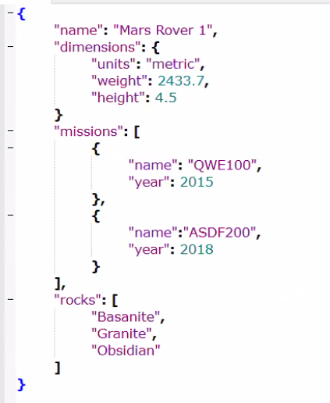

// We will get back an instance of Rover Response

-class RoverResponse{

public string name {get; set;}

public DemensionsResponse dimensions {get; set;}

public List<MissionsResponse> missions {get; set;}

public List<string> rocks {get; set;}

}

-class DimensionsResponse{

public string units {get; set;}

public double weight {get; set;}

public double height {get; set;}

}

-class MissionsResponse{

public string name {get; set}

public int year {get; set;}

}