Jeremy Harrault

Swordfish

– SAFAPS SIM –

API Specification

Objectives of this document

The purpose of this document is to specify the interface of the SAFAPS SIM API. This is the interface between SAFAPS web service and external systems requesting SAFAPS. This document define the functions offered by the API both from static view and dynamic view. The static view of each function is defined by their inputs and outputs whereas the dynamic view is defined using the sequential view showing the action which need to be performed for each function.

Glossary and Terminology

– A –

API: Application Programming Interface

– R –

REST: Representational State Transfer.

– S –

S&F: Stress and Fatigue

SAFAPS: Stress and Fatigue Audit and Prediction Service

Document Description

|  |  |  |
| --- | --- | --- |
| Title | SAFAPS SIM : API Specification | |
| Creation date | 26/01/2016 | |
| Publication date | 28/01/2016 | |
| Product Owner | Augustin Tataru | taau15md@student.ju.se |
| Authors | Jeremy Harrault | hajr15bp@ju.se |
|  |  |
| Subject | API Specification | |
| Model version | 1.0 | |
| Document version | 1.2 | |

Revisions table

|  |  |  |  |  |
| --- | --- | --- | --- | --- |
| Date | Rev. | Author | Modified Section(s) | Comments |
| 26/01/16 | 1.0 | Jeremy Harrault | All | Define API architecture, function and the static view for each of them. |
| 27/01/16 | 1.1 | Jeremy Harrault | 3. | Add dynamic view for all functions |
| 28/01/16 | 1.1.1 | Jeremy Harrault | 3. | Correct typo in evaluation request: “EndlTime” => “EndTime” and  “Equipement” => “Equipment” |
| 01/02/16 | 1.2 | Jeremy Harrault | 3. | Remove “Schedule” tag and bring elements inside at a previous level.  Put “Timezone” in the “Event”’s tag. |

Table of Contents

1. Description of the API 1

1.1. REST architecture 1

1.2. API keys 2

1.2.1. Managers’ API secret keys 2

1.2.2. Organizations’ API keys 2

1.2.3. Sending API keys in a request 2

2. Resource View 1

3. Implementation 2

3.1. Evaluations 2

3.1.1. Description 2

3.1.2. Interface 2

3.1.3. Dynamic view 1

3.2. Manager management 2

3.2.1. Description 2

3.2.2. Interface 2

3.2.3. Dynamic view 4

3.3. Invoices 5

3.3.1. Description 5

3.3.2. Interface 5

3.3.3. Dynamic view 7

List of Tables

Table 1: Explanation on request and response attributes 1

Table 2: Resource view for SAFAPS SIM API 1

Table 3: Interface for S&F evaluation 3

Table 4: Request for S&F results 3

Table 5: Interface for manager management 3

Table 6: Interface for invoices 6

List of Figures

Figure 1: Composition of HTTP request and response 1

Figure 2: Stress and Fatigue indicators meaning 3

Figure 3: Dynamic view for S&F evaluation 1

Figure 4: Dynamic view for manager creation 4

Figure 5: Dynamic view for invoice generation 7

# Description of the API

## REST architecture

The SAFAPS SIM API fulfil a RESTful architecture. It is reachable using the HTTP protocol. It means that each function offered by the API can be executed by sending an HTTP request and return an HTTP response.

Below is the basic composition of any HTTP response and request.

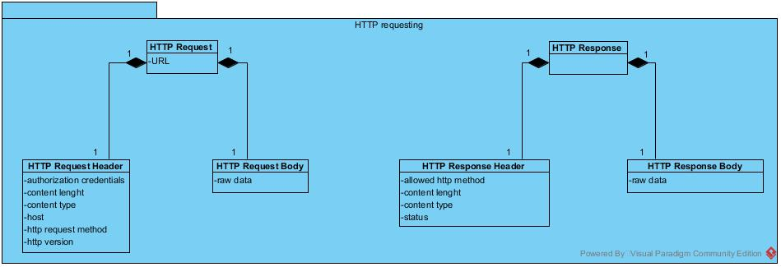

Figure 1: Composition of HTTP request and response

|  |  |  |
| --- | --- | --- |
| Request | Route | This identify the resource on the server to perform an action on |
| Authorization credentials | This field will be used to store the encrypted key allowing the API to authenticate a manager or organization within the system. (cf. 1.2. API keys). |
| Content length | This field contains the number of characters contained in the request body. |
| Content type | This field contains the format of the data sent in the request body. |
| Host | This field contains the host of the requested server |
| HTTP request method | This field specify the action to perform on the route. (GET/POST/PUT/DELETE/etc.) |
| HTTP version | The version the HTTP protocol to be used for the request |
| Raw data | The situational data to send with the request. |
| Response | Allowing HTTP method | The authorized action to perform on the requested resource |
| Content length | This field contains the number of characters contained in the response body. |
| Content type | This field contains the format of the data sent in the response body. |
| Status | This field contains an integer identifying the type of response (OK, redirection, client error, server error). |
| Raw data | The situational data to send back to the caller |

Table 1: Explanation on request and response attributes

For the SAFAPS SIM API, the input and output data in the request and response bodies are formatted in **JSON**.

## API keys

### Managers’ API secret keys

SAFAPS SIM needs to identify the manager who made request to add it to the invoice of his/her organization. To do so, each manager has its own SAFAPS secret key allowing him to be authenticated when he sends a request. Such managers’ API keys are created at the insertion of the managers inside SAFAPS SIM.

### Organizations’ API keys

Some request offered by SAFAPS SIM’s API cannot be perform by managers but by the organizations themselves. To do so, each organization has a secret key allowing it to be authenticated when sending a request.

### Sending API keys in a request

The API keys need to be sent in the request header of the requests, in the “Authorization” field. The value of this field is "Basic base64(apiKey)"

# Resource View

|  |  |  |  |
| --- | --- | --- | --- |
| Resource | HTTP Method | API Key | Description |
| /evaluations | POST | Manager | Perform a SAFAPS request to run the S&F algorithm |
| /organizations/managers | POST | Organization | Add a new manager for the organization |
| /organizations/managers/[manid] | DELETE | Organization | Close a manager account for the organization |
| /organizations/invoices | GET | Organization | Retrieve the list of invoices for an organization |
| /organizations/[orgaid]/invoices | POST | NA | Create an invoice for an organization from the performed request |

Table 2: Resource view for SAFAPS SIM API

# Implementation

## Evaluations

### Description

The managers can send request to SAFAPS to perform Audit and Prediction on the Stress and Fatigue level of the people they are in charge of. The request needs the API key of the manager sending the request. Once the manager authenticated and the check if the request body is properly set, a response is sent back to the caller to notify whether his request has been accepted. If it has been, the request is treated using the S&F algorithm. Once the results have been generated, they are sent back to the caller of the evaluation caller via a new HTTP request sent to the response URL previously sent by the caller.

### Interface

|  |  |  |  |  |
| --- | --- | --- | --- | --- |
| Request | | | Response | |
| Resource | HTTP Method | Body | HTTP Status | Body |
| /evaluations | POST | {  ResponseURL: “[string]”,  Events: [  {  TimeZone: “[string]”,  StartTime: “[datetime]”,  EndTime: “[datetime]”,  ASMEnvironment: “[enum]”,  ControlTechnology: “[enum]”,  ControllerStatus: “[enum]”,  Traffic: “[enum]”,  Equipment: “[enum]”,  Weather: “[enum]”  },  …  ]  } | 200 | {  RequestId: [integer],  ResponseURL: “[string]”  }  *The ResponseURL has the same value as sent in the request. |
| 400 | {  “Error”: “The response URL is not properly set”  } |
| 400 | {  “Error”: “The schedule time zone is not properly set”  } |
| 400 | {  “Error”: “One or several event attributes are missing in the event [event_nbr]: “[ev_missing_attr1]”, “[ev_missing_attr2]”, …  }  *The [event_nbr] refers to the index (starting at 0) of the uncomplete event within the JSON array contained in the request body.  **The [ev_missing_attrn] refers to the name of the missing attribute. |
| 401 | {  “Error”: “The authorization field is not specified or the API key is not valid”  } |
| 415 | {  “Error”: “The data is not in JSON format”  } |

Table 3: Interface for S&F evaluation

#### Response URL

The results containing the S&F level are to be sent by SAFAPS SIM using an HTTP request. The response of this request is ignored by SAFAPS SIM. Below is the schema this request:

Stress

-2

[Boredom]

0

[Normal]

+5

[Overstimulation]

Fatigue

0

[Rested and Fresh]

+5

[High lack of rest]

|  |  |  |
| --- | --- | --- |
| Resource | HTTP Method | Body |
| [ResponseURL] | POST | *{*  *RequestId: [integer],*  *Stress: [integer],*  *Fatigue: [integer]*  *}* |

Figure 2: Stress and Fatigue indicators meaning

Table 4: Request for S&F results

#### Format and possible values

* TimeZone
  + “Continent/City”
* StartTime
  + “YYYY-MM-dd hh:mm:ss”
* EndTime
  + “YYYY-MM-dd hh:mm:ss”
* ASMEnvironment:
  + “E” for Enroute
  + “T” for Terminal
  + “LM” for Local Moves
  + “D” for Departures
  + “A” for Arrivals
  + “GM” for Ground Moves
  + “T” for Tower
* ControlTechnology:
  + “R” for Radar
  + “PS” for Procedural – Supported
  + “PM” for Procedural – Manual
* ControllerStatus:
  + “SC” for Solo controller
  + “MCU” for Multi controller – Unsupported
  + “MCS” for Multi controller – Supported
  + “MCM” for Multi controller – Mentoring
  + “MCT” for Multi controller – Trainee
  + “MCI” for Multi controller – instructor
* Traffic:
  + “VH” for Very Heavy
  + “H” for Heavy
  + “B” for Busy
  + “NB” for Not busy
  + “L” for Light
  + “VL” for Very Light
* Equipment:
  + “SD” for Severely Degraded
  + “BD” for Badly Degraded
  + “D” for Degraded
  + “O” for Operational
* Weather:
  + “HD” for Highly disruptive
  + “D” for Disruptive
  + “MD” for Mildly Disruptive
  + “ND” for No Disruption

### Dynamic view

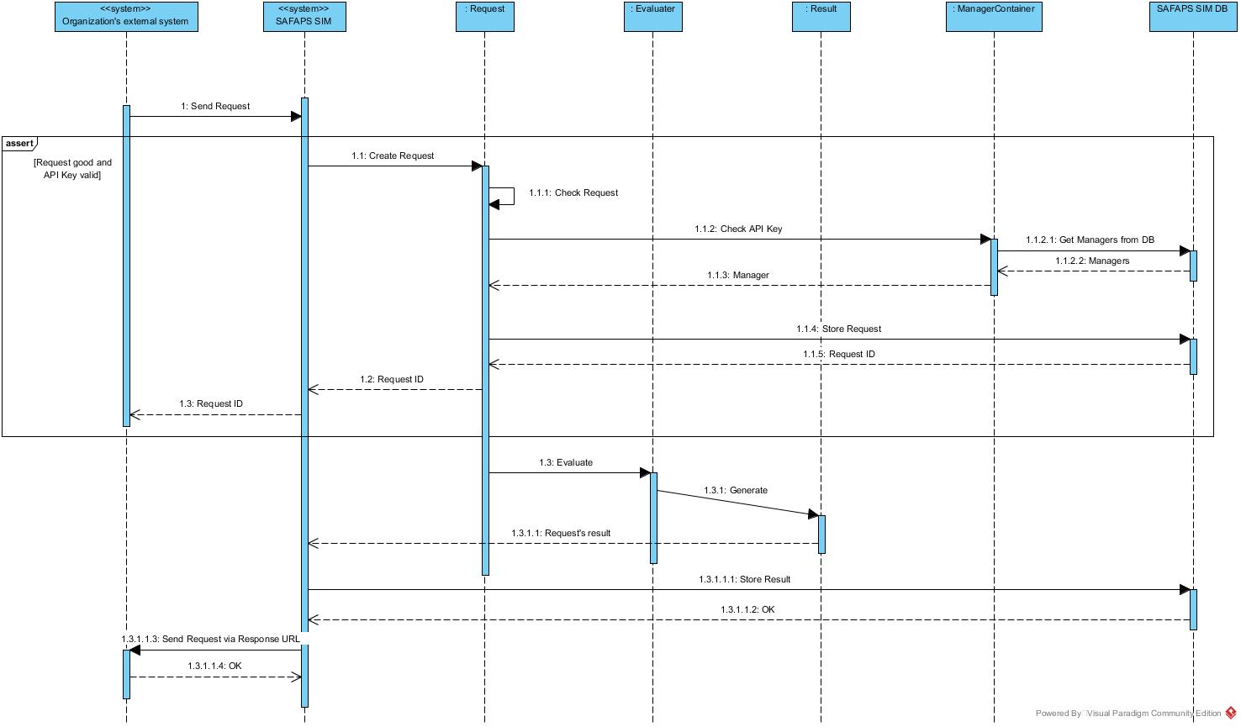

Figure 3: Dynamic view for S&F evaluation

## Manager management

### Description

Organization might add and remove managers able to use SAFAPS SIM. At the creation of a manager, a new API key is created to be used as authentication token for this manager when he attempts to send an S&F evaluation request. When the manager is remove, it is not delete from the database but marked as “CLOSE” disable the use of his/her API key.

### Interface

|  |  |  |  |  |
| --- | --- | --- | --- | --- |
| Request | | | Response | |
| Resource | HTTP Method | Body | HTTP Status | Body |
| /organizations/managers | POST | {  Name: “[string]”  } | 200 | {  ManagerId: [integer]  Name: “[string]”  ApiKey: “[string]”  }  *The API key is the one to use to authenticate the newly created manager on SAFAPS SIM. |
| 400 | {  “Error”: “The name is not properly set”  } |
| 401 | {  “Error”: “The authorization field is not specified or the API key is not valid”  } |
| 415 | {  “Error”: “The data is not in JSON format”  } |
| /organizations/managers/[manid] | DELETE | EMPTY  *Note that the managers are not removed from the database but are marked as CLOSED. | 204 | EMPTY |
| 400 | {  “Error”: “The manager id is not valid”  } |
| 401 | {  “Error”: “The authorization field is not specified or the API key is not valid”  } |

Table 5: Interface for manager management

### Dynamic view

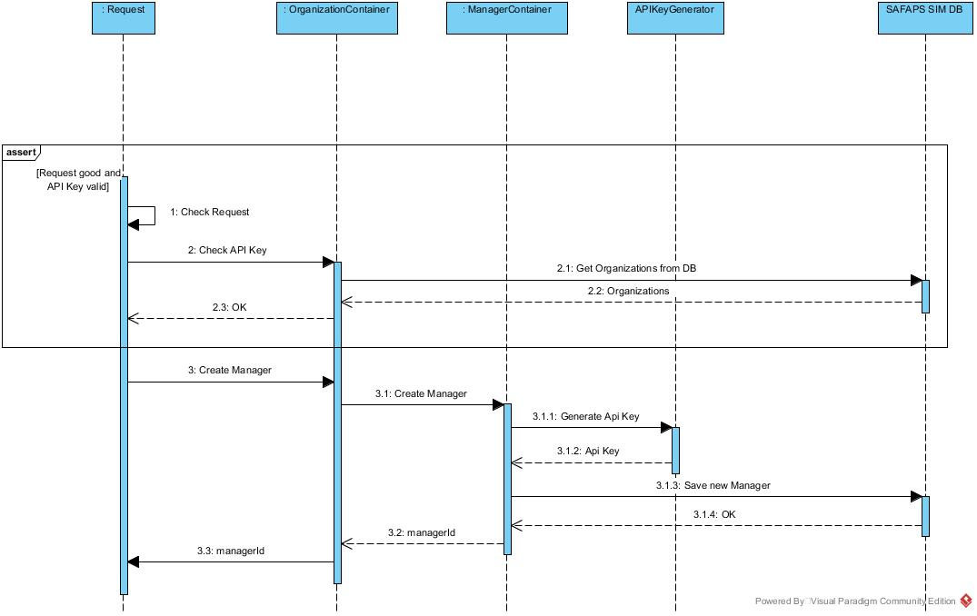

Figure 4: Dynamic view for manager creation

## Invoices

### Description

Periodically, invoices are created for every organization using SAFAPS SIM. To calculate the amount of an invoice, the total number of request sent by the managers of the organizations during the period to invoice, is retrieve and is submitted to a conversion rate. Once the amount calculated, the invoice is sent by mail by SAFAPS SIM. An API route allow the organizations’ financials to get the list of invoices from his/her organization.

### Interface

|  |  |  |  |  |
| --- | --- | --- | --- | --- |
| Request | | | Response | |
| Resource | HTTP Method | Body | HTTP Status | Body |
| /organizations/[orgaId]/invoices | POST | EMPTY | 200 | {  OrganizationName:”[string]”,  Invoice: {  Date: ”[datetime]”,  PeriodStart: “[datetime]”,  PeriodEnd: “[datetime]”,  Amount: [float],  Currency: “[string]”  }  }  *PeriodStart and PeriodEnd refers to the time frame to consider as invoiced.  **Date is the date the invoice is instantiated. |
| 400 | {  “Error”: “The organization id is not valid”  } |
| /organizations/invoices | GET | EMPTY | 204 | {  OrganizationName: “[string]”,  Invoices: [  {  Date: ”[datetime]”,  PeriodStart: “[datetime]”,  PeriodEnd: “[datetime]”,  Amount: [float],  Currency: “[string]”  },  …  ]  } |
| 401 | {  “Error”: “The authorization field is not specified or the API key is not valid”  } |

Table 6: Interface for invoices

### Dynamic view

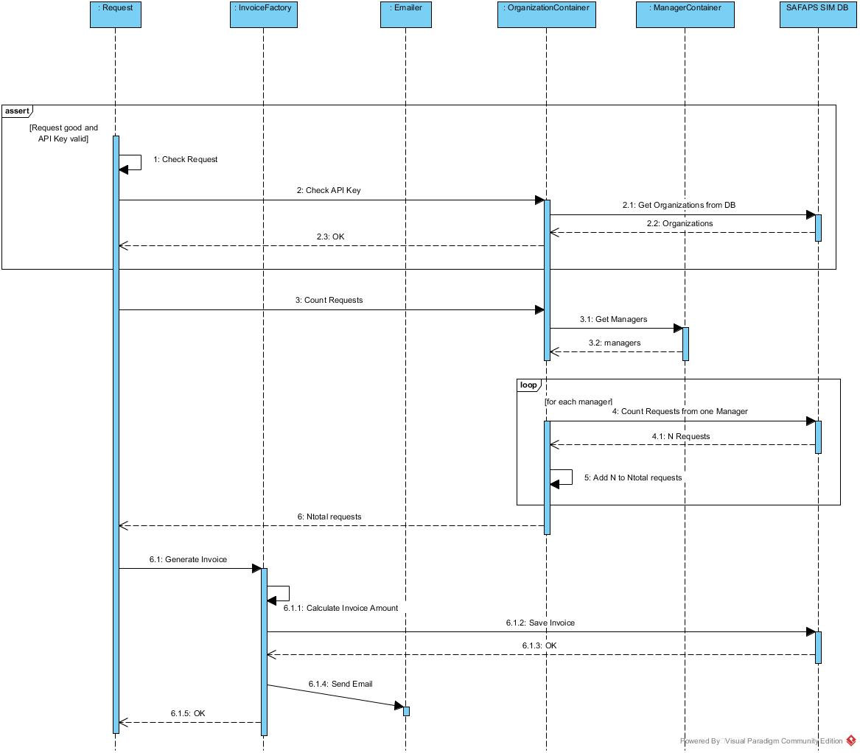

Figure 5: Dynamic view for invoice generation