Jeremy Harrault

Swordfish

– SAFAPS SIM –

Architecture Document

Objectives of this document

The purpose of this document is to present the architecture of the SAFAPS SIM project. It will contain diagrams as well as explanations to describe the architectural choices in order to fulfil the requirements. The information contained in the document act as a guide in order to fully develop, deploy and setup SAFAPS. Reflexions and reviewed decisions are tracked in this document.

Glossary and Terminology

– A –

API: Application Programming Interface

– S –

S&F: Stress and Fatigue

SAFAPS: Stress and Fatigue Audit and Prediction Service

Document Description

|  |  |  |
| --- | --- | --- |
| Title | SAFAPS SIM : Architecture Document | |
| Creation date | 25/01/2016 | |
| Publication date | 26/01/2016 | |
| Product Owner | Augustin Tataru | taau15md@student.ju.se |
| Authors | Jeremy Harrault | hajr15bp@ju.se |
|  |  |
| Subject | Architecture Document | |
| Model version | 1.0 | |
| Document version | 0.2 | |

Revisions table

|  |  |  |  |  |
| --- | --- | --- | --- | --- |
| Date | Rev. | Author | Modified Section(s) | Comments |
| 25/01/16 | 0.1 | Jeremy Harrault | All | Add empty sections |
| 28/01/16 | 0.2 | Jeremy Harrault | 5. | Add context and database view |

Table of Contents

1. Introduction and Management Summary 1

2. General Architecture Principles 2

3. Architectural Design Decisions 3

4. Viewpoints 4

5. Views 5

6. Quality Property Summary 7

7. Important Scenarios 8

8. Issues Awaiting Resolution 9

9. Appendices 10

List of Tables

Aucune entrée de table d'illustration n'a été trouvée.

List of Figures

Aucune entrée de table d'illustration n'a été trouvée.

# Introduction and Management Summary

# General Architecture Principles

# Architectural Design Decisions

# Viewpoints

## The context viewpoint

## The functional viewpoint

## The information viewpoint

## The concurrency viewpoint

## The development viewpoint

## The deployment viewpoint

## The operational viewpoint

# Views

## Context view

SAFAPS SIM is a system that is mainly used by external systems from organizations.

Managers from such organizations can send SAFAPS through their external system to SAFAPS SIM and get authenticated using unique authenticating keys. Managers cannot interrogate SAFAPS SIM directly.

Once the evaluation result is ready, it is sent back to the external system.

When managers are added or removed from the external system, it can notify SAFAPS SIM so that they are added or removed in SAFAPS SIM too.

External organizations’ financials can consult invoices for the organization in two ways. He can either consult them from his mail or directly from SAFAPS SIM website. Indeed, when an invoice is generated by SAFAPS SIM, it is automatically sent to the external organization.

SAPAFS SIM is a simulation software. To limit the work to do on the back-end of SAFAPS website, the information about the organizations is filled in the system by the SAFAPS administrators.

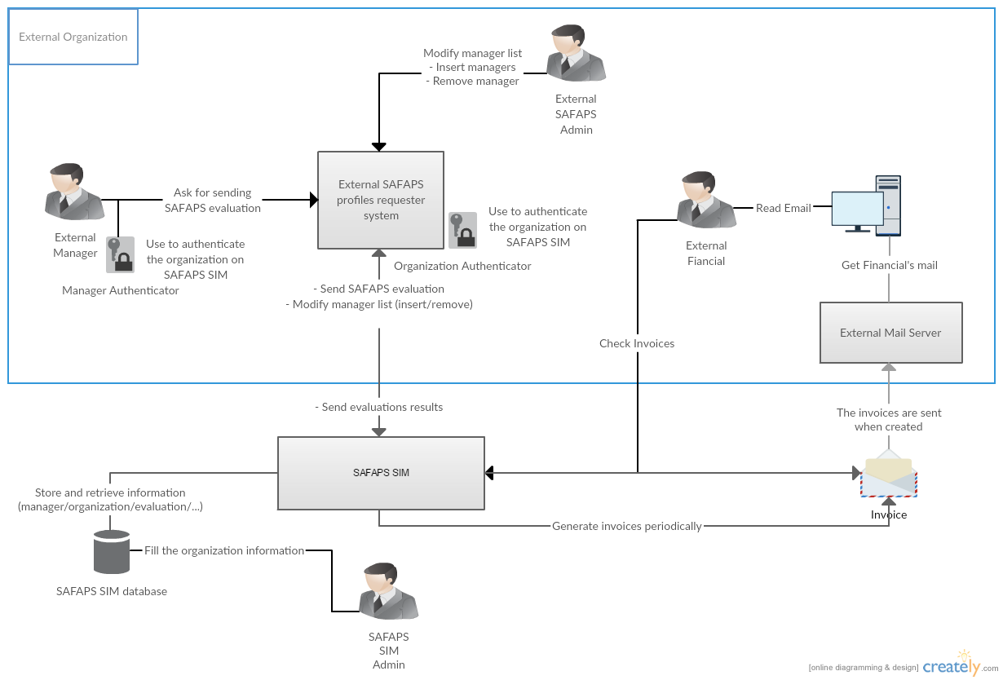

## Database view

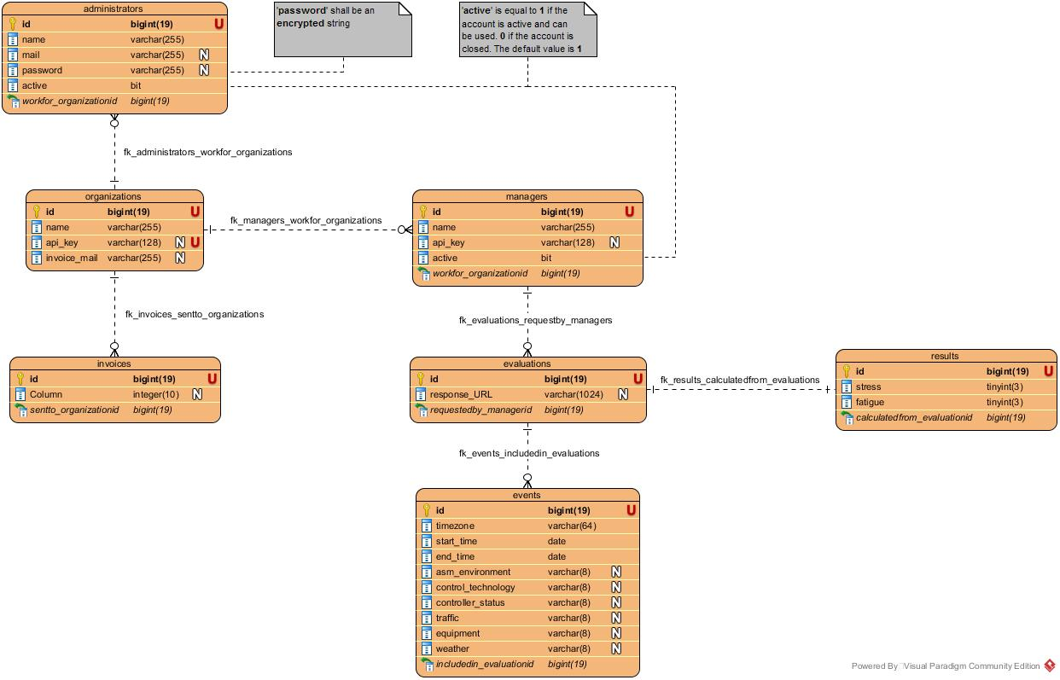

# Quality Property Summary

# Important Scenarios

# Issues Awaiting Resolution

# Appendices