Jeremy Harrault

Swordfish

– SAFAPS SIM –

Architecture Document

Objectives of this document

The purpose of this document is to present the architecture of the SAFAPS SIM project. It will contain diagrams as well as explanations to describe the architectural choices in order to fulfil the requirements. The information contained in the document act as a guide in order to fully develop, deploy and setup SAFAPS.

Glossary and Terminology

– A –

API: Application Programming Interface

– J –

JSON: JavaScript Object Notation

– R –

REST: Representational State Transfer

– S –

S&F: Stress and Fatigue

SAFAPS: Stress and Fatigue Audit and Prediction Service

Document Description

|  |  |  |
| --- | --- | --- |
| Title | SAFAPS SIM : Architecture Document | |
| Creation date | 25/01/2016 | |
| Publication date | 26/01/2016 | |
| Product Owner | Augustin Tataru | taau15md@student.ju.se |
| Authors | Jeremy Harrault | hajr15bp@ju.se |
|  |  |
| Subject | Architecture Document | |
| Model version | 1.0 | |
| Document version | 0.7 | |

Revisions table

|  |  |  |  |  |
| --- | --- | --- | --- | --- |
| Date | Rev. | Author | Modified Section(s) | Comments |
| 25/01/16 | 0.1 | Jeremy Harrault | All | Add empty sections. |
| 28/01/16 | 0.2 | Jeremy Harrault | 3. | Add context and database view. |
| 29/01/16 | 0.3 | Jeremy Harrault | 3. | Add invoice table in database view and add additional information. |
| 02/02/16 | 0.4 | Jeremy Harrault | 1.  3. | Remove “Introduction and Management Summary” part.  Add the general architecture principals.  Add standardization from information viewpoint. |
| 04/02/16 | 0.5 | Jeremy Harrault | 3  . | Explanation “datetime”.  Modify Database standardization rules |
| 05/02/16 | 0.6 | Jeremy Harrault | 3. | Move foreign key between Evaluation and Result into Evaluation table.  Add section for status of S&F evaluation  Add “status” column in database to “evaluation”. |
| 05/02/16 | 0.6.1 | Jeremy Harrault | 1.  3. | Show the asynchronous process in Global architecture diagram.  “S&F Evaluator” => “S&F Evaluator Service” |
| 09/02/16 | 0.7 | Jeremy Harrault | 1.  2.  3. | Describe the goal of SAFAPS SIM  Add architectural decisions and their advantages  Add functional viewpoint |

Table of Contents

1. General Architecture Principles 1

1.1. Web application 1

1.2. Global Architecture 1

2. Architectural Design Decisions 3

2.1. Rest Architecture 3

2.2. PHP 3

2.3. Symfony2 Framework 3

2.4. S&F Evaluator Sub-process 3

3. Viewpoints and Views 5

3.1. Context Viewpoint 5

3.2. Functional Viewpoint 6

3.2.1. Functional parts 6

3.2.2. Preparing and Routing Requests 6

3.2.3. Managing Entities 6

3.2.4. S&F Evaluators 8

3.2.5. Overview 8

3.3. Information Viewpoint 9

3.3.1. S&F Evaluation Request States 9

3.3.2. Database View 10

3.4. Concurrency Viewpoint 11

3.5. Development Viewpoint 11

3.5.1. Symfony2 file system 11

3.5.2. Database Naming Convention 11

3.6. Deployment Viewpoint 12

3.6.1. Production Environment 12

3.6.2. Development Environment 12

3.6.3. Testing Environment 12

3.7. Operational Viewpoint 12

4. Quality Property Summary 13

5. Important Scenarios 14

6. Issues Awaiting Resolution 15

7. Appendices 16

List of Tables

Table 1.1: SAFAPS SIM global layers 2

Table 3.1: Component descriptions for routing request 6

Table 3.2: Description of S&F evaluation request states 9

Table 3.3: Database entity additional information 10

Table 3.4: Example of naming database tables 11

Table 3.5: Example of verbs for database table relationships 11

Table 3.6: Example of naming foreign keys between database tables 11

List of Figures

Figure 1.1: SAFAPS SIM global architecture 1

Figure 2.1: Asynchronous call for S&F request 4

Figure 3.1: Context diagram 5

Figure 3.2: Component diagram for routing requests 6

Figure 3.3: Component diagram for managing entities 7

Figure 3.3: Component diagram for executing S&F requests 8

Figure 3.4: State Chart of the S&F evaluation request 9

Figure 3.5: Database entity diagram 10

# General Architecture Principles

## Web application

SAFAPS SIM is a Web application that can be reached using HTTP. It includes an API that handle the business to be performed. This API can be called by any HTTP client; that is either humans directly requesting the server from a browser for instance or other systems which need Stress and Fatigue information.

Beside the API which returns raw data, SAFAPS SIM can also return these data wrapped in a user interface to be displayed onto a browser and become more human readable.

The SAFAPS SIM API is compliant with the REST architecture.

## Global Architecture

The architecture of SAFAPS SIM presents distinct layers, each of them fulfilling their own tasks.

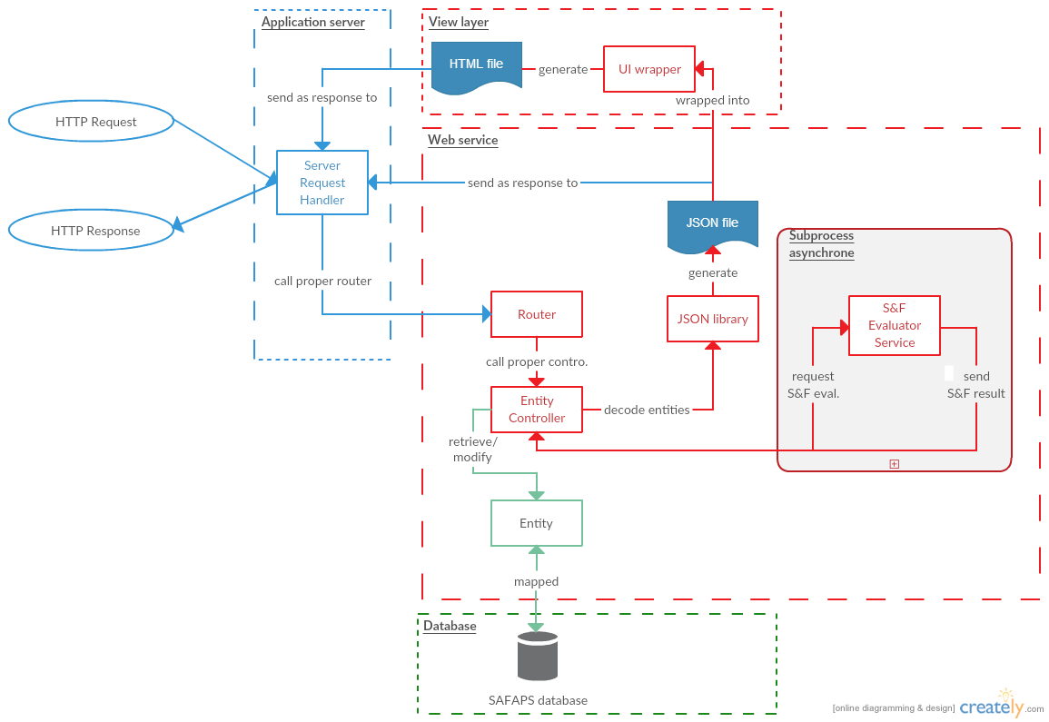

Figure 1.1: SAFAPS SIM global architecture

|  |  |
| --- | --- |
| Layer | Description |
| Application server | The application server is first layer that the request goes across. This layer is between the software application and the operating system that the web server is running on. It catches the HTTP requests received by the server and pass it to web service. |
| Web service | The web service includes all business logic that will be computed. It includes the router which will call controllers depending on the resource pointed by the request.  Controllers can then access and modify values within entities and call the S&F evaluator by launching an asynchronous process. The input and output handled by the web service are formatted in JSON. |
| Database | The layer is in charge of storing data. |
| View layer | The view layer is used to lay out the data returned by the web service within HTML to present data onto browser for example and therefore become more human readable. |

Table 1.1: SAFAPS SIM global layers

# Architectural Design Decisions

## Rest Architecture

The core of SAFAPS SIM is a RESTful web service. REST uses simple HTTP as the communication protocol between the client and the server.

Using HTTP already defines of way of performing requests with URL and HTTP methods.

Unlike SOAP, REST does not need to send the format of the response returned by the server. It facilitates the call to the web service on the client side since it does not need any libraries or extra component to decode the response.

Therefore, testing a REST architecture can be done very easily using a browser.

## PHP

SAFAPS SIM is coded in PHP. This language offers different advantages:

* Open-source language: It makes the support and the extensibility of the language easier considering the huge community of PHP developers.
* Good documentation: Besides the official PHP documentation which is very complete, a lot of technical trouble can be resolve after a search on internet.
* Easily deployed: PHP is a scripting language which does not require any compilation. The PHP file only needs to be placed into the server directory.
* Optimized for building web applications: PHP natively provides tools and features like accessing method and URL of the requests as so that the development of
* Well-known language: A lot of people are using PHP. Then, it is easier to find programmers PHP skills who can handle the project.

## Symfony2 Framework

The codebase of SAFAPS SIM is running with Symfony2 framework. This choice has been made many reasons:

* Premade skeleton: Symfony2 pre-define the architecture basics of the web application.
* Saving time: Using a framework is a gain of development time since a big part of the work is already coded. The developers can focus on the business part of the application.
* Already experienced team: The development team is already familiar with this framework, reducing the learning phase.
* Extensible: Some “bundles” can be plugged to Symfony2 if need be, adding then new features to the system to be built either at runtime or at the development time.

## S&F Evaluator Sub-process

In order to avoid the client to be blocked waiting for the server delivering the response to the S&F request, SAFAPS SIM will execute these kind of request asynchronously.

For that purpose, a parallel process in charge of executing S&F request will be running when a S&F request is submitted. Once the result generated, it will be sent back to the client.

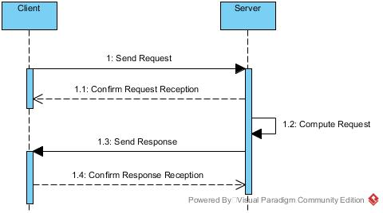

Figure 2.1: Asynchronous call for S&F request

# Viewpoints and Views

## Context Viewpoint

SAFAPS SIM is a system that is mainly used by external systems from external organizations. Managers from such organizations can use SAFAPS through their own internal system. For security concerns, managers get authenticated by SAFAPS SIM using their unique authenticating keys. Managers are not supposed to request SAFAPS SIM directly.

Once the evaluation has been performed by SAFAPS SIM, it will be sent back to the organization’s system.

When managers are added to or removed from the organization’s system, it notifies SAFAPS SIM so that the new managers are added to or removed from SAFAPS SIM too.

The SAFAPS SIM system is not free of charge and organization using SAFAPS must pay for it. Periodically, invoices are automatically sent by SAFAPS SIM to organizations. External organizations’ financials can consult such invoices for the organization in two ways. They either can consult them from their mail or directly from SAFAPS SIM website.

SAPAFS SIM is a simulation software. To limit the work to do on the back-end of SAFAPS website, the information about the organizations is filled in SAFAPS SIM by the SAFAPS administrators.

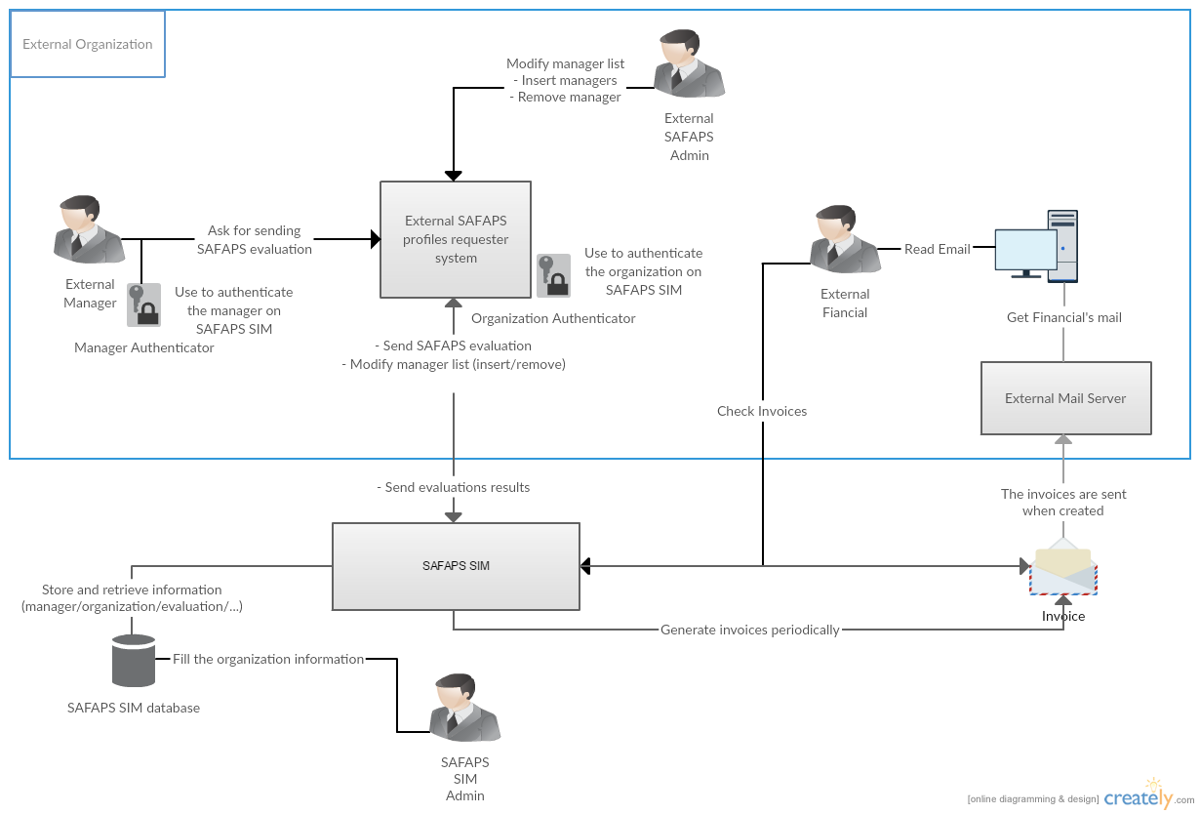

Figure 3.1: Context diagram

## Functional Viewpoint

### Functional parts

### Preparing and Routing Requests

When a client requests SAFAPS SIM, the first task to be done is routing the request. It consists in calling the proper function according to the resource and the method of the HTTP request.

This part is mainly handled by components set up by Symfony2.

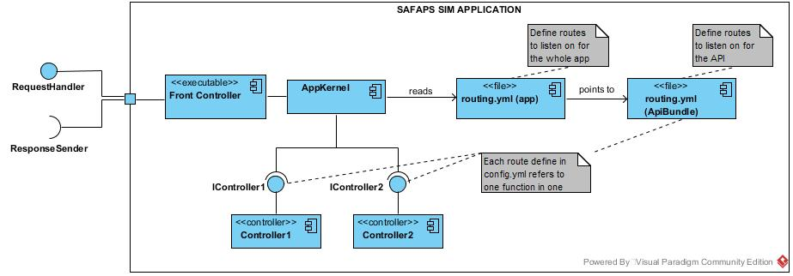

Figure 3.2: Component diagram for routing requests

|  |  |
| --- | --- |
| Component | Description |
| Front Controller | It is first script that is called after receiving the request. It sets the global environment settings (production, debug, testing) |
| App Kernel | It loads all Bundles needed by the application to work. It also calls the proper controller based on the resources and the routing file. |
| routing.yml | The routing files define which controller should be called according to the resource pointed in the request. |
| IControllers | These interfaces are built from the routing.yml files. Indeed, they include functions to be implemented according to which functions have been defined as to be called by the routing.yml |
| Controllers | They are classes implementing the IControllers interfaces. |

Table 3.1: Component descriptions for routing request

### Managing Entities

The process of executing the request, retrieving, creating or modifying entities is conducted by the controllers

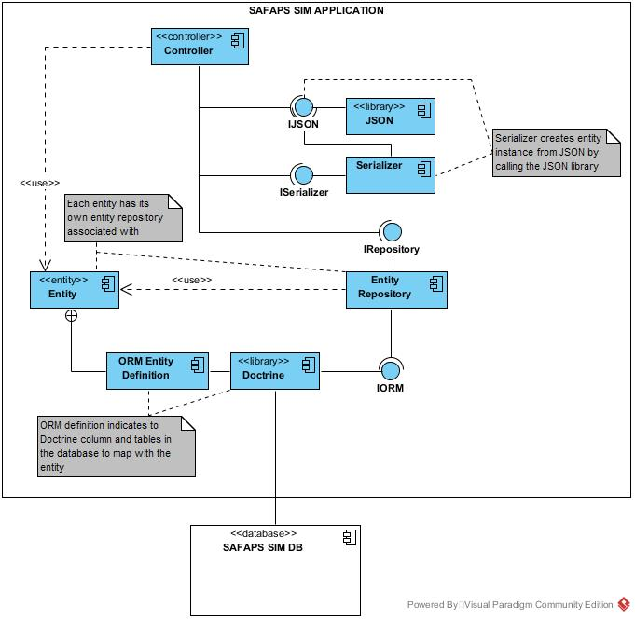

Figure 3.3: Component diagram for managing entities

### S&F Evaluators

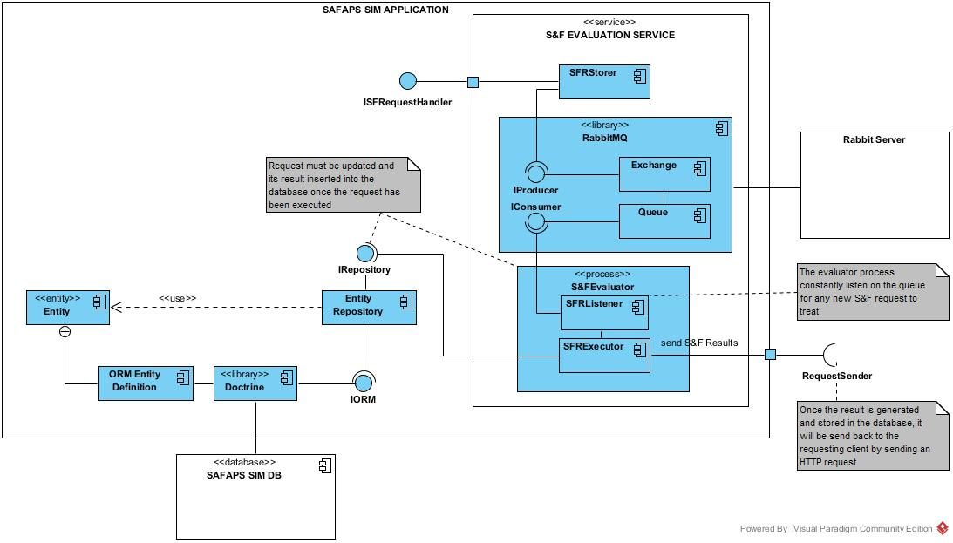

Figure 3.4: Component diagram for executing S&F requests

### Overview

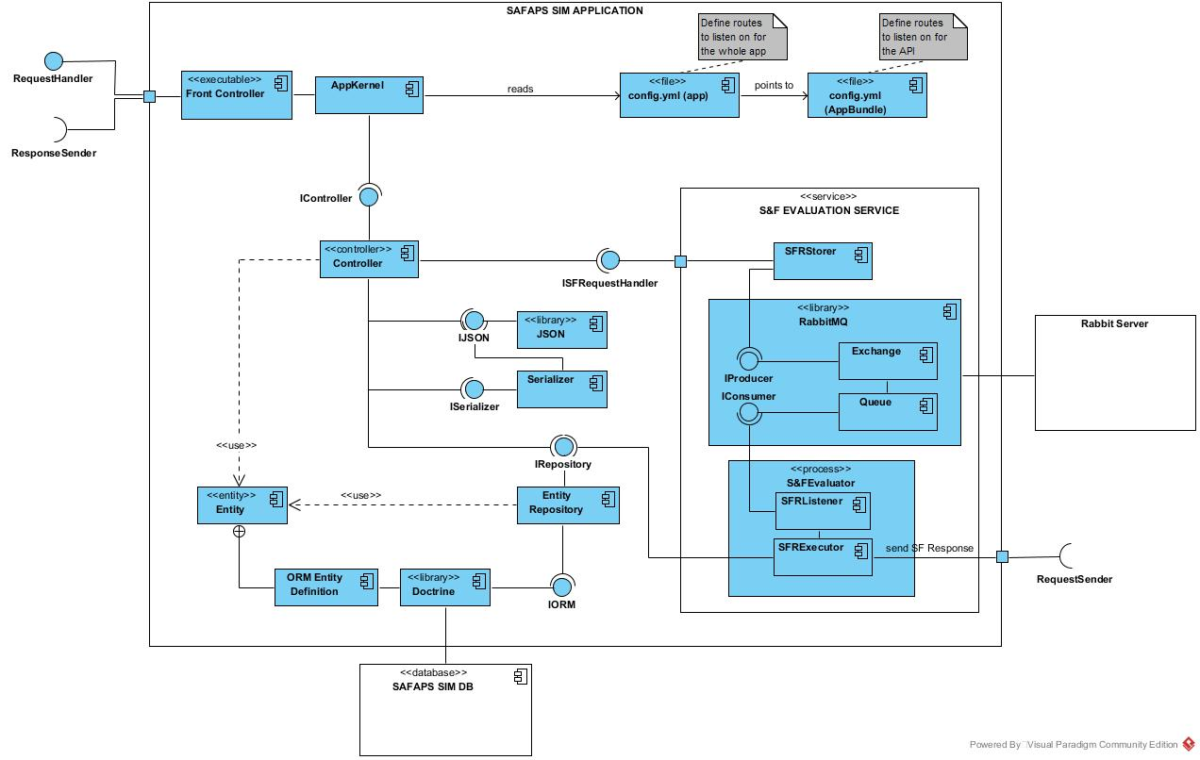

This diagram shows the wide view of how elements are interacting with each other within the Symfony2 Framework.

## Information Viewpoint

### S&F Evaluation Request States

The S&F requests go through different states from the creation to the point of they are actually performed.

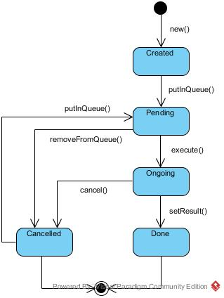

Figure 3.5: State Chart of the S&F evaluation request

|  |  |
| --- | --- |
| State name | Description |
| Created | When the evaluation request is instantiated and inserted into the database, its status is created. |
| Pending | When the evaluation request is put in the queue awaiting to be treated by the S&F evaluator service. |
| Ongoing | When the evaluation request is taken from the queue in order to be treated by the S&F evaluator service. |
| Done | When the result of the S&F evaluation request is set and inserted inside the database. |
| Cancelled | When the S&F evaluation request has been remove from the queue or the execution of the request has been interrupted. |

Table 3.2: Description of S&F evaluation request states

### Database View

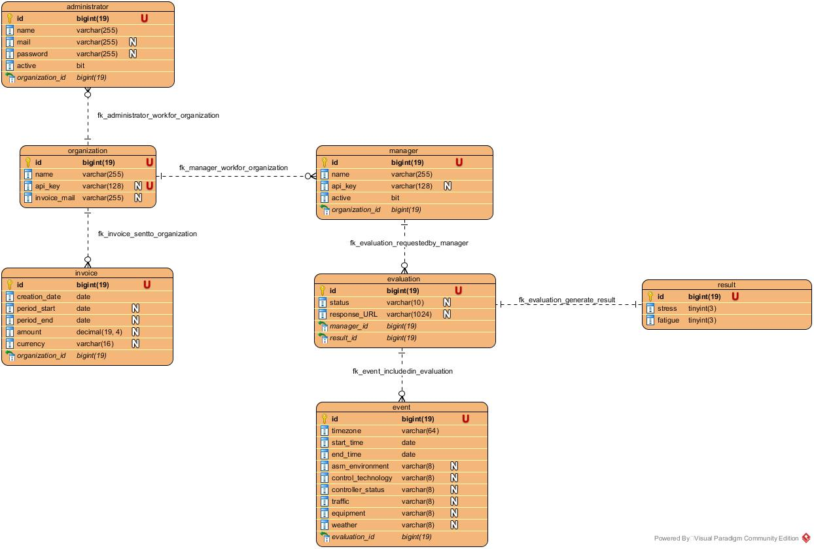

Figure 3.6: Database entity diagram

Some **additional information** regarding this diagram needs to be given in order to fully understand how to manipulated this presented data:

|  |  |  |
| --- | --- | --- |
| Table | Column | Additional information |
| - administrators  - managers | - active | The active field represent whether the account is still authorized to use SAFAPS SIM functionalities. The type of this field represent a data with only 2 exclusive possible values. Depending on the database implementation, these values can either be TRUE/FALSE or 1/0. Both are correct. |
| - invoices | - currency | The currency of the invoice is stored as locale as describe in the RFC 4646 (e.g. en_US, en_UK). |
| - amount | The amount is a floating number that can have up to 4 decimals. The stored value is the amount of the invoice converted into the currency stored in the invoice. |
| - evaluation | - status | It defines the status of the request. The possible values can be:   * “create” * “pending” * “ongoing” * “done” * “canceled” |
| - events | - timezone | The time zone of the event is stored as a string in the format “Continent/City”. |
| - start_time  - end_time | These “date” fields store a date in the calendar (MM/DD/YYYY) **and** a time (hh:mm:ss). On some database instance, this type is also called “datetime” |

Table 3.3: Database entity additional information

**Warning**: This diagram has been made without considering the database type or version which is used in the project. It offers a generic model showing how the data are stored and related to each other.

## Concurrency Viewpoint

## Development Viewpoint

### Symfony2 file system

### Database Naming Convention

Hereafter is the naming convention and other rules adopted for the database implementation.

* Tables:
  + The table names are fully given in low camel case (lowercase letter with ‘_’ as space between words).

|  |  |
| --- | --- |
| Do | Don’t |
| organizations | Organizations (first letter is uppercase) |
| organization_invoices | organizationinvoices (no ‘_’ between words) |

Table 3.4: Example of naming database tables

* Table IDs:
  + Each table representing an entity must have an ID. Only tables made for many-to-many relationships may be without any ID.
  + Entities’ ID are “bigint” stored over 19 bits
  + Entities’ ID are **unique**, “**non-nullable”**, **primary keys**.
  + Entities’ ID named ‘id’
* Foreign keys:
  + Foreign keys are supposed to represent one-to-many or one-to-one relationships between two tables.
  + Each of these relationships needs to be defined using a verb.

Example:

|  |  |  |
| --- | --- | --- |
| One… | Can be related to… | Verb |
| Organization | (many) Invoices | Invoices are => ‘send to’ => Organization |
| Evaluation | (many) Events | Events are => ‘included in’ => Evaluation |
| Evaluation | (one) Result | Result is => ‘calculated from’ => Evaluation |
| Result | (one) Evaluation | Evaluation is => ‘generating’ => Result |

Table 3.5: Example of verbs for database table relationships

**Note**: For one-to-one relationship, either one or the other table is able to store the foreign key (but not both at once).

* + Foreign keys must be named <fk_table_name>_<fk_attribute_name>

Example:

|  |  |
| --- | --- |
| Do | Don’t |
| organization_id | organizationid |
| evaluation_id | workfor |
| organization_id | administrator_organization_id |

Table 3.6: Example of naming foreign keys between database tables

## Deployment Viewpoint

### Production Environment

### Development Environment

### Testing Environment

## Operational Viewpoint

# Quality Property Summary

# Important Scenarios

# Issues Awaiting Resolution

# Appendices