

# Identification of Triangular Patterns in Brain Networks Using Graph Theory

**Submitted By**

|  |  |
| --- | --- |
| 15-30013-2 | Mujahid Abdullah Al |
| 17-33394-1 | Pritom Mitchell Rodrigues |
| 14-27544-3 | Md. Al Jubayer |
| 14-25948-1 | Md. Fahad-Uz-Zaman Khan |

Department of Computer Science

Faculty of Science & Technology

American International University Bangladesh

April 30, 2021

# Declaration

This thesis is our original dissertation, and it has not been submitted in any form for another degree or diploma at any university or other tertiary education institution. The text acknowledges information obtained from others' published and unpublished work, and a list of references is provided.

|  |  |
| --- | --- |
| _______________________________  **Mujahid Abdullah Al**  15-30013-2  Department of Computer Science | _______________________________  **Pritom Mitchell Rodrigues**  17-33394-1  Department of Computer Science |
| _______________________________  **Md. Al Jubayer**  14-27544-3  Department of Computer Science | _______________________________  **Md. Fahad-Uz-Zaman Khan**  14-25948-1  Department of Computer Science |

# Approval

The thesis titled “Identification of Triangular Patterns in Brain Networks Using Graph Theory” has been submitted to the following respected members of the board of examiners of the department of computer science in partial fulfilment of the requirements for the degree of Bachelor of Science in Computer Science on (April 30, 2021) and has been accepted as satisfactory.

|  |  |
| --- | --- |
| _______________________________  **Sajib Hasan**  Assistant Professor & Supervisor  Department of Computer Science  American International University-Bangladesh | _______________________________  **Mohammad Mahmudul Hasan**  Assistant Professor & External Supervisor  Department of Computer Science  American International University-Bangladesh |
| _______________________________  **Dr. Md. Mahbub Chowdhury Mishu**  Assistant Professor & Head  Department of Computer Science  American International University-Bangladesh | _______________________________  **Professor Dr. Tafazzal Hossain**  Dean  Department of Computer Science  American International University-Bangladesh |
| _______________________________  **Dr. Carmen Z. Lamagna**  Vice Chancellor  American International University-Bangladesh | |

# Acknowledgments

First and foremost, we want to thank our honourable supervisor **Sajib Hasan** (Assistant Professor, Department of Computer Science, American International University-Bangladesh) for his invaluable guidance. His extensive expertise in this area, keen interest, persistence, and unwavering support enabled us to complete our project. His directives have made a significant contribution to every aspect of the study. Finally, thanks are extended to esteemed parents, honourable teachers, fellow classmates, and helpful friends for sharing their insights and ideas that aided in the completion of this thesis, as well as to everyone who contributed in various ways during this thesis.

# Abstract

Tringle Sub Graphs are being analysed since many years in Graph Theory. This study proposes to find a pattern in triangle subgraphs of Brain Networks derived from resting state fMRI data of 100 random people. This study proposes the intuition that triangulation may lead to some learning by measuring shortest paths. Then it identifies commonly occurred triangulation patterns in around 300 train graphs and runs test for those patterns against 100 test graphs and successfully finds the results. We believe that this study will help analysing patterns between correlated brain regions and open a few new aspects of analysing brain networks.

**Keywords**: Brain Networks, Shortest Path, Triangulation, Triangle Graph

# Table of Contents

Identification of Triangular Patterns in Brain Networks Using Graph Theory 1

Declaration 2

Approval 3

Acknowledgments 4

Abstract 5

Table of Contents 6

Chapter 1: Introduction 8

1.1 Background of the Study 8

1.2 Statement of the Problem 8

1.3 Significance of the Study 9

1.4 Goals and Objectives 9

Chapter 2: Literature Review 10

2.1 Overview 10

2.2 Study on Construction of Brain Graphs: 13

2.2.1 Static Structural Brain Graphs: 13

2.2.2 Static Functional Brain Graphs: 14

2.2.3 Multimodal Brain Graphs: 14

2.3 Analysing the Graph and Finding Results 15

2.3.1 Finding the Brain Graphs 16

Chapter 3: Methodology 17

3.1 Collecting Data 18

3.2 Analysing Data 24

3.3 Finding Common Triangles and Analysing With Different Measures 24

Chapter 4: Results and Descriptive Analysis 26

4.1 Results 26

4.2 Descriptive Analysis and Summery 43

Chapter 5: Future work and Conclusion 44

5.1 Future Work 44

5.2 Conclusion 44

References 45

Appendices 50

Code Snippet 1 50

Code Snippet 2 52

Code Snippet 3 55

Code Snippet 4 57

# Chapter 1: Introduction

## 1.1 Background of the Study

Neuroscience research works have improved significantly over the recent years and many important methods and observations are beginning to be developed and studied to understand the structure and functions of the human brain. Developed methods for analyzing functional magnetic resonance imaging (fMRI) introduced various methods and measures of analyzing brain function.

Increasing availability of Brain Networks are opening the door of applications of the infinite possibilities and methods of Graph Theory into analysing patterns and behaviour of human brain functions in countless aspects.

Analysing triangular patterns in Brain Networks can provide new aspects and measures of predicting connectivity in incomplete or broken networks and Biological and Psychological aspects of connectivity between multiple regions of the human Brain. Triangular analysis can also help studies like predicting dynamic graph connectivity with respect to time from a given state of a brain network [40].

## 1.2 Statement of the Problem

Triangles are common in undirected graphs in general [38]. But in Brain Networks, the occurrence and significance of triangular sub graphs demands a study in this particular area of Brain Networks. This study focuses on proposing a model for computing and analysing triangular subgraphs of Brain Networks. This study also intends to test the following hypothesis about triangles in Brain Networks – “There are Common Triangles in General Brain Networks Which Tends to Occur Fully if Any Pair of Vertices Exists and Are Connected in a Brain Network Rather Than Occurring Partially ” from Brain Networks derived from resting state fMRI data.

## 1.3 Significance of the Study

If the hypothesis stated can be tested true then correlation of connectivity between many pair of regions of the human brains can be easier to find and this can reveal Psychological and Biological aspects of Brain Region Connectivity in resting state. Also, this method can be applied in other states of Brain Networks including examining a selected disease, a certain emotional state, Psychological disorders, social behaviours and many other aspects. If triangular patterns in Brain Networks can be observed, then broken or partial Brain Networks can be read better with help of common triangular patterns found.

## 1.4 Goals and Objectives

This study focuses on finding common triangular patterns in Brain Networks and testing the fact that common triangular patterns exists in Brain Networks fully rather than partially.

The core objectives of this study are:

* To analyse and find common triangular patterns in Brain Networks generated from resting state fMRI data.
* To test the full and partial existence of common triangular patterns in Brain Networks
* To propose and arise further research questions and possibilities in application of different aspects of Graph Theory in analysing Brain Graphs

# Chapter 2: Literature Review

## 2.1 Overview

Brain behavior and performance are commonly studied and analyzed using state of the art non-invasive brain imaging techniques [1, 2]. Magnetic resonance imaging studies have shown brain regions are connected structurally and functionally. While performing cognitive tasks and in resting state brain regions influence each other. High precision computational models to analyze brain networks are based upon one of these two approaches, functional connectivity, and effective connectivity. Functional connectivity comprises the temporal relations connecting neurophysiological events or statistical dependencies on the other hand effective connectivity reflects upon the dependencies and influences among the brain regions. There are several methods of building brain graphs from MRI, fMRI data practiced and used in recent years. The graph building process includes defining nodes, defining, or determining edges and degrees, determining a threshold for edges. After building the graph, analyzing includes dominator finding, path analysis and other related graph matching studies to find the intended objective.

Functional connectivity indicates temporary connection between signals from different parts of the remote brain area [3, 4]. Functional connectivity methods in fMRI studies are separated into model-based and model-free groups.

By using predefined criteria functional connectivity is identified if there is a direct correlation between one or more “seed” regions of the brain and the connectivity of networks [5]. Even though they have huge usage and exposition in classifying functional connectivity which is a prior requirement particularly in rs-fMRI, reliance on choosing seed and incompetence to identify non-linear forms of behaviours, blocks the finding of all plausible functional architecture [6].

One of the most traditional methods for testing functional connectivity is Cross-correlation analysis. It's defined by scaling the connectivity of BOLD signals of two brain regions which has very high computational complexity. The complexity causes all lags. Luckily studies have overcome this drawback by computing only the thermodynamic response of blood [7, 8]. There are many factors like no blood flow functions, hydrodynamic response functions which cause noise and variations across. To fight these new methods was suggested by Sun et al. (2004) [9] a new scale name coherence, that represents correlation in the frequency domain.

SPM is another approach used for detection of region-specific activity using GLM and GRF. The General linear method (GLM) assists with the prediction of parameters. Gaussian Random Field (GRF) works on multiple comparison problems for continuous information.

In reverse the Model-free method requires no seed selection at all. When there is non-linear neuronal activity, this method is beneficial. Also, for non-temporal and spatial patterns model-free methods are beneficial.

There are various model free methods like decomposition-based-analysis or clustering which has a primary goal of clustering algorithms. Based on matching BOLD time courses into different clusters it is done. There is also a method called Mutual Information (MI) which is a theoretical concept involved with shared information between two random variables. It's also a model-free approach. Effective connectivity is also an approach that analyses connectivity between neural units of the brain network.

Main goal of effective connectivity analysis is to judge casual activity among neural units [10]. Considering the model-based methods, granger causality is most conventional among the easiest implemented methods but it has drawbacks when applied to fMRI. This drawback is caused by underlying assumptions in modelling [11, 12]. The idea behind GC (Granger Causality) is that past data from one part of the brain can help with the prediction of the state of another part of the brain. Due to the time conflict between neural events and sampling interval, the causality method actively cannot be used to the fMRI signals because it leads to the estimation of causal relationships in BOLD signals rather than neuronal responses which is the cons for the method. To tackle the issue fitting a linear vector autoregressive (VAR) to the time series [13] is implemented but it is not compatible with GC in higher moments. Then again non-linear and non-parametric models are used to eradicate the problems faced with the given model. [14, 15]. So, GC is a viable method if certain parameters are under control.

Another model-based approach is DCM (Dynamic Causal Modelling) is based on a general bilinear state correspondence that tests how diversity in one node changes when another node's predefined cusp is enabled [16]. This equation involves variation of data including coupling strength. But here there is also a disadvantage as it is not investigational and requires early knowledge about the predictions and model specification to be implemented. However, a recent trend has emerged for comparing multiple models in a more exploratory way using post hoc analysis, in which only the largest model is inverted and all of the reduced models are quickly searched [17]. Despite the fact that they both depend on model selection, there is a significant difference between them. The model in DCM is chosen after comparing all of the models.

Now model-free method implementations can be seen on Bayesian network (BN) and Transfer entropy (TE) models. BN is a probabilistic model best for showcasing conditional dependencies of a random variable through directed graph (DAG). But because of the statistical nature BN are unable to explicitly model the temporal interactions between multiple processes in different parts of the brain [18] but it is resolved with a proposal method called Gaussian DBM based on first-order linear dynamic systems.

Whereas TE is a non-parametric approach calculating the flow of information between connected processes based on information theory [19]. Caused by the non-linear nature directional connectivity detection is easier and accurate even if there is a wide distribution. It takes less computation also compared to other models. However, due to its generality, this measure is more difficult to interpret in functional connectivity analysis than model-based methods [20].

## 2.2 Study on Construction of Brain Graphs:

Analyzing brain graphs proves to be a very effective approach to understand brain functionality. Static graphs are more common in analysis of brain functionality, but recent methods involving dynamic graphs proves to be more effective. In recent years, multimodal analysis by collecting different kinds of brain data from the same individual has shown great progress.

### 2.2.1 Static Structural Brain Graphs:

There are two universally used methods for building graphs from fMRI (functional magnetic resonance imaging) and dMRI (diffusion magnetic resonance imaging) data such as region of interest (ROI) based graphs and independent component analysis (ICA) based graph [21].

Static structural brain graphs consist of ROI based multiple scale spatial nodes and the edges are defined from the thickness and volume of Gray matter. These graphs are not random but show “small world” properties. Building graphs from dMRI data also doesn’t show any random properties instead show “small world” properties. Previous studies have defined nodes in 3mm * 3mm * 3mm voxel sizes [21]. Brian graphs built using cortical scales based on Desikan-Killiany atlas has also shown small world cortical networks [22].

Diffusion magnetic resonance imaging-based brain graphs have also shown small world properties. Defining 78 ROI nodes from (AAL) atlases [23], the topology of dMRI brain graphs demonstrates small world characteristics. Considering long range while matter pathways as bridges in cortices from dMRI brain graphs also show small world properties. High-degree nodes to be more strongly connected among themselves than nodes of a lower degree in the graph is a demonstration of the tendency of a rich club organization [24].

In summary multi scale ROI nodes-based brain graphs are extensively studied to analyze brain functions. Small world and rich club organization characteristics are commonly observed in static structural brain graphs.

### 2.2.2 Static Functional Brain Graphs:

Static functional brain graphs built from AAL Atlas [23, 25, 26] and single voxels [27, 28] frequently show small world topological properties rather than random topology. While using single voxels to build the brain graphs, it shows scale free topology and non-random modular organization. A discrete cognitive function was associated with each module and nodes were defined using five different node definitions to build the graph [29]. These modules are consistent with cognitive functions [29]. Analyzing brain functional brain graphs built from AAL ROI has shown that small-worldness, hierarchy, assortative property which are second order metrics are tended to be more robust than clustering coefficient, characteristic path length, modularity, global and local efficiency which are first order metrics [29]. As similar to static brain graphs, functional brain graphs have been built with multiple spatial resolution. Small world properties are more prominently observed in functional brain graphs built with ROI nodes with higher resolution. It’s been observed that region-based graphs are more robust since these graphs tend to fragment more at high resolution compared to voxel-based graphs [30].

Building brain graphs from atlas-based ROI’s have some limitations. ROI based graphs fail to fully capture individual subject variability [32, 33, 34]. While building brain graphs from fMRI data, individual component analysis (ICA) is a common data-driven method for defining the nodes to resolve these limitations of ROI-based nodes. After decomposing the fMRI data into a number of spatial components, the components and associated time courses are reconstructed. The graph nodes of spatial brain components evaluated by ICA identify individual differences better than anatomical atlas-based ROI nodes because these nodes are functionally homogeneous [35, 36, 37]

### 2.2.3 Multimodal Brain Graphs:

Multimodal brain graphs can be useful in finding structural basis for functional brain graphs or vice versa. This can be achieved by associating single modal brain graphs with different modalities, building graphs in multiple modalities or building graphs with multimodal nodes.

Associating single modal brain graphs with multiple modalities can be done building graph defining nodes by ROIs of AAL atlas using fMRI data. Previous studies have proposed combining high-resolution diffusion weighted imaging (DWI) with rest state fMRI data [29]. By associating structural graphs with functional networks, new aspects of knowledge regarding brain functions can arise.

Several methods of associating graphs built in multiple modalities have been found over the recent years. Association between sMRI (Gray matter) graphs and magnetoencephalography (MEG), association between fMRI, MEG and Structural fMRI graphs are some examples [29]. Combining two, three even more graphs built on different modalities can reveal information about relation of different aspects of analyzing brain functions such as relation between thickness and functional connectivity in multiple sclerosis (MS) patients [29].

## 2.3 Analysing the Graph and Finding Results

A triangle in an undirected unweighted graph G (V, E) is a planar subgraph containing nodes u, v, w € V such that for any pair of nodes u, v, w there is an edge e € E connecting that pair [38].

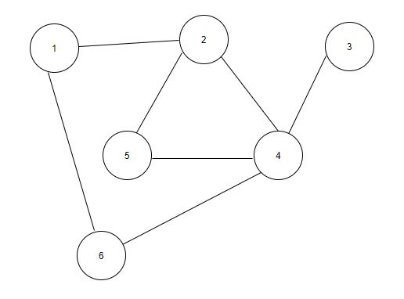

Figure 1 : Example of Triangles

In Figure 1, vertices 2, 5, 4 form a triangle since there is an edge between every pair of these nodes. But there is no other triangle in the graph.

To measure occurrences of triangles in respect to other form of subgraphs, the average or expected length of shortest paths can be compared to paths of length 2. To find average length of shortest paths in a set of Brain Networks, there already exists several shortest path algorithms which are efficient and can serve the purpose of this study [39].

### 2.3.1 Finding the Brain Graphs

There are plenty of existing studies regarding construction of Brain Graphs from fMRI data. This study uses the fMRI dataset provided by Human Connectome Project (HCP) [500-subject data release (2014)](https://www.humanconnectome.org/study/hcp-young-adult/document/500-subjects-data-release) [42] and the Brain Networks which were used in this study were collected from Jithin K. Sreedharan, Abram Magner, Ananth Grama, and Wojciech Szpankowski-[Inferring Temporal Information from a Snapshot of a Dynamic Network](https://rdcu.be/boQ5z) [40]. The graphs contained nodes which were some identified regions and list of identified brain regions can be found in A multi-modal parcellation of human cerebral cortex [41].

# Chapter 3: Methodology

From collection of data, analysing, to find the results the methodology of this study can be shown as following:

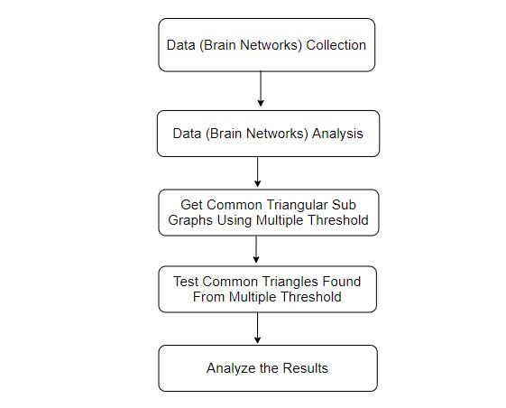

Figure 2: Flow chart of Methodology

## 3.1 Collecting Data

The Brain Graphs used in this study was proposed and built by the study [Inferring Temporal Information from a Snapshot of a Dynamic Network](https://rdcu.be/boQ5z) [40]. The fMRI data set was collected from Human Connectome Project (HCP) [500-subject data release (2014)](https://www.humanconnectome.org/study/hcp-young-adult/document/500-subjects-data-release) [42]. There were 400 graphs built from resting state fMRI of 100 random people. The graph building process can be described as:

* The raw data was in CIFTI format. Fieldtrip [43] tool box was used to load the raw files.
* A global signal regression was used to remove global effects.
* Atlas generated by A multi-modal parcellation of human cerebral cortex [41] was used.
* Each network was broken into 180 Cortical regions
* A correlation on the rows was done to get a 360 by 360 matrix. After that, the matrix was restricted to 180 by 180 to focus only on the hemisphere
* A threshold (Minimum weight needed for the graph to be connected) was applied to get an undirected unweighted graph.

The 180 Cortical regions were defined as:

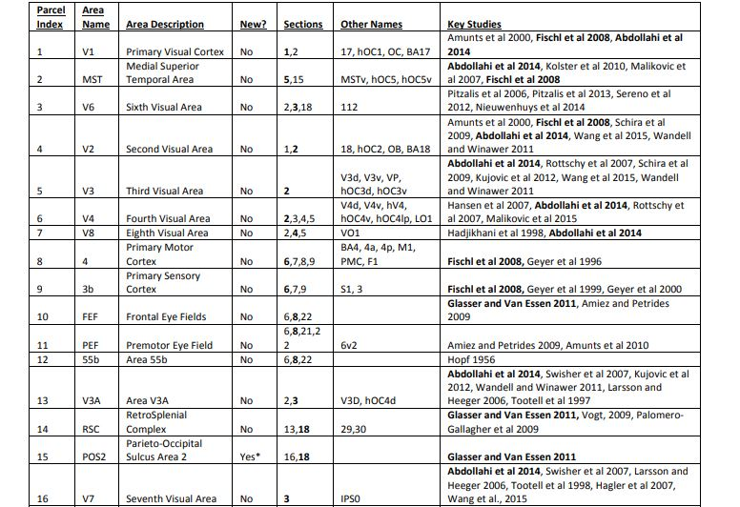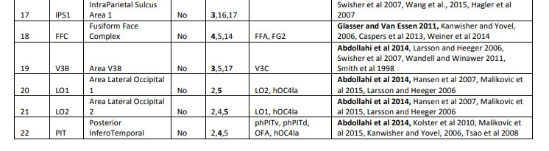

# 

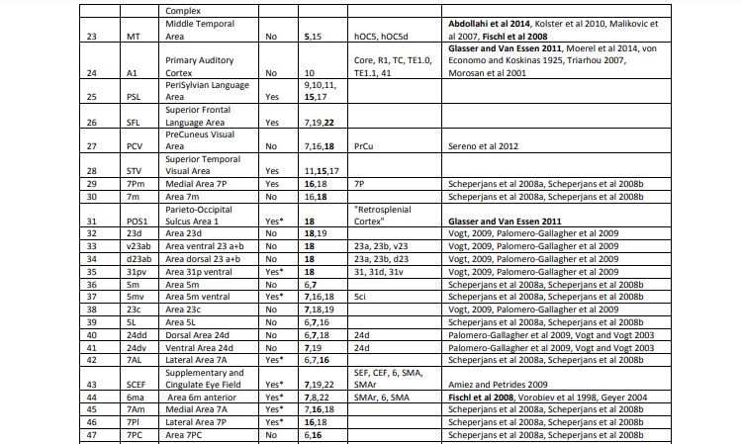

# 

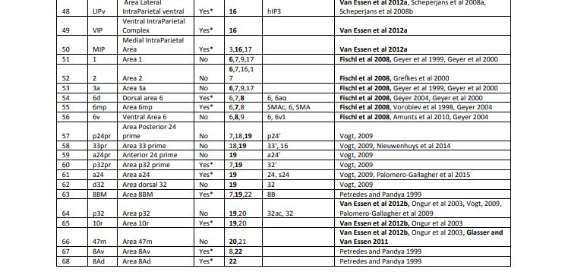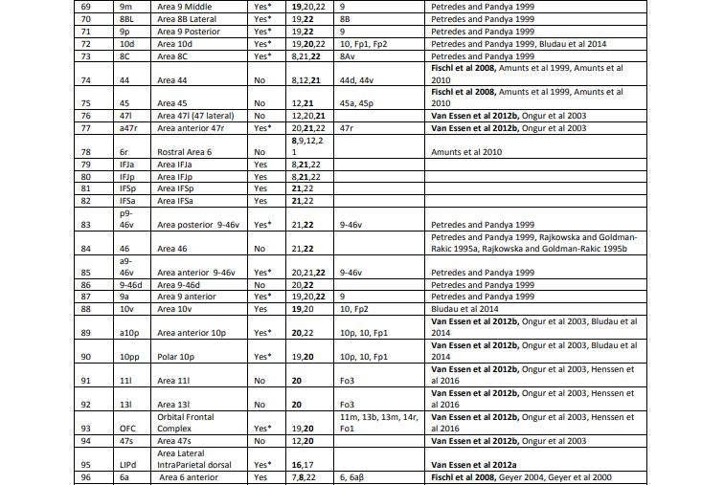

# 

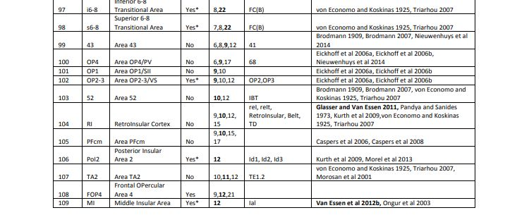

# 

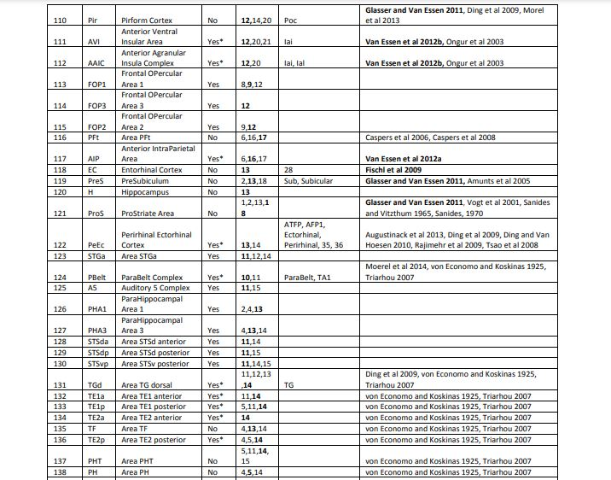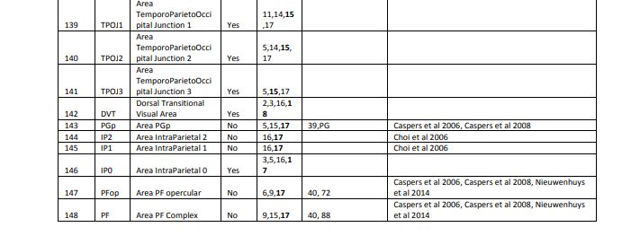

# 

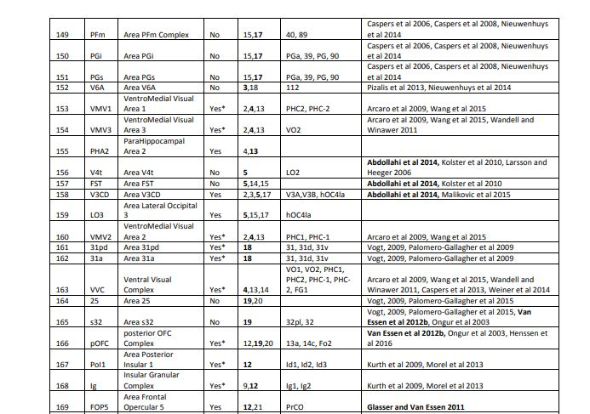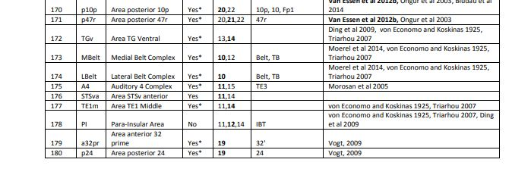

## 3.2 Analysing Data

First step was calculating the average shortest path length of all the 400 graphs. For this, Bellman Ford’s shortest path algorithm [39] was used to calculate all pair shortest paths for every graph and thus for each possible length from 1 to 180 counting number of shortest paths of such length. Finally, the average shortest path length can be written as,

Avg. SPL = ( ∑ l * cnt(l) ) / (T),

where cnt( l ) means number of shortest paths of length l in all the graphs

and T is the total number of paths in all the graphs

Analysing the data, average shortest paths found as approximately 2.03293 which can be counted as 2 since shortest path can only be integer and 2 is the nearest integer to the found real value.

This indicates a higher chance of getting triangles in the brain networks and builds the intuition that triangulation of nodes in Brain Networks may lead to some new learnings.

## 3.3 Finding Common Triangles and Analysing With Different Measures

The first step was generating all possible candidate tuples (all possible subsets of nodes 1 to 180 of size 3) which can form a triangle. There are = 955860 subsets with such properties.

After that the 400 Graphs were divided into two groups. The first 300 Graphs was in a train set to identify common triangles in them and the remaining 100 Graphs were kept for testing the found common triangles for accuracy.

Five different measures were set to define triangles as common. These were:

1. Triangles which were present in at least 80 % in test graphs, there were
2. Triangles which were present in at least 85 % in test graphs
3. Triangles which were present in at least 90 % in test graphs
4. Triangles which were present in at least 95 % in test graphs
5. Triangles which were present in at least 100 % in test graphs

For all these five different measures, the test graphs were processed and for each common triangle, it was checked whether it exists partially or fully. If it exists fully, then there will be edges among all pair of three vertices and if it exists partially, then there will be edges in 1 or 2 of the three possible pairs.

# Chapter 4: Results and Descriptive Analysis

## 4.1 Results

The average length of shortest path among all the pairs of nodes in all the graphs were found: 2.03293

For the 5 different measures, the test results for 100 graphs are show as below:

For triangles present in at least 80 % of train graphs, there were 28254 triangles identified as common. The test results:

|  |  |  |  |
| --- | --- | --- | --- |
| Test | Number of Triangle Which Exists(Fully or Partially) | Number of Triangle Which  Exists Fully | Accuracy |
| 1 | 28254 | 28234 | 99.9292 |
| 2 | 28248 | 27970 | 99.0159 |
| 3 | 28254 | 28235 | 99.9328 |
| 4 | 28253 | 28220 | 99.8832 |
| 5 | 28254 | 28254 | 100 |
| 6 | 28254 | 28254 | 100 |
| 7 | 28254 | 28254 | 100 |
| 8 | 27788 | 23696 | 85.2742 |
| 9 | 28254 | 28254 | 100 |
| 10 | 26793 | 21903 | 81.749 |
| 11 | 28172 | 27100 | 96.1948 |
| 12 | 28247 | 27978 | 99.0477 |
| 13 | 28254 | 28254 | 100 |
| 14 | 28254 | 28223 | 99.8903 |
| 15 | 28219 | 27777 | 98.4337 |
| 16 | 28254 | 28254 | 100 |
| 17 | 28254 | 28185 | 99.7558 |
| 18 | 28254 | 28254 | 100 |
| 19 | 28254 | 28231 | 99.9186 |
| 20 | 28254 | 28247 | 99.9752 |
| 21 | 28254 | 28243 | 99.9611 |
| 22 | 24884 | 18657 | 74.9759 |
| 23 | 28254 | 28254 | 100 |
| 24 | 28254 | 28226 | 99.9009 |
| 25 | 27297 | 23181 | 84.9214 |
| 26 | 26032 | 18945 | 72.7758 |
| 27 | 28254 | 28254 | 100 |
| 28 | 28254 | 28254 | 100 |
| 29 | 28254 | 28254 | 100 |
| 30 | 28221 | 27701 | 98.1574 |
| 31 | 28254 | 28254 | 100 |
| 32 | 28254 | 28254 | 100 |
| 33 | 28250 | 28107 | 99.4938 |
| 34 | 28254 | 28254 | 100 |
| 35 | 28254 | 28254 | 100 |
| 36 | 28254 | 28254 | 100 |
| 37 | 28179 | 27236 | 96.6535 |
| 38 | 28109 | 27174 | 96.6737 |
| 39 | 28254 | 28254 | 100 |
| 40 | 28254 | 28203 | 99.8195 |
| 41 | 25705 | 18866 | 73.3943 |
| 42 | 28254 | 28254 | 100 |
| 43 | 27965 | 26951 | 96.374 |
| 44 | 28254 | 28254 | 100 |
| 45 | 28254 | 28191 | 99.777 |
| 46 | 28254 | 28254 | 100 |
| 47 | 28254 | 28254 | 100 |
| 48 | 28253 | 28186 | 99.7629 |
| 49 | 27446 | 23877 | 86.9963 |
| 50 | 28254 | 28254 | 100 |
| 51 | 28254 | 28254 | 100 |
| 52 | 28230 | 27588 | 97.7258 |
| 53 | 28254 | 28240 | 99.9504 |
| 54 | 28254 | 28254 | 100 |
| 55 | 28254 | 28244 | 99.9646 |
| 56 | 27027 | 22301 | 82.5138 |
| 57 | 28250 | 28161 | 99.685 |
| 58 | 28253 | 28061 | 99.3204 |
| 59 | 28254 | 28226 | 99.9009 |
| 60 | 28254 | 28254 | 100 |
| 61 | 28180 | 26675 | 94.6593 |
| 62 | 28254 | 28254 | 100 |
| 63 | 28254 | 28254 | 100 |
| 64 | 25853 | 20019 | 77.434 |
| 65 | 28012 | 25328 | 90.4184 |
| 66 | 28254 | 28254 | 100 |
| 67 | 28218 | 27706 | 98.1856 |
| 68 | 28254 | 28254 | 100 |
| 69 | 28254 | 28254 | 100 |
| 70 | 28254 | 28254 | 100 |
| 71 | 28254 | 28254 | 100 |
| 72 | 28254 | 28254 | 100 |
| 73 | 28214 | 27678 | 98.1002 |
| 74 | 27663 | 22813 | 82.4676 |
| 75 | 27458 | 25177 | 91.6928 |
| 76 | 28246 | 28020 | 99.1999 |
| 77 | 28177 | 27604 | 97.9664 |
| 78 | 28252 | 28037 | 99.239 |
| 79 | 28254 | 28254 | 100 |
| 80 | 28254 | 28254 | 100 |
| 81 | 28254 | 28156 | 99.6531 |
| 82 | 28254 | 28239 | 99.9469 |
| 83 | 28254 | 28254 | 100 |
| 84 | 27909 | 25294 | 90.6303 |
| 85 | 28254 | 28254 | 100 |
| 86 | 26147 | 19309 | 73.8479 |
| 87 | 28254 | 28254 | 100 |
| 88 | 28254 | 28254 | 100 |
| 89 | 28072 | 25864 | 92.1345 |
| 90 | 28254 | 28254 | 100 |
| 91 | 28254 | 28209 | 99.8407 |
| 92 | 23524 | 16055 | 68.2494 |
| 93 | 19576 | 11095 | 56.6765 |
| 94 | 28254 | 28254 | 100 |
| 95 | 28253 | 28199 | 99.8089 |
| 96 | 28254 | 28254 | 100 |
| 97 | 28252 | 28132 | 99.5753 |
| 98 | 28254 | 28254 | 100 |
| 99 | 27176 | 22710 | 83.5664 |
| 100 | 28254 | 28254 | 100 |

Average Success: 96.109919 %

For triangles present in at least 85% of train graphs, there were 23691 common triangles and the test results:

|  |  |  |  |
| --- | --- | --- | --- |
| Test | Number of Triangle Which Exists (Fully or Partially) | Number of Triangle Which Exists Fully | Success |
| 1 | 23691 | 23691 | 100 |
| 2 | 23689 | 23593 | 99.5947 |
| 3 | 23691 | 23691 | 100 |
| 4 | 23691 | 23691 | 100 |
| 5 | 23691 | 23691 | 100 |
| 6 | 23691 | 23691 | 100 |
| 7 | 23691 | 23691 | 100 |
| 8 | 23579 | 21754 | 92.2601 |
| 9 | 23691 | 23691 | 100 |
| 10 | 23130 | 20261 | 87.5962 |
| 11 | 23671 | 23230 | 98.137 |
| 12 | 23691 | 23647 | 99.8143 |
| 13 | 23691 | 23691 | 100 |
| 14 | 23691 | 23691 | 100 |
| 15 | 23671 | 23452 | 99.0748 |
| 16 | 23691 | 23691 | 100 |
| 17 | 23691 | 23674 | 99.9282 |
| 18 | 23691 | 23691 | 100 |
| 19 | 23691 | 23691 | 100 |
| 20 | 23691 | 23691 | 100 |
| 21 | 23691 | 23691 | 100 |
| 22 | 21707 | 17666 | 81.3839 |
| 23 | 23691 | 23691 | 100 |
| 24 | 23691 | 23691 | 100 |
| 25 | 23210 | 20594 | 88.729 |
| 26 | 22696 | 18052 | 79.5382 |
| 27 | 23691 | 23691 | 100 |
| 28 | 23691 | 23691 | 100 |
| 29 | 23691 | 23691 | 100 |
| 30 | 23681 | 23434 | 98.957 |
| 31 | 23691 | 23691 | 100 |
| 32 | 23691 | 23691 | 100 |
| 33 | 23691 | 23664 | 99.886 |
| 34 | 23691 | 23691 | 100 |
| 35 | 23691 | 23691 | 100 |
| 36 | 23691 | 23691 | 100 |
| 37 | 23672 | 23283 | 98.3567 |
| 38 | 23645 | 23158 | 97.9404 |
| 39 | 23691 | 23691 | 100 |
| 40 | 23691 | 23678 | 99.9451 |
| 41 | 22471 | 17833 | 79.3601 |
| 42 | 23691 | 23691 | 100 |
| 43 | 23619 | 23157 | 98.0439 |
| 44 | 23691 | 23691 | 100 |
| 45 | 23691 | 23674 | 99.9282 |
| 46 | 23691 | 23691 | 100 |
| 47 | 23691 | 23691 | 100 |
| 48 | 23691 | 23679 | 99.9493 |
| 49 | 23441 | 21444 | 91.4807 |
| 50 | 23691 | 23691 | 100 |
| 51 | 23691 | 23691 | 100 |
| 52 | 23688 | 23549 | 99.4132 |
| 53 | 23691 | 23689 | 99.9916 |
| 54 | 23691 | 23691 | 100 |
| 55 | 23691 | 23691 | 100 |
| 56 | 23148 | 20517 | 88.634 |
| 57 | 23691 | 23674 | 99.9282 |
| 58 | 23691 | 23675 | 99.9325 |
| 59 | 23691 | 23685 | 99.9747 |
| 60 | 23691 | 23691 | 100 |
| 61 | 23682 | 23134 | 97.686 |
| 62 | 23691 | 23691 | 100 |
| 63 | 23691 | 23691 | 100 |
| 64 | 22210 | 18303 | 82.4088 |
| 65 | 23638 | 22580 | 95.5242 |
| 66 | 23691 | 23691 | 100 |
| 67 | 23681 | 23507 | 99.2652 |
| 68 | 23691 | 23691 | 100 |
| 69 | 23691 | 23691 | 100 |
| 70 | 23691 | 23691 | 100 |
| 71 | 23691 | 23691 | 100 |
| 72 | 23691 | 23691 | 100 |
| 73 | 23673 | 23389 | 98.8003 |
| 74 | 23543 | 21146 | 89.8186 |
| 75 | 23392 | 22149 | 94.6862 |
| 76 | 23691 | 23629 | 99.7383 |
| 77 | 23671 | 23403 | 98.8678 |
| 78 | 23691 | 23644 | 99.8016 |
| 79 | 23691 | 23691 | 100 |
| 80 | 23691 | 23691 | 100 |
| 81 | 23691 | 23669 | 99.9071 |
| 82 | 23691 | 23691 | 100 |
| 83 | 23691 | 23691 | 100 |
| 84 | 23562 | 22317 | 94.7161 |
| 85 | 23691 | 23691 | 100 |
| 86 | 22703 | 18743 | 82.5574 |
| 87 | 23691 | 23691 | 100 |
| 88 | 23691 | 23691 | 100 |
| 89 | 23640 | 22523 | 95.275 |
| 90 | 23691 | 23691 | 100 |
| 91 | 23691 | 23691 | 100 |
| 92 | 20929 | 15696 | 74.9964 |
| 93 | 17792 | 10853 | 60.9993 |
| 94 | 23691 | 23691 | 100 |
| 95 | 23691 | 23674 | 99.9282 |
| 96 | 23691 | 23691 | 100 |
| 97 | 23691 | 23679 | 99.9493 |
| 98 | 23691 | 23691 | 100 |
| 99 | 23170 | 20441 | 88.2218 |
| 100 | 23691 | 23691 | 100 |

Average Success: 97.309256

For triangles present in at least 90% of train graphs 19623 triangles were identified as common and the test results:

|  |  |  |  |
| --- | --- | --- | --- |
| Test | Number of Triangle Which Exists (Fully or Partially) | Number of Triangle Which Exists Fully | Success |
| 1 | 19623 | 19623 | 100 |
| 2 | 19622 | 19596 | 99.8675 |
| 3 | 19623 | 19623 | 100 |
| 4 | 19623 | 19623 | 100 |
| 5 | 19623 | 19623 | 100 |
| 6 | 19623 | 19623 | 100 |
| 7 | 19623 | 19623 | 100 |
| 8 | 19615 | 19149 | 97.6243 |
| 9 | 19623 | 19623 | 100 |
| 10 | 19436 | 18188 | 93.5789 |
| 11 | 19621 | 19573 | 99.7554 |
| 12 | 19623 | 19623 | 100 |
| 13 | 19623 | 19623 | 100 |
| 14 | 19623 | 19623 | 100 |
| 15 | 19616 | 19515 | 99.4851 |
| 16 | 19623 | 19623 | 100 |
| 17 | 19623 | 19623 | 100 |
| 18 | 19623 | 19623 | 100 |
| 19 | 19623 | 19623 | 100 |
| 20 | 19623 | 19623 | 100 |
| 21 | 19623 | 19623 | 100 |
| 22 | 18565 | 16259 | 87.5788 |
| 23 | 19623 | 19623 | 100 |
| 24 | 19623 | 19623 | 100 |
| 25 | 19376 | 17821 | 91.9746 |
| 26 | 19255 | 16799 | 87.2449 |
| 27 | 19623 | 19623 | 100 |
| 28 | 19623 | 19623 | 100 |
| 29 | 19623 | 19623 | 100 |
| 30 | 19623 | 19531 | 99.5312 |
| 31 | 19623 | 19623 | 100 |
| 32 | 19623 | 19623 | 100 |
| 33 | 19623 | 19623 | 100 |
| 34 | 19623 | 19623 | 100 |
| 35 | 19623 | 19623 | 100 |
| 36 | 19623 | 19623 | 100 |
| 37 | 19622 | 19518 | 99.47 |
| 38 | 19605 | 19368 | 98.7911 |
| 39 | 19623 | 19623 | 100 |
| 40 | 19623 | 19623 | 100 |
| 41 | 19071 | 16452 | 86.2671 |
| 42 | 19623 | 19623 | 100 |
| 43 | 19607 | 19435 | 99.1228 |
| 44 | 19623 | 19623 | 100 |
| 45 | 19623 | 19623 | 100 |
| 46 | 19623 | 19623 | 100 |
| 47 | 19623 | 19623 | 100 |
| 48 | 19623 | 19623 | 100 |
| 49 | 19565 | 18746 | 95.814 |
| 50 | 19623 | 19623 | 100 |
| 51 | 19623 | 19623 | 100 |
| 52 | 19622 | 19578 | 99.7758 |
| 53 | 19623 | 19623 | 100 |
| 54 | 19623 | 19623 | 100 |
| 55 | 19623 | 19623 | 100 |
| 56 | 19412 | 18035 | 92.9064 |
| 57 | 19623 | 19623 | 100 |
| 58 | 19623 | 19623 | 100 |
| 59 | 19623 | 19623 | 100 |
| 60 | 19623 | 19623 | 100 |
| 61 | 19622 | 19549 | 99.628 |
| 62 | 19623 | 19623 | 100 |
| 63 | 19623 | 19623 | 100 |
| 64 | 18824 | 16372 | 86.9741 |
| 65 | 19621 | 19455 | 99.154 |
| 66 | 19623 | 19623 | 100 |
| 67 | 19619 | 19534 | 99.5667 |
| 68 | 19623 | 19623 | 100 |
| 69 | 19623 | 19623 | 100 |
| 70 | 19623 | 19623 | 100 |
| 71 | 19623 | 19623 | 100 |
| 72 | 19623 | 19623 | 100 |
| 73 | 19617 | 19488 | 99.3424 |
| 74 | 19603 | 18897 | 96.3985 |
| 75 | 19493 | 18823 | 96.5629 |
| 76 | 19623 | 19623 | 100 |
| 77 | 19616 | 19511 | 99.4647 |
| 78 | 19623 | 19623 | 100 |
| 79 | 19623 | 19623 | 100 |
| 80 | 19623 | 19623 | 100 |
| 81 | 19623 | 19623 | 100 |
| 82 | 19623 | 19623 | 100 |
| 83 | 19623 | 19623 | 100 |
| 84 | 19576 | 18988 | 96.9963 |
| 85 | 19623 | 19623 | 100 |
| 86 | 19204 | 17286 | 90.0125 |
| 87 | 19623 | 19623 | 100 |
| 88 | 19623 | 19623 | 100 |
| 89 | 19610 | 19260 | 98.2152 |
| 90 | 19623 | 19623 | 100 |
| 91 | 19623 | 19623 | 100 |
| 92 | 18153 | 14879 | 81.9644 |
| 93 | 15822 | 10483 | 66.2558 |
| 94 | 19623 | 19623 | 100 |
| 95 | 19623 | 19623 | 100 |
| 96 | 19623 | 19623 | 100 |
| 97 | 19623 | 19623 | 100 |
| 98 | 19623 | 19623 | 100 |
| 99 | 19403 | 17993 | 92.7331 |
| 100 | 19623 | 19623 | 100 |

Average Success: 98.320565

For triangles present in at least 95% of train graphs, there were 14959 triangles identified as common and the test results:

|  |  |  |  |
| --- | --- | --- | --- |
| Test | Number of Triangle Which Exists (Fully or Partially) | Number of Triangle Which Exists Fully | Success |
| 1 | 14959 | 14959 | 100 |
| 2 | 14959 | 14959 | 100 |
| 3 | 14959 | 14959 | 100 |
| 4 | 14959 | 14959 | 100 |
| 5 | 14959 | 14959 | 100 |
| 6 | 14959 | 14959 | 100 |
| 7 | 14959 | 14959 | 100 |
| 8 | 14959 | 14954 | 99.9666 |
| 9 | 14959 | 14959 | 100 |
| 10 | 14932 | 14675 | 98.2789 |
| 11 | 14959 | 14950 | 99.9398 |
| 12 | 14959 | 14959 | 100 |
| 13 | 14959 | 14959 | 100 |
| 14 | 14959 | 14959 | 100 |
| 15 | 14959 | 14959 | 100 |
| 16 | 14959 | 14959 | 100 |
| 17 | 14959 | 14959 | 100 |
| 18 | 14959 | 14959 | 100 |
| 19 | 14959 | 14959 | 100 |
| 20 | 14959 | 14959 | 100 |
| 21 | 14959 | 14959 | 100 |
| 22 | 14663 | 13780 | 93.978 |
| 23 | 14959 | 14959 | 100 |
| 24 | 14959 | 14959 | 100 |
| 25 | 14925 | 14411 | 96.5561 |
| 26 | 14886 | 14025 | 94.216 |
| 27 | 14959 | 14959 | 100 |
| 28 | 14959 | 14959 | 100 |
| 29 | 14959 | 14959 | 100 |
| 30 | 14959 | 14959 | 100 |
| 31 | 14959 | 14959 | 100 |
| 32 | 14959 | 14959 | 100 |
| 33 | 14959 | 14959 | 100 |
| 34 | 14959 | 14959 | 100 |
| 35 | 14959 | 14959 | 100 |
| 36 | 14959 | 14959 | 100 |
| 37 | 14959 | 14959 | 100 |
| 38 | 14952 | 14879 | 99.5118 |
| 39 | 14959 | 14959 | 100 |
| 40 | 14959 | 14959 | 100 |
| 41 | 14776 | 13629 | 92.2374 |
| 42 | 14959 | 14959 | 100 |
| 43 | 14959 | 14953 | 99.9599 |
| 44 | 14959 | 14959 | 100 |
| 45 | 14959 | 14959 | 100 |
| 46 | 14959 | 14959 | 100 |
| 47 | 14959 | 14959 | 100 |
| 48 | 14959 | 14959 | 100 |
| 49 | 14959 | 14900 | 99.6056 |
| 50 | 14959 | 14959 | 100 |
| 51 | 14959 | 14959 | 100 |
| 52 | 14959 | 14959 | 100 |
| 53 | 14959 | 14959 | 100 |
| 54 | 14959 | 14959 | 100 |
| 55 | 14959 | 14959 | 100 |
| 56 | 14911 | 14370 | 96.3718 |
| 57 | 14959 | 14959 | 100 |
| 58 | 14959 | 14959 | 100 |
| 59 | 14959 | 14959 | 100 |
| 60 | 14959 | 14959 | 100 |
| 61 | 14959 | 14959 | 100 |
| 62 | 14959 | 14959 | 100 |
| 63 | 14959 | 14959 | 100 |
| 64 | 14745 | 13691 | 92.8518 |
| 65 | 14959 | 14959 | 100 |
| 66 | 14959 | 14959 | 100 |
| 67 | 14959 | 14954 | 99.9666 |
| 68 | 14959 | 14959 | 100 |
| 69 | 14959 | 14959 | 100 |
| 70 | 14959 | 14959 | 100 |
| 71 | 14959 | 14959 | 100 |
| 72 | 14959 | 14959 | 100 |
| 73 | 14959 | 14954 | 99.9666 |
| 74 | 14959 | 14874 | 99.4318 |
| 75 | 14940 | 14749 | 98.7216 |
| 76 | 14959 | 14959 | 100 |
| 77 | 14958 | 14930 | 99.8128 |
| 78 | 14959 | 14959 | 100 |
| 79 | 14959 | 14959 | 100 |
| 80 | 14959 | 14959 | 100 |
| 81 | 14959 | 14959 | 100 |
| 82 | 14959 | 14959 | 100 |
| 83 | 14959 | 14959 | 100 |
| 84 | 14957 | 14860 | 99.3515 |
| 85 | 14959 | 14959 | 100 |
| 86 | 14877 | 14218 | 95.5703 |
| 87 | 14959 | 14959 | 100 |
| 88 | 14959 | 14959 | 100 |
| 89 | 14959 | 14917 | 99.7192 |
| 90 | 14959 | 14959 | 100 |
| 91 | 14959 | 14959 | 100 |
| 92 | 14518 | 12942 | 89.1445 |
| 93 | 13172 | 9663 | 73.3602 |
| 94 | 14959 | 14959 | 100 |
| 95 | 14959 | 14959 | 100 |
| 96 | 14959 | 14959 | 100 |
| 97 | 14959 | 14959 | 100 |
| 98 | 14959 | 14959 | 100 |
| 99 | 14914 | 14481 | 97.0967 |
| 100 | 14959 | 14959 | 100 |

Average Success: 99.156%

For triangles present in at all of the test graphs there were 6667 triangles identified as common and the test results:

|  |  |  |  |
| --- | --- | --- | --- |
| Test | Number of Triangle Which Exists (Fully or Partially) | Number of Triangle Which Exists Fully | Success |
| 1 | 6667 | 6667 | 100 |
| 2 | 6667 | 6667 | 100 |
| 3 | 6667 | 6667 | 100 |
| 4 | 6667 | 6667 | 100 |
| 5 | 6667 | 6667 | 100 |
| 6 | 6667 | 6667 | 100 |
| 7 | 6667 | 6667 | 100 |
| 8 | 6667 | 6667 | 100 |
| 9 | 6667 | 6667 | 100 |
| 10 | 6667 | 6667 | 100 |
| 11 | 6667 | 6667 | 100 |
| 12 | 6667 | 6667 | 100 |
| 13 | 6667 | 6667 | 100 |
| 14 | 6667 | 6667 | 100 |
| 15 | 6667 | 6667 | 100 |
| 16 | 6667 | 6667 | 100 |
| 17 | 6667 | 6667 | 100 |
| 18 | 6667 | 6667 | 100 |
| 19 | 6667 | 6667 | 100 |
| 20 | 6667 | 6667 | 100 |
| 21 | 6667 | 6667 | 100 |
| 22 | 6667 | 6667 | 100 |
| 23 | 6667 | 6667 | 100 |
| 24 | 6667 | 6667 | 100 |
| 25 | 6667 | 6667 | 100 |
| 26 | 6667 | 6667 | 100 |
| 27 | 6667 | 6667 | 100 |
| 28 | 6667 | 6667 | 100 |
| 29 | 6667 | 6667 | 100 |
| 30 | 6667 | 6667 | 100 |
| 31 | 6667 | 6667 | 100 |
| 32 | 6667 | 6667 | 100 |
| 33 | 6667 | 6667 | 100 |
| 34 | 6667 | 6667 | 100 |
| 35 | 6667 | 6667 | 100 |
| 36 | 6667 | 6667 | 100 |
| 37 | 6667 | 6667 | 100 |
| 38 | 6667 | 6667 | 100 |
| 39 | 6667 | 6667 | 100 |
| 40 | 6667 | 6667 | 100 |
| 41 | 6667 | 6649 | 99.73 |
| 42 | 6667 | 6667 | 100 |
| 43 | 6667 | 6667 | 100 |
| 44 | 6667 | 6667 | 100 |
| 45 | 6667 | 6667 | 100 |
| 46 | 6667 | 6667 | 100 |
| 47 | 6667 | 6667 | 100 |
| 48 | 6667 | 6667 | 100 |
| 49 | 6667 | 6667 | 100 |
| 50 | 6667 | 6667 | 100 |
| 51 | 6667 | 6667 | 100 |
| 52 | 6667 | 6667 | 100 |
| 53 | 6667 | 6667 | 100 |
| 54 | 6667 | 6667 | 100 |
| 55 | 6667 | 6667 | 100 |
| 56 | 6667 | 6667 | 100 |
| 57 | 6667 | 6667 | 100 |
| 58 | 6667 | 6667 | 100 |
| 59 | 6667 | 6667 | 100 |
| 60 | 6667 | 6667 | 100 |
| 61 | 6667 | 6667 | 100 |
| 62 | 6667 | 6667 | 100 |
| 63 | 6667 | 6667 | 100 |
| 64 | 6667 | 6667 | 100 |
| 65 | 6667 | 6667 | 100 |
| 66 | 6667 | 6667 | 100 |
| 67 | 6667 | 6667 | 100 |
| 68 | 6667 | 6667 | 100 |
| 69 | 6667 | 6667 | 100 |
| 70 | 6667 | 6667 | 100 |
| 71 | 6667 | 6667 | 100 |
| 72 | 6667 | 6667 | 100 |
| 73 | 6667 | 6667 | 100 |
| 74 | 6667 | 6667 | 100 |
| 75 | 6667 | 6667 | 100 |
| 76 | 6667 | 6667 | 100 |
| 77 | 6667 | 6667 | 100 |
| 78 | 6667 | 6667 | 100 |
| 79 | 6667 | 6667 | 100 |
| 80 | 6667 | 6667 | 100 |
| 81 | 6667 | 6667 | 100 |
| 82 | 6667 | 6667 | 100 |
| 83 | 6667 | 6667 | 100 |
| 84 | 6667 | 6667 | 100 |
| 85 | 6667 | 6667 | 100 |
| 86 | 6667 | 6667 | 100 |
| 87 | 6667 | 6667 | 100 |
| 88 | 6667 | 6667 | 100 |
| 89 | 6667 | 6667 | 100 |
| 90 | 6667 | 6667 | 100 |
| 91 | 6667 | 6667 | 100 |
| 92 | 6667 | 6667 | 100 |
| 93 | 6622 | 6154 | 92.9326 |
| 94 | 6667 | 6667 | 100 |
| 95 | 6667 | 6667 | 100 |
| 96 | 6667 | 6667 | 100 |
| 97 | 6667 | 6667 | 100 |
| 98 | 6667 | 6667 | 100 |
| 99 | 6667 | 6667 | 100 |
| 100 | 6667 | 6667 | 100 |

Average Success: 99.9266%

## 4.2 Descriptive Analysis and Summery

Summery:

All the 5 different measures can be summarized in the following table

|  |  |
| --- | --- |
| Present in | Avg. Success |
| >= 80% | 96.109919% |
| >= 85% | 97.309256% |
| >= 90% | 98.320565% |
| >= 95% | 99.1560% |
| 100% | 99.9266% |

What the test results indicate is whenever a part (subset of vertices which are connected) if a common (identified or defined as common triangle from test graphs) triangle exists any Brain network, it tends to exist fully.

In simple words, for a common triangle A with vertices u, v, w if there is any two of u, v, w is active in the brain network and connected, then all three of them must form a triangle (all three of them must be connected with the other two directly with an edge).

The test results supports the hypothesis strongly.

That means, if common triangles are identified, they can be used to reveal or predict brain connectivity and responsible regions for connections between other brain regions can be found effectively.

# Chapter 5: Future work and Conclusion

## 5.1 Future Work

In this study the fact that common triangles exists in brain graphs was examined, this indicates, there are some common patterns in brain connectivity and much more to explore in brain networks. However, testing with such a small number of graphs does not guaranty any proof of correctness of the proposed hypothesis. Thus, testing the hypothesis with a large number of data set remains a future work.

Also, Identifying the Psychological and Psycho-Biological aspects of the triangulation of Brain Networks can be an area of interest for those who want to pursue some more exploration on this topic. Identifying such aspects can significantly provide insights on human brain functions and connections of different brain regions which can open the door of multiple aspects of analysing human behaviour, emotions and psychological disorders.

## 5.2 Conclusion

The objective of this study was to analyse the triangulation perspective of brain networks and try to establish a pattern in triangulation of nodes.

This study was successful in finding a relation in terms of triangulation of nodes in brain networks. It is highly possible according to the study that, there are common triangles in brain networks which exists in almost every brain graph according to the tests. Which indicates there are certain set of brain regions which activates and communicates in a triangulation pattern and such set of brain regions can be identified and analysed in future researches to explore new aspects of knowledge about human brain functions.

# References

[1] DeYoe EA, Bandettini P, Neitz J, Miller D, Winans P. Functional magnetic resonance imaging (FMRI) of the human brain. J Neurosci Methods. Oct.1994 54:171–87. [PubMed: 7869750]

[2] Lawrence SJD, Formisano E, Muckli L, de Lange FP. Laminar fMRI: Applications for cognitive neuroscience. Neuroimage. Jul 04.2017

[3] Lee, L., Harrison, L. M., and Mechelli, A. (2003). A report of the functional connectivity workshop, Dusseldorf 2002. Neuroimage 19, 457–465. doi: 10.1016/S1053-8119(03)00062-4

[4] riston, K. J., Frith, C. D., Liddle, P. F., and Frackowiak, R. S. (1993). Functional connectivity: the principal-component analysis of large (PET) data sets. J. Cereb. Blood Flow Metab. 13, 5–14. doi: 10.1038/jcbfm.1993.4

[5] Li, K., Guo, L., Nie, J., Li, G., and Liu, T. (2009a). Review of methods for functional brain connectivity detection using fMRI. Comput. Med. Imaging Graph. 33, 131–139. doi: 10.1016/j.compmedimag.2008.10.011

[6] Farahani, F. V., and Karwowski, W. (2018). “Computational methods for analyzing functional and effective brain network connectivity using fMRI,” in International Conference on Applied Human Factors and Ergonomics (Cham: Springer), 101–112.

[7] Friston, K. J., Jezzard, P., and Turner, R. (1994b). Analysis of functional MRI time-series. Hum. Brain Mapp. 1, 153–171. doi: 10.1002/hbm.460010207

[8] Saad, Z. S., Ropella, K. M., Cox, R. W., and DeYoe, E. A. (2001). Analysis and use of fMRI response delays. Hum. Brain Mapp. 13, 74–93. doi: 10.1002/hbm.1026

[9] Sun, F. T., Miller, L. M., and D'Esposito, M. (2004). Measuring interregional functional connectivity using coherence and partial coherence analyses of fMRI data. Neuroimage 21, 647–658. doi: 10.1016/j.neuroimage.2003.09.056

[10] Friston, K. J. (1994). Functional and effective connectivity in neuroimaging:~a synthesis. Hum. Brain Mapp. 2, 56–78. doi: 10.1002/hbm.460020107

[11] Wen, X., Rangarajan, G., and Ding, M. (2013). Is Granger causality a viable technique for analyzing fMRI data? PLoS ONE 8:e67428. doi: 10.1371/journal.pone.0067428

[12] Dang, S., Chaudhury, S., Lall, B., and Roy, P. K. (2017). Learning effective connectivity from fMRI using autoregressive hidden Markov model with missing data. J. Neurosci. Methods 278, 87–100. doi: 10.1016/j.jneumeth.2016.12.019

[13] Friston, K., Moran, R., and Seth, A. K. (2013). Analysing connectivity with Granger causality and dynamic causal modelling. Curr. Opin. Neurobiol. 23, 72–178. doi: 10.1016/j.conb.2012.11.010

[14] Dhamala, M., Rangarajan, G., and Ding, M. (2008). Analyzing information flow in brain networks with nonparametric Granger causality. Neuroimage 41, 354–362. doi: 10.1016/j.neuroimage.2008.02.020

[15] Roebroeck, A., Formisano, E., and Goebel, R. (2011). The identification of interacting networks in the brain using fMRI: model selection, causality and deconvolution. Neuroimage 58, 296–302. doi: 10.1016/j.neuroimage.2009.09.036

[16] Friston, K. J., Harrison, L., and Penny, W. (2003). Dynamic causal modelling. Neuroimage 19, 1273–1302. doi: 10.1016/S1053-8119(03)00202-7

[17] Friston, K. J., Li, B., Daunizeau, J., and Stephan, K. E. (2011). Network discovery with DCM. Neuroimage 56, 1202–1221. doi: 10.1016/j.neuroimage.2010.12.039

[18] Rajapakse, J. C., and Zhou, J. (2007). Learning effective brain connectivity with dynamic Bayesian networks. Neuroimage 37, 749–760. doi: 10.1016/j.neuroimage.2007.06.003

[19] Schreiber, T. (2000). Measuring information transfer. Phys. Rev. Lett. 85, 461–464. doi: 10.1103/PhysRevLett.85.461

[20] Bastos, A. M., and Schoffelen, J. (2016). A tutorial review of functional connectivity analysis methods and their interpretational pitfalls. Front. Syst. Neurosci. 9:175. doi: 10.3389/fnsys.2015.00175

[21] van den Heuvel MP, Sporns O, Collin G, Scheewe T, Mandl RC, Cahn W, et al. Abnormal rich club organization and functional brain dynamics in schizophrenia. JAMA Psychiatry. Aug 1.2013 70:783–92. [PubMed: 23739835]

[22] Romero-Garcia R, Atienza M, Clemmensen LH, Cantero JL. Effects of network resolution on topological properties of human neocortex. Neuroimage. Feb 15.2012 59:3522–3532. [PubMed:

22094643]

[23] Tzourio-Mazoyer N, Landeau B, Papathanassiou D, Crivello F, Etard O, Delcroix N, et al.

Automated anatomical labeling of activations in SPM using a macroscopic anatomical

parcellation of the MNI MRI single-subject brain. Neuroimage. Jan.2002 15:273–89. [PubMed:

11771995]

[24] Gong G, He Y, Concha L, Lebel C, Gross DW, Evans AC, et al. Mapping anatomical connectivity patterns of human cerebral cortex using in vivo diffusion tensor imaging tractography. Cereb Cortex. Mar.2009 19:524–36. [PubMed: 18567609]

[25] Achard S, Bullmore E. Efficiency and cost of economical brain functional networks. PLoS Comput Biol. Feb 2.2007 3:e17. [PubMed: 17274684]

[26] Salvador R, Suckling J, Coleman MR, Pickard JD, Menon D, Bullmore E. Neurophysiological architecture of functional magnetic resonance images the human brain.Cereb Cortex. Sep.2005 15:1332–42. [PubMed: 15635061]

[27] Eguiluz VM, Chialvo DR, Cecchi GA, Baliki M, Apkarian AV. Scale-free brain functional

networks. Phys Rev Lett. Jan 14.2005 94:018102. [PubMed: 15698136]

[28] van den Heuvel MP, Stam CJ, Boersma M, Hulshoff Pol HE. Small-world and scale-free

organization of voxel-based resting-state functional connectivity in the human brain. Neuroimage. Nov 15.2008 43:528–39. [PubMed: 18786642]

[29] Qingbao Yu, Yuhui Du, Jiayu Chen, Jing Sui, Tulay Adali, Godfrey Pearlson, Olin Neuropsychiatry. Application of Graph Theory to Assess Static and Dynamic Brain Connectivity: Approaches for Building Brain Graphs [Proc IEEE Inst Electr Electron Eng.2018 May; 106(5):886–906. Doi:10.1109 / JPROC.2018.2825200.]

[29] Bertolero MA, Yeo BTT, D’Esposito M. The modular and integrative functional architecture of the human brain. Proceedings of the National Academy of Sciences of the United States of

America. Dec 8.2015 112:E6798–E6807. [PubMed: 26598686]

[30] Hayasaka S, Laurienti PJ. Comparison of characteristics between region-and voxel-based network analyses in resting-state fMRI data. Neuroimage. Apr 1.2010 50:499–508. [PubMed: 20026219]

[31] A Fast Algorithm for Finding Dominators in a Flow Graph THOMAS LENGAUER and ROBERT ENDRE TARJAN Stanford University

[32] Van Horn JD, Grafton ST, Miller MB. Individual Variability in Brain Activity: A Nuisance or an Opportunity? Brain Imaging Behav. Dec 1.2008 2:327–334. [PubMed: 19777073]

[33]Barnes KA, Cohen AL, Power JD, Nelson SM, Dosenbach YB, Miezin FM, et al. Identifying Basal Ganglia divisions in individuals using resting-state functional connectivity MRI. Front Syst Neurosci. 2010; 4:18. [PubMed: 20589235]

[34] Finn ES, Scheinost D, Finn DM, Shen X, Papademetris X, Constable RT. Can brain state be

manipulated to emphasize individual differences in functional connectivity? Neuroimage. Oct

15.2017 160:140–151. [PubMed: 28373122]

[35] Calhoun VD, Adali T, Pearlson GD, Pekar JJ. A method for making group inferences from

functional MRI data using independent component analysis. Hum Brain Mapp. Nov.2001

14:140–51. [PubMed: 11559959]

[36] Erhardt EB, Rachakonda S, Bedrick EJ, Allen EA, Adali T, Calhoun VD. Comparison of multi-subject ICA methods for analysis of fMRI data. Hum Brain Mapp. Dec.2011 32:2075–95.

[37] Calhoun VD, Kiehl KA, Pearlson GD. Modulation of temporally coherent brain networks

estimated using ICA at rest and during cognitive tasks. Hum Brain Mapp. Jul.2008 29:828–38.

[PubMed: 18438867]

[38] Skiena, S. Implementing Discrete Mathematics: Combinatorics and Graph Theory with Mathematica.

[39] Bellman, Richard. “On a routing problem". Quarterly of Applied Mathematics [[MR](https://en.wikipedia.org/wiki/MR_(identifier)) [0102435](https://www.ams.org/mathscinet-getitem?mr=0102435)]

[40] Jithin K. Sreedharan, Abram Magner, Ananth Grama, and Wojciech Szpankowski. [Inferring Temporal Information from a Snapshot of a Dynamic Network](https://rdcu.be/boQ5z)

[41] Matthew F Glasser, Timothy S Coalson, Emma C Robinson, Carl D Hacker, John Harwell, Essa Yacoub, Kamil Ugurbil, Jesper Andersson, Christian F Beckmann, Mark Jenkinson, Stephen M Smith and David C Van Essen. - A multi-modal parcellation of human cerebral cortex [PMCID: PMC4990127]

[42] Human Connectome Project (HCP) [500-subject data release (2014)](https://www.humanconnectome.org/study/hcp-young-adult/document/500-subjects-data-release)

[43] http://www.fieldtriptoolbox.org/

# Appendices

## Code Snippet 1

FindExpectedShortestPathLength.cpp

Used to find the average shortest path

#include<bits/stdc++.h>

using namespace std;

// path[i] -> number of shortest paths of length i among all the graphs

int paths[185];

int cnt; // -> number of shortest paths of length < infinity

void process(int graph[185][185]){ // Given Adjacency Matrix

int n = 180;

int Dist[185][185];

const int inf = 1e8;

memset(Dist,0,sizeof Dist);

for(int i=1;i<=n;i++){

for(int j=1;j<=n;j++){

if(i==j)Dist[i][j] = 0;

else{

if( graph[i][j] )Dist[i][j] = 1;

else Dist[i][j] = inf;

}

}

}

// Floyd Warshall Algorithm

for(int k=1;k<=n;k++){// k->intermediate node

for(int i=1;i<=n;i++){

for(int j=1;j<=n;j++){

if(Dist[i][k]<inf && Dist[k][j]<inf){

if( Dist[i][j] > Dist[i][k]+Dist[k][j] ){

Dist[i][j] = Dist[i][k]+Dist[k][j];

}

}

}

}

}

for(int i=1;i<=n;i++){

for(int j=1;j<=n;j++){

if(Dist[i][j] < inf){

cnt++;

int d = Dist[i][j];

paths[d]++;

}

}

}

}

void calculate(){

cerr<<cnt<<endl;

double ep = 0;

for(int i=1;i<=180;i++){

ep+= 1.0*i*paths[i];

}

ep /= (1.0)*cnt;

cerr<<ep<<endl;

}

void readFile(int id){// Read Graph From ith File

ifstream infile;

string s = "graph_connectome_";

string num = to_string(id);

s += num;

s += ".txt";

cerr<<s<<endl;

infile.open(s);

int graph[185][185];

memset(graph,0,sizeof graph);

while(!infile.eof()){

int u,v;

string st;

getline(infile, st);

sscanf(st.c_str(), "%d %d", &u,&v);

graph[u][v] = 1;

graph[v][u] = 1;

}

infile.close();

process(graph);

}

int main(){

/*

*

* FOUND EXPECTED LENGTH OF SHORTEST PATH : 2.03293 (ALL GRAPHS)

*/

for(int i=0;i<300;i++)readFile(i);

calculate();

return 0;

}

## Code Snippet 2

Train.cpp

Used to select common triangles from train data set and put them in output file

#include<bits/stdc++.h>

using namespace std;

struct Tuple{

int u,v,w;

Tuple(){}

Tuple(int a,int b,int c){

u=a,v=b,w=c;

}

};

bool operator<(Tuple a,Tuple b){

if(a.u==b.u){

if(a.v==b.v)return a.w<b.w;

return a.v<b.v;

}

return a.u < b.u;

}

vector<Tuple> AllTuples; // Contains All Possible Tuples

vector<int> occurs;

map<Tuple,int> mp;

void process(int graph[185][185]){ // Given Adjacency Matrix

int n = 180;

for(int i=1;i<=n;i++){

for(int j=i+1;j<=n;j++){

if( graph[i][j] && graph[j][i])

for(int k=j+1;k<=n;k++){

if( graph[j][k] && graph[k][j] ){

if( graph[i][k] && graph[k][i] ){

Tuple t(i,j,k);

int id = mp[t];

occurs[id]++;

}

}

}

}

}

}

void readFile(int id){// Read Graph From ith File

ifstream infile;

string s = "graph_connectome_";

string num = to_string(id);

s += num;

s += ".txt";

cerr<<"Processing :: "<<s<<endl;

infile.open(s);

int graph[185][185];

memset(graph,0,sizeof graph);

while(!infile.eof()){

int u,v;

string st;

getline(infile, st);

sscanf(st.c_str(), "%d %d", &u,&v);

graph[u][v] = 1;

graph[v][u] = 1;

}

infile.close();

process(graph);

}

void generateTuples(){

int n = 180;

int ind = 0;

for(int i=1;i<=n;i++)

for(int j=i+1;j<=n;j++)

for(int k=j+1;k<=n;k++)

mp[ Tuple(i,j,k) ] = ind++;

int sz = (int)mp.size();

occurs.resize(sz+10,0);

}

void print(){

ofstream outfile;

outfile.open("Occurrence.txt");

for(auto x:mp){

Tuple t = x.first;

int id = x.second;

int val = occurs[id];

outfile<<id<<" "<<t.u<<","<<t.v<<","<<t.w<<" "<<val<<"\n";

}

outfile.close();

}

int main(){

generateTuples();

cerr<<(int)mp.size()<<endl;

for(int i=0;i<300;i++)readFile(i);

print();

return 0;

}

## Code Snippet 3

testMaker.cpp

Used to produce 5 different set of common triangles

#include<bits/stdc++.h>

using namespace std;

struct Tuple{

int u,v,w;

Tuple(){}

Tuple(int a,int b,int c){

u=a,v=b,w=c;

}

};

bool operator<(Tuple a,Tuple b){

if(a.u==b.u){

if(a.v==b.v)return a.w<b.w;

return a.v<b.v;

}

return a.u < b.u;

}

vector<Tuple> TestTuples; // contains tuples for testing

void print(){

ofstream outfile;

outfile.open("OC100.txt");

for(Tuple t:TestTuples){

outfile<<t.u<<" "<<t.v<<" "<<t.w<<"\n";

}

outfile.close();

}

void takeTestTuples(int threshold){

ifstream infile;

infile.open("Occurrence.txt");

while(!infile.eof()){

string s;

getline(infile, s);

int u,v,w,oc;

int id;

sscanf( s.c_str(),"%d %d,%d,%d %d",&id,&u,&v,&w,&oc );

if(oc >= threshold){

TestTuples.push_back( Tuple(u,v,w) );

}

}

infile.close();

}

int main(){

takeTestTuples(300);

cerr<<(int)TestTuples.size()<<endl;

print();

return 0;

}

## Code Snippet 4

tester.cpp

Used to test individual set of common triangles against 100 test graphs

#include<bits/stdc++.h>

using namespace std;

struct Tuple{

int u,v,w;

Tuple(){}

Tuple(int a,int b,int c){

u=a,v=b,w=c;

}

};

bool operator<(Tuple a,Tuple b){

if(a.u==b.u){

if(a.v==b.v)return a.w<b.w;

return a.v<b.v;

}

return a.u < b.u;

}

vector<Tuple> TestTuples; // contains tuples for testing

typedef pair<int,int> pii;

vector<pii> foundInTestGraph;// first->tuples, second->pairs

void process(int graph[185][185]){ // Given Adjacency Matrix

int n = 180;

int pairs = 0;

int tuples = 0;

for(Tuple t:TestTuples ){

if( graph[t.u][t.v] && graph[t.u][t.w] && graph[t.v][t.w])tuples++;

vector<int> nodes;

nodes.push_back(t.u);

nodes.push_back(t.v);

nodes.push_back(t.w);

bool fnd = 0;

do{

int u = nodes[0],v = nodes[1], w = nodes[2];

if( graph[u][v] && graph[v][w] ){

fnd = 1;

break;

}

}while(next_permutation(nodes.begin(),nodes.end()));

if(fnd)pairs++;

}

foundInTestGraph.push_back(pii(tuples,pairs));

}

void readFile(int id){// Read Graph From ith File

ifstream infile;

string s = "graph_connectome_";

string num = to_string(id);

s += num;

s += ".txt";

cerr<<"Processing Test For :: "<<s<<endl;

infile.open(s);

int graph[185][185];

memset(graph,0,sizeof graph);

while(!infile.eof()){

int u,v;

string st;

getline(infile, st);

sscanf(st.c_str(), "%d %d", &u,&v);

graph[u][v] = 1;

graph[v][u] = 1;

}

infile.close();

process(graph);

}

void takeTestTuples(){

ifstream infile;

infile.open("OC100.txt");

while(!infile.eof()){

string s;

getline(infile,s);

int u,v,w;

sscanf(s.c_str(),"%d %d %d",&u,&v,&w);

TestTuples.push_back(Tuple(u,v,w));

}

infile.close();

}

void print(){

ofstream outfile;

outfile.open("R100.txt");

for(int i=0;i<(int)foundInTestGraph.size();i++){

int t = foundInTestGraph[i].first;

int p = foundInTestGraph[i].second;

int tot = p;

double success = 100.*t / (tot);

outfile<<i+1<<"\t"<<p<<"\t"<<t<<"\t"<<success<<"\n";

}

outfile.close();

}

int main(){

takeTestTuples();

cerr<<(int)TestTuples.size()<<endl;

for(int i=300;i<400;i++){

readFile(i);

}

print();

return 0;

}