Semedico quick reference

This document serves as a quick lookup facility for the main features of Semedico.

General

The central concept of Semedico are ‘terms’. Terms summerize synonyms and writing variants for a particular concept, like ‘Gene’ as example for a general concept or ‘IL-2 (Human)’ as example for a specific concept. Searching for the term ‘IL-2’ causes Semedico to also search for all its Synonyms, e.g. ‘Aldesleukin’, ‘Interleukin-2’ etc.
Terms are organized in facets. A facet is a thematic container for a set of related terms. For instance, the facet ‘Genes and Proteins’ contains terms denoting gene or protein names.
Most terms in facets are organized taxonomically. When facets are displayed in Semedico, they show their most general terms on top. Facets help you to quickly find terms related to your search for result refinement.

Document retrieval

To start a search for documents containing one or more specific search terms, enter these terms into Semedico’s search field, e.g. ‘il-2’. Semedico will deliver suggestions for terms for you. You may select one of these terms to search Semedico’s database for documents containing this exact term, i.e. all documents containing at least of the term’s synonyms or writing variants.
You may also just hit the return key without choosing a suggestion. In this case, Semedico will analyze your query and create search terms on its own.

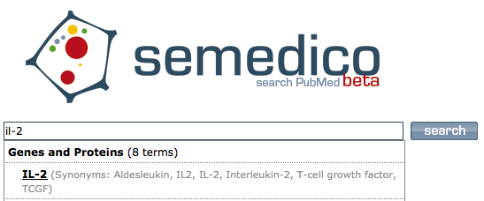

The documents result page will show the terms known to Semedico as facets, located at the left side. Facets arrange their terms taxonomically, where applicable, with the most general terms on the top. If your current search is not specific enough, click on a more specific term of interest to narrow down the set of shown documents. This way, you may refine a general search for ‘Neoplasms’ to specific types of neoplasms with a click on a term in the diseases facet.
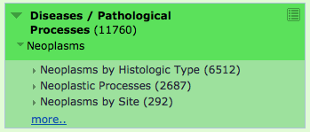

Finding indirect links between literature

As ‘indirect links’ we denote terms which connect documents otherwise unrelated. Two documents sets seemingly unrelated are for example the documents found by searching for ‘bcaa’ and the documents found by searching for ‘zebrafish’. When searching for documents containing both terms, nothing is found. In such a case (or when you did find documents but the results were unsatisfactory) you may carry out a B-Term analysis. Such an analysis finds terms shared by two sets of documents which function as indirect links between the sets.
To carry out a search for indirect links, create the first document set, for example by searching for ‘bcaa’ as in the default document retrieval scenario. Then, click the ‘show B-Term panel’ link:
This will open the panel where you can choose to perform the second search, e.g. for ‘zebrafish’, by click on the ‘add another search for B-Term analysis’ link:
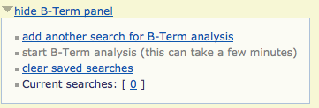
Clicking the link will bring you back to Semedico’s index page. As soon as you committed the second search, the B-Term panel will allow you to click the ‘start B-Term analysis’ link. This starts the analysis. Please be patient, new searches may take up to several minutes.
The result of this action will by a list of indirect links:
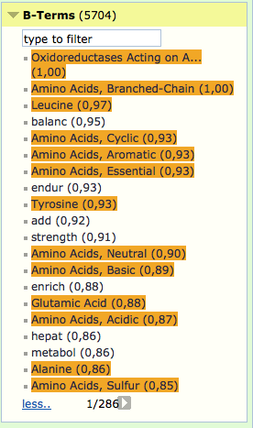
These are terms connecting the documents found by ‘bcaa’ and ‘zebrafish’, respectively. Clicking on a term will show you the documents from both sets containing this term.
The indirect links are ranked by a relevancy formula. The terms on top are those which are most specific in both document sets and thus are deemed most relevant by the system.
You will notice that the other search layers ‘BioMed’, ‘Ageing’ etc. are there as well. These layers offer you the taxonomical view on the found indirect links. This way, the links may be browsed in a more structured way.

