**Social Network Analysis of the Faculty of Engineering and Technology, University of Sindh, Jamshoro** 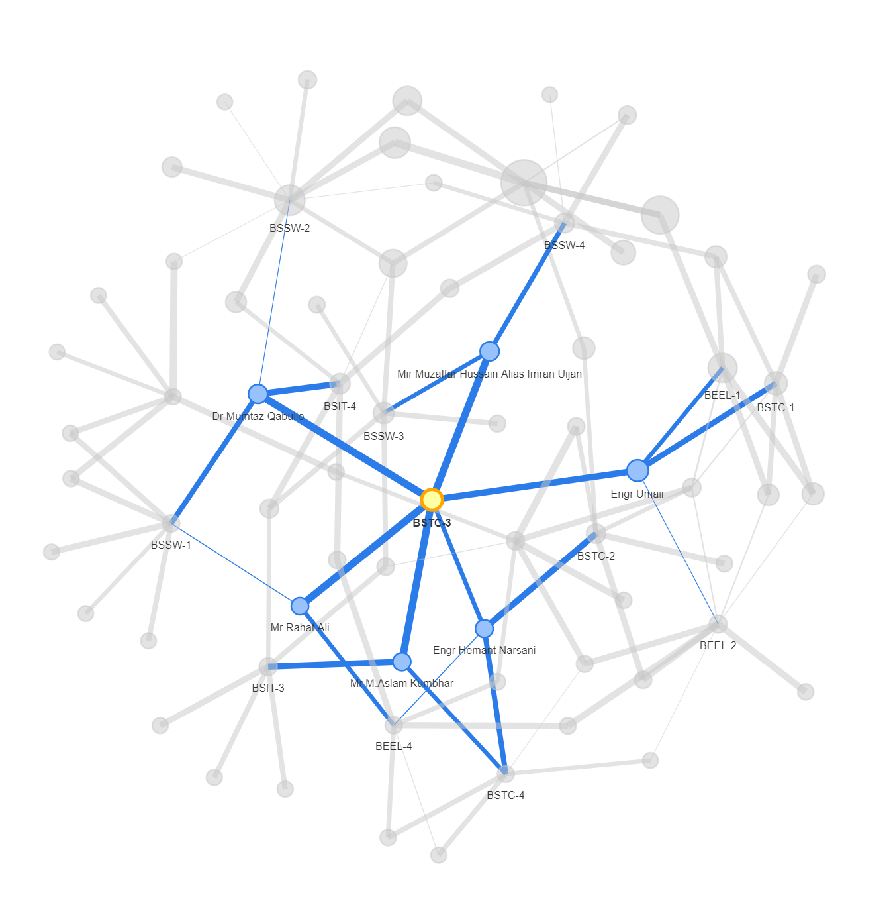

**JUNAID**

**Research Scholar – M.Phil Data Science  
Roll No: 2K23/M-DSC/07**

**Table of Contents**

1. **Introduction ............ ............................................................................. 3  
    1.1 Bipartite Network Analysis  
    1.2 Unipartite (One-Mode) Network Analysis**
2. **Data Collection and Preparation ............................................................. 4**
3. **Analysis and Visualizations ..................................................................... 5  
    3.1 Bipartite Network Analysis: Faculty-Batch Interactions .................... 6  
     3.1.1 Total Faculty Involvement per Batch .......................................... 7  
     3.1.2 Faculty Workload: Total Teaching Load ...................................... 7  
     3.1.3 Distribution of Faculty Workloads ............................................. 8  
     3.1.4 Faculty Coverage per Batch ...... ................................................ 9  
     3.1.5 Faculty: Weighted Degree Centrality (Teaching Load) ..... ............10  
     3.1.6 Batch: Degree Centrality (Faculty Connections) ........................ 11  
     3.1.7 Betweenness Centrality ........................................................... 12  
     3.1.8 Eigenvector Centrality ............................................................. 13  
     3.1.9 Bipartite Network Visualization: Faculty-Batch ......................... 14**

**3.2 Unipartite (One-Mode) Network Analysis: Faculty-to-Faculty Connections   
  3.2.1 Individual Faculty Network Views ................................................. 15  
   • Dr. Sander Ali ................................................................................. 17  
   • Mr. Kamran Dahri ............................................................................ 18  
   • Dr. Abdul Waheed ........................................................................... 19  
   • Dr. Niaz Arijo ................................................................................... 20  
   • Dr. Dil Nawaz .................................................................................. 21  
  3.2.2 Entire One-Mode Faculty Network ................................................. 22**

1. **Conclusion and Recommendations ........................................................ 23**

**Report: Bipartite and Unipartite Network Analysis of Faculty Teaching Load and Connections at the Faculty of Engineering and Technology, University of Sindh**

**1. Introduction**

This report details my Social Network Analysis (SNA) project, which aimed to understand the teaching load distribution and collaborative connections among faculty members and across different academic batches within the **Faculty of Engineering and Technology, University of Sindh, Pakistan**. A core strength of this analysis is the foundational dataset, which I **meticulously created myself** by extracting information directly from publicly available teaching timetables. This hands-on data generation provided a rich and accurate representation of faculty-batch interactions and quantified teaching commitments.

My analysis involved two primary network types:

1. **Bipartite Network Analysis:** Examining the direct connections between two distinct sets of nodes – faculty members and academic batches.
2. **Unipartite (One-Mode) Network Analysis:** Projecting the bipartite network to create a faculty-only network, revealing co-teaching relationships among faculty members.

Through various centrality measures and network visualizations, this study reveals insights into faculty workload, identifies key individuals and batches in the teaching network, and highlights potential areas for resource optimization and collaboration within the Faculty of Engineering and Technology.

**2. Data Collection and Preparation: My Hands-On Approach**

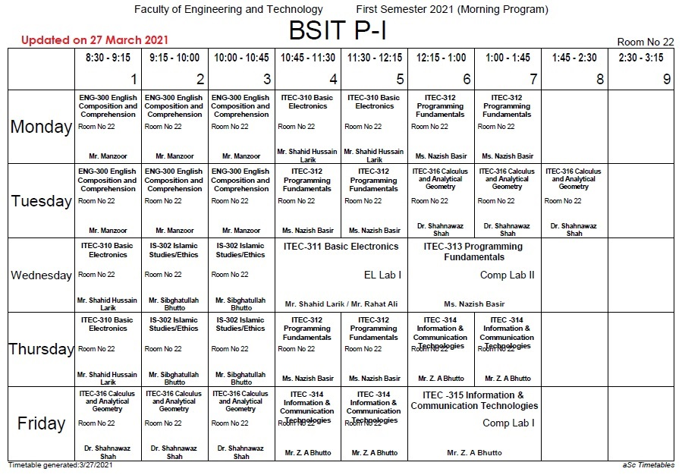

The foundational dataset for this SNA project was not readily available; instead, I **personally compiled it** from the official timetables published on the **Faculty of Engineering and Technology, University of Sindh** website(https://fet.usindh.edu.pk/Timetable/1stsem2021/timetable/index.html). This involved a detailed and time-consuming process of extracting, interpreting, and structuring information from numerous timetable entries. Each entry, typically indicating a faculty member, the course they teach, and the associated batch, was carefully parsed to construct the network's nodes and edges.

The core of my dataset was structured as follows:

* **Source Node (Faculty):** The name of the faculty member.
* **Target Node (Batch):** The specific academic batch (e.g., BSIT-1, BEEL-2, BSTC-1).
* **Weight (Teaching Load/Classes per Week):** This crucial metric was derived by **counting the number of classes a faculty member taught for a particular batch in a week, as indicated by the timetable**. This quantitative measure served as the edge weight in the network, representing the strength of the connection between a faculty member and a batch.

A sample of the prepared data is provided below, showcasing the precise data points I derived from the timetables:

|  |  |  |  |
| --- | --- | --- | --- |
| **weight** | **source** | **target** | **TYPE** |
| 6 | Mr Manzoor | BSIT-1 | Undirected |
| 5.5 | Mr Shahid Hussain Larik | BSIT-1 | Undirected |
| 7 | Ms Nazish Basir | BSIT-1 | Undirected |
| 6 | Dr Shahnawaz Shah | BSIT-1 | Undirected |
| 4 | Mr Shibghatullah Bhutto | BSIT-1 | Undirected |
| 5 | Mr ZA Bhutto | BSIT-1 | Undirected |
| 4 | Mr Ahmad Hussain Shah | BSIT-2 | Undirected |
| 6 | Mr Fahad Razak | BSIT-2 | Undirected |
| 5 | Dr Dil Nawaz | BSIT-2 | Undirected |
| 6 | Dr Muhammad Ali Memon | BSIT-2 | Undirected |
| 7.5 | Dr Shiraz Laghari | BSIT-2 | Undirected |

**This extensive manual data extraction and structuring process was a critical first step and a testament to the effort I invested in ensuring the accuracy and relevance of the network analysis.** This unique dataset, representing a bipartite network (faculty on one side, batches on the other), formed the robust foundation for all subsequent analyses and visualizations.

**3. Analysis and Visualizations**

I utilized the R-Studio environment, coupled with relevant SNA packages, to perform the network analyses and generate the following visualizations, all built upon the diligently prepared dataset:

**3.1 Bipartite Network Analysis: Faculty-Batch Interactions**

These initial plots analyse the direct relationships between faculty members and the batches they teach.

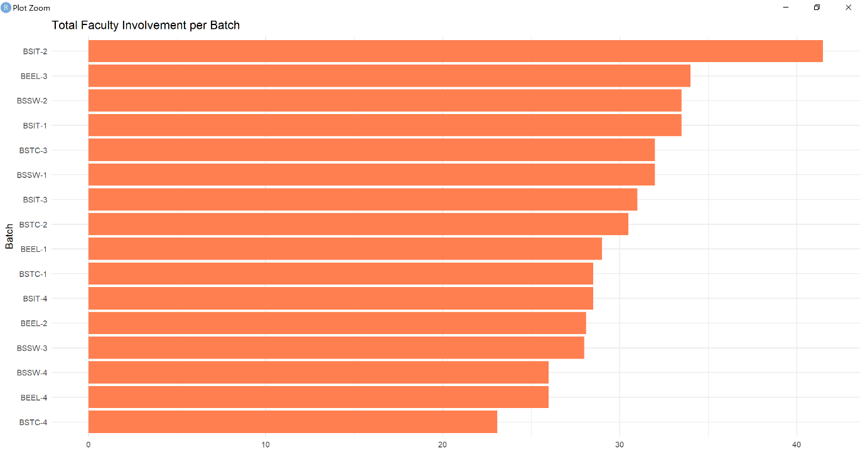

**3.1.1 Total Faculty Involvement per Batch**

This horizontal bar chart illustrates the cumulative teaching involvement of all faculty members within each academic batch. The length of each bar directly corresponds to the total sum of "weights" (classes per week) for that specific batch, **derived directly from the constructed dataset.**

**Interpretation:**

* **BSIT-2** clearly demonstrates the highest total faculty involvement, suggesting it has the most demanding teaching schedule or a larger number of courses requiring faculty interaction.
* **BEEL-3, BSSW-2, BSIT-1, and BSTC-3** also show significant faculty involvement, indicating substantial teaching loads for these batches. (Note: "BSTC" typically refers to Telecommunication batches).
* Conversely, **BSTC-4, BEEL-4, BSSW-4, and BSSW-3** exhibit lower total faculty involvement, potentially indicating fewer courses, smaller class sizes, or a different pedagogical structure.

This plot is crucial for understanding the distribution of teaching resources across different academic programs and years, allowing for identification of batches with higher or lower teaching intensity.

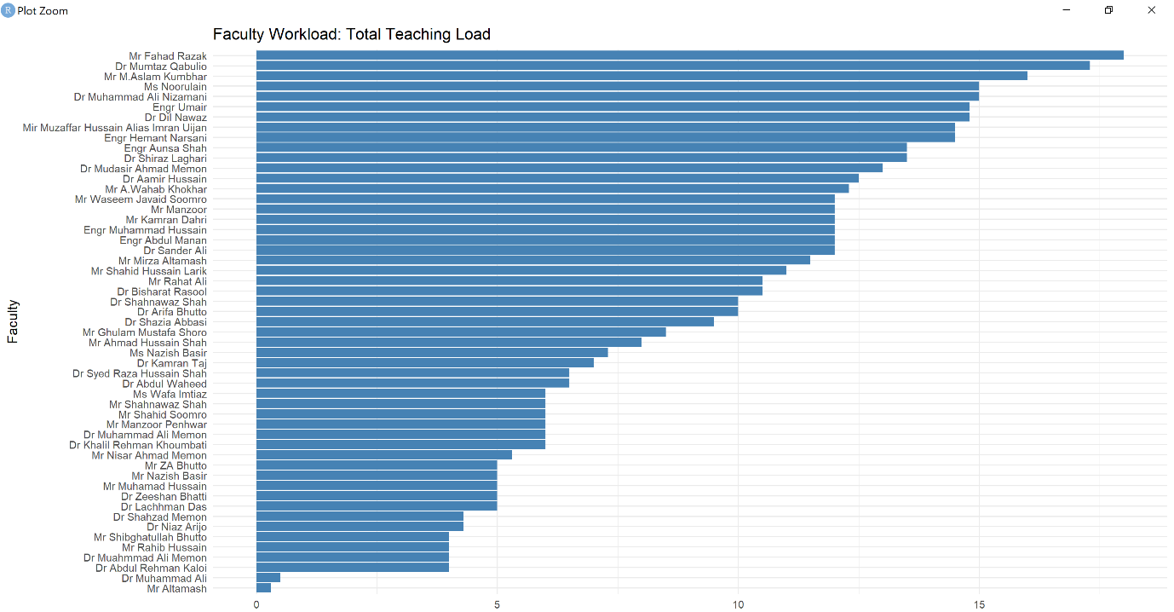

**3.1.2 Faculty Workload: Total Teaching Load**

This horizontal bar chart ranks individual faculty members based on their total teaching load, which is the sum of all "weights" (classes per week) across all batches they teach. **This direct summation from my created dataset provides an accurate representation of individual teaching commitments.**

**Interpretation:**

* **Mr. Fahad Razak** stands out with the highest total teaching load, suggesting he carries a significant portion of the teaching burden within the faculty.
* Other faculty members like **Dr. Mumtaz Gabolio, Mr. M. Aslam Qambrani, and Ms. Nazimain** also demonstrate very high teaching loads.
* The chart reveals a considerable disparity in teaching workload among faculty members. Some faculty members have very high teaching loads, while others, like **Mr. Attamash**, have significantly lower loads.

This visualization is essential for assessing workload distribution equity among faculty members and can inform discussions about faculty assignments, resource allocation, and potential over- or under-utilization of faculty resources.

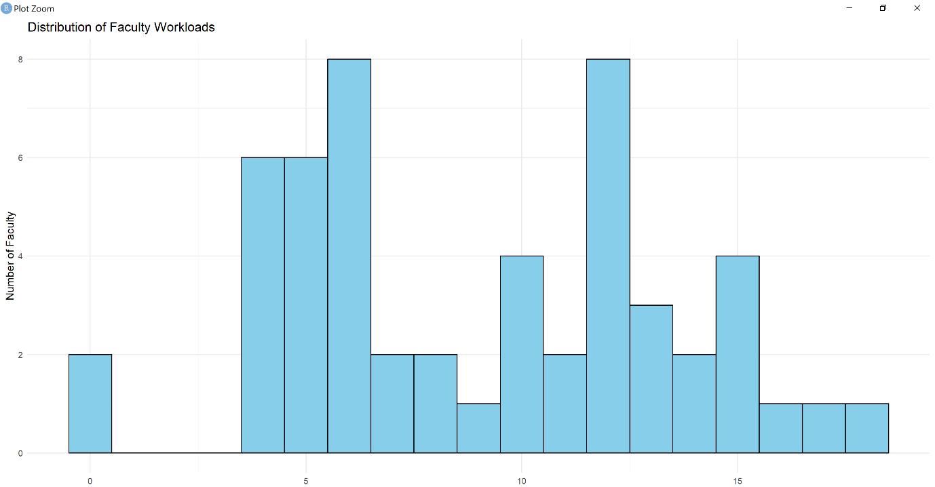

**3.1.3 Distribution of Faculty Workloads**

This histogram provides a frequency distribution of faculty workloads, showing how many faculty members fall into different ranges of teaching load (number of classes per week). **This aggregation of teaching loads, derived from my meticulously built dataset, offers a statistical overview of faculty commitments.**

**Interpretation:**

* The histogram shows a multimodal distribution, indicating several peaks in faculty workload.
* There are notable concentrations of faculty members with teaching loads around **5-7 classes per week** and another significant group around **12-14 classes per week**.
* A smaller number of faculty members have very low (0-2 classes) or very high (>15 classes) workloads.

This plot offers a more generalized view of the teaching workload landscape. It helps identify common workload patterns and outliers, providing a statistical summary of how teaching responsibilities are distributed across the entire faculty.

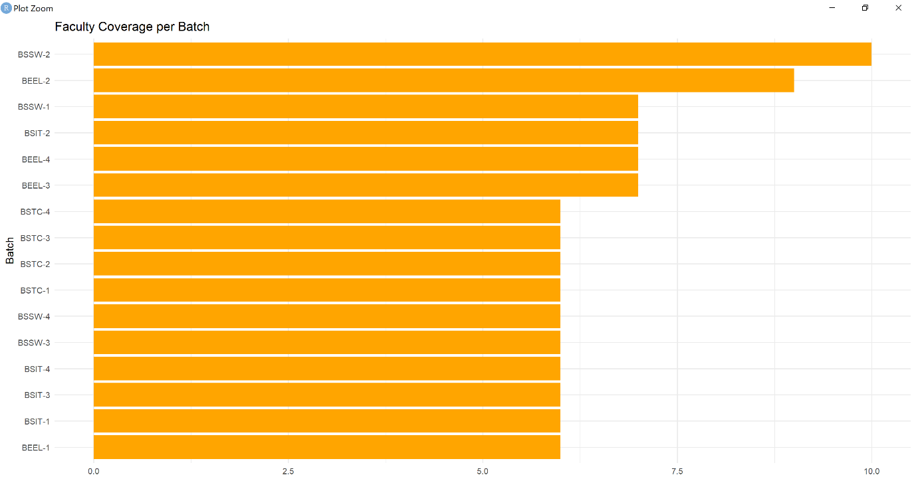

**3.1.4 Faculty Coverage per Batch**

This horizontal bar chart displays the number of distinct faculty members involved in teaching each specific batch. Unlike "Total Faculty Involvement," this focuses on the *breadth* of faculty engagement, **directly counted from the connections established in my constructed dataset.**

**Interpretation:**

* **BSSW-2** and **BEEL-2** have the highest faculty coverage, implying that a larger number of distinct faculty members are involved in teaching courses for these batches. This could indicate a diverse curriculum or a collaborative teaching approach.
* **BSIT-1, BSIT-2, BEEL-1, and BSTC-1** also show good faculty coverage.
* In contrast, batches like **BSTC-4, BSTC-3, BSSW-3, BSIT-4, BSIT-3, and BEEL-1** have lower faculty coverage, suggesting fewer distinct faculty members are involved.

This chart helps to understand the diversity of teaching perspectives and expertise a batch is exposed to. High faculty coverage might suggest a more integrated curriculum or a shared teaching responsibility model.

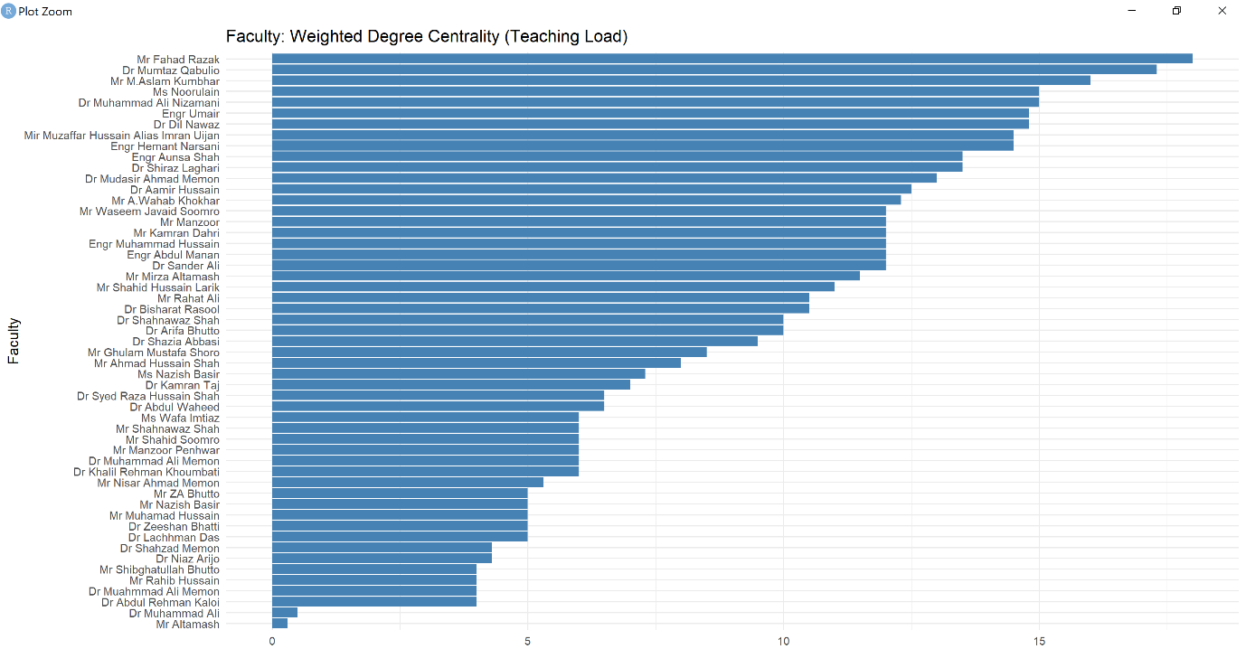

**3.1.5 Faculty: Weighted Degree Centrality (Teaching Load)**

This bar chart represents the weighted degree centrality of each faculty member, where the "weight" is their teaching load (classes per week). This centrality measure directly leverages the "weight" values **I extracted and compiled during the dataset creation phase.**

**Interpretation:**

* This plot is essentially a re-visualization of the "Total Teaching Load" but framed within the context of network centrality.
* Faculty members with higher weighted degree centrality, such as **Mr. Fahad Razak** and **Dr. Mumtaz Gabolio**, are those who have the most "strong" connections in the teaching network, meaning they are responsible for a large volume of teaching across different batches.
* These individuals are central to the teaching network due to their extensive teaching commitments.

This metric is vital for identifying faculty members who are heavily involved in the teaching process and could be considered "hubs" of teaching activity.

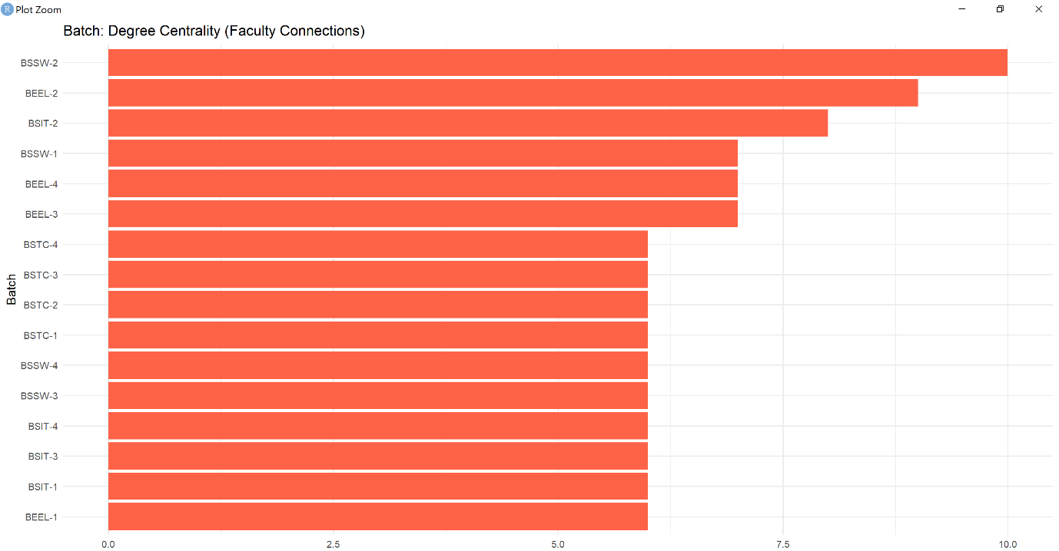

**3.1.6 Batch: Degree Centrality (Faculty Connections)**

This horizontal bar chart shows the degree centrality of each batch, indicating the number of distinct faculty members connected to (teaching) that batch. This is conceptually similar to "Faculty Coverage per Batch" but explicitly presented as a network centrality measure, **derived from the connections I defined in the meticulously constructed network.**

**Interpretation:**

* **BSSW-2** and **BEEL-2** exhibit the highest degree centrality, meaning they are connected to the largest number of different faculty members.
* This indicates that these batches interact with a wide range of teaching staff, potentially leading to diverse learning experiences.
* Batches with lower degree centrality have fewer distinct faculty connections, suggesting a more focused or specialized teaching team.

This centrality measure helps to understand which batches are more "connected" within the faculty's teaching ecosystem, revealing patterns of faculty engagement with specific academic programs.

**3.1.7 Betweenness Centrality**

This bar chart illustrates the betweenness centrality for both faculty and batch nodes in the network. Betweenness centrality measures the extent to which a node lies on the shortest path between other nodes. Nodes with high betweenness centrality act as "bridges" or "brokers" in the network, **a characteristic directly influenced by the connectivity patterns captured in my created dataset.**

**Interpretation:**

* **BSSW-2** and **Engr Aunea Shah** exhibit the highest betweenness centrality. This suggests that these nodes (a batch and a faculty member) play a crucial role in connecting different parts of the teaching network. For instance, **BSSW-2** might be taught by faculty members who also teach other distinct batches, effectively bridging those teaching groups. Similarly, **Engr Aunea Shah** might be teaching courses that are prerequisites or common to multiple diverse batches, making him a critical intermediary.
* Other faculty members like **Dr Mumtaz Gabolio, Dr Shiraz Laghari, and Dr Bisharat Rasool** also show high betweenness, indicating their role in facilitating connections between different teaching components.
* The plot also highlights that some faculty and batches have very low betweenness centrality, meaning they are less central to connecting different parts of the network.

High betweenness centrality indicates a critical role in information flow and collaboration. Disrupting these nodes could fragment the network.

**3.1.8 Eigenvector Centrality**

This bar chart presents the eigenvector centrality for both faculty and batch nodes. Eigenvector centrality measures the influence of a node in a network. A node has high eigenvector centrality if it is connected to other nodes that also have high centrality. It's a measure of influence within the network, **directly reflecting the interconnectedness patterns derived from my comprehensive dataset.**

**Interpretation:**

* **Mr Fahad Razak** and **Dr Shiraz Laghari** demonstrate exceptionally high eigenvector centrality. This implies that they are not just teaching a lot, but they are also connected to other faculty members and batches that are themselves well-connected or influential in the teaching network. They are likely highly influential in shaping the overall teaching landscape.
* **BSSW-2** and **BSIT-2** also show high eigenvector centrality, suggesting these batches are taught by influential faculty members.
* Conversely, nodes with low eigenvector centrality are connected to less influential nodes.

High eigenvector centrality suggests that these faculty members or batches are at the heart of the most influential teaching connections and their activities have a broader impact on the network.

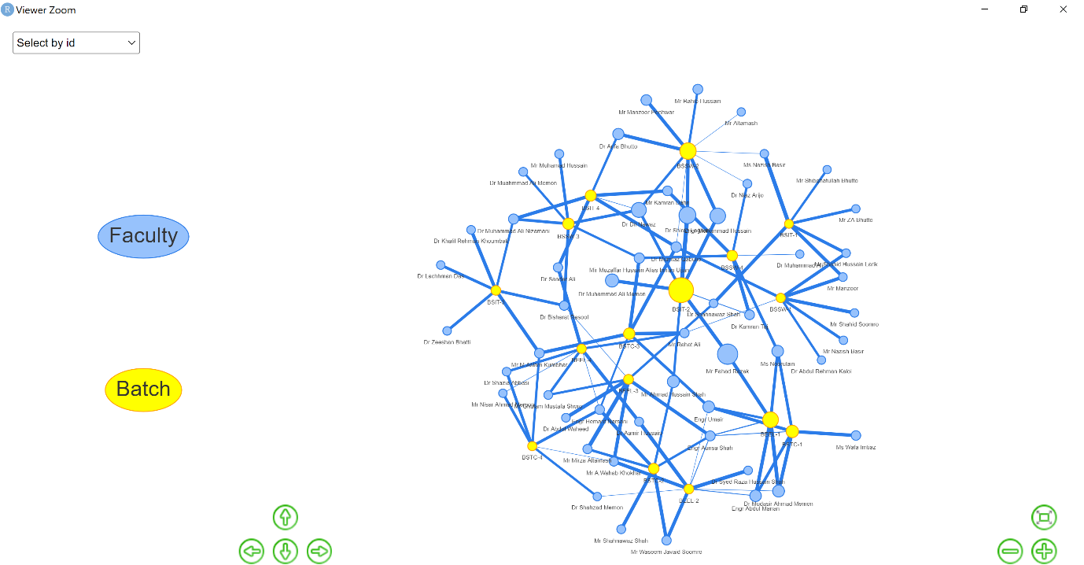

**3.1.9 Bipartite Network Visualization: Faculty-Batch Connections**

This image displays a visual representation of the bipartite faculty-batch network. The nodes are colored differently to distinguish between "Faculty" (blue) and "Batch" (yellow). The thickness of the lines (edges) connecting the nodes represents the "weight" (teaching load/classes per week) between a faculty member and a batch.

**Interpretation:**

* The network forms a complex interconnected structure, highlighting the intricate relationships between faculty and batches.
* The yellow nodes (Batches) appear as central hubs in many clusters, with multiple blue nodes (Faculty) radiating outwards, indicating that each batch is taught by several faculty members.
* Conversely, some blue nodes (Faculty) also appear as central figures, connecting to multiple yellow nodes (Batches), signifying faculty members who teach across various programs.
* The varying thickness of the lines visually reinforces the teaching load: thick lines denote significant teaching commitments between a faculty member and a batch. For instance, I can observe the dense connections around certain yellow batch nodes and certain blue faculty nodes, signifying high teaching intensity.

This overall network map provides a qualitative understanding of the connections and concentrations within the teaching system. It visually confirms the insights gleaned from the centrality measures, showing which faculty and batches are most interconnected and have the strongest teaching ties.

**3.10 Unipartite (One-Mode) Network Analysis: Faculty-to-Faculty Connections**

To further explore the collaborative structure within the faculty, I created a unipartite (one-mode) projection of the bipartite faculty-batch network. In this projection, only faculty members are represented as nodes, and a connection (edge) exists between two faculty members if they both teach the same batch. The weight of this connection can represent the number of shared batches or the combined teaching load in those shared batches.

This section presents the individual faculty network views, highlighting their immediate connections and the strength of those connections:

**3.10.1 Individual Faculty Network Views**

These five images showcase specific individual faculty members within the one-mode projected network. The selected faculty member is highlighted, and their direct connections (other faculty members they share batches with) are more prominently displayed with thicker lines indicating stronger shared teaching commitments. Grayed-out nodes represent faculty members not directly connected to the selected individual in these specific views. The names of the selected faculty members are visible in the upper left corner of each image.

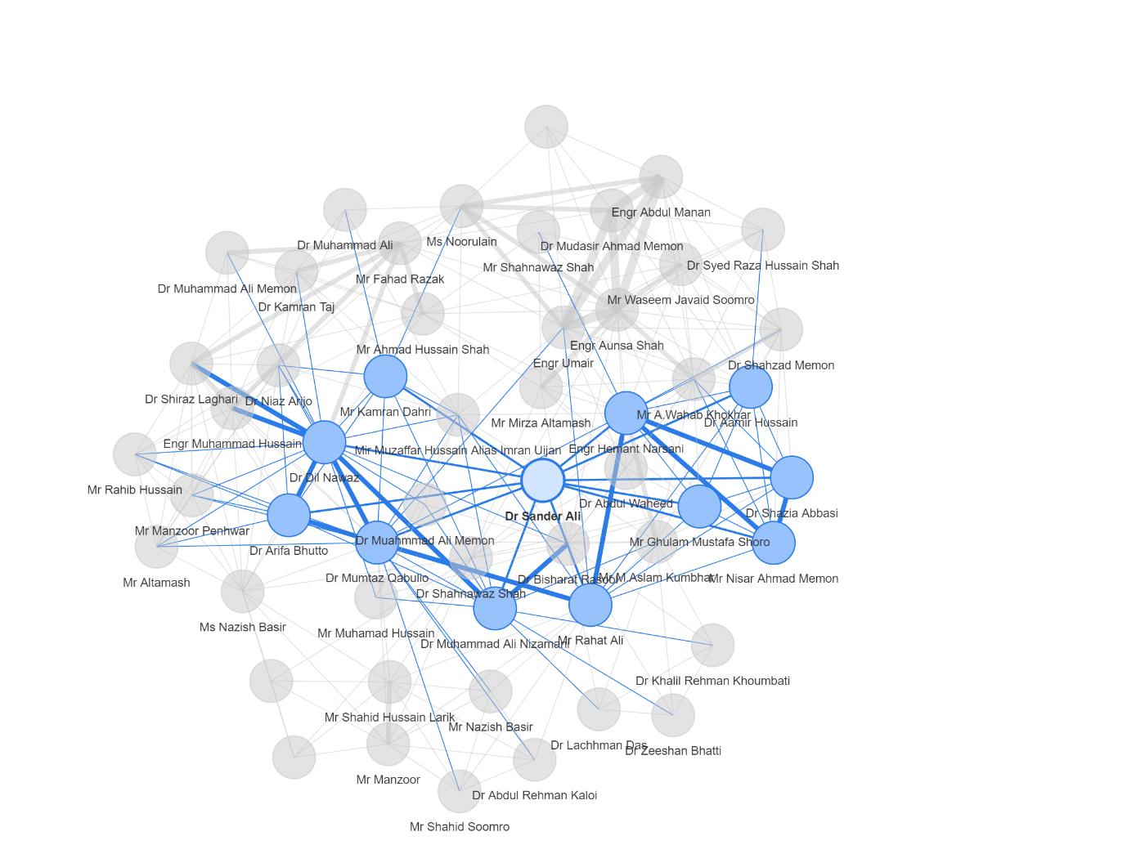

* **Dr. Sander Ali :**This view centers on Dr. Sander Ali. The thicker lines emanating from his node indicate strong teaching collaborations with certain other faculty members, meaning they share several batches or significant teaching loads within common batches. This helps identify his immediate collaborative circle.

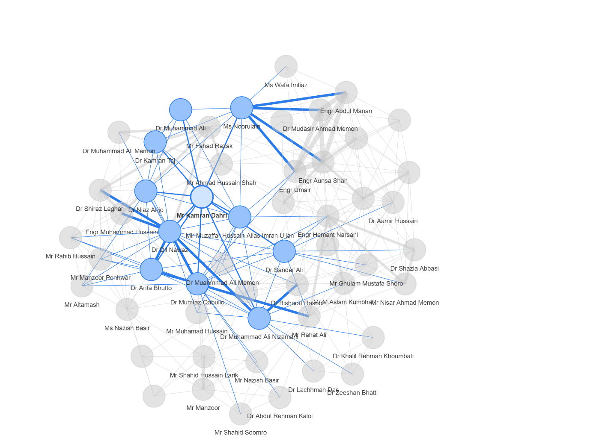

* **Mr. Kamran Dahri :**Similarly, this highlights Mr. Kamran Dahri's direct co-teaching relationships. I can observe the thickness of lines to understand the intensity of collaboration (e.g., teaching many courses in the same batch).

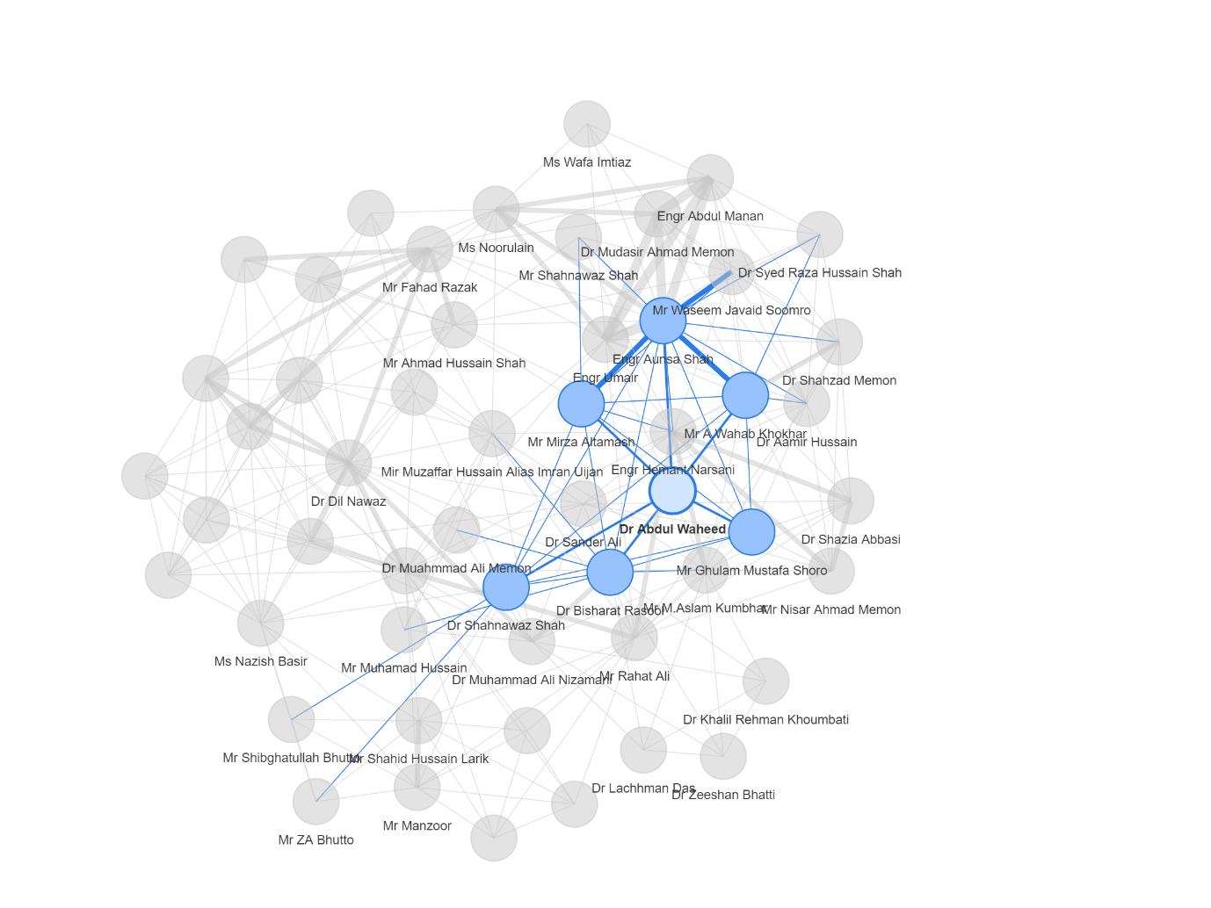

* **Dr. Abdul Waheed :**This view focuses on Dr. Abdul Waheed's direct co-teaching network. The connections reveal which other faculty members he most frequently collaborates with on teaching responsibilities.

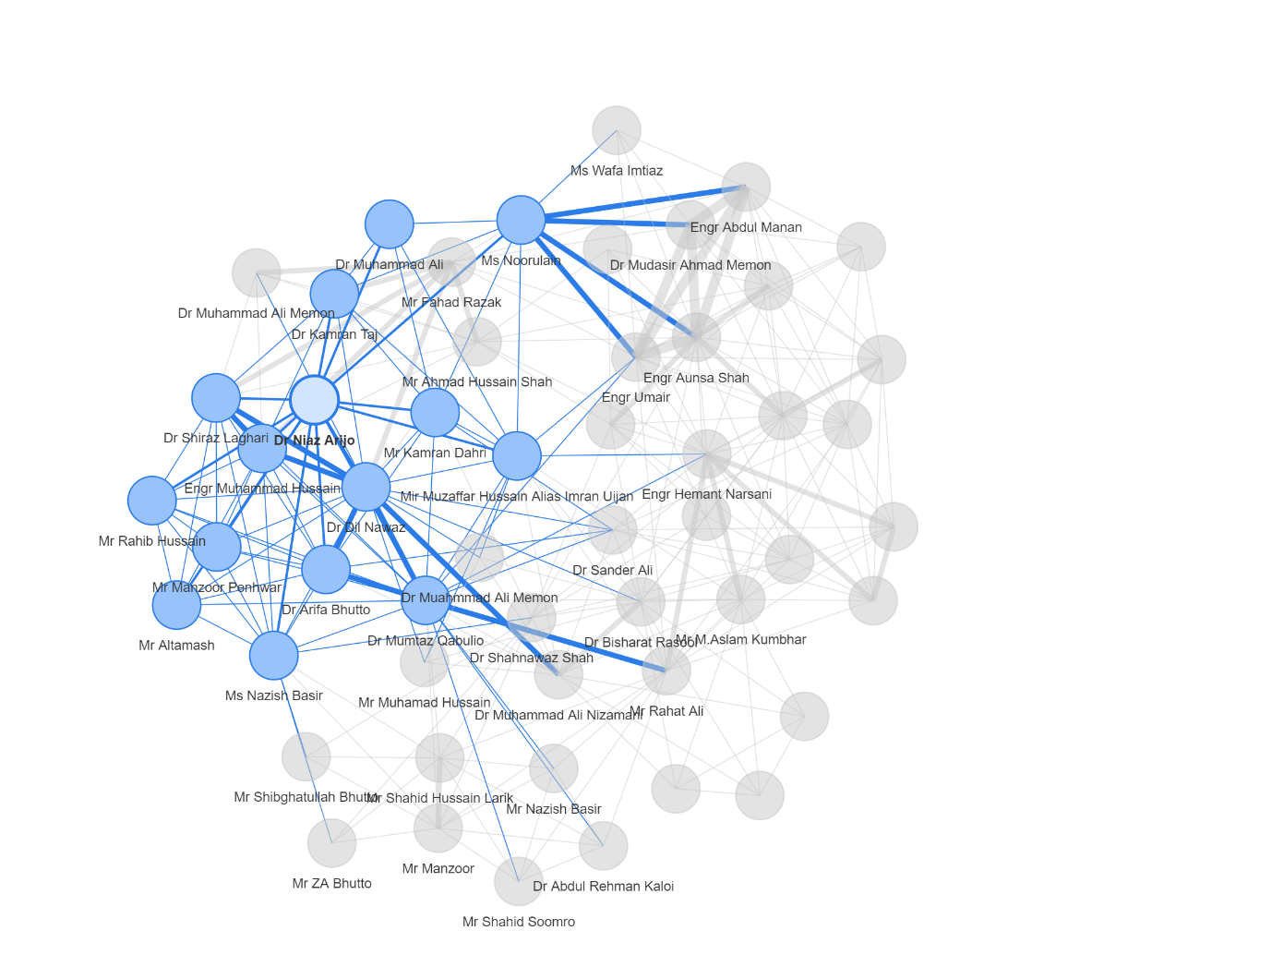

* **Dr. Niaz Arijo :** This image showcases Dr. Niaz Arijo's direct connections within the faculty network. The distinct connections highlight faculty members who are most closely linked through shared teaching responsibilities across batches.

* **Dr. Dil Nawaz :**This final individual view centers on Dr. Dil Nawaz, displaying his immediate teaching collaborations. The strength of these connections (line thickness) indicates the extent of shared teaching efforts.

These individual unipartite network views are powerful for understanding:

* **Direct Collaboration:** Who directly co-teaches with whom.
* **Strength of Collaboration:** The intensity of these shared teaching efforts.
* **Faculty Clusters:** Implicitly, how groups of faculty members might naturally form around shared batches.

**3.10.2 Entire One-Mode Faculty Network:**

These two images present the complete unipartite (one-mode) projected network of faculty members. In this visualization, every node represents a faculty member, and an edge (line) connects two faculty members if they teach a common batch. The thickness of the edge signifies the strength of their shared teaching involvement (e.g., how many classes they co-teach or how many batches they share).

**Interpretation:**

* **Overall Connectivity:** Both images show a dense and interconnected network of faculty members, indicating a high degree of shared teaching responsibilities across various batches. This suggests a collaborative teaching environment where faculty members often work together on different programs.
* **Highly Connected Faculty (Hubs):** I can observe the nodes with numerous thick connections. These represent faculty members who co-teach with many others and/or have significant shared teaching loads with their collaborators. These are likely central figures in teaching coordination and curriculum delivery.
* **Potential Clusters:** While not explicitly clustered by an algorithm in these visualizations, visual inspection can suggest areas where faculty members are more densely connected, potentially forming informal teaching groups around specific disciplines or batches.
* **Strength of Relationships:** The varying line thicknesses clearly illustrate the differences in the intensity of co-teaching relationships. Thicker lines highlight strong collaborative ties, while thinner lines indicate more limited shared teaching.

These complete unipartite network views are invaluable for:

* **Understanding Faculty Collaboration Patterns:** Identifying how faculty members naturally group or collaborate through shared teaching.
* **Identifying Key Collaborative Bridges:** Locating faculty members who connect otherwise disparate groups of teachers.
* **Informal Leadership:** Highlighting faculty members who, through their extensive collaborations, might exert informal leadership or influence within the teaching staff.

**4. Conclusion and Recommendations**

This comprehensive Social Network Analysis project, **underpinned by the robust and accurate dataset I personally constructed from raw timetable data**, has provided profound insights into the teaching dynamics at the **Faculty of Engineering and Technology, University of Sindh, Pakistan**. By examining both bipartite faculty-batch connections and unipartite faculty-to-faculty collaborations, I have uncovered critical information regarding workload distribution, influential individuals, and the underlying structure of teaching interactions across various programs.

**Key Findings Reconfirmed and Extended:**

* **Workload Disparity:** My initial findings regarding uneven distribution of teaching load among faculty members are reinforced, urging for a careful review of resource allocation.
* **Batch-Specific Demands:** Certain batches (e.g., BSIT-2, BEEL-3, and notably BSTC) consistently require higher faculty involvement and coverage, highlighting their intensive teaching requirements.
* **Key Intermediaries and Influencers:** Specific faculty members and batches play crucial "bridging" roles (high betweenness centrality) and possess significant influence within the network (high eigenvector centrality), demonstrating their critical importance to the academic ecosystem.
* **Interconnected Faculty Collaboration:** The unipartite projections clearly reveal a highly interconnected faculty network, indicating significant co-teaching and shared responsibilities. Some faculty members emerge as central hubs in these collaborative efforts, suggesting their pivotal role in connecting diverse teaching domains.

**Recommendations:**

Building upon these findings, the following recommendations are proposed:

1. **Strategic Workload Balancing:** Leverage the detailed workload and centrality analyses to implement strategies for more equitable teaching load distribution. This could involve re-evaluating course assignments, promoting team-teaching where appropriate, or providing additional support for highly loaded faculty members.
2. **Optimize Resource Allocation:** Use the insights into batch-specific demands and faculty coverage to refine curriculum planning and resource allocation, ensuring that all academic programs receive adequate and diverse teaching support.
3. **Support and Empower Key Faculty:** Recognize and actively support faculty members identified as having high centrality measures (degree, betweenness, eigenvector) in both bipartite and unipartite networks. These individuals are crucial for communication, coordination, and overall network resilience. Consider formalizing their roles in mentorship or curriculum development.
4. **Foster Targeted Collaboration:** Utilize the unipartite network insights to deliberately foster collaboration among faculty members. Identify individuals who are not yet strongly connected but could benefit from shared teaching experiences, or strengthen ties between existing collaborative clusters.
5. **Longitudinal Network Analysis:** Conduct periodic analyses of these networks (e.g., annually) to track changes in teaching load, collaboration patterns, and faculty influence over time. This longitudinal approach can help identify emerging trends, assess the impact of policy changes, and proactively address potential issues.

This SNA project stands as a powerful demonstration of how **rigorous data collection and sophisticated network analysis, initiated by my direct efforts in dataset creation**, can provide actionable intelligence for academic administration. The insights gained are instrumental in making informed decisions regarding faculty management, curriculum planning, and resource optimization to enhance the overall academic environment at the Faculty of Engineering and Technology.